YOUNG-OS


Supervisor
SIR WAQAS ALI

Submitted by
Muhammad Salman {2021_SE_04}
Noman Ahmad {2021_SE_24}
Muhammad Usama {2021_SE_41}
Muhammad Haroon {2021_SE_44}
Muhammad Farjad Waseem {2021_SE_56}

Department of Computer Science,
University of Engineering and Technology, Lahore, New-Campus.

INTRODUCTION:
Young-OS is an Operating System simulator that works just like an ordinary Operating System and provides you with the basic operations and applications. It is a lightweight OS simulator that helps understand how an Operating Systems works. You can run the OS simulator in UNIX systems, and it will work just like a mini-OS that performs the required tasks.

Project Statement:
“An operating system (OS) is system software that manages computer hardware, software resources and provides common services for computer programs. In this project we will design a simulation of the operating system of our own. The simulation should be made using and following all concepts studied in the course.”

Key features:
- Our operating system has a name of its own that will display on starting the program that is “Young-OS”.
Detail: We made the program in such a way that when it starts it displays the name of our operating system on terminal using sleep command for some seconds like it is loading.
- The RAM hard drive and the number of cores will be given by the user while
starting the OS
- This instance of OS will have 2GB RAM, 256GB Hard drive and 8 cores you can choose your own convention.
- Fork, Exec, Shared Memory and Semaphores are used to run, exit and share data between Main and Tasks Process

- The resources are being managed by the Young-OS keeping RAM, Hard drive and cores kept in mind while making new processes or threads.
- We have defined basic applications and tasks that Young-OS can perform
  - Basic activities include moving, copying, deleting, checking file information, creating files in Notepad with an auto-save feature, and playing mini games like tic-tac-toe.
  - Total Tasks
Detail: Each task has a defined task its own separate code file and it makes a new process. Once a process is created it will send the creating process message that will contain memory required in Hard drive and RAM if available then the process will reply to grantee else the process will be terminated each process will have its own terminal so the output is not messed up. This will help to enable multi-tasking in our operating system.
- You can also manually create an interruption to stop the specific task or minimize it.
Detail: Each task has a button + shortcut key (CTRL+ESC) to close it in the middle to simulate an interruption.
- Our operating system can multitask.
- Our operating system would have user mode and kernel mode (in kernel mode you can access hardware resources)
Detail: In kernel Mode users can close or delete the processes from memory meaning you can close running programs.
- All the operations can be performed just by using an interactive user-friendly GUI.
Project Working:
You will provide Hardware resources on starting program. The operating system will start and its name will be written on boot screen. After starting some basic tasks like time and calendar should start on their own. An instruction guide will show all the tasks a user can perform in your operating system. The user can then select a specific task and it should start working in a new terminal. It will take specific location and size in RAM and wait for its turn to execute which will be controlled by using scheduling techniques if the processes increase the total number of cores they will be scheduled then. If the user starts any other program that will be added into the RAM too. A ready queue will schedule all the tasks in the RAM on its own and send them for processing. If any interrupt for input in task or some other external interrupt occurs the task should move into blocked section. Each process will execute according to its turnaround time which is set during coding. User will not provide this on runtime. After task is completed, it should be removed from the RAM. If user saves something it should be saved in the hard disk.

Operating system concepts:
The following OS ideas guide our project.:
- Multitasking
- Context switching
- Resource allocation
- User mode and Kernel mode
- Process creation
- Threads
- EXEC commands
- Scheduling using semaphore
- Scheduling techniques used is ready queue and running queue.
- Running Queue will have can have process equal to the number of cores
- Kill(pid,SIGCONT) and kill(pid,SIGSTOP) and kill(pid,0) are used for process pausing and stoping
Project Full Workflow:
Program loads after asking for resources, followed by operating system. Our OS will load the programs we have created as soon as the visuals have been integrated, and each of them will have unique icons and names. Otherwise, the terminal can also be used to run our OS. There is a list of apps you can run in the terminal. When an app is launched, there is an option to minimize or close it in the middle. The user can choose any other task after closing the current process and removing it from the RAM. By minimizing it, the user can choose whatever other work he wishes to carry out while it remains in RAM. Users can pick a task among those that are already in progress. The amount of RAM will not be exceeded by the active tasks. Some of the tasks require constant user input, like a calculator. A few may operate in the background. Some are just processed; others are not.

Types of Tasks:
- Real-time response that mimics a game. Only by minimizing or shutting it will it come to an end. The area they occupy should correspond to their work.
- a background process, such as background music. You can use a beep sound that plays in the background for a certain period and stops when the duration of a song dictates that it should. Another similar procedure would be to copy a file or print it.
- There are some tasks that complete themselves. like a clock or an automated notepad file save.

Working Diagram (you can change the name as well):

Tasks:
- Notepad
- Calculator
- Time
- Creating a File
- Move file
- Copy file
- Delete File
- Check File Info
- Image Viewer
- Text Editor
- Game
- Task Manager
- File Encryption Tool
- File Decryption Tool
- Text Encryption Tool
- Text Decryption Tool

Notepad:

Description:
Notepad is a simple file-text editor with autosave feature which enable user to locate its file and then open inside notepad. Notepad provides a Text Editing Area where user can edit the text of file with autosave feature. Autosave features trigger whenever the text is changed in text editing area.

Features:
- Open File to edit its text
- “Q File Dialog” to locate file
- Auto Save feature

UI-Screenshot:
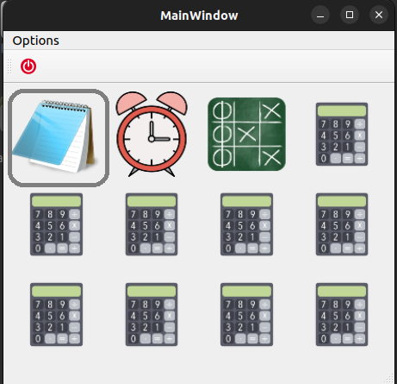
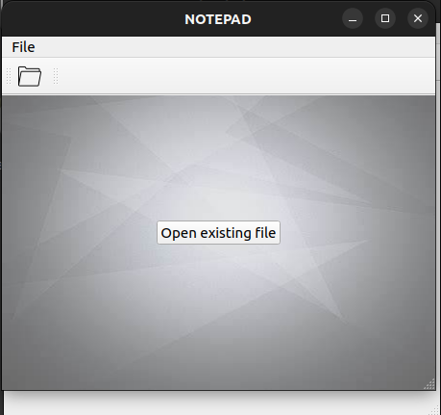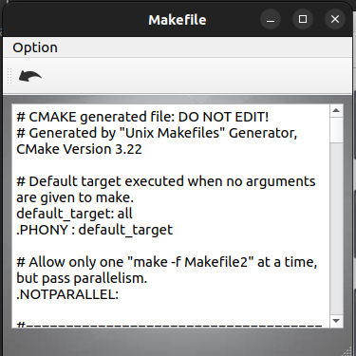

Steps using Notepad:
- Click on Notepad Icon
- Click on Open File
- Select File You want to open in notepad
- Press Open
- Now edit text, notepad will automatically save it in file
- Close file

Shortcut-Keys:
No. | Actions | Shortcut Keys
1. | Open Notepad from Desktop Window | Ctrl+1
2. | Close Running Notepad from Desktop | Ctrl+Alt+1
3. | Open File inside Notepad | Ctrl + O
4. | Close Open File | Esc
5. | Close Notepad While file is opened | Ctrl + Esc
6. | Close Notepad while file is not opened | Esc

Calculator:

Description:
A simple calculator that works just like an ordinary calculator and performs the basic mathematical operations like Summation, Subtraction, Multiplication, Division etc. It can used for quick calculations as it is a low storage highly effective app. Numbers can be entered just by pressing the number keys of keyboard not by manually clicking on the screen.

Features:
- Type by pressing number keys on Keyboard
- Can append calculations

UI-Screenshot:
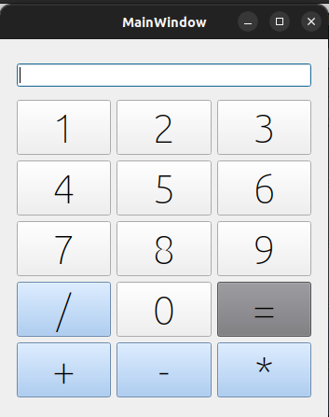

Steps using Calculator:
- Click on the Calculator icon
- Press any number key on keyboard
- Press the operator on the keyboard to perform operation
- Press the 2nd operand
- Hit the equal button
- For appending the calculations just start appending operands spaced with operators.

Shortcut-Keys:
No. | Actions | Shortcut Keys
1. | Open Task from Desktop Window | Ctrl+ 5
2. | Close Running Task from Desktop | Ctrlt+ 5
3. | Close Task | Ctrl + ESC

Calendar:

Description:
The Calendar task is useful in terms of when a person quickly wants to look for upcoming dates and look for upcoming holidays. Users can view the calendar and pretend what day of the year will be on May 6, similarly it can be used to view weekend plannings as well.

Features:
- Displays the Calendar in a user-friendly GUI.
- User can view previous month’s as well as upcoming month’s dates.
- User can Also select years as well.

UI-Screenshot:
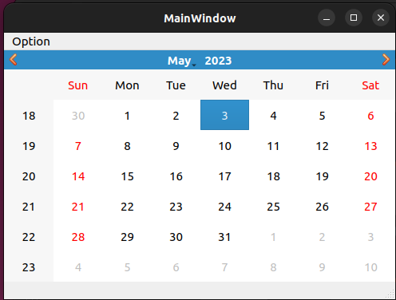

Steps using Calendar:
- Click on the Calendar icon.
- A GUI will open showing the current date selected.
- You can play around with its interface.

Shortcut-Keys:
No. | Actions | Shortcut Keys
1. | Open Task from Desktop Window | Ctrl+T
2. | Close Running Task from Desktop | Ctrlt+T
3. | Close Task | Ctrl + ESC

Time:

Description:
Young-OS can show continuous and precise time measurements according to the current country. It shows the exact time and keeps on updating as we see in all the famous Operating Systems today. It also shows the current day (i.e., Monday, Sunday) and the time according to the formats MM/DD/YY. Thread is used and update time function will be called every second.

Features:
- Active & Precise Time
- Keeps on updating itself
- Always running in the background for efficiency.

UI-Screenshot:
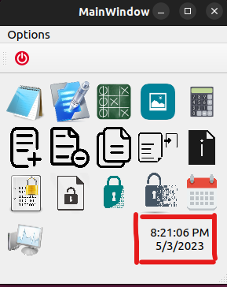

Steps For getting Time:
- Run The Young-OS Operating System.
- There it is in the bottom right corner.

Creating a File:

Description:
Creating a file tool in an operating system is a software function that allows users to create new files on their system. When creating a file, users can specify the file's name and location and define its permissions for read, write, and execute access for the file's owner, group, and others. This feature is particularly useful for managing access to sensitive files and ensuring that only authorized users can read, modify, or execute the file.

Features:
- Can specify read, write and execute permissions directly from the tool to owner, group, and others.
- Users can manually type in the folder location or choose the folder from the “Browse” button.

UI-Screenshot:

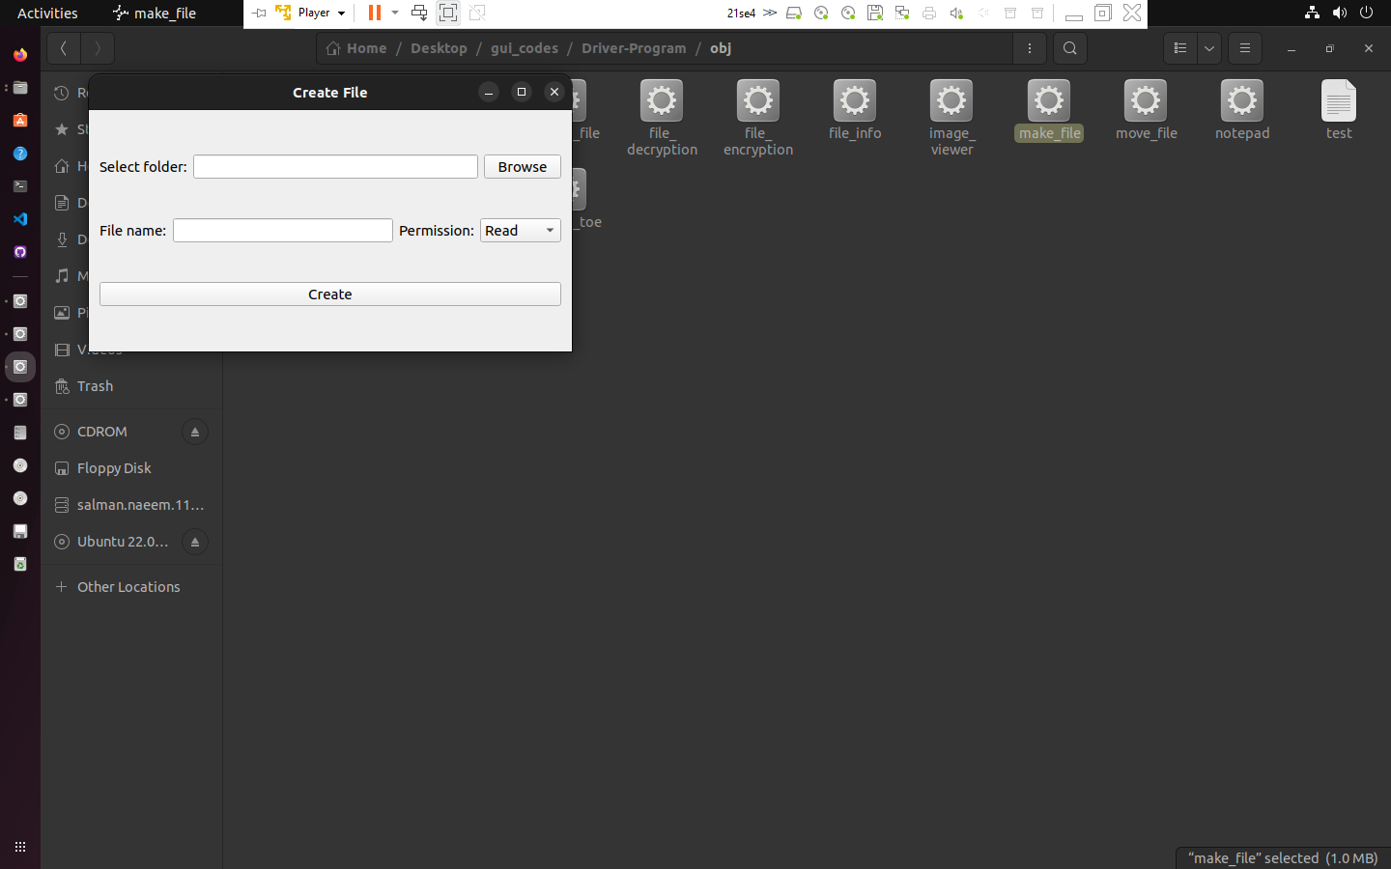
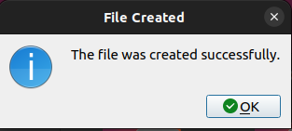

Steps creating a file:
- Select the folder location to store the file.
- Type in the name for the file.
- Allow the permissions (read, write, execute).
- Press the create file button.

Shortcut-Keys:
No. | Actions | Shortcut Keys
1. | Open Task from Desktop Window | Ctrl+6
2. | Close Running Task from Desktop | Ctrlt+6
3. | Close Task | Ctrl + ESC

Move file:

Description:
The "Moving File" task in an operating system allows users to relocate a file from its current location to a different folder or directory. This task is useful when organizing files or freeing up space on a hard drive. When a file is moved, its original location is no longer accessible, and it can only be accessed from its new location. The process of moving a file typically involves selecting the file, choosing the "Move" option, selecting the destination folder, and confirming the action.

Features:
- Opens The Dialog for both selecting file source and destinations.
- You can type manually as well as by selecting from the browse button.

UI-Screenshot:
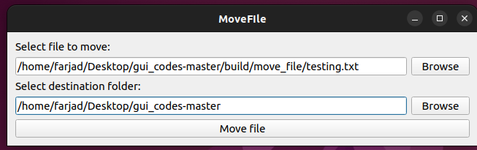

Steps using Notepad:
- Run the Young-OS
- Select the move file task
- Type in the source location of file or choose from “Browse” dialog.
- Type in the destination location of file or choose from “Browse” dialog.

Shortcut-Keys:
No. | Actions | Shortcut Keys
1. | Open Task from Desktop Window | Ctrl+9
2. | Close Running Task from Desktop | Ctrlt+9
3. | Close Task | Ctrl + ESC

Copy file:

Description:
A copy file system is a type of file system used in operating systems that allows files to be copied from one location to another. This is typically done to make backups or to move files between different storage devices. Copy file systems are often used in conjunction with other file systems, such as the FAT or NTFS file systems, to provide additional functionality and flexibility to the user.

Features:
- Copy File
- Creating backup of files

UI-Screenshot:
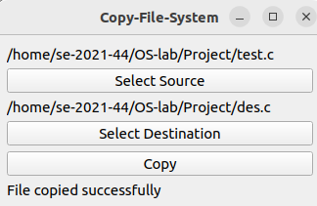

Steps Copying File:
- Open Notepad and type the file path and name of the file you want to copy and the destination folder where you want to copy it. For example, "C:\Users\Username\Documents\File1.txt" to "D:\Backup\File1.txt".

- Save the Notepad file with a .bat extension, for example, "CopyFile.bat".

- Open the file explorer or command prompt and navigate to the location where you saved the CopyFile.bat file.

- Double-click the CopyFile.bat file to execute it. This will initiate the copy process, and the file will be copied from the source location to the destination folder.

Shortcut-Keys:
No. | Actions | Shortcut Keys
1. | Open Task from Desktop Window | Ctrl+8
2. | Close Running Task from Desktop | Ctrlt+8
3. | Close Task | Ctrl + ESC

Delete File:

Description:
A delete file system is a component of an operating system responsible for removing files from a storage device. When a file is deleted, the delete file system marks the space occupied by the file as available for reuse. The delete file system ensures that the file is permanently removed from the storage device, preventing it from being recovered through file recovery software.
Features:
- Deletion:
- Permanent deletion:
- File recovery:

UI-Screenshot:
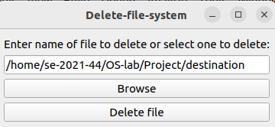
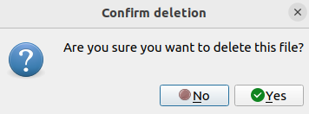
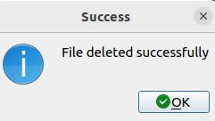

Steps Deleting File:
- Open a text editor and type the command to delete the file. The command to delete a file in Ubuntu Linux is "rm" followed by the file path and name. For example, "rm /home/username/Documents/File1.txt".

- Save the text file with a .sh extension, for example, "DeleteFile.sh". Make sure to choose "All files" as the file type when saving the file.

- Open the terminal and navigate to the location where you saved the DeleteFile.sh file.

- Make the script executable by typing the command "chmod +x DeleteFile.sh".

- Run the script by typing the command "./DeleteFile.sh". This will initiate the deletion process, and the specified file will be permanently deleted from the system.

Shortcut-Keys:
No. | Actions | Shortcut Keys
1. | Open Task from Desktop Window | Ctrl+7
2. | Close Running Task from Desktop | Ctrlt+7
3. | Close Task | Ctrl + ESC

Check File Info:

Description:
A check file info system is a component of an operating system that provides detailed information about a file, such as its size, location, and creation date. The check file info system helps users keep track of their files and manage their storage space more effectively.

Features:
- File properties:
- File metadata:

UI-Screenshot:
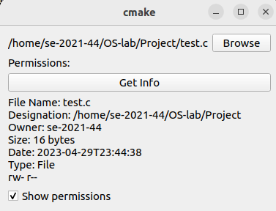

Shortcut-Keys:
No. | Actions | Shortcut Keys
1. | Open Task from Desktop Window | Ctrl+0
2. | Close Running Task from Desktop | Ctrlt+0
3. | Close Task | Ctrl + ESC

Image Viewer:

Description:
An image viewer is a software application that allows users to view digital images. It is commonly used for browsing, viewing and displaying images stored on a computer or other devices. Image viewers usually support common image file formats such as JPEG, PNG, BMP and GIF.

Features:
- Can view any type of image in the given field area.
- Images are automatically centered to the required field.

UI-Screenshot:
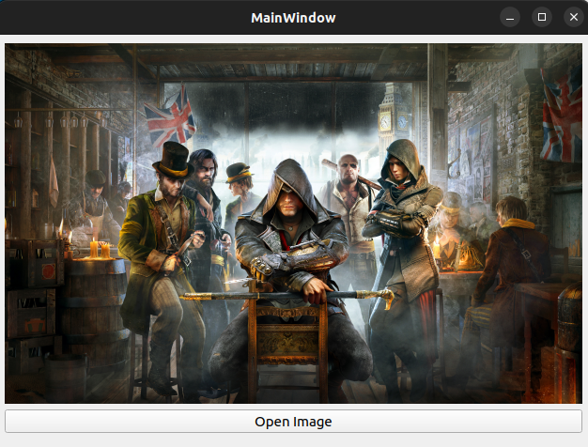

Steps using image viewer:
- Open the image viewer tool.
- A default image will be shown on the start of the tool.
- Press on the “Open image”.
- Select the image you want to open.
- Image will be shown on the screen.

Shortcut-Keys:
No. | Actions | Shortcut Keys
1. | Open Task from Desktop Window | Ctrl+4
2. | Close Running Task from Desktop | Ctrlt+4
3. | Close Task | Ctrl + ESC

Text Editor:

Description:
It is an Advance Version of Notepad with no built-in function of AUTO-SAVE but consists many features

Features:
- Open new file
- Close file
- Ask to Save if text is edit before Opening new File
- Save as
- Save
- Open Existing File
- Undo
- Redo
- Cut
- Copy
- Paste

UI-Screenshot:
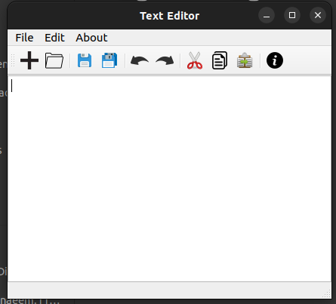

Steps using Notepad:
- Step 1
- Step 2

Shortcut-Keys:
No. | Actions | Shortcut Keys
1. | Open Task from Desktop Window | Ctrl+2
2. | Close Running Task from Desktop | Ctrlt+2
3. | Close Task | Ctrl + ESC

Game:

Description:
Tic Tac Toe is a popular two-player game that is often available as an option in many operating systems. The game involves a 3x3 grid in which players take turns placing their symbols (typically X's and O's) in an attempt to get three in a row horizontally, vertically, or diagonally. The player who achieves this first wins the game. Tic Tac Toe is a simple yet engaging game that can be played quickly, making it a popular choice for passing the time or entertaining children.

Features:
- Gui based game
- If one game ends either by win/loss or tie it prompts a dialog that asks if the players want to continue playing or not.

UI-Screenshot:
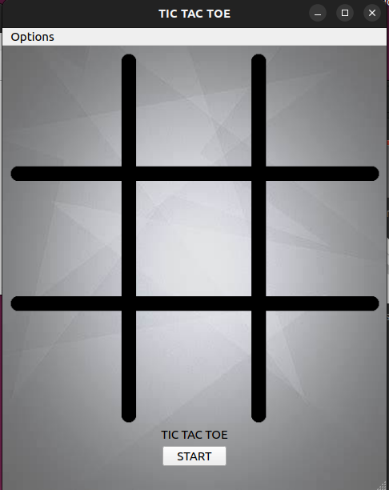
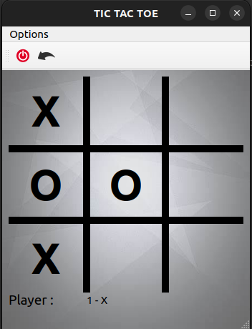
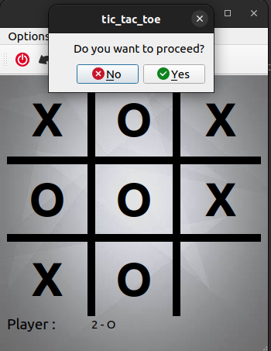
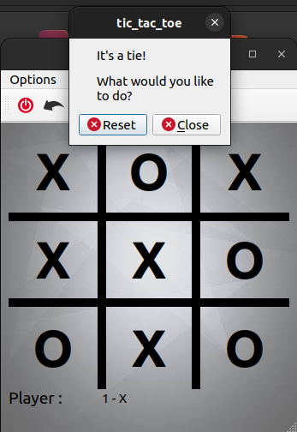

Steps using Game:
- Open the Game by clicking onto the game icon among available tasks.
- Press start option to start playing.
- Player, one has a key of “X” & of player two is” O”.
- Then just play as the ordinary tic tac toe works.
- If the game ends either by winning/losing or tie it prompts the players to start again or just terminate the game.

Shortcut-Keys:
No. | Actions | Shortcut Keys
1. | Open Task from Desktop Window | Ctrl+3
2. | Close Running Task from Desktop | Ctrlt+3
3. | Close Task | Ctrl + ESC

File Encryption Tool:

Description:
file encryption tool is a program designed to protect sensitive information by converting the original data into a secret code that is unreadable to unauthorized users. The encryption tool I built offers a user-friendly interface that allows users to easily encrypt files and it is stored in the same place as the input file that is to be encrypted.

Features:
- It Uses the Famous Caesar Cipher algorithm to encrypt files
- It Stores the encrypted file in the same place as the input file
- It also shows you the name of the encrypted file so its easier to check.

UI-Screenshot:
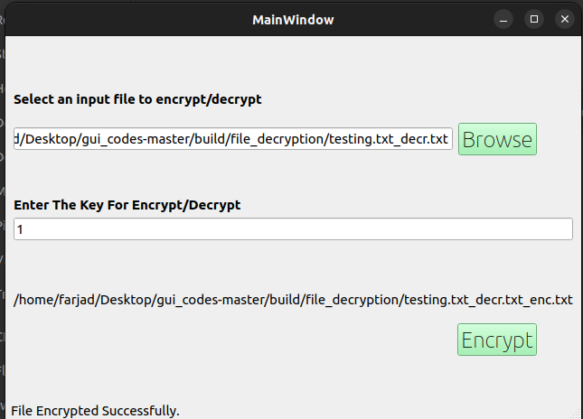

Steps using File Encryption Tool:
- Open-up the File Encryption Tool
- Enter the file name manually or click the browse button
- A Dialog will open that lets you select a file.
- Find the file to encrypt and select it.
- After selecting it, it will take you back to the Tool screen.
- Now Enter the Key between 1-25.
- Click the Button that says "Encrypt”.
- Your Encrypted File will be generated with the name shown on the tool
- The Encrypted file will be generated in the same place as the input file.
- Verify the Encryption by locating the generated file.

Shortcut-Keys:
No. | Actions | Shortcut Keys
1. | Open Task from Desktop Window | Ctrl+Q
2. | Close Running Task from Desktop | Ctrlt+Q
3. | Close Task | Ctrl + ESC

File Decryption Tool:

Description:
“File Decryption Tool” is a program designed to protect sensitive information by converting the encrypted data that is unreadable to unauthorized users to readable data such as plain text. The Decryption tool I built offers a user-friendly interface that allows users to easily decrypt files and it is stored in the same place as the input file that is to be decrypted.

Features:
- It Uses the Famous Caesar Cipher algorithm to decrypt files
- It Stores the decrypted file in the same place as the input file
- It also shows you the name of the decrypted file so it's easier to find.

UI-Screenshot:
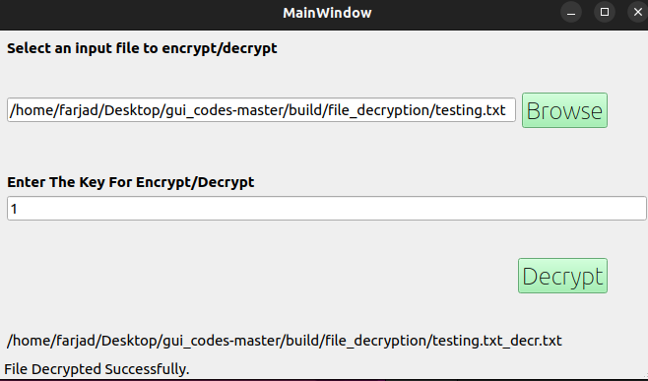

Steps using File Decryption Tool:
- Open-up the File Decryption Tool
- Enter the file name manually or click the browse button
- A Dialog will open that lets you select a file.
- Find the file to decrypt and select it.
- After selecting it, it will take you back to the Tool screen.
- Now Enter the Key between 1-25.
- Click the Button that says "Decrypt”.
- Your Decrypted File will be generated with the name shown on the tool
- The Decrypted file will be generated in the same place as the input file.
- Verify the Decryption by locating the generated file.

Shortcut-Keys:
No. | Actions | Shortcut Keys
1. | Open Task from Desktop Window | Ctrl+W
2. | Close Running Task from Desktop | Ctrlt+W
3. | Close Task | Ctrl + ESC

Text Encryption Tool:

Description:
Text encryption tool is a program designed to protect sensitive information by converting the original data into a secret code that is unreadable to unauthorized users. The Text Encryption Tool I built offers a user-friendly interface that allows users to easily encrypt text and it shows text that is encrypted.

Features:
- It Uses the Famous Caesar Cipher algorithm to encrypt text.

UI-Screenshot:
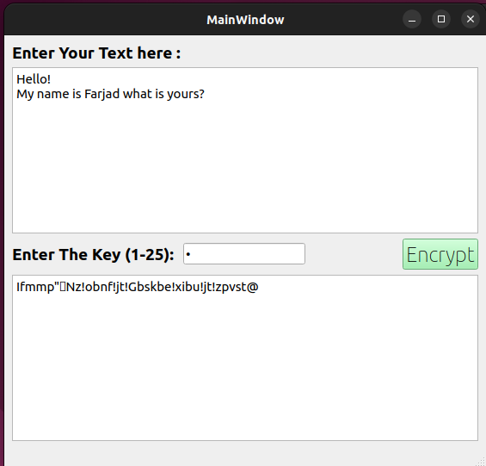

Steps using Text Encryption Tool:
- Open-up the Text Encrypt Tool.
- Enter the text to encrypt in the first box.
- Enter the key to encrypt the text.
- Press the Encrypt Button.
- The encrypted text will be shown in the second text field box.

Shortcut-Keys:
No. | Actions | Shortcut Keys
1. | Open Task from Desktop Window | Ctrl+E
2. | Close Running Task from Desktop | Ctrlt+E
3. | Close Task | Ctrl + ESC

Text Decryption Tool:

Description:
A text decryption tool in an operating system is a software program that allows users to decrypt encrypted text. It can be used to decode messages, passwords, or other sensitive data that has been encrypted using a cryptographic algorithm. The decryption process involves inputting the encrypted text into the tool and using a secret key or password to decipher the text into its original, readable format. Text decryption tools are commonly used in security and cryptography applications to protect confidential data.

Features:
- It Uses the Famous Caesar Cipher algorithm to decrypt text.

UI-Screenshot:
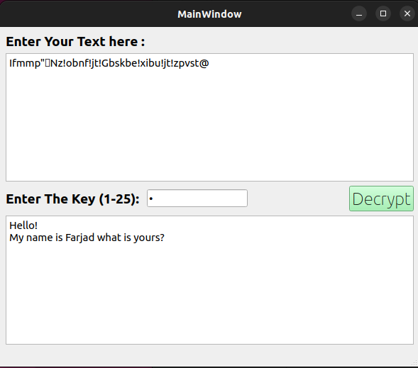

Steps using Text Decryption Tool:
- Open-up the Text Decryption Tool.
- Enter the text to decrypt in the first box.
- Enter the key to decrypt the text.
- Press the Decrypt Button.
- The encrypted text will be shown in the second text field box.

Shortcut-Keys:
No. | Actions | Shortcut Keys
1. | Open Task from Desktop Window | Ctrl+R
2. | Close Running Task from Desktop | Ctrlt+R
3. | Close Task | Ctrl + ESC

Task Manager :

Description :
When you start program by terminal a screen with running and not running task list will be shown in terminal that will be update after 100ms

Features :
- Tells Running Task
- Tells Not Running Task
- No of Task in Running Queue
- No of Task in Ready Queue

UI-Screenshot:
