CALL Online Course Evaluation

Page 1

Thank you for taking the time to complete this brief anonymous survey about your CALL online course. We appreciate your feedback and listen carefully to your comments.

Course Process and Content

1 Please indicate your level of satisfaction with the following dimensions of this course:

Very

Dissatisfied Neutral Satisfied Very Satisfied

Dissatisfied

|  |  |  |  |  |
| --- | --- | --- | --- | --- |
| o | o | o | o | o |
| o | o | o | o | o |
| o | o | o | o | o |
| o | o | o | o | o |

Quality of Course

Personal Value to You O

Impact in Your Christian Life and Ministry O

Course Overall OO

What worked well in the course?

2

Paragraph

JL



**4**

**Path: p**

**\* What could be improved?**

3

|  |  |  |  |  |  |  |  |  |  |  |
| --- | --- | --- | --- | --- | --- | --- | --- | --- | --- | --- |
|  | **Paragraph** |  |  |  |  | **,**  , |  | I |  |  |
|  | a |
| **um** |
|  |  |

**4**

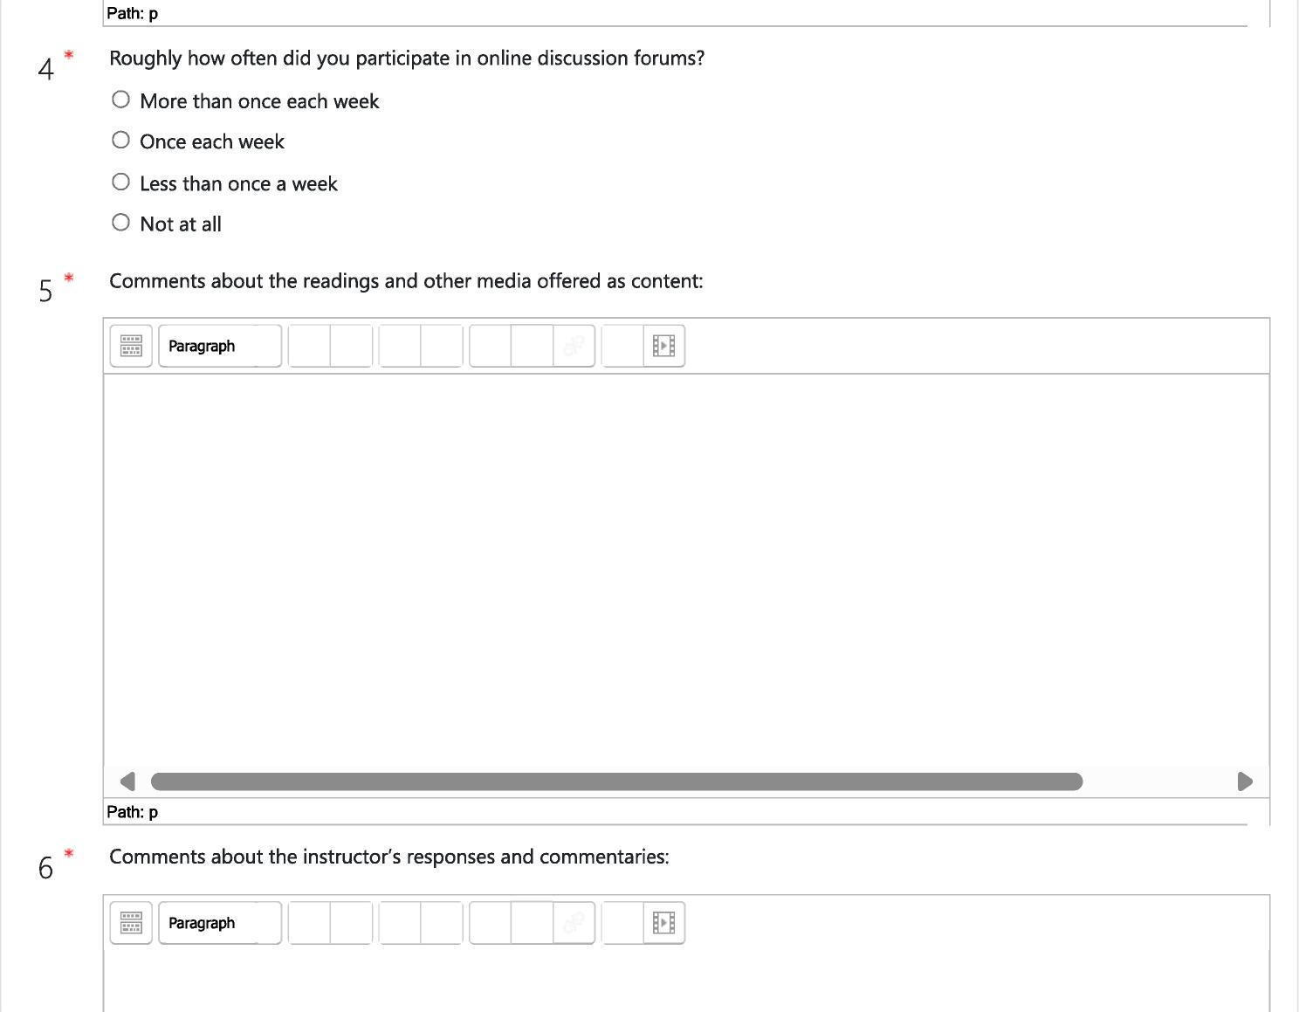

**Path: p**

4

* Roughly how often did you participate in online discussion forums?
* More than once each week
* Once each week
* Less than once a week
* Not at all

5 * Comments about the readings and other media offered as content:

6

* Comments about the instructor's responses and commentaries:

=

**Paragraph**

*..0*

,.-

m

**Path: p**

**Paragraph**

El

=CI

UM

**4**

**Path: p**

* What was the most important or surprising thing you learned during the course?

7

Paragraph 1

**4**

**Path: p**

Page 2

Technology.

Did you find Moodie easy to use?

|  |  |  |
| --- | --- | --- |
| Very Difficult Difficult | Some  Challenge | Easy Very Easy |

8

10 *

|  |  |  |  |  |
| --- | --- | --- | --- | --- |
| o | o | o | o | o |
| 0 | 0 | 0 | 0 | 0 |

At the Beginning of the Course

By the End of the Course O

Did technical problems have a substantial impact on your learning experience?

* Other:::Yes (if yes, please explain)
* No

Were you prepared for the level of technology use in the class?

* Yes
* No

Page 3

CALL

Did the registration process and communication with CALL staff go smoothly?

* Yes
* Other:::No (if no, please comment)

12 * Would you take another CALL online course?

* Yes

About You

* No

13 * What kinds of courses would you like to see CALL offer in the future?

**Paragraph 1**

=

LW

**4**

**Path: p**

m

[_

|  |  |
| --- | --- |
| 14* | Please select:   * Lay person * In formation for diaconate * Ordained deacon * In formation for priesthood |

* Ordained priest
* Other:

15 Please select:

Episcopalian

* Other:::Other Christian
* Other:

16' How did you learn about this CALL online course?

* CDSP eNewsletter
* CDSP website
* Other website
* Instructor publicity/personal contact
* Assigned/recommended part of formation process
* Clergy person's recommendation
* Friend/colleague's recommendation
* Announcement/newsletter from my church
* Advertisement in the press
* Other:

17 * Have you taken online courses from other sources?

* Other:::Yes (if yes, from whom?)
* No

18 * Final comments:

|  |  |  |  |  |  |  |  |  |  |  |  |  |  |
| --- | --- | --- | --- | --- | --- | --- | --- | --- | --- | --- | --- | --- | --- |
|  |  |  |  |  |  |  |  |  |  |  |  |  |  |
|  |  | **Paragraph** |  |  |  |  |  |  |  |  |  | El |  |
|  |  |  |  |  |  |  |  |  |  |  |  |  |
|  |  |  |  |  |  |  |  |  |  |  |  |  |  |

**4**

**Path: p**

Thank you for your participation in the course and in this survey. We invite you to come back to CALL for future courses and events as the spirit moves you.

Close this window