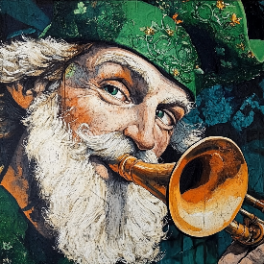**Theo *a chara***

"How's the craic?"

Saint Patrick blowing a traditional Irish horn

That’s a common Irish greeting, translating roughly to “How’s the fun?” As we know how much fun it can be contributing to your *Heritage Happenings* monthly newsletter, we welcome your submissions for March!

You may have guessed that March Happenings transports us to Ireland — land of verdant landscapes, pints of Guinness, leprechauns (perhaps?), cliffs and crumbling castles.

So, you’re spoiled for choices! We’ve come up with a bevy of prompts for you to play with. Please choose one (or more!), write your heart out, and deliver it to me by February 24 or thereabouts.

No need to write a *Ulysses*-length tome! We look for little snippets of fun . We happily accept a shorter anecdote, memory, joke, folklore, recipe, or any evidence of the gift of the gab!

Writing Prompts for March in Ireland:

**Family & Fond Memories**: Share heartwarming tales of your Irish kin and jolly reunions.

**Savory Irish Recipes**: Dish out your treasured family stew or a modern Irish twist.

**Irish Lit & Language:** Pass along a cherished book, poem, or a lil’ Gaelic gem.

**Wanderin’ the Emerald Isle**: Tell us about your favourite Irish landmark or travel yarn.

**Tunes & Jiggin’**: Regale us with a lively jig, song, or dance memory.

**Myths & Magic**: Spin a tale of quirky leprechauns, fairy legends, or enchanted lore.

**Crafty Creations**: Flaunt your Irish-inspired art or crafty handiwork with pride.

**Jolly Jokes**: Brighten our day with a clever Irish quip or pun.

**Festive Frolics**: Reminisce about a grand St. Paddy’s Day or a heartwarming Irish festival.

**Cherished Keepsakes**: Share that special Irish memento with a story to match.

We look forward to reading (and publishing) your submissions!

*Slán*,

Theo