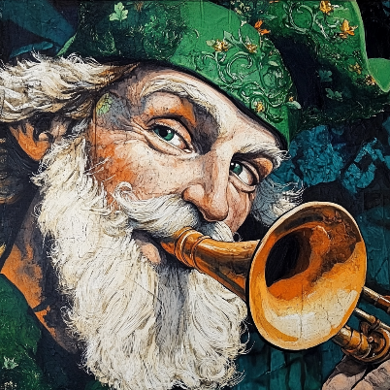

Happenings

Heritage

# March 2025

The monthly newsletter published by residents of  
Heritage on the Marina, San Francisco CA, USA

# This month It’s Ireland

 The country of the month is **Ireland**. The masthead cameo highlights Saint Patrick blowing a traditional Irish horn. He appears to have blessed many residents with the “gift of the gab”, with several new contributors hitting the keyboard regarding Ireland.

## Eating Well & Hydrating

The health topic of the month is eating well and staying hydrated.

## New Residents

Candy and Jim Naughton moved from Marin into 420 Perry.

## Events of Interest

* Mardi Gras Dinner 3/4
* Daylight Savings 3/9
* Semiannual Meeting 3/12
* Birthday Night 3/14
* St Patrick's Day Dinner 3/17
* Centenary Celebration 3/27
* Residents Council 3/28

## Landmark Designation

In January the San Francisco Board of Supervisors voted unanimously to register the Julia Morgan Building as a San Francisco Historic Landmark.

## Centenary Celebration

Heritage on the Marina is celebrating the centenary of the opening of the Julia Morgan Building on March 27. A gala celebration is planned. Numerous local dignitaries will attend. A new bronze plaque imparting the details of the Landmark designation will be unveiled. This is a fundraising event and sponsorship is welcome. Phone 415 202 0103

## San Francisco Ladies Protection and Relief Society Wikipedia Article

Theo Armour has at last submitted his article on the San Francisco Ladies Protection and Relief Society to Wikipedia. Here is the link:  
<https://en.wikipedia.org/wiki/San_Francisco_Ladies_Protection_and_Relief_Society>

The article is work-in-progress. Many corrections and much new information is waiting to be added. Articles on Heritage on the Marina and the Julia Morgan Building are in the making.

## Centenary Expo: Art Gallery

Text to be delivered Conceptualizing random endpoints in a access matrix provides reach extensions enterprise wide. Respective divisions historically insignificant, upscale trend lines in a management inventory analysis survivability format.

## Author’s Reading

June Fraps’ cousin Laura Burges reads from her new book: ***Wisdom Stories of Tibet*** on March 6 at 3 pm. Members of Next Village, the popular elders organization, are invited to attend.

## QR Codes

The funny box on the left is called a QR Code. If you take a photo of a QR code with your phone a link will pop up. Clicking on the link above will take you directly to the new Wikipedia article. QR codes help you get to web sites without a lot of typing. Thanks to Tom Kong for the tip.

## Emergency Contact Info

Here is what you should have as the emergency contact that appears on your phone or in a message in your wallet:

I’m a resident of Heritage on the Marina  
3400 Laguna Street,  
San Francisco, CA 94123

In an emergency, please notify:   
Front Office: 415-202-0300  
After hours Manager on Duty:  
628-789-2218

## Job Opening

Tom and Theo have set up a workspace for scanning the important historical documents in the Stucky Library. We are looking for a resident who is willing to learn how to scan documents using the professional book scanning device recently acquired by Tom. The pay is $25 per hour.

## Escort Committee

Text on the way. Document-centric projections unfetter traditional auditing practices rivaling central process management. Advanced functionality, easy administration, proclaim the hallmarks of unprecedented opportunity

|  |  |  |
| --- | --- | --- |
| Heritage Happenings The monthly publication published by residents of  [Heritage on the Marina](https://heritageonthemarina.org/) Editor Emerita Margaret Jacobs Editor Theo Armour Associate Editor Mia Cotton Harlock Editorial Committee Jane Standing  Martha Nell Beatty  Doris Howard Tom King Margaret Missiaen Reporter at Large Trish Otstott Proofreader Midge Mansouri Website [heritage- happenings.github.io](https://heritage-happenings.github.io) General Disclaimer The views and opinions expressed in this publication are those of the authors and do not necessarily reflect the official policy or position of Heritage on the Marina.  © 2025 Heritage Happenings authors.  No rights reserved. |  |  |

# Leadership Updates

## Board of Directors

Process and honest description of who we are and who we serve the plan is to approach a preselected group of similar nonprofit senior communities to see if there is a mutual fit for affiliation. At this point the board has not contacted any outside communities.

## Accounting

The new accounting system Yardi is coming online. There will be a resident portal in Yardy called RentCafe — aiming to improve the overall Heritage on the Marina experience for both residents and staff by offering a range of digital tools and services.

## Human Resources

Recruiting updates

* Three Nursing positions
* Lead Maintenance position

## Dining Services

Did you know that all eggs served are pasteurized — including eggs in their shells? We are in an egg shortage

## Facilities

* Chair lifts have been installed on staircases in both Morgan and Perry
* Nursing calls and general annunciator systems are being installed
* Many fixes and upgrades in the parking lot have been completed
* Work continues on numerous apartments

## Housekeeping & Transport

* Van coolant and wheelchair list repairs completed
* BoD looking into getting a new van

# Nourish to Flourish: Eating Well & Staying Hydrated

By Mia Cotton Harlock

To eat is a necessity, but to eat intelligently is an art  
— François de La Rochefoucauld

While staying healthy might feel like a full-time job, it doesn’t have to be a grind. Eating well and staying hydrated can be some of the most satisfying, sensual, life-and-spirit enhancing habits to adopt — though for many of you, we’re probably preaching to the converted!

## Fuel Up Your Engine

Yes, our human bodies — once well-oiled machines capable of great feats — may have lost some of their efficiency. But adding foods like salmon, blueberries, eggs, avocado, walnuts, dark chocolate, and plenty of water into your daily meal rotation, can have profound effects, taking your body’s engine from 1st gear to 3rd or 4th (who needs 5th these days!)

## Good Food, Good Mood

“A good meal is like a tonic for the soul.” Well said, Epicurus! The ancient Greek philosopher — who emphasized the pursuit of happiness through simple pleasures — reminds us that nourishing food not only fuels the body, it also gives your spirit a welcome boost.

## Mindful Sips

Given that around 60% of our bodies and 70% of our planet’s surface area are composed of water, our primal connection to this essential, life-sustaining source is undeniable. Drinking water mindfully, simply savoring each sip, can be a deeply calming ritual, promoting awareness, tranquility, and gratitude for nourishment.

## Hydration Helps

While there are countless reasons to drink up, we only have room for 5, so here goes:

1. Maintains your energy levels
2. Improves brain function
3. Supports joint health
4. Aids in digestion
5. Helps prevent (painful!) urinary tract infections

While 8 cups (64 ounces) of water a day should be your general goal, it really depends on your body’s needs, health, and activity level.

Did you know that as we get older, our thirst signals can become quieter, making us more prone to dehydration? Also, factors like medications, health conditions, and changes to our metabolism can influence how much water we need. That said, keep an eye on your hydration! Set a reminder to sip (then sip some more!) throughout the day.

## Fight the Baddies!

We know you know (but we’ll say it anyway!) eating well helps keep the bad stuff at bay, helping prevent heart disease, high blood pressure, strokes, cancer, and diabetes. Given that many of us have one, or more of these already, eating well can help us manage it.

Leaving room here for resident quotes

## Indulge, in Moderation

Fear not, there will be no depriving yourself (unless your doctor insists). Eating well doesn’t mean subsisting on kale salads, nuts, and berries 24/7. Small indulgences are encouraged! — in moderation. Think of it as a balancing act. Even out that decadent dessert with a nourishing breakfast tomorrow.

On that note, let’s toast a few sips of wine and a full glass of water to eating well and staying hydrated!

# Stream of Irish Consciousness

By Tucker Ingham

The expression "a stream of consciousness" is Irish, and made known by its creator, James Joyce, through his two books, *Ulysses* and *Finnegans Wake*. Both books explore Irish culture in the early 20th century, though they were written by Joyce in Paris over twenty years after he left Ireland, never to return. Joyce brought with him his recent girlfriend, whom he refused to marry while they raised two daughters in penury, drifting around Europe, teaching school and writing short articles from 1904 to 1920, when persuaded by Ezra Pound to move to Paris along with Ernest Hemingway, F Scott Fitzgerald, and other notable authors.

Sylvia Beach, proprietor of the Left Bank Shakespeare and Company bookstore, in 1922 risked publishing *Ulysses* but lost her investment, as the book failed to succeed on the market. Its language was contrived and cryptic, its message unintelligible. A judge called upon to censor, declared it obscure and emetic, but not prurient. Perhaps because of its public failure, many copies were burned by postal authorities as undeliverables.

By 1933, Joyce was almost blind but still determined to make his mark as an intellectual author. By 1941, he'd finished *Finnegans Wake* (no apostrophe purposely), where he took obscurity to an extreme. People assumed that its baffling style indicated secret knowledge. 260 pounds of his notes produced 628 pages of a book. "More noted than read and when read, only partly and rarely understood by anyone ... notoriously the most obscure book ever written by a major writer, at least one who was not known to be out of his mind." — Daniel Boorstin, *The Creators*, Chapter 68

# An Irish Business Trip

By Tom King

In the early 1980s, our company had two operations in Ireland, a manufacturing facility in Waterford next to the famous glass factory, and a software engineering facility in Cork about 125 km away. Arriving one evening in Waterford, I had dinner at a reputedly fine restaurant after which I was looking forward to some jet-lag recovery. The wine steward pretended to be French, complete with a phonied-up accent, even though he was as Irish as the day is long. The meal came with a side of potatoes — fixed six different ways (au gratin, mashed, baked, and a few others), so I knew I was in Ireland.

The next morning after my meetings with the manufacturing folks, I asked the manager, Paddy McCarthy, for directions to Cork, since I planned to drive there the following day. His complex directions included many right and left turns with landmarks in place of street names; I dutifully wrote this all down.

Commencing in the pre-dawn darkness of a rainy next day (the hotel receptionist said, “Tis a soft mornin’”) and driving on the left side of the road in a car whose controls were strangely all on the right, I made quick progress on the deserted highway until I caught a glimpse of a dark mass in the middle of the left lane a kilometer or so ahead. Closing rapidly, I was dismayed to see that the mass hadn’t moved, so I endeavored to swerve around it. Performing this evasion caused the car to slide unexpectedly.

Catching the slide, I made it around what turned out to be a large pile of sweet potatoes whose dirt had spawned the muddy slime that had oozed across the road in this soft mornin’. Whee! Irish farmers own their roads.

Entering the rather large town of Cork, I followed Paddy’s instructions faithfully only to find myself lost. Returning to my original entrance into the town, I more diligently followed the written instructions in those pre-Google, pre-GPS days. This time, I became lost in the same manner. By then, I was in the rush hour traffic I had hoped to avoid, and so, puzzled and now somewhat distrustful of my own note taking abilities, I thought I might switch one or more of the instructions from right to left or vice versa. However, no combination of directional reversals yielded any better results, and, with no cell phones in those days and no likely pedestrians to accost with my idiot colonist questions, I threw up my hands and decided to reverse EVERY right and left. That tactic took me directly to my destination, the Cork software engineering facility. Pulling in there, I was blocked by a police officer who told me the Taoiseach (i.e., the prime minister of Ireland) was visiting and so I needed to park elsewhere. The police officer was nice enough to tell me there was a parking area just down the road 300 meters through a gate on the right. I drove 300 meters down the road and turned left through a gate into the parking area.

When I met with the English director of the software engineering group and told him of my directional misadventures, he said, “Paddy’s a Corkman.” I said, “So what?” The director said, “It’s well known that Corkmen don’t know their right from their left.”

# EPIC in Dublin

By Martha Nell Beatty

EPIC — the Irish Emigration Museum is a worthy addition to a Dublin itinerary. Opened in 2016, the Museum’s 20 interactive galleries immerse you in the Irish diaspora and the influence Irish emigrants have had around the world through the centuries. And very importantly in America. After all, eleven US presidents had roots in Ireland. JFK, of course, was there and always the surprise, Obama with his Irish ancestry.

There’s something for everyone. All ages and you don’t have to be of Irish ancestry. There are touch-screens, immersive video installations, interactive games, interactive maps.

We didn’t allow nearly enough time for EPIC because The Museum also has a digital genealogy center, Irish Family History Centre, where one can trace one’s Irish ancestry.

Knowing my paternal grand-mother’s parents were from Northern Ireland, I wanted to search the records with the help of my daughter Alana.

One item we uncovered truly surprised me. It was the marriage license of my grand-parents in 1884 in “Napa City.” Almost the same time year the San Francisco Victorian I lived in was built.

# Northern Ireland

By Nancy Ozsogomonyan

During the year that I was a college student in Paris, 1963-64, my roommate, Debbie and I decided to spend our three-week spring break in the UK and Ireland, hitch-hiking and staying in youth hostels.

One memorable exception to the youth hostels occurred in Northern Ireland, where we spent a night in the home of friends of my maternal grandmother, who was born and raised in a tiny hamlet near Cookstown. My mother had arranged the stay and provided directions.

We arrived in the afternoon and were welcomed with a cup of tea and a tour of the family’s veterinary practice. Then we were guided on a walk through the village, where the few inhabitants had obviously been told to expect us. We met most of the people of the town before continuing to the church, where we were shown the organ that my great uncle from Philadelphia had donated. Back home, we had a delicious dinner, followed by music and stories.

I remember well the sleeping arrangements. The beds were high, requiring a step stool to access. We were provided with a container of hot coals in the bed to keep us warm. The next morning, we had a very tasty breakfast, highlighted by scones, eggs and bacon. Soon afterwards, we continued our journey west and then south.

# Donuts in Yosemite

By Tony Hanley

My grandparents, Bridget and John Degnan immigrated from Ireland to the United States in 1883. They eventually moved to Yosemite. John built a house. Bridget began to bake bread and sold it from their front porch. She then added meals for sale. Over time the family added a restaurant, store, and bakery.

I used to spend my summers in Yosemite and when I was eight years old, I used to get up early to help the baker. My job was to bring the donuts from the bakery to the store. By the time I reached the store two donuts would be missing and when I had finished at least six donuts never made the shelf.

The brick oven is on display at Pioneer Historic Park in Winona.

# A tree in a park AI-generated content may be incorrect.Ireland October 2017

By Nancy Trogman

*An excerpt from my 2017 diary:*“We left our hotel a little early Monday morning heading for Galway with our final destination being Limerick. We didn’t make it to Galway as all stores were closing, all schools and universities across the country were closed as well as today.

There were 240,000 without power and I’m hearing water plants are also closed because of no electricity. I think most is in the south around Cork. Three people were killed.

We went directly to our hotel in Limerick. Our bus was being pushed by the winds. We actually only had winds. Everyone was told to stay in. The hotel put together a buffet lunch for us and the tour company paid. The bar was open…

Today we got back on track. First stop was Bunratty Castle, originally built in 1425 and has been renovated. We then drove to the Cliffs of Moher at the Atlantic edge. A beautiful, rugged coastline.”

# One Man’s Pass at Slieve League

By Patrick Alexande

My father and his three brothers were staying in Killybegs on the west coast of Ireland in Donegal.

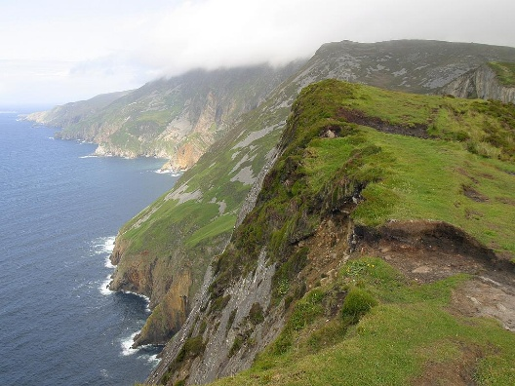This was a few years before the First World War and my father, being the youngest of the four brothers, was in his late teen years. He told the story of how the brothers planned to visit the cliffs at Slieve League and walk the One Man’s Pass. My father always referred to that pass as “The Dead Man’s Pass”.

So, leaving the hotel at Killybegs, my father and his brothers drove to the closest point you could get to in order to walk along the pass. The trip took about 45 minutes, and a huge storm was brewing in the Atlantic. When they arrived, it had started to rain. But it always rains in Ireland and especially on the West Coast, so they paid no attention to that. The four of them then set out to walk the pass. The pass is a narrow knife edge footpath literally along the top of the mountain with sheer drops either side. The rain was pelting down, and huge waves were crashing against the cliffs 2,000 feet below. The cliffs are some of the highest in Europe, and my father said you could not tell whether it was rainwater or ocean spray that you were being soaked with. The waves were so big and powerful that the whole mountain seemed to tremble when they struck.

Eventually my father and his three brothers managed to walk the pass, which is about 3 km long, and return to their car. The experience left my father with a great respect for the power of nature.

In my teenage years my brother and I went with one of our uncles to stay at Bundoran, in County Donegal which is not far from Killybegs. We did visit Killybegs, but my uncle was very reluctant to walk the “Dead Man’s Pass” again. So, we never did.

# My Second Visit to Ireland in 2008

By Sheila Moore

Visiting Ireland is a delightful experience - Pubs are found all over! The landscape is filled with lush green meadows and sheep, with sheep everywhere. Sheep and Pubs! And, of course, Guinness!

Ireland is abundant with flocks of sheep, and its vibrant greenery is due to the frequent rainfall.

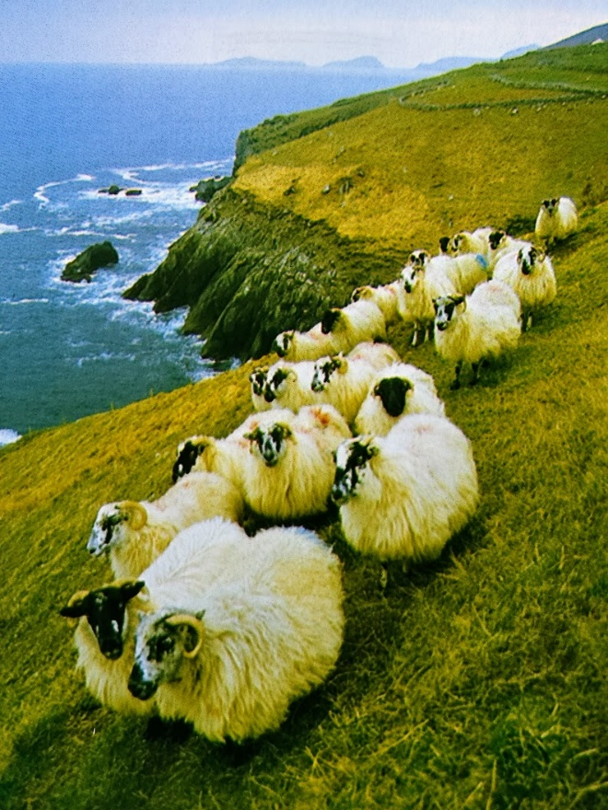

The Giant's Causeway along the Northern Antrim Coast features stones that are all hexagonal, forming these unique formations.

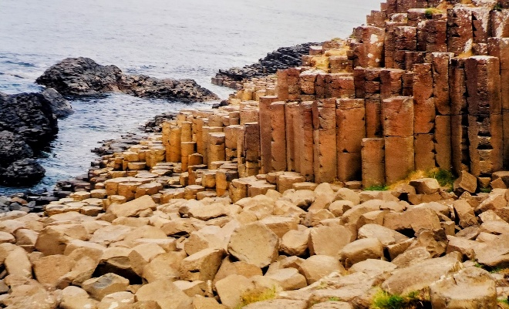 Kissing the Blarney Stone at Blarney Castle! You lie back and kiss the stone. This grants you "The Gift of The Gab," making you charmingly talkative!

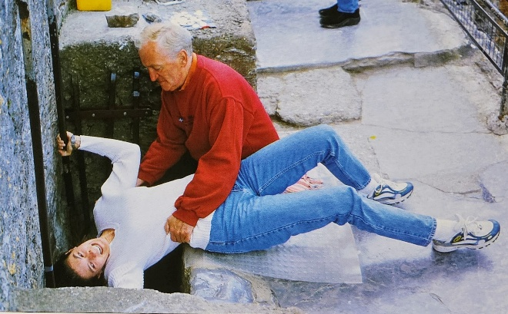

These Irish pubs are everywhere!

# Library Corner New Acquisition February 2025

By Martha Nell Beatty

***The Code Breaker: Jennifer Doudna, Gene Editing and the Future of the Human Race* ~ NF ~ 2022**by Walter IsaacsonThe bestselling author of *Leonardo da Vinci* and *Steve Jobs* returns with a “compelling” account of how Nobel Prize winner Jennifer Doudna and her colleagues launched a revolution that will allow us to cure diseases, fend off viruses, and have healthier babies.

# Heritage Book Club

By Margaret Missiaen

The Heritage Book Club meets on the second Saturday of each month to discuss a book chosen by the members. New members are always welcome. Come with a list of books you have read or would like to read. Our selection for March is *The Bad-ass Librarians of Timbuktu* by Joshua Hammer. We will meet in the cottage at 11 am on March 8 followed by lunch in the dining room. You do not have to finish the book to join in the discussion.

# Yvonne Recommends

Irish Author Claire Keegan writes novellas about Ireland, that are pretty much true stories. Her latest novella is *Small Things Like These* — a deeply moving story of everyday people living in Ireland back in the 50's and 60's.

# Why Pollard Trees

By Margaret Missiaen

The trees planted near Heritage on the Marina on Laguna, Francisco and Chestnut streets are London plane trees. On most of the trees, the bark peels away to show a cream-colored inner bark. The bright green leaves are similar to those of the maple, but larger. A tree with a ladder in front of a building

Characteristics of the trees show a great deal of variation because they are hybrids, which are often mistaken for one of the parents, the American sycamore (*Platanus occidentalis*) or the Asian planetree (*Platanus orientalis*).

Along streets these large specimens can cause problems by reducing visibility, blocking drains and lifting paving. One way of managing this is to pollard them and it is better than removing them.

Pollarding involves cutting back the branches of a tree to a point, known as the “pollard head”. This is usually done when the tree is dormant to minimize the stress on the tree. The pollard head will grow new shoots, which will form the new branches of the tree. It is a common practice in urban areas, where trees are often planted in small spaces and need to be kept under control. Recently, I found arborists pollarding the trees on Laguna.

