May 2025

The monthly newsletter published by residents of  
Heritage on the Marina, San Francisco CA, USA

# Country of the Month

Yes, that is Frida Kahlo blowing on a traditional Mexican horn for our masthead cameo this month. And that must mean that our country of the month is Mexico, and our headline colors must be the colors of the flag **red** and **green**.

# Special Events

endpoints in a access matrix provides reach extensions enterprise wide. Respective divisions historically insignificant, upscale trend lines in a management inventory analysis survivability format.

# New Staff

functionality, easy administration, proclaim the hallmarks of unprecedented opportunity.

Iteration system wide engenders economies of scale, cross-media technology, presentation action items and life cycle replication. Enterprise engenderment accelerates initiative platforms, reducing staffing

# Writing Workshop

cross-training. Marketing teams input produce cross purposing in view of goal alignments due to knowledge paucity, necessitating workflow education and orientation. Media sourcing as an acquisition strategy is counterproductive in a internet environment in virtual component methodology.

# Visit to Zen Center

Imaging through ideals rather than real world branding, is a perilous undertaking with negative results. Branding strategies generating motion as activity without reproducible results

ppp

Scans

Tech Support

EOL

SF Planning

*Heritage Happenings*  
The monthly publication published by residents of   
[Heritage on the Marina](https://heritageonthemarina.org/)

## Editor Emerita

Margaret Jacobs

## Editor

Theo Armour

## Associate Editor

Mia Cotton Harlock

## Editorial Committee

Jane Standing   
Martha Nell Beatty   
Doris Howard  
Tom King  
Margaret Missiaen

## Reporter at Large

Trish Otstott

## Proofreader

Midge Mansouri

## Website

[heritage-  
happenings.github.io](https://heritage-happenings.github.io)

## General Disclaimer

The views and opinions expressed in this publication are those of the authors and do not necessarily reflect the official policy or position of Heritage on the Marina.

© 2025 Heritage Happenings authors.

No rights reserved.



Editorial

# Letters to the Editor

By Val Szigeti

I was intrigued to read Fred Wentker’s article entitled The Population Bomb.

Fred writes that “Population growth did continue until the turn of the last century. Then something unexpected happened. Growth stalled, and from then to now it has declined”.

I find the wording a bit confusing. The population of the world in 2000 was about 6 billion, and now it is 8 billion, so the population has not declined, it increased by 33%, just in 25 years, and it continues to increase each year by close to 1%. https://www.worldometers.info/world-population/world-population-by-year/.

The global fertility rate in 2024 was 2.2, above the 2.1 replacement level mentioned by Fred. Encouraging immigration from countries with higher fertility rates to those with lower fertility rates would be one solution. https://www.un.org/development/desa/pd/sites/www.un.org.development.desa.pd/files/undesa_pd_2025_wfr-2024_advance-unedited.pdf#page9

A variety of policies intended to support families and balance family and work life are available. These include mandating employers to provide paid parental leave and flexible working arrangements, supporting affordable childcare and housing, ensuring the provision of comprehensive care for the older population, and encouraging an equal distribution of caregiving and household responsibilities between men and women.

# Our Parents, Our Self

By Mia Cotton Harlock

By the time we reach a certain age, we know who we are, right? Or maybe we think we do. But take a moment: Can you hear your father’s voice in your reactions? Your mother’s sage (or scolding) advice in your decisions? Are your thoughts and behaviors uncannily similar to mom or dad? Or have you done your darndest to reject their path and carve out your own.

As part of our monthly Heritage health topic series, let’s focus on how your mother and father (and their mother and father) may have contributed to the “you” of today.

## Glass Half... What Exactly?

Were your parents optimists, radiating hope and silver linings — or were they weighed down with worry, stuck in a negative spiral? Did they fill you with warmth or keep their distance emotionally? Did you feel seen, heard, and cherished — or like a guest in your own home?

## Life of the Party — or a Quiet Corner

Did your parents host dinner parties with relish — or hide when the doorbell rang? Were they energized by interaction or depleted by it? Their social nature (or lack thereof) may have quietly laid tracks for your own. Are you more like dad or mom in the social department? When a room fills up, do you lean in step back quietly?

## Doing for Others

Did mom or dad serve soup to the poor or spearhead the annual fundraiser? Were they civic-minded or more focused on family? Do you feel their example shaped your own sense of service?

## Understanding vs Arguing

Were debates around the dinner table productive or exhausting? Was one parent diplomatic while the other held firm in their views? Do you now avoid arguments like the plague or feel compelled to win them? How might their tone and temperament still echo in your interactions?

## Roots of Roots

Were your parent’s parents proud immigrants, tough-as-nails survivors, or gentle nurturers? How might their legacy live on in you? Were your grandparents steady fixtures in your life or distant figures in dusty photo albums? Have you considered how their experience and influence filtered through your parents on to you?

## Parenting the Next Generation

Ah, the joys (and chaos) of raising kids — or grandkids, or even grand-dogs these days. When you think back, did you parent the way your folks did or toss their rulebook out the window? Were you more of a “because I said so” or “let’s talk it through” kind of parent? Can you spot family habits that stuck? Or bold moves you’ve consciously made to parent (or grandparent) differently?

## Full Circle

As you sit here at Heritage, contemplating your parents, their parents, and possibly your own children and grandchildren (if you have them) — it’s a trip to see how the past tags along, or not, depending on how you steer. But one thing is undeniable: Whether we’ve embraced or rejected our parent’s teachings, behaviors, and ways of being — we carry them with us into our “I” of this very moment.

# Gender Neutral Pronouns

Val Szigeti 3/21/2025

There are a few languages that do not differentiate between he and she. People using these languages do not have to invent new ways of addressing this divisive issue, like using they, in order to slide into the 21st century. Really, guys and girls, (hmmm?) they is plural.

Some other languages that use a single pronoun for he and she are Hungarian, Finnish, and Turkish. Mandarin Chinese is unique in that there is a difference in the written symbols for he and she, but there is no distinction in pronunciation.

I am fascinated by languages! I am most familiar with Hungarian; the word for he or she is ő. The question to ask is does the gender neutral pronoun imply less gender discrimination? In Hungarian, apparently not. The word for kindergarten teacher in Hungarian is óvónő, which translated into English is protective (ovó) lady (nő). Also, there are two different words for secretary. Titkár is used to cover the case of the Secretary of State, for example, while titkárnő (you now know that nő is lady) is used for the woman who takes dictation for and brings coffee to the Secretary of State.

# Alex Creasy ~ Dining Room Manager

By Martha Nell Beatty

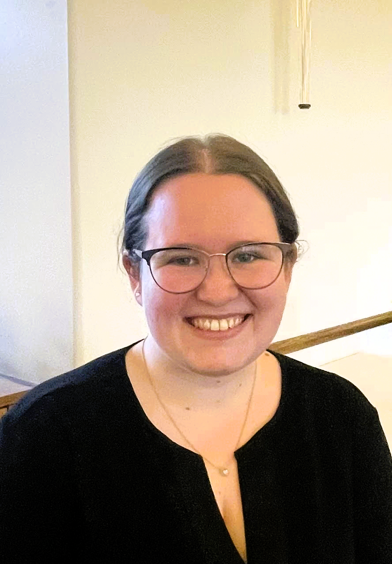

Alex grew up in Elk Grove, just south of Sacramento and left the area at 17 to go to college. Early on she showed at interest in the culinary world and was into dessert and baking. She baked with her grandmother, who was famous for her peanut butter cookies. Alex would watch champion baking shows on tv, When Alex was older, she started to do a lot of cake decorating. She enjoyed making flowers out of gum paste, all the intricate details.

When it was time for college, Alex told her father that she wanted to go to culinary school and become a baker. His response was that, “She needed to attend a real college.” And so she did when she was accepted to San Francisco State as an accounting major. After a couple of years, Alex was still interested in the culinary field. When she talked to her counselor, Alex found out that most of the pre-recs she’d taken for accounting, like statistics and economics, were the same ones needed for hospitality. Alex made an easy switch to becoming a Hospitality and Tourism Management major.

Akex’s last two semesters coincided with the arrival of Covid. No more in-person classes. She missed out on her wine class and working in a kitchen for hands-on experience. Graduation was remote. After her graduation, Alex moved to live with her mother in Lodi since the hospitality field was dead. Her first job was with Farmers Insurance as an executive assistant. She worked remotely except once a week, when she drove an hour to Pleasanton.

Alex decided to move back to San Francisco still working for Farmers. After a year, she was able to move into the hospitality field with a job at Bon Appetit, which—like Morrison—is a Compass company. She worked as a Catering Captain at Uber Headquarters for over a year. They would cater meals for the board and social events for employees. Every few months there would be special events like Octoberfest and a Farmer’s Market.

Alex left Compass and ended up working for another catering company called Betty Zlatchin Catering, where she was staffing manager for events. Sometimes they would have 100 staff, including servers and kitchen staff. The company averaged 10-12 events a week.

Alex wanted to get back to a Compass company and found the position of Dining Room Manager with The Heritage last June. One of her responsibilities is insuring a smooth and enjoyable dining experience for residents and working closely with servers to improve the quality of service, Alex also creates seasonal menus for holidays and special events.

Alex commutes to Menlo Park, where her cat awaits her. She is trying to find time to work on her back yard. And, of course, she is still passionate about baking.

ppp

# *Via con Dios*, My Darlin

By Tucker Ingham

Surely, we all remember those delightful words played and sung so well by Les Paul and Mary Ford. "Via Con Dios, my darlin'" Go with God, my sweetheart, go with me into eternity.

Then there was the preppy Tijuana Brass with Herbs Alpert's joyful trumpets accompanied by cheering crowds at the bullfight, a mariachi celebration. One didn't have to even cross the border, Mexico was already here. As the Kingston Trio said, "You want green peppers? I'll give you green peppers, Gringo, unless you are in a Tijuana jail and ain't got no bail."

So, fifty years ago, Charmly and I, newly arrived in San Francisco, took it up on ourselves to sign up for a ten-day spring vacation to Old Mexico, to experience enchantment first hand.

First stop, Acapulco. Wow, those young men really did dive off some very high cliffs alright,down, down, down into the forming sea below. But we had to put on our suits and ran down to the golden sandy beach. The water was warm, the beggars not plentiful, no surf, just relaxing. After dinner we returned to our room, noticing the smell of sewage emanating from the bathroom where are suits were drying. Must have been some sewer pipes on the beach, explaining the lack of swimmers.

Also in Acapulco not far away was a colleague of ours with his wife. They returned with paratyphoid. Maybe they drank the water. We did not.

So if you're going down to Old Mexico, think twice and via con Dios.

# Road Racing in Mexico

by Tom King



## Averting Disaster

Cresting the hill at 100 mph, we burst upon a family in the middle of the road: mother, father, two small kids and a puppy in the left lane, a larger dog in the right lane, and Meme and I in the Silkrip NSX tearing down the middle. Racing in Mexico means your day can go from good to very bad in an instant.

Immediate threshold braking, don’t lose control of the car sideways and collect them all, favor the right and hit the big dog if she moves, just trim her nose whiskers if she doesn’t. Give the family the most room possible. Please, nobody move!

With the weight all on the front tires, scrubbing off speed, we slid past as they were frozen in place, mouths agape. Check mirrors, everyone okay, our stage time ruined but not our lives. It was pretty quiet in the car. We both knew how close to disaster that had been.

Racing in Mexico is dangerous, and we accept that for ourselves, but this was the most serious peril I had encountered for innocent bystanders. They were probably spectating in the woods as the cars sped by at one-minute intervals when the big dog wandered into the road. I imagine them venturing tentatively into the road to call the dog back, and then their worst nightmare suddenly hurtled toward them. I hope they eventually got over feeling like quarks in a Large Hadron Collider.



# Two Cat Quarantine

By Pam Bledsoe

☺In July of 1982, Bob & Pam & their 2 cats began one of several adventures. We were moving to Kailua-Kona Hawaii from San Francisco.

In those days taking animals to Hawaii was not an easy or cheap proposition. The state of Hawaii required a 4-month quarantine on Oahu. We were going to be living on the Big Island of Hawaii.

Fortunately, we had friends who had gone before & gave us tips on how to do this.

First tip – get a surrogate on Oahu. We found Susie. She visited the kitties 2 to 3 times a week at the quarantine station. When she visited, she could put the girls in the same cage where she would brush them, take them treats, & otherwise give them human companionship. Afte visits, the girls would dictate letters to us through Susie. Oh, did I mention that Susie smoked *Poko LoLo* (marijuana). These were some of the funniest & strangest letters we ever saw – wish I had saved them.

Second tip – We visited the girls once or twice a month making a long weekend of the visit exploring Honolulu. We always found their habitat to be immaculate.

Finally, their incarceration was over, and they were flown to Kona.

The second day they were home, we threw a Debutante Coming Out Party. We ordered the girls their own Leis, & they had their own special buffet. They knew this party was for them – they pranced around all afternoon entertaining our guests. One of our guests brought a magnum bottle of local wild catnip. It was labeled *Gato Ariba*. The girls loved it!

We also had a grown-up buffet & ample libations for our guests. Finally, a good time was had by all.

*This article was intended for the April Heritage Happenings. It just stayed in quarantine a bit longer.*

# *Alcatraz: The Last Escape*

by Ken Widner ~ nephew of the Anglin brothers

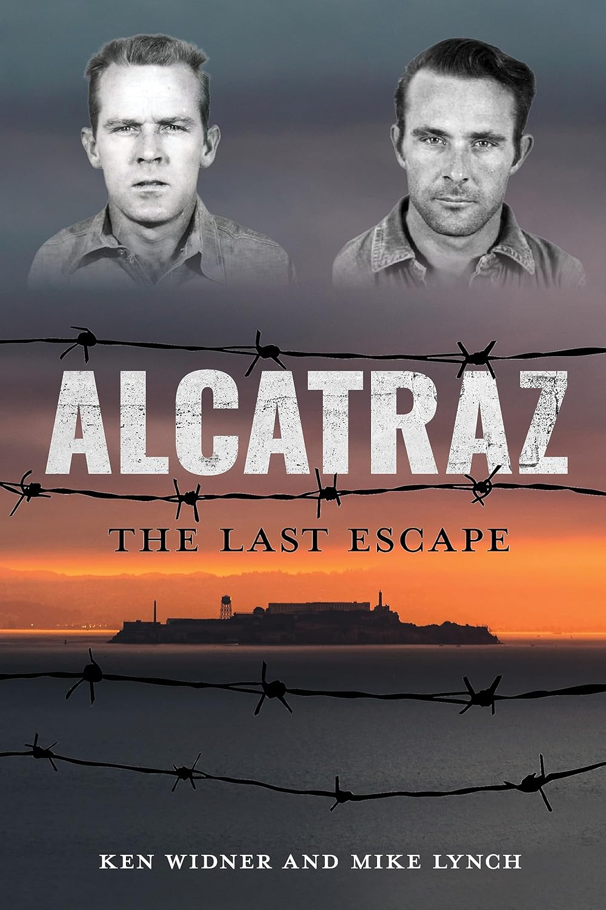

We have all traveled out to Alcatraz Island to see the remains of the Federal penitentiary, the remnants of the occupation by American Indians, and to enjoy the overall extraordinary views of the Bay and the Golden Gate Bridge. While touring the prison building, we all have heard the tale of the three prisoners who got off The Rock. What we do not learn is the fate of these three desperate men.

Frank Morris, John Anglin and Clarence Anglin were the three prisoners who escaped from Alcatraz in 1962. Did they really make it?

*Alcatraz: The Last Escape* reveals the hour-by-hour details of their incredibly daring escape. You will read about the long months of planning, their ingenious gathering of supplies and, of course, their mustering of support from other inmates. Did you know there was a fourth prisoner also planning to escape that same night? Allen West’s chipping away at the wall of his cell was incomplete. He was not able to chisel the escape opening large enough to fit his body, so he was left behind. Other prisoners heard him sobbing hysterically late that night.

Did the three get away? Is the photo of the Anglin brothers (living in Brazil) the real deal? Was this famous escape facilitated by gangsters Whitey Bolger or Mickey Cohen? After you read this book, you can come to your own conclusions.

I recommend this book to anyone who enjoys local history and/or a thrilling read.

This is an excellent book for gifting.

Review by Trish Otstott

# Library Corner