Julia Morgan Building Centenary 2025

## Revision 2024-09-24

Theo Armour ~ t.armour@gmail.com ~ 415 828 0000

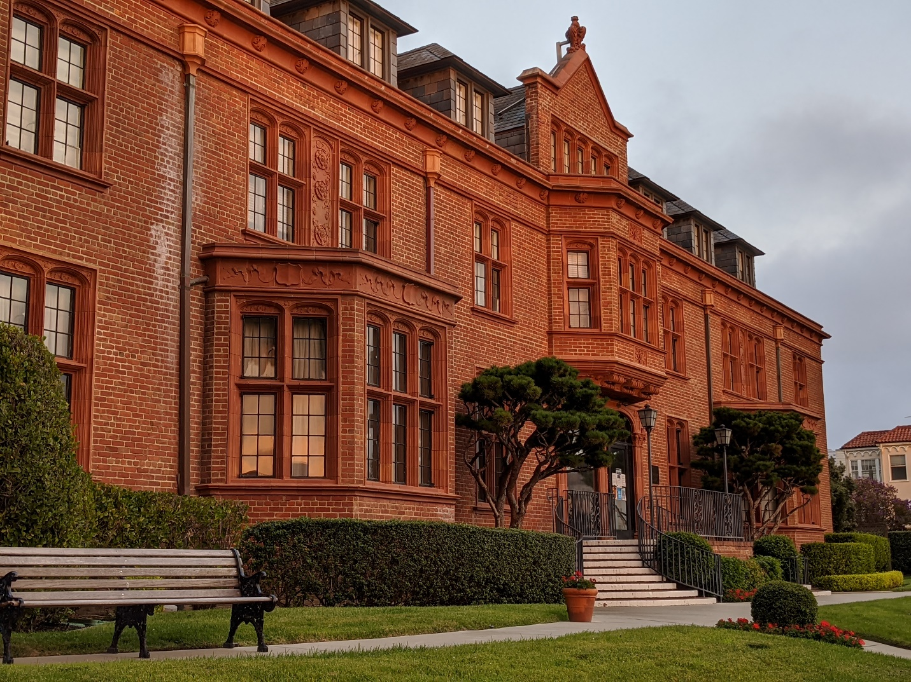

## Table of Contents

Revision 2024-09-24 1

Table of Contents 1

Fact Check: Date of Opening 2

Preface 2024-09-14 2

Preface 2024-09-24 3

Introduction 3

Architectural History and Preservation 4

People to Contact 4

Architecturally Themed Activities 5

Funding Opportunities 5

Lighting 5

References 6

Front Door 6

Wrought Iron Fence 6

Other Architectural Opportunities 6

Non-Architectural Funding Opportunities 7

Crafted Architectural Details 7

Signage: Hand-painted Signs 8

Signage: Banners 8

Architectural Monograph 8

Building Naming 8

Conclusion 9

People 9

Activities and Events 9

Sponsorship and Fundraising 9

Other Efforts 9

Takeaway 9

## Fact Check: Date of Opening

* https://en.wikipedia.org/wiki/Draft:San_Francisco_Ladies_Protection_and_Relief_Society

On March 3, 1925, the Society held its first meeting in the front parlor of the new Tudor-style structure at 3400 Laguna Street.

## Preface 2024-09-14

The centenary of the Julia Morgan building at 3400 Laguna Street, San Francisco, is an opportunity to celebrate the life and work of Julia Morgan - one of the most important architects of the 20th century. There are also elements that resonate with the draft Heritage on the Marina (HotM) Environmental Impact Report (EIR) and the Strategic Plan.

As of this writing, the HotM Centenary Committee has met twice and is well on the way toward planning a celebration of the long and wonderful life of the building.

This particular paper adds a different lens to the centenary of the building—and that is from the point of view of an architectural historian, preservationist or perhaps even from well-heeled lovers of fine architecture. The centenary offers a number of opportunities to engage the interest of historians, architectural critics and devotees of arts and crafts. In doing so, the centenary of the building might be used to raise awareness of the building and its history, and to raise funds for its preservation and maintenance.

This paper is a first look at various aspects of such an “awareness” project and is intended to be a starting point for further research, definition and discussion.

## Preface 2024-09-24

Added table of contents, new sections on signage, more text throughout,

# Introduction

This paper covers three topics:

* Identifying parties with historical or architectural interest
* Imagining relevent events and activities that interested parties might wish to pursue
* Coming up with sponsorship and funding opportunities

# Architectural History and Preservation

## People to Contact

Below is a first list of people and organizations that might have an architectural, historical or academic interest in the centenary of the Julia Morgan building:

* Dr Karen McNeil ~ Julia Morgan expert ~ See HotM webinar https://player.vimeo.com/video/776287564?dnt=1&app_id=122963
* John King ~ Chronicle Urban Design Critic ) ~ close friend of resident Marty Nolan ~ jking@sfchronicle.com ~ @johnkingsfchron
* Tom Jones ~ Dean School of Architecture, CalPoly ~ Margaret Johnson's son-in-law
* UC Berkeley ~ https://ced.berkeley.edu/collections/morgan-julia
* CalPoly Kennedy Library ~ https://lib.calpoly.edu/search-and-find/collections-and-archives/architectural/julia-morgan/
* California Historical Society ~ https://californiahistoricalsociety.org/
* San Francisco Historical Society ~ https://www.sfhistory.org/
* San Francisco Heritage ~ https://www.sfheritage.org/
* AIA, San Francisco ~
* ICAA ~ Institute of Classical Architecture and Art ~ https://classicist-nocal.org/ ~ Major supporter of Julia Morgan
* Page & Turnbull ~ Peter Birkholz? ~ Organization that will work on listing with National Register of Historic Places

Please suggest other organization or people who might be interested.

Please note that the above list is not the list of people to be invited to the HotM celebration event to be held in March 2025.

## Architecturally Themed Activities

Any of the above people or organizations might be interested in participating in or sponsoring events such as the following:

* Tours of the building pointing architectural highlights
* Lectures that are on the premises or streamed online
* Exhibitions of drawings, details and craftsmanship
* Workshop to help identify the artisans and crafts people

These are all items I am interested in progressing. Other Aspects to Consider

Apart from centenary-related events and activities, there are a number of other aspects to consider:

* Progressing the listing of the building on the National Register of Historic Places
* Developing and completing the Wikipedia entry on the building
* Preparing documentation and presentation materials for the California Historical Society and other interested bodies

See for example my draft Wikipedia article:

<https://en.wikipedia.org/wiki/Draft:San_Francisco_Ladies_Protection_and_Relief_Society>

# Funding Opportunities

As and when the HotM Strategic Plan is approved, there may be opportunities to develop funding for capital projects.

In the short term, various centenary-related projects might be eligible for funding, and these might serve as an incubator for developing funding expertise useful later as the Strategic Plan gets into gear.

The following are some possible sources of funding:

### Lighting

Problem: The lighting of the outside of the building at night makes the Julia Morgan building look like an industrial wasteland.

Resolution: Architectural outdoor lighting should be installed to highlight the building's architectural features and make it look more inviting at night. A well-crafted lighting design does not shine light into interior spaces.

For example, a sound and light show is a form of nighttime entertainment that is usually presented in an outdoor venue of historic significance. Examples include the projection light of San Francisco City Hall and the Whitehouse.

### References

* <https://en.wikipedia.org/wiki/Son_et_lumi%C3%A8re_(show)>
* <https://en.wikipedia.org/wiki/Projection_mapping>
* <https://en.wikipedia.org/wiki/Architecture_of_the_night>
* <https://en.wikipedia.org/wiki/Architectural_lighting_design>
* <https://lumenandforge.com/>
* <https://www.breezecreative.com>

### Front Door

Problem: The solid plate glass window and front door are modern add-ons to the Julia Morgan Building and are not at all in keeping with the Tudor, many small windowpanes style of the building.

Resolution: The door should be replaced with a more traditional style door with small windowpanes. The window should be replaced with a more traditional style window with small windowpanes.

### Wrought Iron Fence

Problem: the wrought iron fence at the front of the house on Laguna Street is rusting away

Resolution: The fence should be replaced with a new wrought iron fence that is in keeping with the style of the house.

### Other Architectural Opportunities

* Seating and tables for the two front gardens
* Updates to landscaping to be more environmentally sustainable

# Non-Architectural Funding Opportunities

## Crafted Architectural Details

3D-printed replicas of interesting architectural details incorporating the symbology of the roses may be fabricated and sold as a premium to interested donors.

I have a personal interest in this project. I hope to create 3D scans of one or more of the terracotta architectural details and cause them to be 3D printed with the correct colors and textures in a size that would look handsome on a book shelf or mounted on a wall. These could be sold as fund-rasing opportunities.

Close up of the column capital by front door

## Signage: Hand-painted Signs

Resident Shirley Ertola’s grandson, Charlieboy, paints large, gorgeous hand-painted tempotary signs for shop windows for hildays and special events costing in the low hundreds. The large plate glass window to the left of the front door might offer an opportunity for a tasteful and engaging message.

## Signage: Banners

The two verical banners in the front garden could be replaced with new banners that announce “Julia Morgan Building Centenary 2025”.

## Architectural Monograph

An architectural monograph is a large, heavy, often expensive tome that contains a formalized portfolio of a studio's professional output, interspersed by essays penned by influential writers, thinkers or practitioners. They are often funding opportunities.

An architectural monograph documenting and cataloging the symbolism embedded in craftwork in the Julia Morgan building.

This is the sort of thing I would have a great personal interest in assusting.

## Building Naming

A brief search of the Internet reveals that there is no building with the name “Julia Morgan Building” or “Julia Morgan Hall”. Looking at the various histories of the San Francisco Ladies Protection and Relief Society, I see reference to “Morgan Building”, but nothing official.

The idea comes to mind that the centenary celebration might include an “official” naming of the premises as “Julia Morgan Building”, “Julia Morgan Hall”, “Julia Morgan Manor” or “Julia Morgan Residence”. This might include acquiring the bragging rights to be the first building with that name. In turn this could enhance a future listing in the National Register of Historic Places.

Of course, any such dedication can include funding opportunities.

# Conclusion

Things I can do or am working on:

## People

* Draft a letter for sending to people and organizations on the list above to gauge interest in collaborating in the project
* Use the draft to contact and follow up with people and organizations on the list above

## Activities and Events

The planning and promotion of any activities or events depends almost entirely on the responses of contacts with people of interest.

Little effort should be spent on these until a level of interest can be determined.

## Sponsorship and Fundraising

* Theo: Prepare mock-ups of 3D-printed architectural craftsmanship
* *Work-in-progress…*

## Other Efforts

* Prepare further revisions of this paper as more information becomes available

## Takeaway

As of this writing, I feel the building naming opportunity as being able to make the biggest splash. I see a bronze plaque to the left of the front door with the name of the building, “Julia Morgan Building”, in large letters and perhaps the name of the mayor or whoever does the dedication. The plaque is unveiled at the centenary celebration to be held on March 25, 2025.