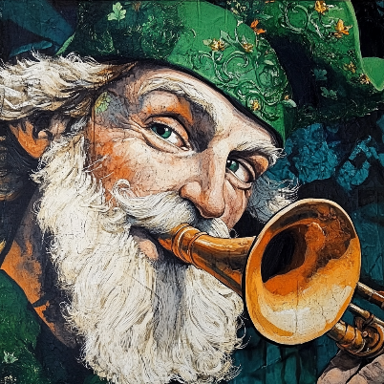**Heritage  
Happenings**

# March ~ Heritage Happenings Agenda

## Previous Issue Review

Newsletter: ??

## Content for March Issue

Ireland  
Health: Eating Well & Hydration  
Cameo: Saint Patrick blowing a traditional Irish horn

## Events

Mardi Gras dinner March 4  
Daylight Savings March 9  
Birthday Night March 14  
St Patrick's Day dinner March 17

## Leadership

Draw from Leadership Update Meeting file & Financial Report

## Residents Council

Margaret Johnson ??

## Content for March Issue

* Bob Granucci: Maybe a duck story
* Doris:
* Jane: unlikely
* Margaret Jacobs:
* Margaret Johnson: unlikely
* Margaret Missiaen:
* Martha Nell:
* Martha Nell: Library Corner
* Patrick:
* Sheila:
* Trish:
* Tucker: James Joyce
* Theo: Front page
* Theo: Editorial
* Tom King: Ireland ~ Car racing Driver Manual