**नमस्ते Namaste !**

**Ignore my previous message! It links back to the August calendar. ;-(**

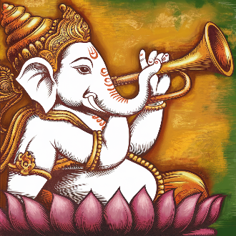  
  
Click on the website link below to open your digital copy of the completely reformatted:

[***Heritage Happenings* Calendar**](https://heritage-happenings.github.io/happenings-issues/2024/2024-09-happenings-calendar.pdf)

The Newsletter will be published next week. See the first page of the Calendar for details about the changes.

As part of the monthly **Around the World** program, *Heritage Happenings* visits**India**. The colors are **saffron** and **India green**. The masthead cameo mascot is Ganesha.

Cheers,

Theo

Editor and Designer, *Heritage Happenings*

***

Theo Armour

Apartment 227 C  
415 828 0000  
[t.armour@gmail.com](mailto:t.armour@gmail.com)