Input geometries for mesh 1 and mesh 2 respectively:

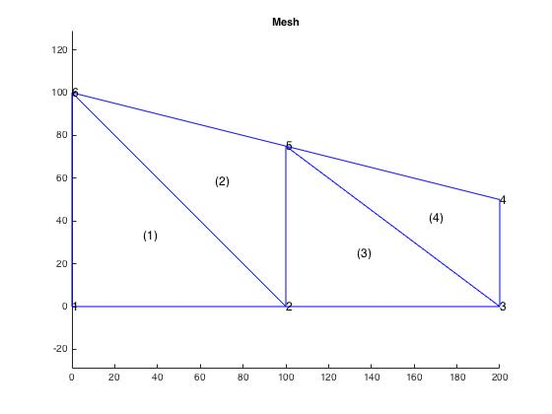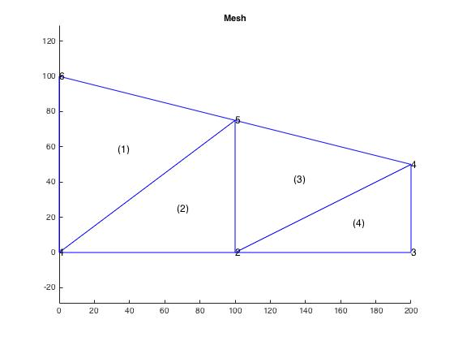

Gradients for mesh 1 and mesh 2 respectively:

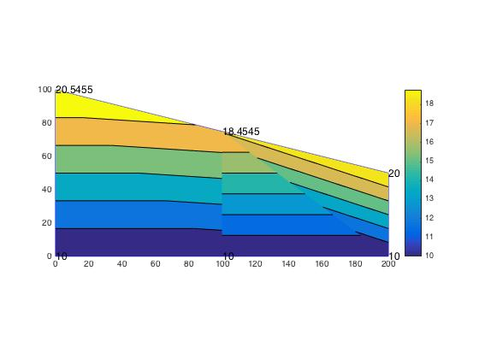

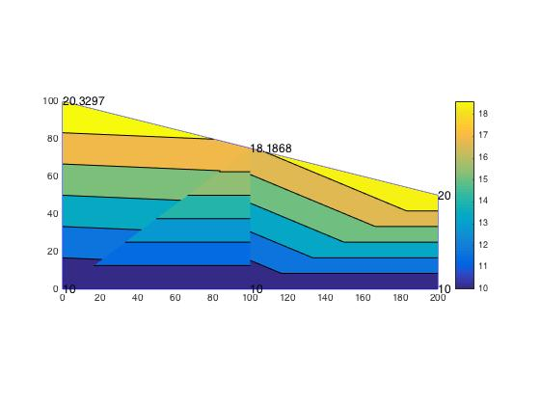

Comparison between MATLAB and hand calculations for mesh 1 and mesh 2 respectively (oC):

|  |  |  |  |  |
| --- | --- | --- | --- | --- |
| **-** | **MATLAB Mesh 1** | **Hand Calcs Mesh 1** | **MATLAB Mesh 2** | **Hand Calcs Mesh 2** |
| Θ5 | 18.4545 | 18.4588 | 18.1868 | 18.1821 |
| Θ6 | 20.5455 | 20.5244 | 20.3297 | 20.3047 |

For point A our values are (oC):

|  |  |  |
| --- | --- | --- |
| **-** | **MATLAB Grad value** | **Hand Calc’ed value** |
| ΘA | ~16 | 16.31 |

Discussion:

An interesting part of the solution is that node 5 has a slightly lower temperature even though it is exposed directly to the external q that is applied. There is a prescribed temperature at 4 and approximately the same value is attained at node 6.