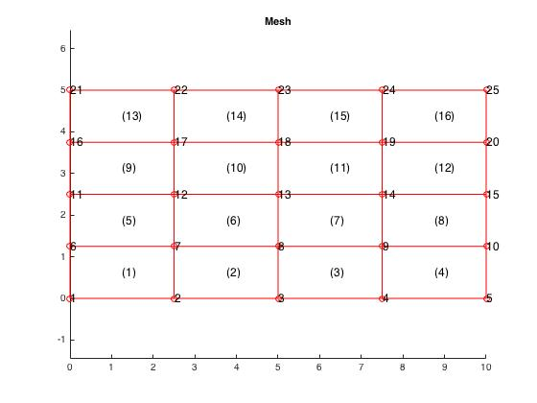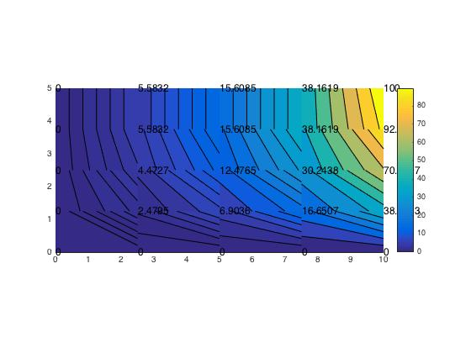

|  |  |  |  |  |  |  |
| --- | --- | --- | --- | --- | --- | --- |
| **Node #** | **MATLAB Solution** | **MATLAB Solution** | **Exact Solution** | **% Error** |  |  |
| 1 | 0 | 0 | 0 | 0 |  |  |
| 2 | 0 | 0 | 0 | 0 |
| 3 | 0 | 0 | 0 | 0 |
| 4 | 0 | 0 | 0 | 0 |
| 5 | 0 | 0 | 0 | 0 |
| 6 | 0 | 0 | 0 | 0 |
| 7 | 2.47946 | 2.47946 | 2.878461232 | 13.86161562 |
| 8 | 6.90362 | 6.90362 | 7.625671821 | 9.468697812 |
| 9 | 16.6507 | 16.6507 | 17.32360718 | 3.884336401 |
| 10 | 38.6283 | 38.6283 | 38.26834324 | 0.940612352 |
| 11 | 0 | 0 | 0 | 0 |
| 12 | 4.47273 | 4.47273 | 5.318702834 | 15.90562324 |
| 13 | 12.4765 | 12.4765 | 14.09040423 | 11.4539243 |
| 14 | 30.2438 | 30.2438 | 32.0098522 | 5.517214493 |
| 15 | 70.7107 | 70.7107 | 70.71067812 | 3.09449E-05 |
| 16 | 0 | 0 | 0 | 0 |
| 17 | 5.58325 | 5.58325 | 6.949220144 | 19.65645232 |
| 18 | 15.6085 | 15.6085 | 18.41000033 | 15.21727475 |
| 19 | 38.1619 | 38.1619 | 41.8228874 | 8.7535501 |
| 20 | 92.388 | 92.388 | 92.38795325 | 5.06006E-05 |
| 21 | 0 | 0 | 0 | 0 |
| 22 | 5.58325 | 5.58325 | 7.521781682 | 25.77224073 |
| 23 | 15.6085 | 15.6085 | 19.92684077 | 21.67097543 |
| 24 | 38.1619 | 38.1619 | 45.26876712 | 15.69927252 |
| 25 | 100 | 100 | 100 | 1.42109E-14 |
|  |  |  |  |  |

**Discussion:**

We have a slight deviation from the exact solution values due to the nature of the MATLAB approximation. However, we are provided with a solution that is rather accurate, given the small error percentages we see above.