CEE 361

Tehila Stone | Theo Dimitrasopoulos

January 12, 2015

You are required to implement the plate quad element into your MATLAB program and analyze one quadrant of the plate shown below. L = 10 m, t = 100 mm, E = 30 x 106 MPa, and υ = 0.3.

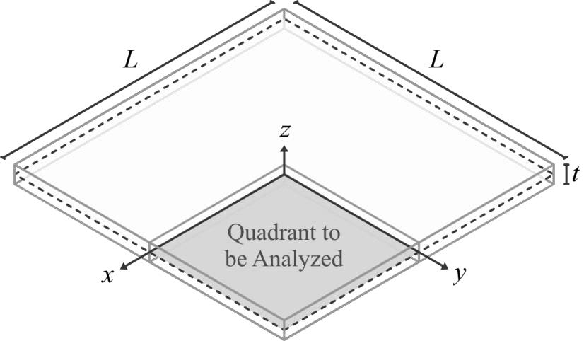

Your analysis should include permutations of all of the following conditions:

i) **Supports** (in both cases, all perimeter displacements are restrained)

a. Edges are fully clamped (all perimeter rotations are restrained)

b. Edges are simply supported (all perimeter rotations are released)

ii) **Loading**

a. Distributed load of q = 10 Pa downward applied to the entire plate

b. Concentrated load of P = 1 kN downward applied to the plate center

iii) Mesh Refinement: quadrant is modelled with 1, 4, 16, and 64 elements

iv) Gaussian Quadrature: shear stiffness found using 1x1 and 2x2 integration

As part of your analysis, you need to include graphs and tabulations of the normalized center deflection of the plate against the logarithm of the number of elements (nel) used. The exact solutions for the center deflection are provided below:

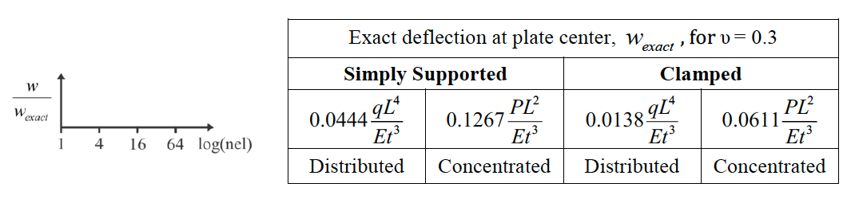

Your deliverable is a report which should include, but does not need to be limited to: the above convergence studies, code changes, code description, deformed geometries, displacement tabulations, stress or stress resultant analyses (in plot and/or tabulated form), and discussions. While an exhaustive set of results is not expected (irrelevant/redundant content will likely cost you points), you should include a sufficient cross-section of results to demonstrate the element performance.

One report and one set of code are expected per group. Discussion or sharing of work between groups is not permitted. Groups are to contain no more than two students unless permission is received from the instructors. A hard copy of the report is to be submitted in E218 and a single .zip file containing all MATLAB scripts is to be sent to fabieng@princeton.edu by the deadline.

1. Explanations on notation

Chapter 0 is to serve as an acquaintance with the notation and methods used to present and visualize the data acquired from our permutations:

* Regarding number notation, all powers of ten were presented as e##, which is equivalent to 10##
* All permutations used 2x2 quadrature and 1x1 quadrature is explained in chapter V, describing some of the strange behaviors seen in the graphics in chapters I-IV and what caused them.
* All quantities presented in the report use m, kN, rads and any combination of the three as their units, including graphics.
* The element is modeled as a two-dimensional plate element, lacking a third dimension in the analysis.
* Moments and Shears are always taken at the plate center, or point 9 in this case (a diagram of our numbering is provided in the appendix)

1. Clamped Condition for distributed load of 10 Pa downward applied to the entire plate.

The method followed implemented a set of loops that applied a load that was derived by multiplying the entire distributed load with the area under analysis (25 m2) and divided by the number of total points on the mesh. The points along the bottom and right side of the element were clamped, meaning all displacements and rotations were constrained.

For a one-element division the following were obtained:

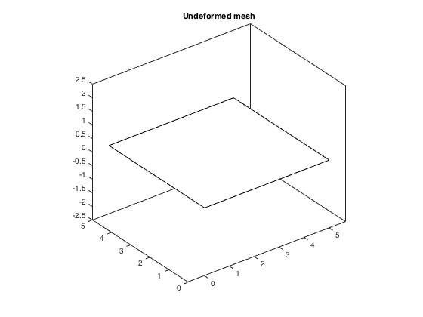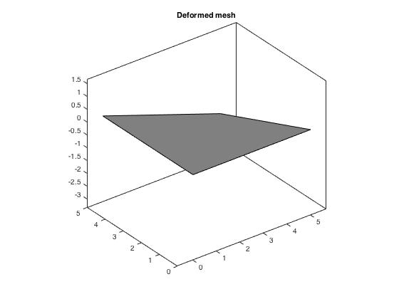

**Nodal Displacements:**

node Displacement(x,y,θ; m,m,rad respectively)

3 -2.3188e-05 -1.473434e-05 -1.46669e-05

**Moment:**

0

0

0

**Shear:**

0

0

For a four-element division the following were obtained:

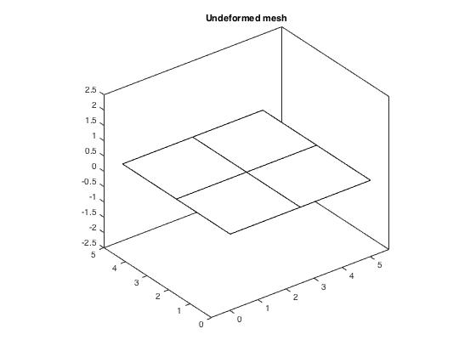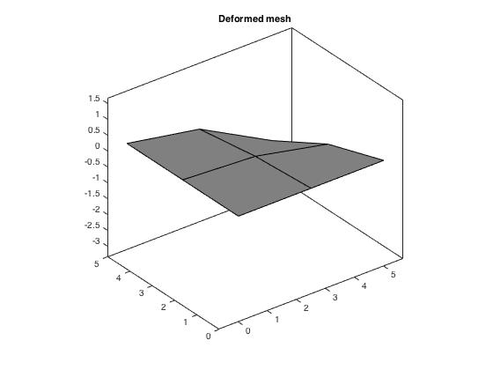

**Nodal Displacements:**

node Displacement(x,y,θ; m,m,rad respectively)

3 -4.39344e-5 -1.365293e-05 -6.74751e-06

6 -1.66587e-05 -5.978767e-06 -1.05225e-05

7 -1.12138e-05 -7.095827e-06 -2.53943e-06

9 -3.60221e-06 -2.303440e-06 -2.29872e-06

**Moment:**

0

0

0

**Shear:**

0

0

For a sixteen-element division the following were obtained:

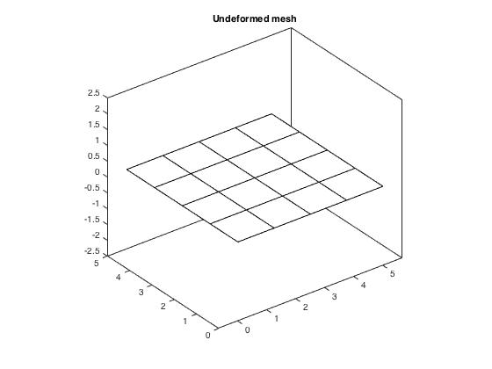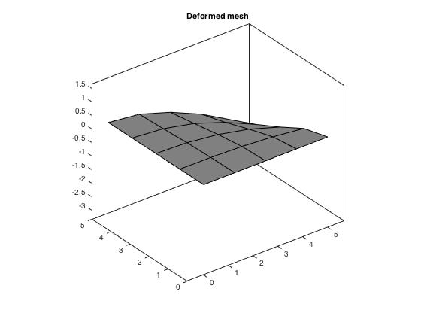

**Nodal Displacements:**

node Displacement(x,y,θ; m,m,rad respectively)

3 -8.58949e-05 -1.253481e-05 -6.36802e-06

6 -4.01585e-05 -7.245269e-06 -8.5763e-06

7 -2.58045e-05 -7.679855e-06 -2.74592e-06

9 -9.15406e-06 -3.284892e-06 -2.93058e-06

12 -1.33077e-05 -2.225503e-06 -7.52575e-06

13 -6.47667e-05 -8.905038e-06 -7.00889e-06

14 -5.20325e-05 -8.936392e-06 -3.69497e-06

15 -6.84932e-06 -4.341658e-06 4.23232e-08

17 0 0 9.0071e-07

18 -5.54785e-07 -3.564168e-07 -1.24976e-06

19 -2.25484e-06 -7.227601e-07 -5.33293e-07

20 -6.59012e-06 -2.035748e-06 -5.07637e-06

21 -2.15400e-05 -4.558579e-06 -5.31466e-06

22 -3.80671e-05 -8.021299e-06 -5.17376e-06

23 -1.76219e-05 -4.953394e-06 -2.43078e-06

24 -4.90075e-06 -3.109405e-06 -1.28336e-06

25 -1.9897e-06 -1.260726e-06 -5.66066e-07

**Moment:**

0

0

0

**Shear:**

0

0

For a sixty-four-element division the following were obtained:

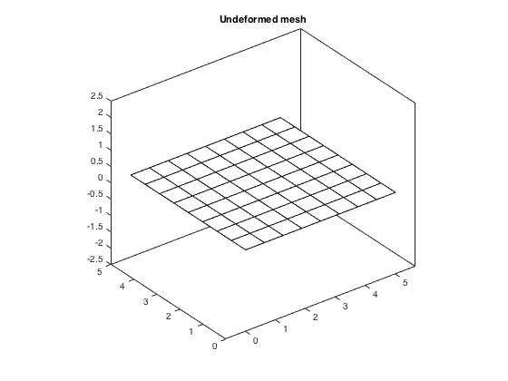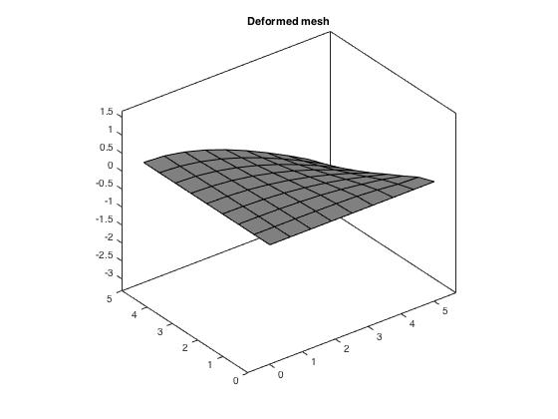

**Nodal Displacements:**

node Displacement(x,y,θ; m,m,rad respectively)

3 -0.000192445 -1.255895e-05 -4.89994e-06

6 -0.000103917 -8.418367e-06 -7.38556e-06

7 -6.02998e-05 -8.691931e-06 -1.84522e-06

9 -2.63095e-05 -4.150039e-06 -2.72188e-06

12 -4.77662e-05 -5.281564e-06 -6.31832e-06

13 -0.000153426 -1.088017e-05 -6.1216e-06

14 -0.000120902 -1.102095e-05 -3.5689e-06

15 -1.68541e-05 -5.333781e-06 -3.07688e-07

17 0 0 2.2673e-07

18 -1.60505e-06 -6.408612e-07 -3.71936e-07

19 -8.16852e-06 -1.582929e-06 -2.18082e-06

20 -2.3964e-05 -3.014220e-06 -3.63187e-06

21 -5.93335e-05 -6.334050e-06 -4.73863e-06

22 -9.28505e-05 -8.966046e-06 -4.18263e-06

23 -4.48419e-05 -6.577044e-06 -2.44037e-06

24 -1.2458e-05 -3.811614e-06 -9.06989e-07

25 -6.51235e-06 -2.087984e-06 -9.30809e-07

29 0 0 -7.59255e-06

30 -1.87526e-05 7.185802e-08 -1.16347e-05

31 -7.51774e-05 -5.275905e-06 -1.08157e-05

32 -0.000129672 -8.696994e-06 -8.92263e-06

33 -0.000173897 -1.083061e-05 -6.84666e-06

34 -0.000155438 -1.087999e-05 -5.53702e-06

35 -8.87833e-05 -9.342287e-06 -3.50046e-06

36 -3.59565e-05 -6.753899e-06 -1.28112e-06

37 -4.24025e-06 -2.679955e-06 2.67956e-07

41 0 0 2.08081e-07

42 -7.16936e-08 -5.100677e-08 -2.50587e-07

43 -3.21771e-07 -1.027878e-07 -5.79002e-10

44 -1.05206e-06 -3.683305e-07 -8.71439e-07

45 -2.17765e-06 -3.405416e-07 -1.1734e-06

46 -3.99570e-06 -8.230162e-07 -2.74715e-06

47 -8.95192e-06 -2.316764e-06 -5.44506e-06

48 -1.57499e-05 -1.987779e-06 -2.63712e-06

49 -3.40569e-05 -3.392093e-06 -9.40743e-06

50 -5.76436e-05 -5.861142e-06 -5.78544e-06

51 -7.99573e-05 -6.749327e-06 -8.37746e-06

52 -0.000102059 -8.831908e-06 -5.65107e-06

53 -0.000121604 -9.270622e-06 -6.75376e-06

54 -0.000139483 -1.100999e-05 -4.58948e-06

55 -0.000107358 -9.350733e-06 -5.00768e-06

56 -7.85306e-05 -8.923985e-06 -3.00837e-06

57 -5.30375e-05 -7.261370e-06 -2.75162e-06

58 -3.17303e-05 -6.234059e-06 -1.40357e-06

59 -1.51271e-05 -4.314689e-06 -7.83552e-07

60 -4.14034e-06 -2.634008e-06 -3.328e-07

61 -3.24440e-06 -2.046433e-06 -2.36185e-07

62 -2.42950e-06 -1.551962e-06 -2.8413e-07

63 -1.63045e-06 -1.022661e-06 -2.23544e-07

64 -8.90139e-07 -5.754886e-07 -2.51174e-07

65 -3.11436e-07 -1.897077e-07 -3.39932e-07

66 -4.16160e-06 -9.677626e-07 -1.54312e-06

67 -1.49513e-05 -2.702964e-06 -4.64031e-06

68 -4.09488e-05 -4.715068e-06 -6.90108e-06

69 -7.65316e-05 -7.344239e-06 -6.1509e-06

70 -6.69808e-05 -7.436614e-06 -4.31919e-06

71 -2.64968e-05 -5.067118e-06 -1.91695e-06

72 -9.50094e-06 -2.915193e-06 -9.61813e-07

73 -3.78658e-06 -1.248085e-06 -7.88366e-07

74 -8.95764e-06 -2.047395e-06 -1.72079e-06

75 -1.69796e-05 -3.026537e-06 -3.17936e-06

76 -2.76163e-05 -3.734853e-06 -3.61843e-06

77 -4.11163e-05 -5.217995e-06 -4.95485e-06

78 -5.45505e-05 -6.589389e-06 -3.5722e-06

79 -3.57957e-05 -5.321953e-06 -3.2851e-06

80 -2.07230e-05 -4.220387e-06 -1.75149e-06

81 -1.48102e-05 -3.153916e-06 -2.00138e-06

**Moment:**

0

0

0

**Shear:**

0

0

1. Clamped Condition for a concentrated load of 1kN downward applied to plate center

The method followed implemented a single applied load of 1kN downward at point 9 of our mesh (plate center or top left corner of the bottom right plate element under consideration). The points along the bottom and right side of the element were clamped, meaning all displacements and rotations were constrained.

For a one-element division the following were obtained:



**Nodal Displacements:**

node Displacement(x,y,θ; m,m,rad respectively)

3 -0.000371008 -2.357494e-04 -0.00023467

**Moment:**

0

0

0

**Shear:**

0

0

For a four-element division the following were obtained:

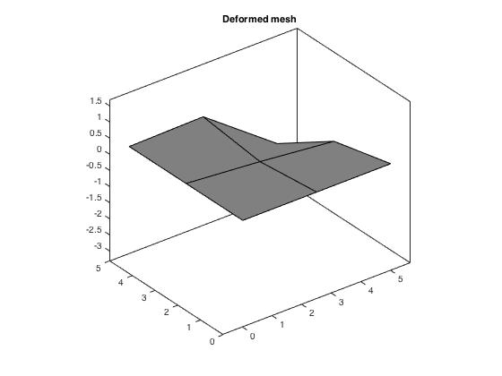

**Nodal Displacements:**

node Displacement(x,y,θ; m,m,rad respectively)

3 -0.000658963 -4.419187e-04 -0.000190744

6 -0.000177958 -1.021598e-05 -0.00011305

7 1.754950e-05 1.213625e-05 0.000111129

9 -7.979330e-05 -5.146773e-05 -5.02272e-05

**Moment:**

0

0

0

**Shear:**

0

0

For a sixteen-element division the following were obtained:

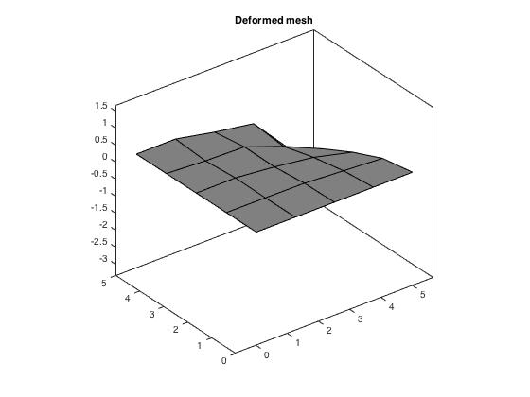

**Nodal Displacements:**

Node Displacement(x,y,θ; m,m,rad respectively)

3 -0.00131106 -6.509762e-04 -0.000189404

6 -0.000437553 -1.308059e-04 -0.000111916

7 -0.000184001 -1.239123e-04 -0.00010965

9 -8.59442e-05 -6.466750e-05 -3.57364e-05

12 -0.000128992 3.011384e-07 -6.66093e-05

13 -0.000810387 -2.120479e-05 -0.000125014

14 -0.000334631 3.010319e-05 0.000121662

15 3.06182e-06 3.767991e-06 7.71686e-05

17 0 0 1.60298e-05

18 -4.41712e-06 -3.647318e-06 -1.83213e-05

19 -1.35155e-05 -1.455952e-06 6.65457e-06

20 -7.16677e-05 -3.609281e-05 -6.05475e-05

21 -0.000211361 -1.364606e-05 -4.50032e-05

22 -0.000407089 -2.329287e-04 -7.84217e-05

23 -7.45689e-05 2.053435e-05 4.22734e-05

24 -5.0957e-05 -3.406569e-05 -4.40124e-05

25 5.98668e-06 5.215490e-06 8.37281e-06

**Moment:**

0

0

0

**Shear:**

0

0

For a sixty-four-element division the following were obtained:

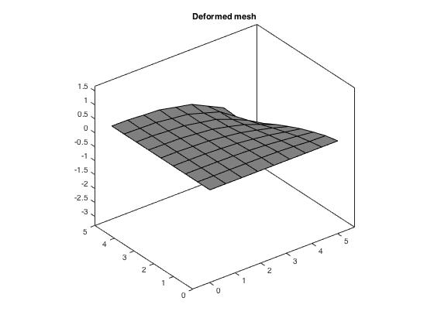

**Nodal Displacements:**

Node Displacement(x,y,θ; m,m,rad respectively)

3 -0.00276497 -8.650769e-04 -0.000182314

6 -0.00104307 -1.607475e-04 -8.95294e-05

7 -0.000337436 -1.475383e-04 -8.54121e-05

9 -0.000186893 -7.342358e-05 -2.6759e-05

12 -0.00042475 -6.751816e-05 -5.63305e-05

13 -0.00181054 -3.338587e-04 -0.000117108

14 -0.00100053 -3.272049e-04 -0.000111012

15 -7.58242e-05 -4.674519e-05 -5.88898e-05

17 0 0 -7.51542e-07

18 -8.19455e-06 -8.260578e-06 -3.89717e-06

19 -5.86501e-05 -2.646540e-05 -1.84524e-05

20 -0.000208386 -4.990300e-05 -3.2701e-05

21 -0.000530773 -1.297137e-04 -4.82452e-05

22 -0.000838832 -2.491159e-04 -5.40661e-05

23 -0.000297119 -1.244960e-04 -4.81338e-05

24 -6.85862e-05 -4.389853e-05 -3.27628e-05

25 -3.74844e-05 -2.527359e-05 -1.26457e-05

29 0 0 -6.91872e-05

30 -0.00016671 1.084845e-05 -0.000102434

31 -0.000704782 -7.273834e-06 -0.000123009

32 -0.00140171 -1.506159e-05 -0.000139197

33 -0.00222862 -1.527169e-05 -0.00015002

34 -0.00146408 3.682958e-05 0.000100081

35 -0.000532216 2.716388e-05 9.51032e-05

36 -0.000131857 1.423069e-05 7.94355e-05

37 -6.44507e-06 -4.544981e-07 3.9855e-05

41 0 0 4.22669e-06

42 3.48281e-08 -8.311697e-07 -3.78822e-06

43 -4.36499e-07 1.289837e-06 3.20833e-06

44 -6.52429e-06 -5.854039e-06 -7.39492e-06

45 -1.35565e-05 2.061153e-06 -5.48703e-06

46 -3.24692e-05 -1.473423e-05 -2.36354e-05

47 -7.70847e-05 -1.293594e-05 -4.57545e-05

48 -0.000139892 -2.742497e-05 -2.27022e-05

49 -0.000304234 -9.765990e-06 -8.62873e-05

50 -0.000532642 -1.005050e-04 -5.66686e-05

51 -0.000765577 -1.699729e-05 -9.28856e-05

52 -0.001032 -2.170224e-04 -7.46095e-05

53 -0.00126244 -1.637591e-05 -7.42834e-05

54 -0.00150834 -4.381429e-04 -7.94287e-05

55 -0.00086769 2.8584130e-05 3.35263e-05

56 -0.000575811 -2.1056530e-04 -7.33342e-05

57 -0.000282518 2.1567450e-05 5.54695e-05

58 -0.000171292 -8.915773e-05 -5.82095e-05

59 -4.86375e-05 8.4243990e-06 4.42432e-05

60 -2.56131e-05 -1.984812e-05 -2.90291e-05

61 -4.82888e-06 4.247927e-07 1.64944e-05

62 -1.5715e-05 -1.318669e-05 -1.03249e-05

63 -2.97446e-06 9.257488e-07 2.76152e-06

64 -5.10905e-06 -5.512063e-06 -1.96592e-06

65 2.16325e-08 1.623245e-06 -1.18652e-07

66 -2.11005e-05 1.395844e-06 -6.32699e-06

67 -0.000116948 -9.232186e-06 -3.46629e-05

68 -0.000354401 -1.412736e-05 -6.17502e-05

69 -0.000676957 -1.069605e-05 -4.58857e-05

70 -0.000474216 1.509533e-05 1.10642e-05

71 -0.000123725 1.178252e-05 2.96457e-05

72 -3.54115e-05 3.517255e-06 1.30582e-05

73 -1.39872e-05 1.882098e-06 -1.25858e-06

74 -5.62831e-05 -3.054741e-05 -1.42798e-05

75 -0.000113547 -3.983233e-06 -1.81787e-05

76 -0.000223249 -6.734510e-05 -3.08464e-05

77 -0.000317877 -7.391090e-06 -3.08681e-05

78 -0.000432213 -1.419281e-04 -4.01819e-05

79 -0.000222349 6.280832e-06 2.92894e-06

80 -0.000126993 -6.419420e-05 -2.93881e-05

81 -7.77515e-05 2.026184e-06 -6.55825e-07

**Moment:**

0

0

0

**Shear:**

0

0

1. Simply supported Condition for distributed load of 10 Pa downward applied to the entire plate.

The method followed implemented a set of loops that applied a load that was derived by multiplying the entire distributed load with the area under analysis (25 m2) and divided by the number of total points on the mesh. The points along the bottom and right side of the element were simply supported, meaning all displacements were constrained and the rotation was free.

For a one-element division the following were obtained:



**Nodal Displacements:**

Node Displacement(x,y,θ; m,m,rad respectively)

1 0 0 -8.72642e-05

2 0 0 4.52624e-05

3 -0.000101925 -6.461804e-05 -4.52624e-05

4 0 0 2.26461e-05

**Moment:**

-0.0373

-0.1243

0.0839

**Shear:**

-100.6897

-52.2261

For a four-element division the following were obtained:

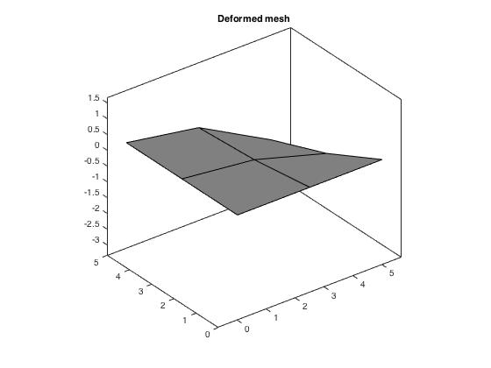

**Nodal Displacements:**

Node Displacement(x,y,θ; m,m,rad respectively)

1 0 0 5.06891e-06

2 0 0 -9.56736e-06

3 -7.27591e-05 -2.396893e-05 -2.34009e-06

4 0 0 5.79805e-06

5 0 0 -9.00469e-06

6 -4.1516e-05 -1.126177e-05 -1.11086e-05

7 -1.74768e-05 -1.108189e-05 -5.74917e-06

8 0 0 5.49338e-07

9 -1.18754e-05 -7.531819e-06 -4.15507e-06

**Moment:**

0.0079

0.0263

-0.0049

**Shear:**

-5.8488

-11.0393

For a sixteen-element division the following were obtained:

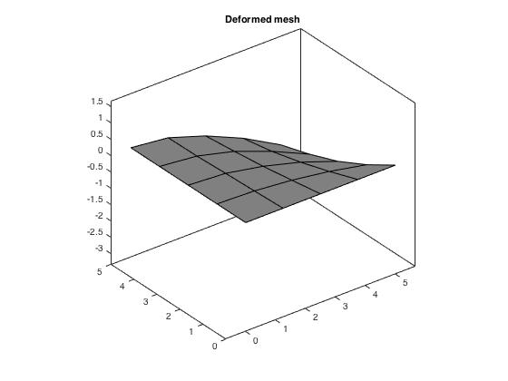

**Nodal Displacements:**

Node Displacement(x,y,θ; m,m,rad respectively)

1 0 0 -4.30764e-06

2 0 0 -1.88855e-05

3 -0.000132698 -1.905879e-05 -9.98893e-06

4 0 0 -3.22374e-06

5 0 0 -8.07762e-06

6 -8.18004e-05 -1.227328e-05 -1.45545e-05

7 -4.10923e-05 -1.255902e-05 -5.8147e-06

8 0 0 -4.52541e-06

9 -2.38904e-05 -7.304303e-06 -7.92412e-06

10 0 0 3.04887e-06

11 0 0 -4.37239e-06

12 -4.44931e-05 -6.575943e-06 -7.66315e-06

13 -0.000109827 -1.307292e-05 -3.00829e-06

14 -8.17742e-05 -1.322841e-05 -1.54002e-07

15 -1.06303e-05 -6.748303e-06 3.92985e-06

16 0 0 4.7197e-06

17 0 0 5.94297e-06

18 -3.3697e-06 -2.137047e-06 -6.82384e-06

19 -1.22384e-05 -3.488251e-06 1.96005e-06

20 -2.59289e-05 -5.194713e-06 -1.37149e-05

21 -4.89292e-05 -8.567005e-06 -2.29478e-06

22 -6.80645e-05 -1.340266e-05 -1.00379e-05

23 -3.31299e-05 -8.749873e-06 2.26408e-06

24 -9.67329e-06 -6.125585e-06 -6.03209e-06

25 -6.17971e-06 -3.921259e-06 3.62072e-06

**Moment:**

0.0156

0.0519

0.0041

**Shear:**

-4.9704

-21.7911

For a sixty-four-element division the following were obtained:

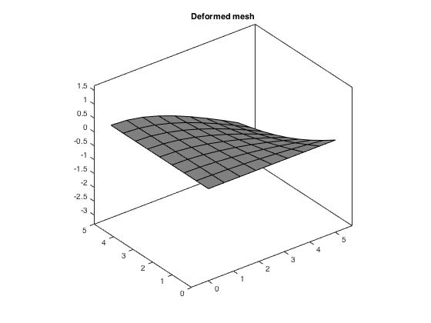

**Nodal Displacements:**

Node Displacement(x,y,θ; m,m,rad respectively)

1 0 0 0.000120007

2 0 0 0.000104782

3 -0.000264692 -1.650893e-05 0.000114389

4 0 0 0.000120407

5 0 0 0.000115759

6 -0.000166962 -1.136843e-05 0.000109713

7 -8.56586e-05 -1.217737e-05 0.000118265

8 0 0 0.000119985

9 -5.08126e-05 -7.264126e-06 0.000116519

10 0 0 0.000118873

11 0 0 0.000111143

12 -9.17966e-05 -6.692921e-06 0.000106698

13 -0.000223274 -1.452708e-05 0.000112614

14 -0.000169326 -1.483794e-05 0.000115998

15 -2.37836e-05 -7.597014e-06 0.000120239

16 0 0 0.000120133

17 0 0 0.000119937

18 -7.46793e-06 -2.267536e-06 0.000118849

19 -2.68252e-05 -3.872134e-06 0.000115927

20 -5.50245e-05 -5.193389e-06 0.000111744

21 -0.000102703 -9.468658e-06 0.000113295

22 -0.000140167 -1.256906e-05 0.000114938

23 -7.06161e-05 -9.946197e-06 0.000117266

24 -2.03644e-05 -6.139002e-06 0.000119122

25 -1.43062e-05 -4.337102e-06 0.000118974

26 0 0 -0.000120366

27 0 0 -0.000122667

28 0 0 -0.000126602

29 0 0 -0.000131977

30 -4.7468e-05 -3.628425e-06 -0.000134406

31 -0.00013172 -8.836299e-06 -0.00013173

32 -0.000197289 -1.235408e-05 -0.00012881

33 -0.000245169 -1.443728e-05 -0.000126503

34 -0.000215698 -1.455392e-05 -0.000125308

35 -0.000125394 -1.300647e-05 -0.00012328

36 -5.11053e-05 -9.720711e-06 -0.000121109

37 -5.88914e-06 -3.746066e-06 -0.00011977

38 0 0 -0.000120147

39 0 0 -0.000119864

40 0 0 -0.000119674

41 0 0 -0.000119561

42 -9.90363e-07 -6.277133e-07 0.000119292

43 -3.76995e-06 -1.134959e-06 -0.000120816

44 -8.06409e-06 -1.588859e-06 0.000117105

45 -1.36005e-05 -1.922588e-06 -0.00012393

46 -2.02917e-05 -2.321315e-06 0.000113283

47 -2.80427e-05 -2.594094e-06 -0.000128462

48 -3.69387e-05 -3.047419e-06 0.000108095

49 -7.22295e-05 -5.712262e-06 -0.000130859

50 -0.00010459 -8.363700e-06 0.000110069

51 -0.000133338 -9.949264e-06 -0.000128617

52 -0.000158564 -1.219629e-05 0.000112497

53 -0.000180181 -1.279356e-05 -0.000126478

54 -0.000199076 -1.478307e-05 0.000114508

55 -0.000155368 -1.293369e-05 -0.000124586

56 -0.000115158 -1.256528e-05 0.00011653

57 -7.87106e-05 -1.054824e-05 -0.00012241

58 -4.75357e-05 -9.223032e-06 0.000118588

59 -2.27402e-05 -6.500029e-06 -0.000120642

60 -6.25354e-06 -3.953482e-06 0.000119742

61 -5.33341e-06 -3.389310e-06 -0.000120312

62 -4.60949e-06 -2.916370e-06 0.000119583

63 -3.72917e-06 -2.368555e-06 -0.000120262

64 -2.88436e-06 -1.826058e-06 0.000119414

65 -1.9444e-06 -1.234527e-06 -0.000120274

66 -1.58808e-05 -3.064646e-06 -0.00012244

67 -3.98832e-05 -4.404158e-06 -0.000126087

68 -8.00484e-05 -7.198068e-06 -0.000127337

69 -0.000122613 -1.060064e-05 -0.000125792

70 -0.000103323 -1.078366e-05 -0.000124021

71 -4.24853e-05 -7.882169e-06 -0.000121776

72 -1.73339e-05 -5.151057e-06 -0.000120774

73 -1.09473e-05 -3.285775e-06 -0.000120791

74 -2.33654e-05 -4.589397e-06 0.00011743

75 -3.92472e-05 -5.482343e-06 -0.000123536

76 -5.82941e-05 -6.596570e-06 0.000114146

77 -7.50195e-05 -8.078441e-06 -0.000125067

78 -9.01147e-05 -1.000731e-05 0.000115374

79 -6.11856e-05 -8.338320e-06 -0.000122974

80 -3.67477e-05 -7.159712e-06 0.000117868

81 -3.02499e-05 -5.768413e-06 -0.000122109

**Moment:**

-0.0864

-0.2879

-0.1154

**Shear:**

-138.4698

-120.9024

1. Simply supported condition a concentrated load of 1kN downward applied to plate center.

The method followed implemented a single applied load of 1kN downward at point 9 of our mesh (plate center or top left corner of the bottom right plate element under consideration). The points along the bottom and right side of the element were simply supported, meaning all displacements were constrained and the rotation was free.

For a one-element division the following were obtained:



**Nodal Displacements:**

Node Displacement(x,y,θ; m,m,rad respectively)

1 0 0 -0.00139623

2 0 0 0.000724199

3 -0.0016308 -1.033889e-03 -0.000724199

4 0 0 0.000362338

**Moment:**

-0.5969

-1.9896

1.3425

**Shear:**

-1.6110 e+03

-0.8356 e+03

For a four-element division the following were obtained:

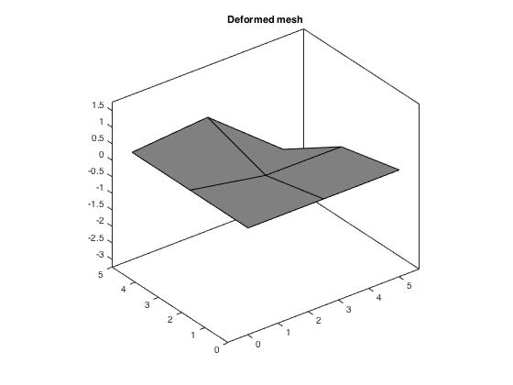

**Nodal Displacements:**

Node Displacement(x,y,θ; m,m,rad respectively)

1 0 0 -0.00046992

2 0 0 -0.000398618

3 -0.00121781 -9.429267e-04 -9.49259e-05

4 0 0 0.00019502

5 0 0 0.000243056

6 -0.000323461 1.945726e-04 9.65035e-05

7 0.000133964 8.545261e-05 6.1336e-05

8 0 0 0.0003729

9 -0.000314589 -1.999109e-04 -0.000345337

**Moment:**

0.3285

1.0951

0.4518

**Shear:**

-542.2171

-459.9459

For a sixteen-element division the following were obtained:

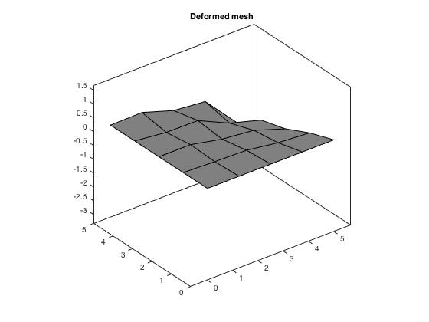

**Nodal Displacements:**

Node Displacement(x,y,θ; m,m,rad respectively)

1 0 0 -0.000247708

2 0 0 -0.00019151

3 -0.0018917 -1.068114e-03 4.19715e-05

4 0 0 0.000352112

5 0 0 -0.000160094

6 -0.000846185 -3.665292e-04 -0.000139246

7 -0.000397432 -2.816625e-04 0.00014891

8 0 0 -0.000121632

9 -0.000272936 -1.748150e-04 -0.000103246

10 0 0 0.000152091

11 0 0 2.283e-05

12 -0.000363992 7.245898e-05 -5.70864e-05

13 -0.00113639 2.373692e-04 -0.000194801

14 -0.000526151 2.008660e-04 -0.000124493

15 2.16846e-05 1.537492e-05 -0.000185345

16 0 0 -2.7722e-05

17 0 0 0.000230009

18 -4.97717e-05 -3.241541e-05 -0.000165785

19 -8.10873e-05 1.292812e-05 9.0758e-05

20 -0.000268867 -1.323237e-04 -0.00017539

21 -0.000409543 8.885171e-05 -2.30738e-05

22 -0.000763206 -4.726887e-04 -5.09908e-05

23 -0.000159096 8.889146e-05 2.52595e-05

24 -0.000147862 -9.540429e-05 -3.19625e-05

25 -2.25807e-07 1.333607e-06 8.82899e-05

**Moment:**

0.1578

0.5261

0.2382

**Shear:**

-285.8181

-220.9740

For a sixty-four-element division the following were obtained:

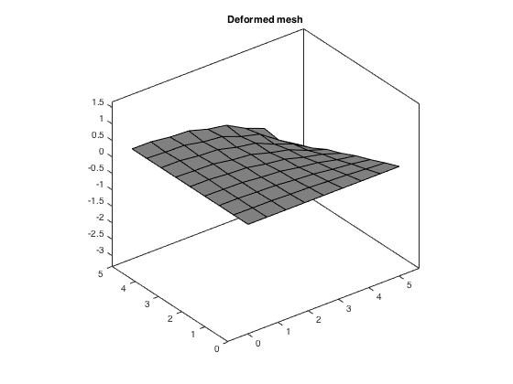

**Nodal Displacements:**

Node Displacement(x,y,θ; m,m,rad respectively)

1 0 0 0.000632112

2 0 0 0.000683829

3 -0.003394 -1.247495e-03 0.00089351

4 0 0 0.00121379

5 0 0 0.000710572

6 -0.00151778 -3.670280e-04 0.000733672

7 -0.000569514 -2.828272e-04 0.00102244

8 0 0 0.000749363

9 -0.000389263 -1.658089e-04 0.000767044

10 0 0 0.00069743

11 0 0 0.000699795

12 -0.000743042 -1.696420e-04 0.000695703

13 -0.00236132 -6.360677e-04 0.000802678

14 -0.00141127 -5.603033e-04 0.000980918

15 -0.000164607 -1.010785e-04 0.00107295

16 0 0 0.000915952

17 0 0 0.000660146

18 -5.817e-05 -3.165947e-05 0.000714538

19 -0.000205961 -7.957696e-05 0.000723959

20 -0.000443727 -1.301774e-04 0.00071282

21 -0.000869907 -2.783295e-04 0.000756986

22 -0.00122732 -4.570948e-04 0.000847571

23 -0.000522116 -2.479739e-04 0.000846829

24 -0.000153603 -9.520956e-05 0.000863162

25 -0.000110835 -6.402917e-05 0.000767003

26 0 0 -0.000677743

27 0 0 -0.000743632

28 0 0 -0.000803392

29 0 0 -0.000873786

30 -0.000357886 3.473135e-05 -0.000914774

31 -0.00108759 1.088176e-04 -0.000947953

32 -0.00185937 1.925403e-04 -0.00101862

33 -0.00270999 2.799261e-04 -0.0011364

34 -0.00186553 2.750237e-04 -0.000988274

35 -0.000774011 1.545560e-04 -0.00100632

36 -0.000225734 6.372370e-05 -0.00103671

37 -7.35406e-06 -7.988801e-07 -0.00111555

38 0 0 -0.001027

39 0 0 -0.000816062

40 0 0 -0.000692816

41 0 0 -0.000636037

42 -8.89067e-06 -6.640961e-06 0.000676125

43 -1.9931e-05 2.802085e-07 -0.000714153

44 -6.12175e-05 -2.689563e-05 0.000708943

45 -9.06402e-05 8.591781e-06 -0.000772176

46 -0.000158425 -5.190604e-05 0.000707089

47 -0.00020915 2.010814e-05 -0.00083651

48 -0.000294322 -7.455785e-05 0.000691283

49 -0.000563709 5.501010e-05 -0.000887138

50 -0.000885673 -2.354224e-04 0.000716872

51 -0.00112672 1.172450e-04 -0.000928091

52 -0.00147481 -4.340248e-04 0.000775856

53 -0.00165725 1.869577e-04 -0.000993715

54 -0.00200486 -7.237678e-04 0.000886111

55 -0.00118571 2.017905e-04 -0.000934013

56 -0.000889758 -3.876921e-04 0.000890458

57 -0.000446827 1.054913e-04 -0.000911622

58 -0.000324961 -1.815619e-04 0.000911613

59 -8.83961e-05 3.013718e-05 -0.000933773

60 -6.31011e-05 -4.394037e-05 0.000963816

61 -6.66442e-06 -2.486442e-07 -0.000888026

62 -4.39684e-05 -3.167677e-05 0.000811121

63 -9.22789e-06 -2.457277e-06 -0.000765782

64 -2.65365e-05 -1.958207e-05 0.000719601

65 -6.61723e-06 -2.249586e-06 -0.000699097

66 -9.54667e-05 8.857599e-06 -0.000755443

67 -0.000286013 2.948621e-05 -0.000812951

68 -0.000618927 6.498836e-05 -0.000857767

69 -0.00098555 1.217534e-04 -0.000898772

70 -0.000712199 1.288470e-04 -0.000890315

71 -0.000219547 5.491500e-05 -0.000866178

72 -7.48843e-05 1.434162e-05 -0.000812036

73 -5.40789e-05 3.837351e-06 -0.000745403

74 -0.000176637 -8.270674e-05 0.00073765

75 -0.000259116 3.135037e-05 -0.000791457

76 -0.000464006 -1.621825e-04 0.000733966

77 -0.000542777 6.964302e-05 -0.00084215

78 -0.000723859 -2.861421e-04 0.000795781

79 -0.000384521 6.970271e-05 -0.000832368

80 -0.000271214 -1.403176e-04 0.000797531

81 -0.000171763 2.679939e-05 -0.00079245

**Moment:**

-0.5636

-1.8786

-0.6078

**Shear:**

-729.3627

-789.0358

1. Shear-locking: what exactly is it and how we prevent it from happening.

Looking at some of the graphs above, such as the 4, 16 and 64-element division for the simply supported condition with a 1kN concentrated load applied at the center of the plate, we notice that some of the subdivisions look distorted and the element as a whole discontinuous and “wrinkled”. When 2x2 shear quadrature is being implemented for the shear, the shear stiffness of the structure is predicted to be more than tensile stress and the bending stress much lower than the tensile stress. Our selection of a quad element as the base for the analysis was not a good one in this case, as the quad is not a very “smart” shape, and is therefore unable to acquire the correct shape for the shear stress within the plate. A simple solution to this would be to add a point in the middle of each subdivision and connect it to the four nodes of the quad subdivision, thus turning each quad to 4 triangular elements, which will not be susceptible to shear locking.

To prevent shear locking from happening, we can under-integrate for the shear stiffness matrix and move from a 2x2 Gaussian integration to a 1x1 Gaussian integration, in which case the shear stiffness contribution is not over-exaggerated and the end-result looks “smoother” across the plate element. We are switching from an nglx=ngly=2 to a nglx=ngly=1 and remove the extraneous r and s values to acquire the new values for 1x1 quadrature. The following graphics include only the deformed shapes of all the scenarios above and the accompanying values underneath them.

The adjusted one-element cases are as follows:

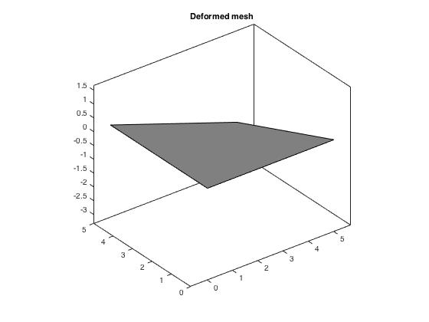Clamped condition | Concentrated Load

**Nodal Displacements:**

Node Displacement(x,y,θ; m,m,rad respectively)

3 -0.00058521 -5.885470e-04 -0.000581872

**Moment:**

0

0

0

**Shear:**

0

0

Clamped Condition | Distributed Load

**Nodal Displacements:**

Node Displacement(x,y,θ; m,m,rad respectively)

3 -3.65756e-05 -3.678418e-05 -3.6367e-05

**Moment:**

0

0

0

**Shear:**

0

0

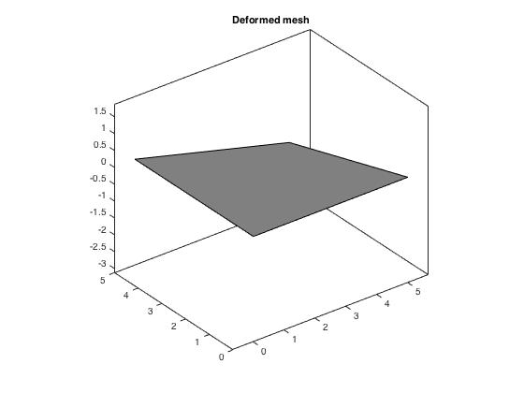Simply Supported Condition | Concentrated Load

**Nodal Displacements:**

Node Displacement(x,y,θ; m,m,rad respectively)

1 0 0 -0.00340205

2 0 0 0.00173002

3 -0.00257235 -2.572350e-03 -0.00173002

4 0 0 0.000829697

**Moment:**

-1.4258

-4.7528

3.2712

**Shear:**

-3.9255e+03

-1.9962e+03

 Simply Supported Condition | Distributed Load

**Nodal Displacements:**

Node Displacement(x,y,θ; m,m,rad respectively)

1 0 0 -0.000212628

2 0 0 0.000108126

3 -0.000160772 -1.607719e-04 -0.000108126

4 0 0 5.1856e-05

**Moment:**

-0.0891

-0.2970

0.2044

**Shear:**

-245.3407

-124.7614

The adjusted 4-element cases are as follows:

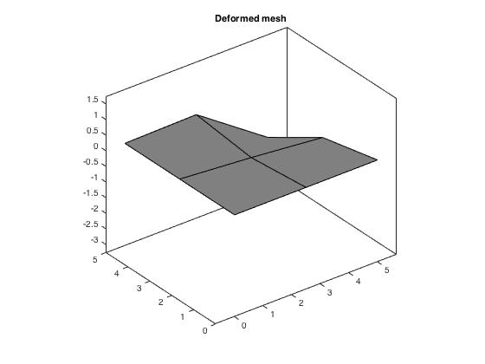Clamped Condition | Concentrated Load

**Nodal Displacements:**

Node Displacement(x,y,θ; m,m,rad respectively)

3 -0.0010411 -1.106763e-03 -0.000468712

6 -0.000281955 -2.140917e-05 -0.000283327

7 2.69896e-05 3.317781e-05 0.000271559

9 -0.000125877 -1.312747e-04 -0.000123691

**Moment:**

0

0

0

**Shear:**

0

0

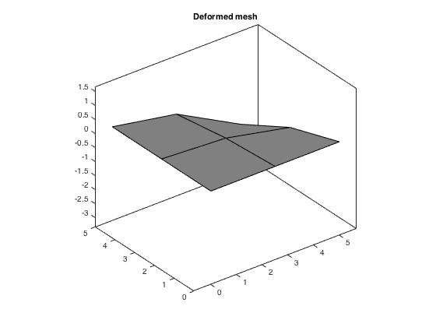Clamped Condition | Distributed Load

**Nodal Displacements:**

Node Displacement(x,y,θ; m,m,rad respectively)

3 -6.9412e-05 -3.406575e-05 -1.67839e-05

6 -2.63653e-05 -1.490699e-05 -2.61264e-05

7 -1.7729e-05 -1.764678e-05 -6.34833e-06

9 -5.68298e-06 -5.804499e-06 -5.77552e-06

**Moment:**

0

0

0

**Shear:**

0

0

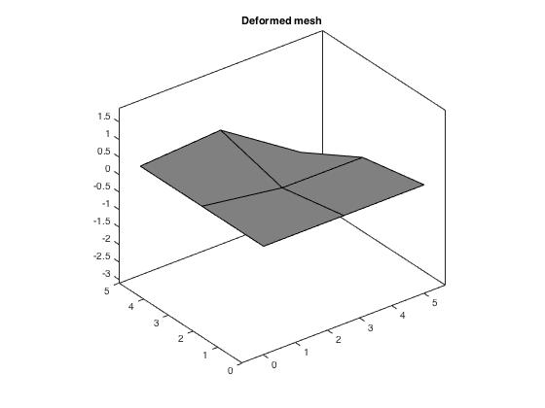Simply Supported Condition | Concentrated Load

**Nodal Displacements:**

Node Displacement(x,y,θ; m,m,rad respectively)

1 0 0 -0.000607703

2 0 0 -0.000430834

3 -0.00192065 -2.348151e-03 0.000326136

4 0 0 0.00104503

5 0 0 4.47977e-05

6 -0.000510346 4.854131e-04 -0.000320753

7 0.000210646 2.138559e-04 -0.000409839

8 0 0 0.000366638

9 -0.00049555 -4.984365e-04 -0.000298417

**Moment:**

0.3551

1.1836

0.5843

**Shear:**

-701.1986

-497.1181

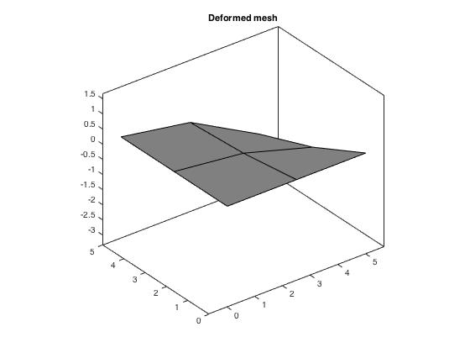Simply Supported Condition | Distributed Load

**Nodal Displacements:**

Node Displacement(x,y,θ; m,m,rad respectively)

1 0 0 -3.52473e-07

2 0 0 -3.67229e-05

3 -0.00011479 -5.965250e-05 -1.8758e-05

4 0 0 1.4792e-06

5 0 0 -9.46947e-06

6 -6.55068e-05 -2.803448e-05 -1.46847e-05

7 -2.75722e-05 -2.758493e-05 -1.36296e-06

8 0 0 1.42915e-05

9 -1.87334e-05 -1.875252e-05 -2.32821e-05

**Moment:**

0.0303

0.1009

0.0003

**Shear:**

-0.4067

-42.3727

The adjusted 16-element cases are as follows:

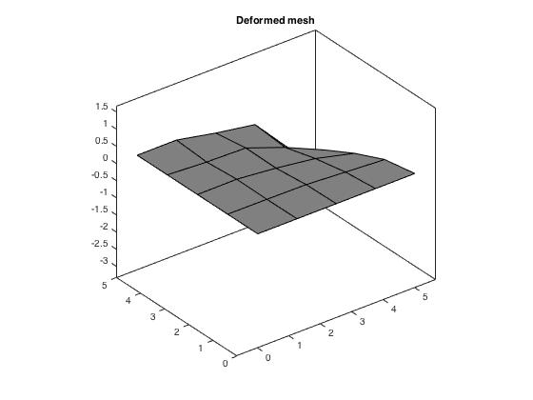Clamped Condition | Concentrated Load

**Nodal Displacements:**

Node Displacement(x,y,θ; m,m,rad respectively)

3 -0.00207161 -1.644155e-03 -0.000451146

6 -0.000691663 -3.411961e-04 -0.000270172

7 -0.000288963 -3.184538e-04 -0.000255702

9 -0.000135346 -1.694364e-04 -8.31627e-05

12 -0.00020509 9.160840e-06 -0.000169407

13 -0.0012803 -3.329063e-05 -0.000321799

14 -0.000528215 8.941540e-05 0.000283485

15 4.69829e-06 1.552484e-05 0.00018084

17 0 0 4.07175e-05

18 -7.02719e-06 -1.201621e-05 -4.4783e-05

19 -2.13718e-05 1.609097e-06 1.46305e-05

20 -0.000113263 -9.760886e-05 -0.0001486

21 -0.000334472 -2.245596e-05 -0.000118962

22 -0.000642809 -5.946837e-04 -0.000185425

23 -0.000117739 6.001575e-05 9.67311e-05

24 -7.93745e-05 -8.980158e-05 -0.000103438

25 9.36929e-06 1.775525e-05 1.7453e-05

**Moment:**

0

0

0

**Shear:**

0

0

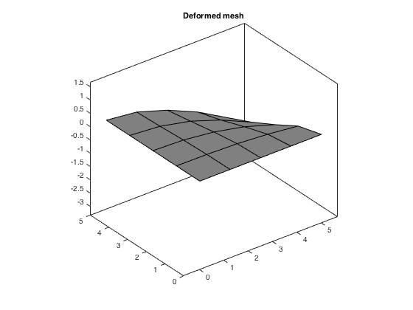Clamped Condition | Distributed Load

**Nodal Displacements:**

Node Displacement(x,y,θ; m,m,rad respectively)

3 -0.000135588 -3.129617e-05 -1.57801e-05

6 -6.33895e-05 -1.808028e-05 -2.12821e-05

7 -4.07095e-05 -1.913461e-05 -6.76561e-06

9 -1.44455e-05 -8.199204e-06 -7.24977e-06

12 -2.10255e-05 -5.520433e-06 -1.87306e-05

13 -0.000102234 -2.212045e-05 -1.74649e-05

14 -8.21135e -05-2.219885e-05 -9.26914e-06

15 -1.08019e-05 -1.079921e-05 7.39687e-08

17 0 0 2.22965e-06

18 -8.7039e-07 -8.985988e-07 -3.08457e-06

19 -3.55655e-06 -1.796834e-06 -1.35319e-06

20 -1.04061e-05 -5.114118e-06 -1.2623e-05

21 -3.40047e-05 -1.130598e-05 -1.32807e-05

22 -6.00782e-05 -2.003149e-05 -1.28583e-05

23 -2.78079e-05 -1.231755e-05 -6.0695e-06

24 -7.7323e-06 -7.746233e-06 -3.17835e-06

25 -3.13532e-06 -3.132229e-06 -1.4426e-06

**Moment:**

0

0

0

**Shear:**

0

0

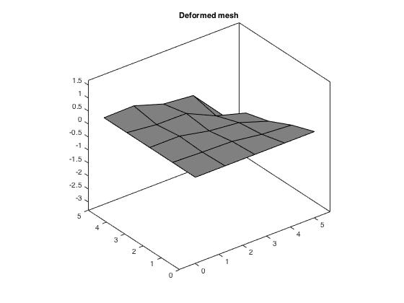Simply Supported Condition | Concentrated Load

**Nodal Displacements:**

Node Displacement(x,y,θ; m,m,rad respectively)

1 0 0 0.000482544

2 0 0 0.00061921

3 -0.00298277 -2.669817e-03 0.00121009

4 0 0 0.00197027

5 0 0 0.000695364

6 -0.00133384 -9.198901e-04 0.000751637

7 -0.000625578 -7.062831e-04 0.00147354

8 0 0 0.000794054

9 -0.00042936 -4.395688e-04 0.000840043

10 0 0 -0.000715782

11 0 0 -0.00103737

12 -0.000573975 1.846782e-04 -0.00123765

13 -0.00179228 6.013077e-04 -0.00158484

14 -0.000829554 5.072290e-04 -0.00141433

15 3.37759e-05 4.348479e-05 -0.00156213

16 0 0 -0.00116454

17 0 0 -0.000526207

18 -7.79596e-05 -8.312354e-05 0.000682453

19 -0.000128265 3.502035e-05 -0.000868675

20 -0.000423531 -3.324049e-04 0.000658677

21 -0.000646032 2.268096e-04 -0.0011545

22 -0.00120262 -1.183129e-03 0.000973203

23 -0.000250983 2.265697e-04 -0.00103703

24 -0.000231985 -2.419288e-04 0.00101969

25 -1.09154e-06 7.755279e-06 -0.000876633

**Moment:**

-0.5103

-1.7011

-0.4640

**Shear:**

-556.7838

-714.4755

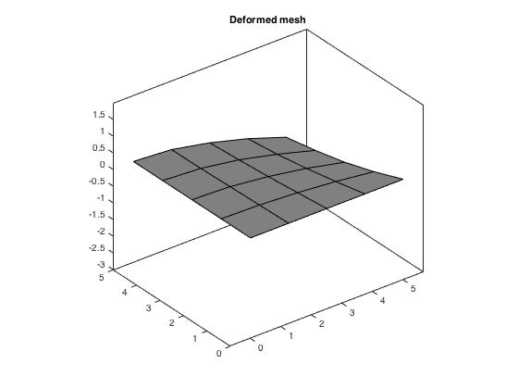Simply Supported Condition | Distributed Load

**Nodal Displacements:**

Node Displacement(x,y,θ; m,m,rad respectively)

1 0 0 0.000309161

2 0 0 0.000272919

3 -0.00020937 -4.743291e-05 0.000295041

4 0 0 0.000311872

5 0 0 0.000299789

6 -0.000129064 -3.054071e-05 0.000283681

7 -6.4832e-05 -3.122721e-05 0.000305419

8 0 0 0.000308619

9 -3.76933e-05 -1.815865e-05 0.000300168

10 0 0 -0.000312299

11 0 0 -0.000330784

12 -7.02046e-05 -1.637568e-05 -0.000338938

13 -0.000173286 -3.254416e-05 -0.000327367

14 -0.000129019 -3.293572e-05 -0.000320281

15 -1.67604e-05 -1.681508e-05 -0.000310093

16 0 0 -0.000308153

17 0 0 -0.00030512

18 -5.31397e-06 -5.318858e-06 0.000302924

19 -1.93085e-05 -8.692654e-06 -0.00031502

20 -4.09084e-05 -1.292912e-05 0.000285751

21 -7.71983e-05 -2.133015e-05 -0.000325604

22 -0.000107388 -3.334850e-05 0.000294904

23 -5.22675e-05 -2.180193e-05 -0.000314256

24 -1.52681e-05 -1.522535e-05 0.000304884

25 -9.74909e-06 -9.770041e-06 -0.000310883

**Moment:**

-0.2249

-0.7498

-0.2973

**Shear:**

-356.7252

-314.9079

The adjusted 64-element cases are as follows:

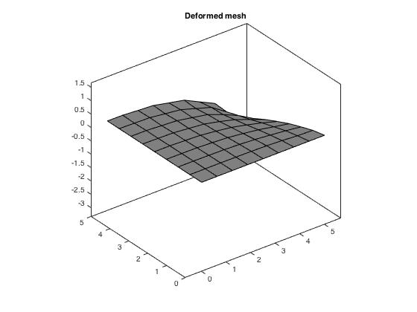Clamped Condition | Concentrated load

**Nodal Displacements:**

Node Displacement(x,y,θ; m,m,rad respectively)

3 -0.00437853 -2.235432e-03 -0.000388991

6 -0.00165451 -4.496880e-04 -0.000201388

7 -0.000531158 -3.980657e-04 -0.000157669

9 -0.000296235 -2.081630e-04 -5.25982e-05

12 -0.000678465 -1.968670e-04 -0.000129623

13 -0.00286592 -8.966442e-04 -0.000255474

14 -0.00158274 -8.640379e-04 -0.000212531

15 -0.000115641 -1.337759e-04 -0.000109584

17 0 0 -3.61589e-06

18 -1.31069e-05 -2.923090e-05 -8.30855e-06

19 -9.32589e-05 -8.204353e-05 -4.24036e-05

20 -0.000331896 -1.473841e-04 -7.62938e-05

21 -0.000842125 -3.604627e-04 -0.000102926

22 -0.00132854 -6.665812e-04 -0.000102401

23 -0.00046956 -3.391517e-04 -9.18731e-05

24 -0.000106898 -1.246622e-04 -6.26952e-05

25 -5.90326e-05 -7.678110e-05 -2.30672e-05

29 0 0 -0.000176768

30 -0.000270647 3.857172e-05 -0.000263059

31 -0.00112118 1.996279e-05 -0.000321571

32 -0.00222124 1.887711e-05 -0.000372592

33 -0.0035262 3.401468e-05 -0.000417139

34 -0.00231615 1.515159e-04 0.000184357

35 -0.000841925 1.049508e-04 0.00017739

36 -0.000207679 5.809869e-05 0.000151615

37 -9.17156e-06 1.006122e-05 7.81864e-05

41 0 0 1.20727e-05

42 -9.285e-08 -4.483664e-06 -1.01657e-05

43 -5.81467e-07 7.931281e-06 7.90327e-06

44 -1.04474e-05 -2.151993e-05 -1.78179e-05

45 -2.16213e-05 1.393222e-05 -1.50191e-05

46 -5.17607e-05 -4.787809e-05 -5.80863e-05

47 -0.000123719 -2.056732e-05 -0.000116977

48 -0.000223866 -8.275590e-05 -5.43602e-05

49 -0.000486347 -6.202206e-07 -0.000223106

50 -0.000846774 -2.861088e-04 -0.000128571

51 -0.00121563 -3.196472e-07 -0.000250372

52 -0.00163525 -5.908222e-04 -0.000161645

53 -0.00199974 1.363158e-05 -0.000218957

54 -0.00238829 -1.152172e-03 -0.000156634

55 -0.00137376 1.173481e-04 4.38261e-05

56 -0.000910619 -5.626918e-04 -0.00014376

57 -0.000447238 8.196130e-05 0.000102815

58 -0.000268687 -2.443170e-04 -0.000113082

59 -7.67001e-05 3.616443e-05 8.60398e-05

60 -3.83758e-05 -5.748452e-05 -5.68629e-05

61 -8.48616e-06 9.924445e-06 3.07231e-05

62 -2.42649e-05 -4.123489e-05 -1.9072e-05

63 -5.03822e-06 9.694022e-06 2.61161e-06

64 -8.08145e-06 -1.993077e-05 -2.51253e-06

65 1.55685e-07 8.489393e-06 -8.91258e-08

66 -3.37085e-05 1.562911e-05 -1.88149e-05

67 -0.000186767 -4.420144e-06 -9.15935e-05

68 -0.000564338 -5.952923e-06 -0.000165115

69 -0.001074 1.398035e-05 -0.000136808

70 -0.000751792 7.320676e-05 -2.36089e-06

71 -0.000196396 5.057424e-05 5.01876e-05

72 -5.69548e-05 2.355290e-05 2.02714e-05

73 -2.24798e-05 1.606288e-05 -8.23066e-06

74 -8.92479e-05 -9.273427e-05 -2.85267e-05

75 -0.000181086 1.057865e-05 -5.42279e-05

76 -0.000354646 -1.941163e-04 -6.72532e-05

77 -0.000505454 1.147633e-05 -9.27618e-05

78 -0.000684845 -3.884402e-04 -7.88444e-05

79 -0.000353318 4.222687e-05 -1.18208e-05

80 -0.0002004 -1.811441e-04 -5.65075e-05

81 -0.000124131 2.395508e-05 -1.33989e-05

**Moment:**

m =

0

0

0

**Shear:**

s =

0

0

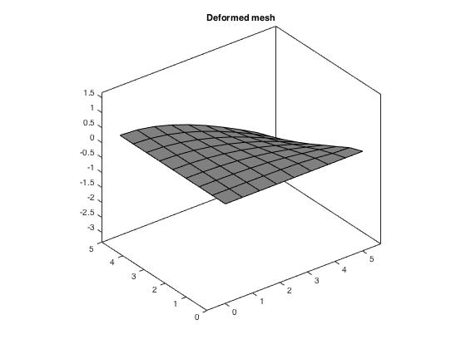Clamped Condition | Distributed Load

**Nodal Displacements:**

Node Displacement(x,y,θ; m,m,rad respectively)

3 -0.000304063-3.145348e-05 -1.21833e-05

6 -0.000164276-2.105199e-05 -1.83106e-05

7 -9.52212e-05-2.179206e-05 -4.43907e-06

9 -4.15838e-05-1.050119e-05 -6.7021e-06

12 -7.56048e-05-1.316666e-05 -1.56969e-05

13 -0.000242441-2.722969e-05 -1.51759e-05

14 -0.000190984-2.764691e-05 -8.80161e-06

15 -2.65916e-05-1.335445e-05 -6.38431e-07

17 0 0 5.57456e-07

18 -2.53674e-06-1.651597e-06 -9.08644e-07

19 -1.29199e-05-4.075237e-06 -5.42694e-06

20 -3.79201e-05-7.672556e-06 -9.04933e-06

21 -9.37946e-05-1.599092e-05 -1.17287e-05

22 -0.000146708-2.255331e-05 -1.03361e-05

23 -7.08407e-05-1.653904e-05 -5.97062e-06

24 -1.96772e-05-9.560967e-06 -2.16886e-06

25 -1.02898e-05-5.275507e-06 -2.25384e-06

29 0 0 -1.90769e-05

30 -2.98011e-058.631662e-08 -2.90245e-05

31 -0.000118914-1.312675e-05 -2.6944e-05

32 -0.000204942-2.159665e-05 -2.22361e-05

33 -0.000274742-2.687021e-05 -1.70645e-05

34 -0.000245536-2.694118e-05 -1.38236e-05

35 -0.000140244-2.309583e-05 -8.84075e-06

36 -5.67853e-05-1.671307e-05 -3.32688e-06

37 -6.68259e-06-6.644788e-06 6.13797e-07

41 0 0 4.93019e-07

42 -1.12386e-07-1.418424e-07 -5.90308e-07

43 -5.06622e-07-2.278814e-07 -3.76747e-08

44 -1.66509e-06-9.762657e-07 -2.14082e-06

45 -3.44246e-06-7.752476e-07 -2.95081e-06

46 -6.32647e-06-2.173594e-06 -6.85851e-06

47 -1.42115e-05-5.697324e-06 -1.35804e-05

48 -2.49506e-05-5.010528e-06 -6.593e-06

49 -5.39393e-05-8.393111e-06 -2.34626e-05

50 -9.11664e-05-1.474602e-05 -1.44052e-05

51 -0.000126413-1.667883e-05 -2.09336e-05

52 -0.000161294-2.218759e-05 -1.4049e-05

53 -0.000192147-2.292935e-05 -1.68804e-05

54 -0.000220379-2.762838e-05 -1.14029e-05

55 -0.000169604-2.311021e-05 -1.25183e-05

56 -0.000124051-2.243933e-05 -7.40404e-06

57 -8.37873e-05-1.795850e-05 -6.95245e-06

58 -5.01084e-05-1.565087e-05 -3.38172e-06

59 -2.38941e-05-1.068959e-05 -2.0379e-06

60 -6.5364e-06-6.579595e-06 -7.68701e-07

61 -5.12877e-06-5.077647e-06 -6.45152e-07

62 -3.83668e-06-3.895964e-06 -6.67511e-07

63 -2.57694e-06-2.521371e-06 -6.00164e-07

64 -1.40482e-06-1.462891e-06 -6.0146e-07

65 -4.90323e-07-4.509853e-07 -8.57924e-07

66 -6.57932e-06-2.323927e-06 -3.86932e-06

67 -2.36725e-05-6.594790e-06 -1.15753e-05

68 -6.4781e-05-1.159200e-05 -1.71983e-05

69 -0.000120955-1.810568e-05 -1.53482e-05

70 -0.000105834-1.833035e-05 -1.0845e-05

71 -4.18672e-05-1.251022e-05 -4.87568e-06

72 -1.50171e-05-7.199496e-06 -2.45893e-06

73 -5.98529e-06-3.050139e-06 -2.00237e-06

74 -1.416e-05-5.219870e-06 -4.25359e-06

75 -2.6856e-05-7.410861e-06 -7.95131e-06

76 -4.3669e-05-9.505942e-06 -9.00129e-06

77 -6.50065e-05-1.281233e-05 -1.24158e-05

78 -8.62046e-05-1.663628e-05 -8.84544e-06

79 -5.65738e-05-1.311566e-05 -8.24315e-06

80 -3.27426e-05-1.064260e-05 -4.29309e-06

81 -2.34136e-05-7.745032e-06 -5.0642e-06

**Moment:**

0

0

0

**Shear:**

0

0

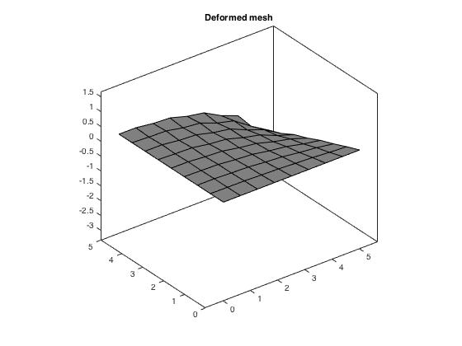Simply Supported Condition | Concentrated Load

**Nodal Displacements:**

Node Displacement(x,y,θ; m,m,rad respectively)

1 0 0 0.000341245

2 0 0 0.000457983

3 -0.00535221-3.150193e-03 0.00101889

4 0 0 0.00177395

5 0 0 0.00051937

6 -0.00239248-9.432349e-04 0.000591188

7 -0.000894773-7.226541e-04 0.00132854

8 0 0 0.000626819

9 -0.000612206-4.283374e-04 0.000670879

10 0 0 0.000489295

11 0 0 0.000493819

12 -0.00117125-4.384683e-04 0.00048988

13 -0.00372233-1.622210e-03 0.00077407

14 -0.00222278-1.420613e-03 0.00123245

15 -0.000256214-2.665854e-04 0.00144557

16 0 0 0.0010365

17 0 0 0.000409269

18 -9.09489e-05-8.648309e-05 0.000533782

19 -0.000323915-2.072937e-04 0.000555614

20 -0.000699035-3.352841e-04 0.000529037

21 -0.00137045-7.125673e-04 0.000646795

22 -0.00193351-1.162140e-03 0.000883936

23 -0.000821061-6.352202e-04 0.00088036

24 -0.000240108-2.514297e-04 0.000917206

25 -0.000173329-1.724282e-04 0.000669804

26 0 0 -0.000445128

27 0 0 -0.000602125

28 0 0 -0.000750492

29 0 0 -0.000928085

30 -0.0005643759.484317e-05 -0.00103254

31 -0.00171512.945603e-04 -0.00111965

32 -0.002932255.145786e-04 -0.00130429

33 -0.004274177.396768e-04 -0.00161079

34 -0.002941447.182805e-04 -0.0012533

35 -0.001218854.064053e-04 -0.00129143

36 -0.0003543161.759155e-04 -0.00135934

37 -1.11269e-059.811772e-06 -0.00154355

38 0 0 -0.00131192

39 0 0 -0.00079056

40 0 0 -0.000488802

41 0 0 -0.000350766

42 -1.37567e-05-1.926240e-05 0.000441419

43 -3.17891e-054.734772e-06 -0.000531521

44 -9.60873e-05-7.146367e-05 0.000516658

45 -0.0001432452.626163e-05 -0.000673335

46 -0.00024942-1.343915e-04 0.000511748

47 -0.0003299755.595595e-05 -0.000834376

48 -0.000463837-1.925217e-04 0.000474641

49 -0.0008890861.506024e-04 -0.000963877

50 -0.00139579-6.053320e-04 0.000543337

51 -0.001776973.164092e-04 -0.00107314

52 -0.00232428-1.108428e-03 0.000699485

53 -0.002613554.966788e-04 -0.00124813

54 -0.00315988-1.834486e-03 0.000987267

55 -0.001869085.276632e-04 -0.00110531

56 -0.00140058-9.859701e-04 0.000996324

57 -0.0007035572.809893e-04 -0.00104688

58 -0.000509717-4.683334e-04 0.00104548

59 -0.000138948.980927e-05 -0.00109667

60 -9.76793e-05-1.190680e-04 0.00116638

61 -1.14201e-051.027677e-05 -0.000974234

62 -6.81911e-05-8.898646e-05 0.000781252

63 -1.53997e-053.184790e-06 -0.000666521

64 -4.10986e-05-5.621603e-05 0.000550762

65 -1.09271e-05-2.627330e-07 -0.000498799

66 -0.000151223.085754e-05 -0.000634127

67 -0.0004514498.355123e-05 -0.000777194

68 -0.0009763481.779752e-04 -0.000892663

69 -0.001554293.258747e-04 -0.00100449

70 -0.001122713.414715e-04 -0.000989041

71 -0.0003461841.535214e-04 -0.000926527

72 -0.0001190825.042689e-05 -0.000785716

73 -8.62096e-052.050824e-05 -0.000613029

74 -0.000277266-2.179994e-04 0.000593247

75 -0.0004093089.116753e-05 -0.000726917

76 -0.000730534-4.177711e-04 0.000584339

77 -0.0008563491.908375e-04 -0.00085787

78 -0.00113965-7.315710e-04 0.000748206

79 -0.0006066491.910741e-04 -0.000838385

80 -0.000425705-3.652619e-04 0.000751368

81 -0.0002717598.165231e-05 -0.000733403

**Moment:**

-0.3775

-1.2582

-0.3281

**Shear:**

-393.7457

-528.4432

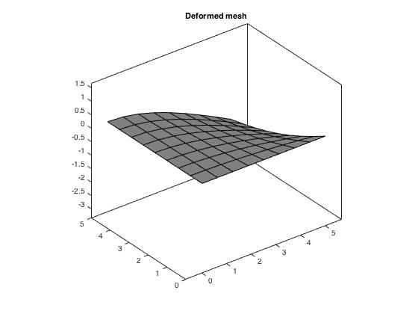Simply Supported Condition | Distributed Load

**Nodal Displacements:**

Node Displacement(x,y,θ; m,m,rad respectively)

1 0 0 9.18412e-05

2 0 0 5.39798e-05

3 -0.000417651-4.109599e-05 7.78724e-05

4 0 0 9.28462e-05

5 0 0 8.12704e-05

6 -0.00026343-2.829449e-05 6.62372e-05

7 -0.000135147-3.027574e-05 8.75105e-05

8 0 0 9.17833e-05

9 -8.01676e-05-1.805977e-05 8.31638e-05

10 0 0 8.90139e-05

11 0 0 6.97949e-05

12 -0.000144837-1.665828e-05 5.87398e-05

13 -0.000352282-3.615717e-05 7.34542e-05

14 -0.000267167-3.690597e-05 8.18729e-05

15 -3.75179e-05-1.887852e-05 9.2422e-05

16 0 0 9.2149e-05

17 0 0 9.16698e-05

18 -1.17807e-05-5.637470e-06 8.89589e-05

19 -4.23209e-05-9.628170e-06 8.16897e-05

20 -8.68122e-05-1.291755e-05 7.12855e-05

21 -0.000162037-2.355000e-05 7.51425e-05

22 -0.00022115-3.126018e-05 7.92316e-05

23 -0.000111415-2.472547e-05 8.50233e-05

24 -3.21342e-05-1.525293e-05 8.96396e-05

25 -2.25709e-05-1.077934e-05 8.92727e-05

26 0 0 -9.2732e-05

27 0 0 -9.84577e-05

28 0 0 -0.000108259

29 0 0 -0.00012165

30 -7.4897e-05-9.035337e-06 -0.00012765

31 -0.000207827-2.199562e-05 -0.000120999

32 -0.000311282-3.074914e-05 -0.000113741

33 -0.000386836-3.593227e-05 -0.000108016

34 -0.000340339-3.622532e-05 -0.000105059

35 -0.000197843-3.237619e-05 -9.99956e-05

36 -8.06212e-05-2.420390e-05 -9.45798e-05

37 -9.27818e-06-9.351959e-06 -9.12348e-05

38 0 0 -9.21967e-05

39 0 0 -9.14946e-05

40 0 0 -9.10312e-05

41 0 0 -9.07607e-05

42 -1.56149e-06-1.561067e-06 9.0084e-05

43 -5.94754e-06-2.827943e-06 -9.38722e-05

44 -1.27218e-05-3.954999e-06 8.46332e-05

45 -2.1457e-05-4.789194e-06 -0.000101611

46 -3.20136e-05-5.778219e-06 7.51081e-05

47 -4.42432e-05-6.460208e-06 -0.000112876

48 -5.82792e-05-7.585771e-06 6.21803e-05

49 -0.00011396-1.421915e-05 -0.000118862

50 -0.000165016-2.081529e-05 6.70985e-05

51 -0.000210374-2.476499e-05 -0.00011328

52 -0.000250176-3.035272e-05 7.31448e-05

53 -0.000284287-3.184419e-05 -0.000107957

54 -0.000314104-3.679311e-05 7.81566e-05

55 -0.000245137-3.221415e-05 -0.000103243

56 -0.000181693-3.126830e-05 8.31917e-05

57 -0.000124183-2.628273e-05 -9.78268e-05

58 -7.50005e-05-2.294229e-05 8.83158e-05

59 -3.58753e-05-1.620277e-05 -9.34227e-05

60 -9.87285e-06-9.807652e-06 9.11887e-05

61 -8.41449e-06-8.461167e-06 -9.26027e-05

62 -7.27294e-06-7.238992e-06 9.07992e-05

63 -5.8837e-06-5.908434e-06 -9.24782e-05

64 -4.54965e-06-4.535475e-06 9.03833e-05

65 -3.06739e-06-3.077633e-06 -9.25068e-05

66 -2.50545e-05-7.628443e-06 -9.78977e-05

67 -6.29233e-05-1.096193e-05 -0.000106977

68 -0.000126294-1.792585e-05 -0.000110079

69 -0.000193452-2.640115e-05 -0.000106239

70 -0.000163017-2.684267e-05 -0.000101836

71 -6.70301e-05-1.962584e-05 -9.62472e-05

72 -2.73482e-05-1.283891e-05 -9.37623e-05

73 -1.72712e-05-8.186911e-06 -9.38088e-05

74 -3.68626e-05-1.141856e-05 8.544e-05

75 -6.19198e-05-1.365675e-05 -0.000100631

76 -9.19704e-05-1.641508e-05 7.72578e-05

77 -0.000118359-2.010839e-05 -0.00010444

78 -0.000142177-2.490095e-05 8.03137e-05

79 -9.65336e-05-2.077376e-05 -9.92311e-05

80 -5.79796e-05-1.780963e-05 8.65278e-05

81 -4.77253e-05-1.436133e-05 -9.70759e-05

**Moment:**

-0.0445

-0.1483

-0.0883

**Shear:**

-105.9709

-62.2846

**Comments:** As it can be seen in most of the graphs above the plates have become smoother since the integration was changed to a 1x1 basis. The values, if analyzed also decrease in size (pay close attention to the values of inner elements, that created “kinks” in the plates), which is the reason why the plates look smoother in the first place.

1. Convergence studies on plate

For the analysis as a whole, it seems that when the number of elements increases, the difference between exact and MATLAB-simulated values also increases. Concentrated load tended to produce more accurate values in MATLAB than distributed, which makes sense considering that we approximated the distributed load with point loads as opposed to in the case of the concentrated loading, where the exact value and point of application was put into the code.

|  |  |  |  |  |  |  |  |
| --- | --- | --- | --- | --- | --- | --- | --- |
|  |  |  | Exact | MATLAB | Ratio | Log NEL | Average Ratio |
| 1 | Clamped | Dist | -0.000000046 | -2.32E-05 | 5.04E+02 | 0 | 3.00E+02 |
| Con | -0.000203667 | -0.000371008 | 1.82E+00 | 0 |  |
| Simple | Dist | -0.000000148 | -0.000101925 | 6.89E+02 | 0 |  |
| Con | -0.000422333 | -0.00163 | 3.86E+00 | 0 |  |
| 4 | Clamped | Dist | -0.000000046 | -4.39E-05 | 9.55E+02 | 0.602059991 | 3.63E+02 |
| Con | -0.000203667 | -0.000658963 | 3.24E+00 | 0.602059991 |  |
| Simple | Dist | -0.000000148 | -7.28E-05 | 4.92E+02 | 0.602059991 |  |
| Con | -0.000422333 | -0.00121781 | 2.88E+00 | 0.602059991 |  |
| 16 | Clamped | Dist | -0.000000046 | -8.59E-05 | 1.87E+03 | 1.204119983 | 6.93E+02 |
| Con | -0.000203667 | -0.00131106 | 6.44E+00 | 1.204119983 |  |
| Simple | Dist | -0.000000148 | -0.000132698 | 8.97E+02 | 1.204119983 |  |
| Con | -0.000422333 | -0.000132698 | 3.14E-01 | 1.204119983 |  |
| 64 | Clamped | Dist | -0.000000046 | -0.000168829 | 3.67E+03 | 1.806179974 | 1.37E+03 |
| Con | -0.000203667 | -0.00255106 | 1.25E+01 |  |  |
| Simple | Dist | -0.000000148 | -0.000264692 | 1.79E+03 |  |  |
| Con | -0.000422333 | -0.003394 | 8.04E+00 |  |  |

The following graphs show the various permutations and each ratio vs. log(nel) in the permutation represented as a point.

1. Code changes

Across the analysis, we created some separate files that where a single one before, such as **shape_quad.m**, which was replaced by **shape_quad_bending.m** and **shape_quad_shear.m** to calculate the bending and shear stiffness element contributions separately and then add them together in **Ke_Plate.m.**

**The following are the snippets of code that were altered to fit the context and requirements of the current analysis (for the case of new functions, the entire code is included, and for the case of preexisting programs, only the snippets that were modified are highlighted in yellow)**

Shape2_quad.m: for shape and derivative calculations (please refer to attached file in accompanying .zip folder)

function [N, Nr, Ns] = shape2_quad(r,s)

%o = [1; 1; 1; 1];2

N = zeros(1,4);

Nr = zeros(1,4);

Ns = zeros(1,4);

N1 = 1/4*(1-r(1))*(1-s(1));

N2 = 1/4*(1+r(2))*(1-s(2));

N3 = 1/4*(1+r(3))*(1+s(3));

N4 = 1/4*(1-r(4))*(1+s(4));

N(1,1) = N1;

N(1,2) = N2;

N(1,3) = N3;

N(1,4) = N4;

Nr(1,1) = 1/4*(-1+s(1));

Nr(1,2) = 1/4*(1-s(2));

Nr(1,3) = 1/4*(1+s(3));

Nr(1,4) = 1/4*(-1-s(4));

Ns(1,1) = 1/4*(-1+r(1));

Ns(1,2) = 1/4*(-1-r(2));

Ns(1,3) = 1/4*(1+r(3));

Ns(1,4) = 1/4*(1-r(4));

Shape_quad_bending.m: to assemble the B matrix for Bending contributions.

function [Bblarge] = shape_quad_bending(r, s, xn, ien, nen)

[N, Nr, Ns] = shape2_quad(r,s);

Bb = zeros(3,3,nen);

for i=1:nen

Bb(1,2,i) = Nr(1,i);

Bb(2,3,i) = Ns(1,i);

Bb(3,2,i) = Ns(1,i);

Bb(3,3,i) = Nr(1,i);

%disp(Bb);

end

Bblarge=horzcat(Bb(:,:,1), Bb(:,:,2), Bb(:,:,3), Bb(:,:,4));

disp(Bblarge);

end

Shape_quad_shear.m: to assemble the B matrix for Shear contributions.

function [Bslarge] = shape_quad_shear(r, s, xn, ien, nen)

x = zeros(1,nen);

y = zeros(1,nen);

for i= 1:nen

x(1,i) = xn(1, ien(i));

y(1,i) = xn(2, ien(i));

end

[N, Nr, Ns] = shape2_quad(r,s);

Bs = zeros(2,2,nen);

for i=1:nen

Bs(1,1,i)=Nr(1,i);

Bs(1,2,i)=-N(1,i);

Bs(2,1,i)=Ns(1,i);

Bs(2,3,i)=-N(1,i);

end

Bslarge=horzcat(Bs(:,:,1), Bs(:,:,2), Bs(:,:,3), Bs(:,:,4));

disp(Bslarge);

end

Jacobian_2d.m: to assemble the Jacobian matrix containing individual Jacobian values for the corner points of each quad.

function [J] = jacobian_2d(r, s, x, y, nen)

J = zeros(2);

J(1,1) = 1/4*((1-s(1))*(x(2)-x(1)) + (1+s(1))*(x(3)-x(4)));

J(1,2) = 1/4*((1-s(2))*(y(2)-y(1)) + (1+s(2))*(y(3)-y(4)));

J(2,1) = 1/4*((1-r(3))*(x(4)-x(1)) + (1+r(3))*(x(3)-x(2)));

J(2,2) = 1/4*((1-r(4))*(y(4)-y(1)) + (1+r(4))*(y(3)-y(2)));

end

Ke_plate.m: to compute the final element stiffness matrix using the contributions and calculated values generated by the functions above.

function [ke]=Ke_plate(r,s,t,v,E,l,xn,ien,nen,ndf,nsd,point,weight,nglx,ngly)

k=5/6;

x = zeros(1,nen);

y = zeros(1,nen);

for i= 1:nen

x(1,i) = xn(1, ien(i));

y(1,i) = xn(2, ien(i));

end

Db=zeros(3,3);

Db=(3.2967e7)*[1 v 0; v 1 0; 0 0 0.5*(1-v)];

Ds=zeros(2,2);

Ds=(1.15385e7)*[1 0; 0 1];

[J] = jacobian_2d(r,s, x, y, nen);

detJ = det(J);

ke = zeros(12,12);

keb = zeros(12,12);

kes = zeros(12,12);

for j=1:l

[Bblarge] = shape_quad_bending(r, s, xn, ien, nen);

[Bslarge] = shape_quad_shear(r, s, xn, ien, nen);

disp(Bblarge);

disp(Bslarge);

kjb=0.6220*Bblarge.'*Db*Bblarge;

kjs=0.6220*Bslarge.'*Ds*Bslarge;

keb = keb+t^3/12*kjb;

kes = kes+t*k*kjs;

end

ke = keb+kes;

disp(keb);

disp(kes);

disp(ke);

end

%%%%%%%%%%%%%%%%%%%%%%%%%%%%%%%%%%%%%%%%%%%%%%%%%%%%%%%%%%%

% final_project.m - 1/12/16 %

% author: Tehila Stone | Theo Dimitrasopoulos %

%%%%%%%%%%%%%%%%%%%%%%%%%%%%%%%%%%%%%%%%%%%%%%%%%%%%%%%%%%%%

clear; % removes all variables from the workspace.

%%%%%%%%%%%%%%%%%%%%%%%%%%%%%%%%%%%%%%%%%%%%%%%%%%%%%%%%%%%%

% DATA %

%%%%%%%%%%%%%%%%%%%%%%%%%%%%%%%%%%%%%%%%%%%%%%%%%%%%%%%%%%%%

%%%%%%%%%%%%

% Material %

%%%%%%%%%%%%

L = 10; % meters

t = 0.1; % meters

E = 30.0e6; % MPa

v = 0.3;

%%%%%%%%%%%%

% Other %

%%%%%%%%%%%%

icase = 0;

%%%%%%%%

% Mesh %

%%%%%%%%

nsd=2; % number of space dimensions

ndf=3; % number of freedom per node

nen=4; % number of element nodes

nel=64; % number of elements. Changes between 1,4,16 and 64

nnp=81; % number of nodal points. Changes between 4,9,25 and 81

nglx = 2;

ngly = 2;

nglz = 0;

%%%%%%%%%%%%%%%%%%%%%

% Nodal coordinates %

%%%%%%%%%%%%%%%%%%%%%

% xn(i,N):= coordinate i for node N

% N=1,...,nnp

% i=1,...,nsd

xn=zeros(nsd,nnp);

% 1 or more elements

xn(1,2) = 5;

xn(1,3) = 5;

xn(2,3) = 5;

xn(2,4) = 5;

% 4 or more elements

xn(1,5) = 2.5;

xn(1,6) = 5;

xn(2,6) = 2.5;

xn(1,7) = 2.5;

xn(2,7) = 5;

xn(2,8) = 2.5;

xn(1,9) = 2.5;

xn(2,9) = 2.5;

% 16 or more elements

xn(1,10)=1.25;

xn(1,11)=3.75;

xn(1,12)=5;

xn(2,12)=1.25;

xn(1,13)=5;

xn(2,13)=3.75;

xn(1,14)=3.75;

xn(2,14)=5;

xn(1,15)=1.25;

xn(2,15)=5;

xn(2,16)=3.75;

xn(2,17)=1.25;

xn(1,18)=1.25;

xn(2,18)=1.25;

xn(1,19)=2.5;

xn(2,19)=1.25;

xn(1,20)=3.75;

xn(2,20)=1.25;

xn(1,21)=3.75;

xn(2,21)=2.5;

xn(1,22)=3.75;

xn(2,22)=3.75;

xn(1,23)=2.5;

xn(2,23)=3.75;

xn(1,24)=1.25;

xn(2,24)=3.75;

xn(1,25)=1.25;

xn(2,25)=2.5;

%64 or more elements

xn(1,26)=0.625;

xn(1,27)=1.875;

xn(1,28)=3.125;

xn(1,29)=4.375;

xn(1,30)=5;

xn(2,30)=0.625;

xn(1,31)=5;

xn(2,31)=1.875;

xn(1,32)=5;

xn(2,32)=3.125;

xn(1,33)=5;

xn(2,33)=4.375;

xn(1,34)=4.375;

xn(2,34)=5;

xn(1,35)=3.125;

xn(2,35)=5;

xn(1,36)=1.875;

xn(2,36)=5;

xn(1,37)=0.625;

xn(2,37)=5;

xn(2,38)=4.375;

xn(2,39)=3.125;

xn(2,40)=1.875;

xn(2,41)=0.625;

xn(1,42)=0.625;

xn(2,42)=0.625;

xn(1,43)=1.25;

xn(2,43)=0.625;

xn(1,44)=1.875;

xn(2,44)=0.625;

xn(1,45)=2.5;

xn(2,45)=0.625;

xn(1,46)=3.125;

xn(2,46)=0.625;

xn(1,47)=3.75;

xn(2,47)=0.625;

xn(1,48)=4.375;

xn(2,48)=0.625;

xn(1,49)=4.375;

xn(2,49)=1.25;

xn(1,50)=4.375;

xn(2,50)=1.875;

xn(1,51)=4.375;

xn(2,51)=2.5;

xn(1,52)=4.375;

xn(2,52)=3.125;

xn(1,53)=4.375;

xn(2,53)=3.75;

xn(1,54)=4.375;

xn(2,54)=4.375;

xn(1,55)=3.75;

xn(2,55)=4.375;

xn(1,56)=3.125;

xn(2,56)=4.375;

xn(1,57)=2.5;

xn(2,57)=4.375;

xn(1,58)=1.875;

xn(2,58)=4.375;

xn(1,59)=1.25;

xn(2,59)=4.375;

xn(1,60)=0.625;

xn(2,60)=4.375;

xn(1,61)=0.625;

xn(2,61)=3.75;

xn(1,62)=0.625;

xn(2,62)=3.125;

xn(1,63)=0.625;

xn(2,63)=2.5;

xn(1,64)=0.625;

xn(2,64)=1.875;

xn(1,65)=0.625;

xn(2,65)=1.25;

xn(1,66)=1.875;

xn(2,66)=1.25;

xn(1,67)=3.125;

xn(2,67)=1.25;

xn(1,68)=3.75;

xn(2,68)=1.875;

xn(1,69)=3.75;

xn(2,69)=3.125;

xn(1,70)=3.125;

xn(2,70)=3.75;

xn(1,71)=1.875;

xn(2,71)=3.75;

xn(1,72)=1.25;

xn(2,72)=3.125;

xn(1,73)=1.25;

xn(2,73)=1.875;

xn(1,74)=1.875;

xn(2,74)=1.875;

xn(1,75)=2.5;

xn(2,75)=1.875;

xn(1,76)=3.125;

xn(2,76)=1.875;

xn(1,77)=3.125;

xn(2,77)=2.5;

xn(1,78)=3.125;

xn(2,78)=3.125;

xn(1,79)=2.5;

xn(2,79)=3.125;

xn(1,80)=1.875;

xn(2,80)=3.125;

xn(1,81)=1.875;

xn(2,81)=2.5;

%%%%%%%%%%%%%%%%

% Connectivity %

%%%%%%%%%%%%%%%%

% ien(a,e)=N

% N: global node number - N=1,...,nnp

% e: element number - e=1,...,nel

% a: local node number - a=1,...,nen

% each set will be activated separately

ien=zeros(nen,nel);

% 1 element

% ien(1,1) = 1;

% ien(2,1) = 2;

% ien(3,1) = 3;

% ien(4,1) = 4;

% 4 elements

% ien(1,1)=1; ien(1,2)=5; ien(1,3)=9; ien(1,4)=8;

% ien(2,1)=5; ien(2,2)=2; ien(2,3)=6; ien(2,4)=9;

% ien(3,1)=9; ien(3,2)=6; ien(3,3)=3; ien(3,4)=7;

% ien(4,1)=8; ien(4,2)=9; ien(4,3)=7; ien(4,4)=4;

% 16 elements

% ien(1,1)=1; ien(1,2)=10; ien(1,3)=5; ien(1,4)=11;

% ien(2,1)=10; ien(2,2)=5; ien(2,3)=11; ien(2,4)=2;

% ien(3,1)=18; ien(3,2)=19; ien(3,3)=20; ien(3,4)=12;

% ien(4,1)=17; ien(4,2)=18; ien(4,3)=19; ien(4,4)=20;

%

% ien(1,5)=20; ien(1,6)=21; ien(1,7)=22; ien(1,8)=23;

% ien(2,5)=12; ien(2,6)=6; ien(2,7)=13; ien(2,8)=22;

% ien(3,5)=6; ien(3,6)=13; ien(3,7)=3; ien(3,8)=14;

% ien(4,5)=21; ien(4,6)=22; ien(4,7)=14; ien(4,8)=7;

%

% ien(1,9)=24; ien(1,10)=16; ien(1,11)=8; ien(1,12)=17;

% ien(2,9)=23; ien(2,10)=24; ien(2,11)=25; ien(2,12)=18;

% ien(3,9)=7; ien(3,10)=15; ien(3,11)=24; ien(3,12)=25;

% ien(4,9)=15; ien(4,10)=4; ien(4,11)=16; ien(4,12)=8;

%

% ien(1,13)=18; ien(1,14)=19; ien(1,15)=9; ien(1,16)=25;

% ien(2,13)=19; ien(2,14)=20; ien(2,15)=21; ien(2,16)=9;

% ien(3,13)=9; ien(3,14)=21; ien(3,15)=22; ien(3,16)=23;

% ien(4,13)=25; ien(4,14)=9; ien(4,15)=23; ien(4,16)=24;

% 64 elements

ien(1,1)=1; ien(1,2)=26; ien(1,3)=10; ien(1,4)=27;

ien(2,1)=26; ien(2,2)=10; ien(2,3)=27; ien(2,4)=5;

ien(3,1)=42; ien(3,2)=43; ien(3,3)=44; ien(3,4)=45;

ien(4,1)=41; ien(4,2)=42; ien(4,3)=43; ien(4,4)=44;

ien(1,5)=5; ien(1,6)=28; ien(1,7)=11; ien(1,8)=29;

ien(2,5)=28; ien(2,6)=11; ien(2,7)=29; ien(2,8)=2;

ien(3,5)=46; ien(3,6)=47; ien(3,7)=48; ien(3,8)=30;

ien(4,5)=45; ien(4,6)=46; ien(4,7)=47; ien(4,8)=48;

ien(1,9)=48; ien(1,10)=49; ien(1,11)=50; ien(1,12)=51;

ien(2,9)=30; ien(2,10)=12; ien(2,11)=31; ien(2,12)=6;

ien(3,9)=12; ien(3,10)=31; ien(3,11)=6; ien(3,12)=32;

ien(4,9)=49; ien(4,10)=50; ien(4,11)=51; ien(4,12)=52;

ien(1,13)=52; ien(1,14)=53; ien(1,15)=54; ien(1,16)=55;

ien(2,13)=32; ien(2,14)=13; ien(2,15)=33; ien(2,16)=54;

ien(3,13)=13; ien(3,14)=33; ien(3,15)=3; ien(3,16)=34;

ien(4,13)=53; ien(4,14)=54; ien(4,15)=34; ien(4,16)=14;

ien(1,17)=56; ien(1,18)=57; ien(1,19)=58; ien(1,20)=59;

ien(2,17)=55; ien(2,18)=56; ien(2,19)=57; ien(2,20)=58;

ien(3,17)=14; ien(3,18)=35; ien(3,19)=7; ien(3,20)=36;

ien(4,17)=35; ien(4,18)=7; ien(4,19)=36; ien(4,20)=15;

ien(1,21)=60; ien(1,22)=38; ien(1,23)=16; ien(1,24)=39;

ien(2,21)=59; ien(2,22)=60; ien(2,23)=61; ien(2,24)=62;

ien(3,21)=15; ien(3,22)=37; ien(3,23)=60; ien(3,24)=61;

ien(4,21)=37; ien(4,22)=4; ien(4,23)=38; ien(4,24)=16;

ien(1,25)=8; ien(1,26)=40; ien(1,27)=17; ien(1,28)=41;

ien(2,25)=63; ien(2,26)=64; ien(2,27)=65; ien(2,28)=42;

ien(3,25)=62; ien(3,26)=63; ien(3,27)=64; ien(3,28)=65;

ien(4,25)=39; ien(4,26)=8; ien(4,27)=40; ien(4,28)=17;

ien(1,29)=42; ien(1,30)=43; ien(1,31)=44; ien(1,32)=45;

ien(2,29)=43; ien(2,30)=44; ien(2,31)=45; ien(2,32)=46;

ien(3,29)=18; ien(3,30)=66; ien(3,31)=19; ien(3,32)=67;

ien(4,29)=65; ien(4,30)=18; ien(4,31)=66; ien(4,32)=19;

ien(1,33)=46; ien(1,34)=47; ien(1,35)=20; ien(1,36)=68;

ien(2,33)=47; ien(2,34)=48; ien(2,35)=49; ien(2,36)=50;

ien(3,33)=20; ien(3,34)=49; ien(3,35)=50; ien(3,36)=51;

ien(4,33)=67; ien(4,34)=20; ien(4,35)=68; ien(4,36)=21;

ien(1,37)=21; ien(1,38)=69; ien(1,39)=22; ien(1,40)=70;

ien(2,37)=51; ien(2,38)=52; ien(2,39)=53; ien(2,40)=22;

ien(3,37)=52; ien(3,38)=53; ien(3,39)=54; ien(3,40)=55;

ien(4,37)=69; ien(4,38)=22; ien(4,39)=55; ien(4,40)=56;

ien(1,41)=23; ien(1,42)=71; ien(1,43)=24; ien(1,44)=61;

ien(2,41)=70; ien(2,42)=23; ien(2,43)=71; ien(2,44)=24;

ien(3,41)=56; ien(3,42)=57; ien(3,43)=58; ien(3,44)=59;

ien(4,41)=57; ien(4,42)=58; ien(4,43)=59; ien(4,44)=60;

ien(1,45)=62; ien(1,46)=63; ien(1,47)=64; ien(1,48)=65;

ien(2,45)=72; ien(2,46)=25; ien(2,47)=73; ien(2,48)=18;

ien(3,45)=24; ien(3,46)=72; ien(3,47)=25; ien(3,48)=73;

ien(4,45)=61; ien(4,46)=62; ien(4,47)=63; ien(4,48)=64;

ien(1,49)=18; ien(1,50)=66; ien(1,51)=19; ien(1,52)=67;

ien(2,49)=66; ien(2,50)=19; ien(2,51)=67; ien(2,52)=20;

ien(3,49)=74; ien(3,50)=75; ien(3,51)=76; ien(3,52)=68;

ien(4,49)=73; ien(4,50)=74; ien(4,51)=75; ien(4,52)=76;

ien(1,53)=76; ien(1,54)=77; ien(1,55)=78; ien(1,56)=79;

ien(2,53)=68; ien(2,54)=21; ien(2,55)=69; ien(2,56)=78;

ien(3,53)=21; ien(3,54)=69; ien(3,55)=22; ien(3,56)=70;

ien(4,53)=77; ien(4,54)=78; ien(4,55)=70; ien(4,56)=23;

ien(1,57)=80; ien(1,58)=72; ien(1,59)=25; ien(1,60)=73;

ien(2,57)=79; ien(2,58)=80; ien(2,59)=81; ien(2,60)=74;

ien(3,57)=23; ien(3,58)=71; ien(3,59)=80; ien(3,60)=81;

ien(4,57)=71; ien(4,58)=24; ien(4,59)=72; ien(4,60)=25;

ien(1,61)=74; ien(1,62)=75; ien(1,63)=9; ien(1,64)=81;

ien(2,61)=75; ien(2,62)=76; ien(2,63)=77; ien(2,64)=9;

ien(3,61)=9; ien(3,62)=77; ien(3,63)=78; ien(3,64)=79;

ien(4,61)=81; ien(4,62)=9; ien(4,63)=79; ien(4,64)=80;

%%%%%%%%%%%%%%%%%%%%%%%

% Boundary conditions %

%%%%%%%%%%%%%%%%%%%%%%%

% prescribed displacement (essential boundary condition)

%

% idb(i,N)=1 if the degree of freedom i of the node N is prescribed

% =0 otherwise

%

% 1) initialize idb to 0

idb=zeros(ndf,nnp);

% 2) enter the flag for prescribed displacement boundary conditions

% 1 or more elements

idb(1,1) = 1; idb(2,1) = 1; idb(3,1) = 1;

idb(1,2) = 1; idb(2,2) = 1; idb(3,2) = 1;

idb(1,4) = 1; idb(2,4) = 1; idb(3,4) = 1;

% 4 or more elements

idb(1,5) = 1; idb(2,5) = 1; idb(3,5) = 1;

idb(1,8) = 1; idb(2,8) = 1; idb(3,8) = 1;

% 16 or more elements

idb(1,10) = 1; idb(2,10) = 1; idb(3,10) = 1;

idb(1,11) = 1; idb(2,11) = 1; idb(3,11) = 1;

idb(1,16) = 1; idb(2,16) = 1; idb(3,16) = 1;

idb(1,17) = 1; idb(2,17) = 1; idb(4,17) = 1;

% 64 or more elements

idb(1,38) = 1; idb(2,38) = 1; idb(3,38) = 1;

idb(1,39) = 1; idb(2,39) = 1; idb(3,39) = 1;

idb(1,40) = 1; idb(2,40) = 1; idb(3,40) = 1;

idb(1,41) = 1; idb(2,41) = 1; idb(4,41) = 1;

idb(1,26) = 1; idb(2,26) = 1; idb(3,26) = 1;

idb(1,27) = 1; idb(2,27) = 1; idb(3,27) = 1;

idb(1,28) = 1; idb(2,28) = 1; idb(3,28) = 1;

idb(1,29) = 1; idb(2,29) = 1; idb(4,29) = 1;

%%%%%%%%%%%%%%%%%%%%%%%%%%%%%%%%%%%%%%%%%%%%%%%%%%%%%

% prescribed nodal displacement boundary conditions %

%%%%%%%%%%%%%%%%%%%%%%%%%%%%%%%%%%%%%%%%%%%%%%%%%%%%%

% g(i,N): prescribed displacement for the dof i of node N

% initialize g

g=zeros(ndf,nnp);

% enter the values

%%%%%%%%%%%%%%%%%%%%%%%%%%%

% prescribed nodal forces %

%%%%%%%%%%%%%%%%%%%%%%%%%%%

% f(i,N): prescribed force for the dof i of node N

% initialize f

f=zeros(ndf,nnp);

% enter the values

%only one condition should be active at a time.

% concentrated load - for all meshes

%f(2,3)=-1; %kN

% distributed load - 1 element

% for i = 1:4

% f(2,i)=-0.0625;

% end

% distributed load - 4 elements

% for i = 1:9

% f(2,i)=-0.02778;

% end

% distributed load - 16 elements

% for i = 1:25

% f(2,i) = -0.01;

% end

% distributed load - 64 elements

for i = 1:81

f(2,i) = -0.003086;

end

%---------------------------------------------------------------

%%%%%%%%%%%%%%%%%%%%%%%%%%%%%%%%%%%%%%%%%%%%

% number the equations; build the id table %

%%%%%%%%%%%%%%%%%%%%%%%%%%%%%%%%%%%%%%%%%%%%

[id,neq]=number_eq(idb,nnp,ndf)

%%%%%%%%%%%%%%%%%%%%%%%%%%%%%%%%%%%%%%%%%%%%

% Gaussian Integration Parameters %

%%%%%%%%%%%%%%%%%%%%%%%%%%%%%%%%%%%%%%%%%%%%

[point,weight]=gauss(nglx,ngly,nglz,nsd)

r = zeros(4,1);

s = zeros(4,1);

r(1) = point(1,1);

r(2) = point(2,1);

r(3) = point(2,2);

r(4) = point(1,2);

s(1) = point(1,1);

s(2) = point(1,2);

s(3) = point(2,1);

s(4) = point(2,2);

**%the following content was only altered in terms of the names of the stiffness element matrix (ke instead of Ke for example)**

for e=1:nel

[ke(:,:,e)] = Ke_plate(r,s,t,v,E,l,xn,ien(:,e),nen,ndf,nsd,point,weight,nglx,ngly);

end;

disp(ke);

% Contribution of the prescribed displacements to the elemental force vector

%f=f-Ke*Ue;

(this section was omitted as no changes were made in the code.)

%%%%%%%%%%%%%%%%%%%%%%%%%%%%%%%%%%%%%%%%%%%%%%%%%%%%%%%%%%%%%%%%%%%%%

% Assembly operation %

%%%%%%%%%%%%%%%%%%%%%%%%%%%%%%%%%%%%%%%%%%%%%%%%%%%%%%%%%%%%%%%%%%%%%

(this section was omitted as no changes were made in the code.)

%%%%%%%%%%%%%%%%%%%%

% Post-processing %

%%%%%%%%%%%%%%%%%%%%

(this section was omitted as no changes were made in the code.)

%%%%%%%%%%%%%%%%%%%%

% Moment and Shear %

%%%%%%%%%%%%%%%%%%%%

[m] = zeros(3,1);

[s] = zeros(2,1);

kappa = zeros(3,1);

gamma = zeros(2,1);

Db=zeros(3,3);

Db=(3.2967e7)*[1 v 0; v 1 0; 0 0 0.5*(1-v)];

Ds=zeros(2,2);

Ds=(1.15385e7)*[1 0; 0 1];

% Calculate curvature kappa. Extracting directly from the displacement matrix

[kappa] = [Ucomp(2);

Ucomp(6);

Ucomp(3) + Ucomp(5)];

% Calculate shear gamma. Extracting directly from the displacement matrix

[gamma] = [-sqrt(Ucomp(2)^2+Ucomp(3)^2) + Ucomp(1);

-sqrt(Ucomp(5)^2+Ucomp(6)^2) + Ucomp(4)];

% Calculate moment vector

[m] = (-t^3/12)*Db*kappa;

disp('Moment');

[m]

% Calculate shear vector

[s] = t*Ds*gamma;

disp('Shear');

[s]

%%%%%%%%%%%%%%%%%%%%

% plot the results %

%%%%%%%%%%%%%%%%%%%%

plot_results_shell(icase,xn,Ucomp,ien,nel,nen,nsd,ndf,nnp);

1. Appendix

This is the system that we used to number our plate section:

