Theodore Kim

CS-GY 6843

Lab 1 – Getting Started with Wireshark

1. TCP, UDP, HTTP
2. 0.011369 seconds
3. (My computer) 192.168.0.100, (www.net.cs.umass.edu) 128.119.245.12

**GET Request**

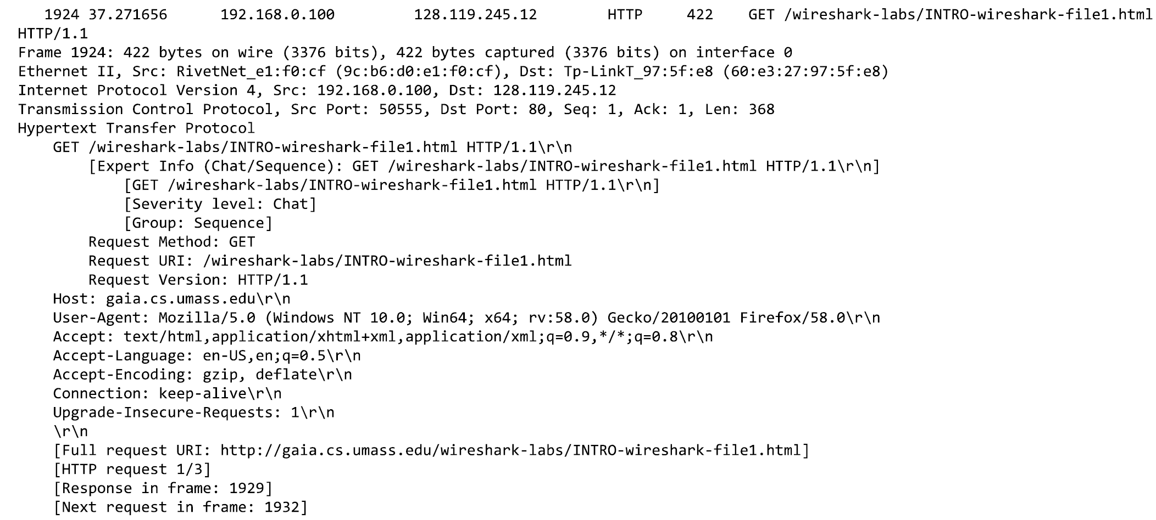

**OK Response**

