Theodore Kim

CS-GY 6843

Lab 5 – IP

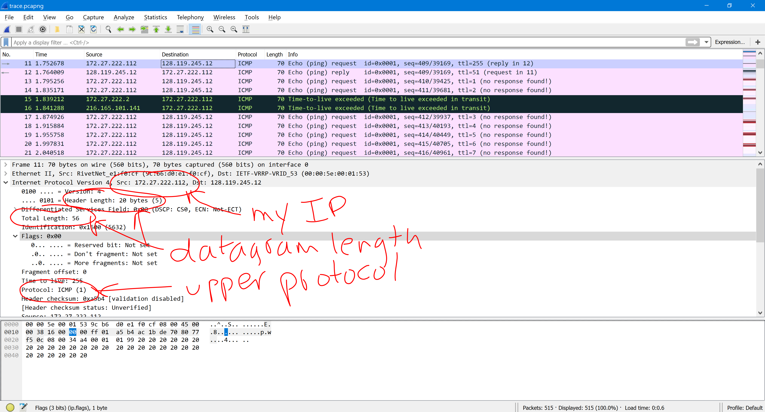

1. The IP address of my computer is 172.27.222.112
2. The value in the upper layer protocol field of the IP packet header is ICMP (the corresponding hex value is 0x01)
3. The IP header is 20 bytes long and the payload is 36 bytes long. The number of payload bytes can be found by subtracting the header length from the total datagram length, which is indicated in the total length field of the IP header.
4. The datagram is not fragmented as the fragment bit is equal to 0.
5. The identification header field, the time to live and the checksum fields always change between each sent datagram
6. The version byte **must** staythe same as the entire exchange is occurring in IPv4. Furthermore, the header lengths **must** stay the same as all ICMP packets are the same length and all of the IP packets are the same length. The source and destination IP addresses **must** stay constant because all of the datagrams observed are being sent from my computer to the server. The upper layer protocol also **must** stay the same as they are all ICMP packets. Finally, the differentiated services header **must** stay the same as all the datagrams are of the same type.

On the other hand, the identification byte and checksum are both unique to each datagram, the former because all datagrams must have a unique ID, and the latter because b any change in the header results in a different checksum. The time to live also changes because the traceroute increments each subsequent packet.

1. The identification byte increments by 1 with every ping request
2. The identification field value is 0xf87a (63610) while the value in the TTL field is 255 (0xFF)
3. The identification field changes with each datagram as every IP datagram has a unique header (unless it’s a fragment). The TTL remains the same as the TTL for the first hop router is the same for each datagram.

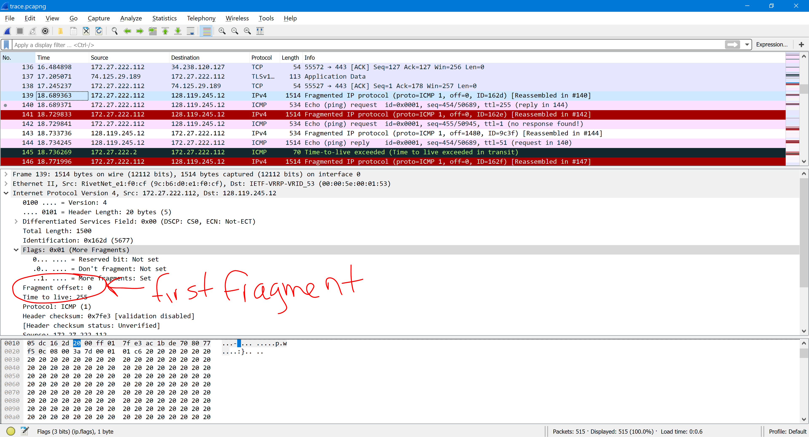

**FIRST FRAGMENT**

1. Yes, this datagram has been fragmented
2. We know that the packet was fragmented because the flag bit for “more fragments” is set (therefore the value of the flag is 0b001 or 0x04). It is known that this data fragment is the first fragment because the fragment offset is 0. The length of the fragment 1500 bytes.

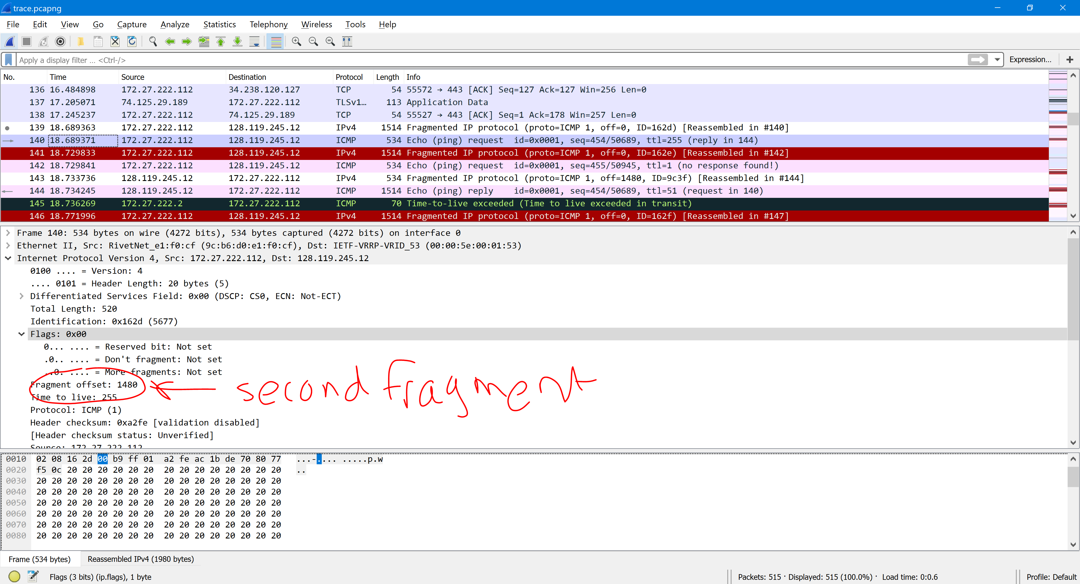

**SECOND FRAGMENT**

1. We know that the second datagram is not the first fragmented datagram as the fragment offset is greater than 0 (it’s 1480).
2. Total length, flag, fragment offset and checksum changed between the fragments.

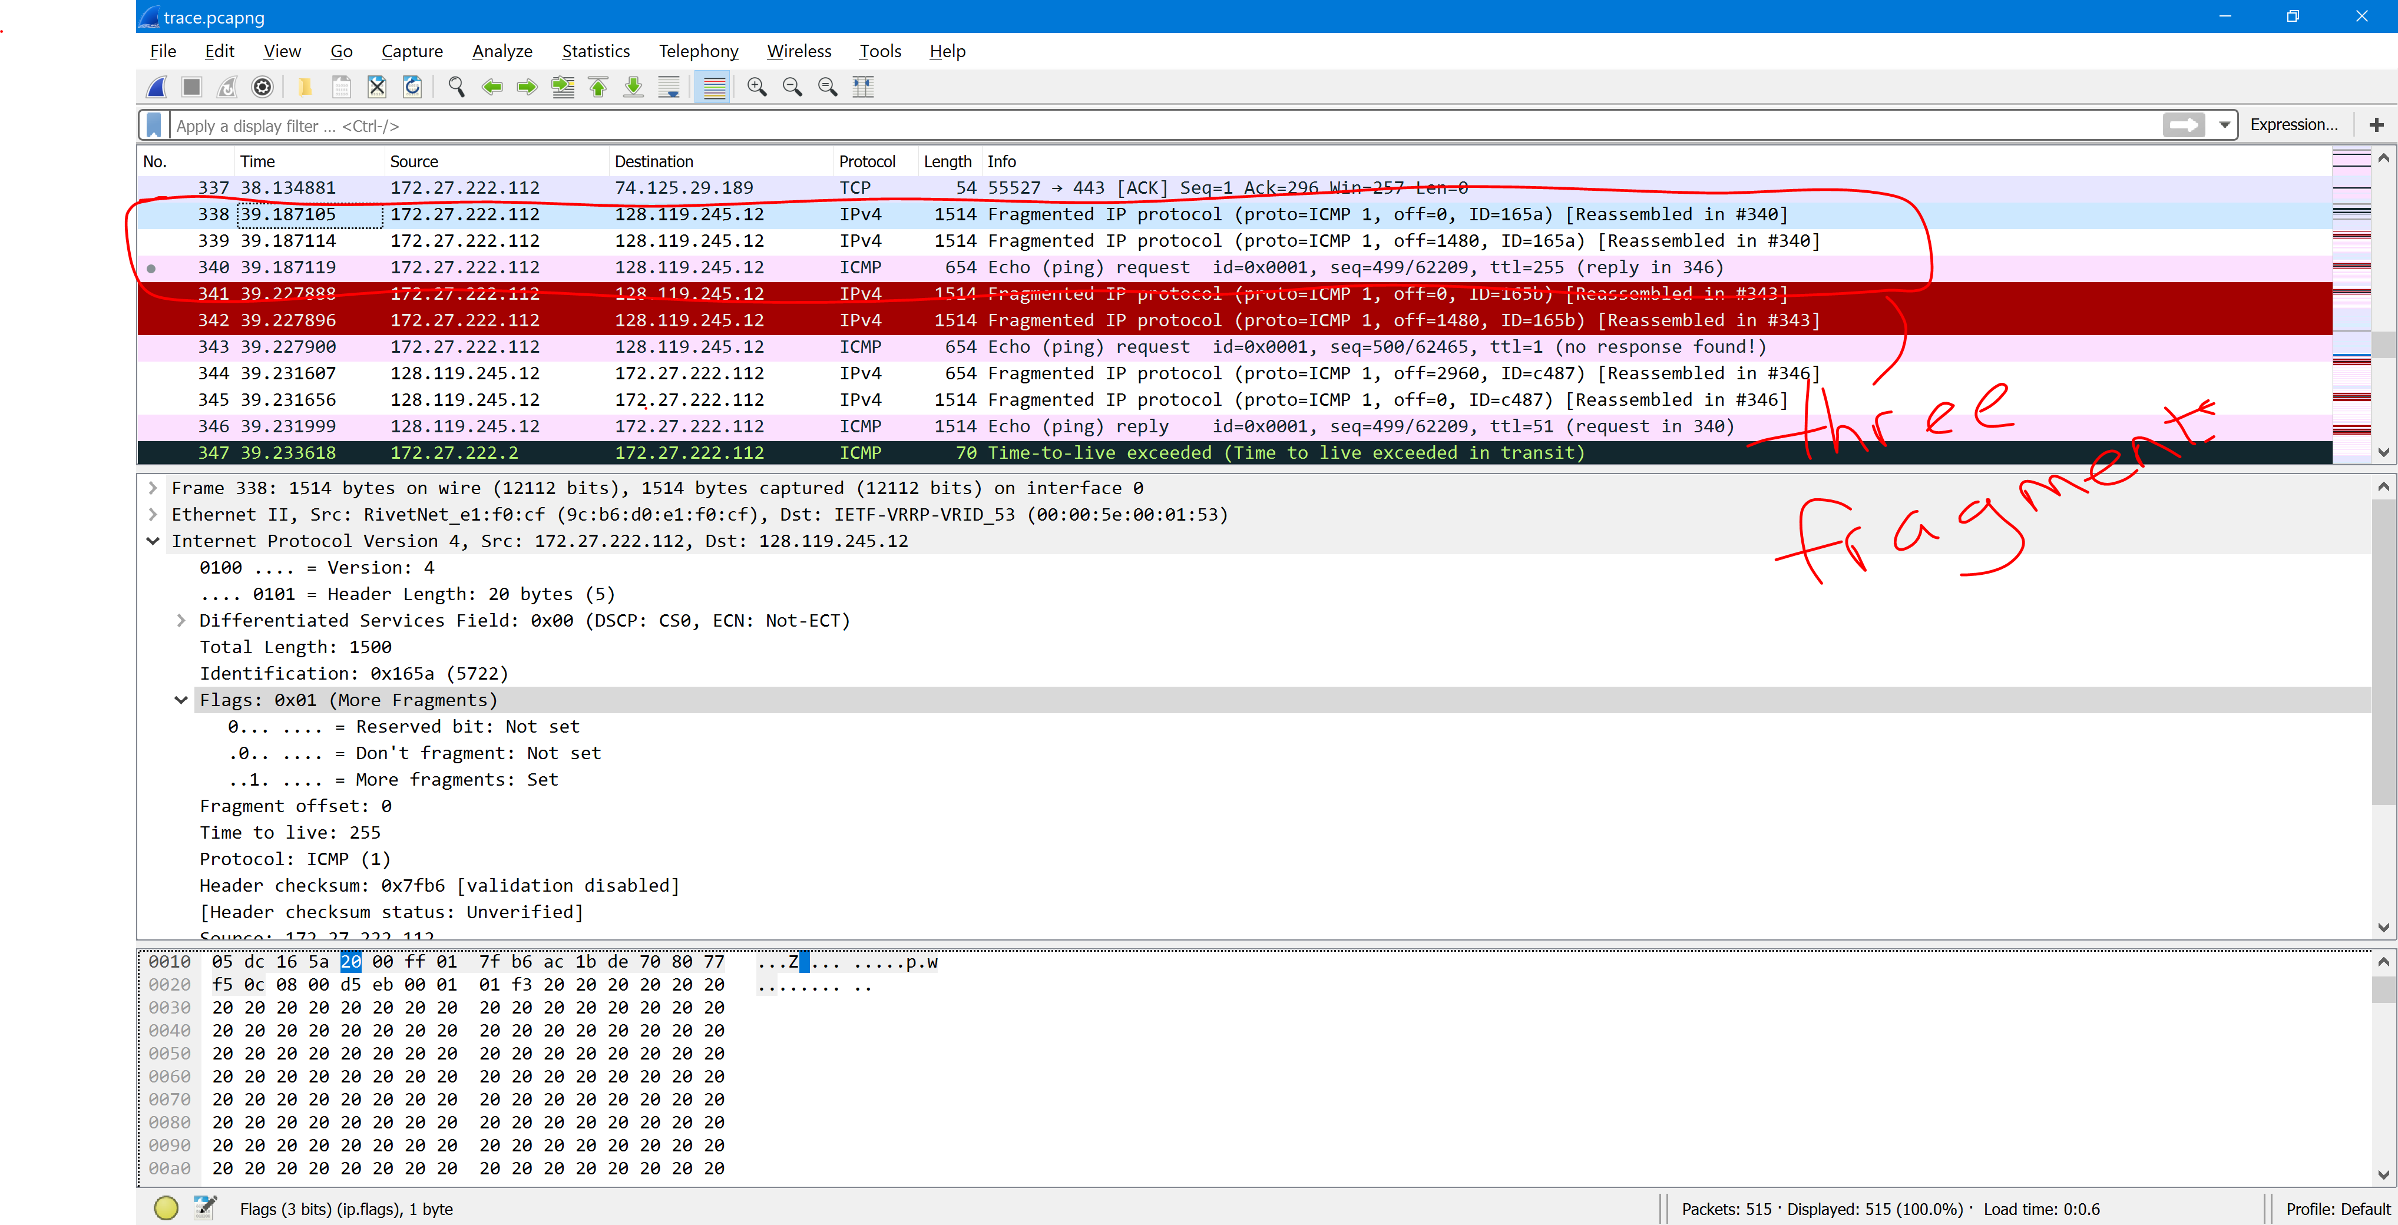

1. Three fragments were created from the original datagram.
2. The changes between the IP datagram fragments are: fragment offset and checksum. The first two fragments have the same flag value and data length, while the last packet has a different flag value (indicating that it’s the last fragment in the sequence) and a different total length.