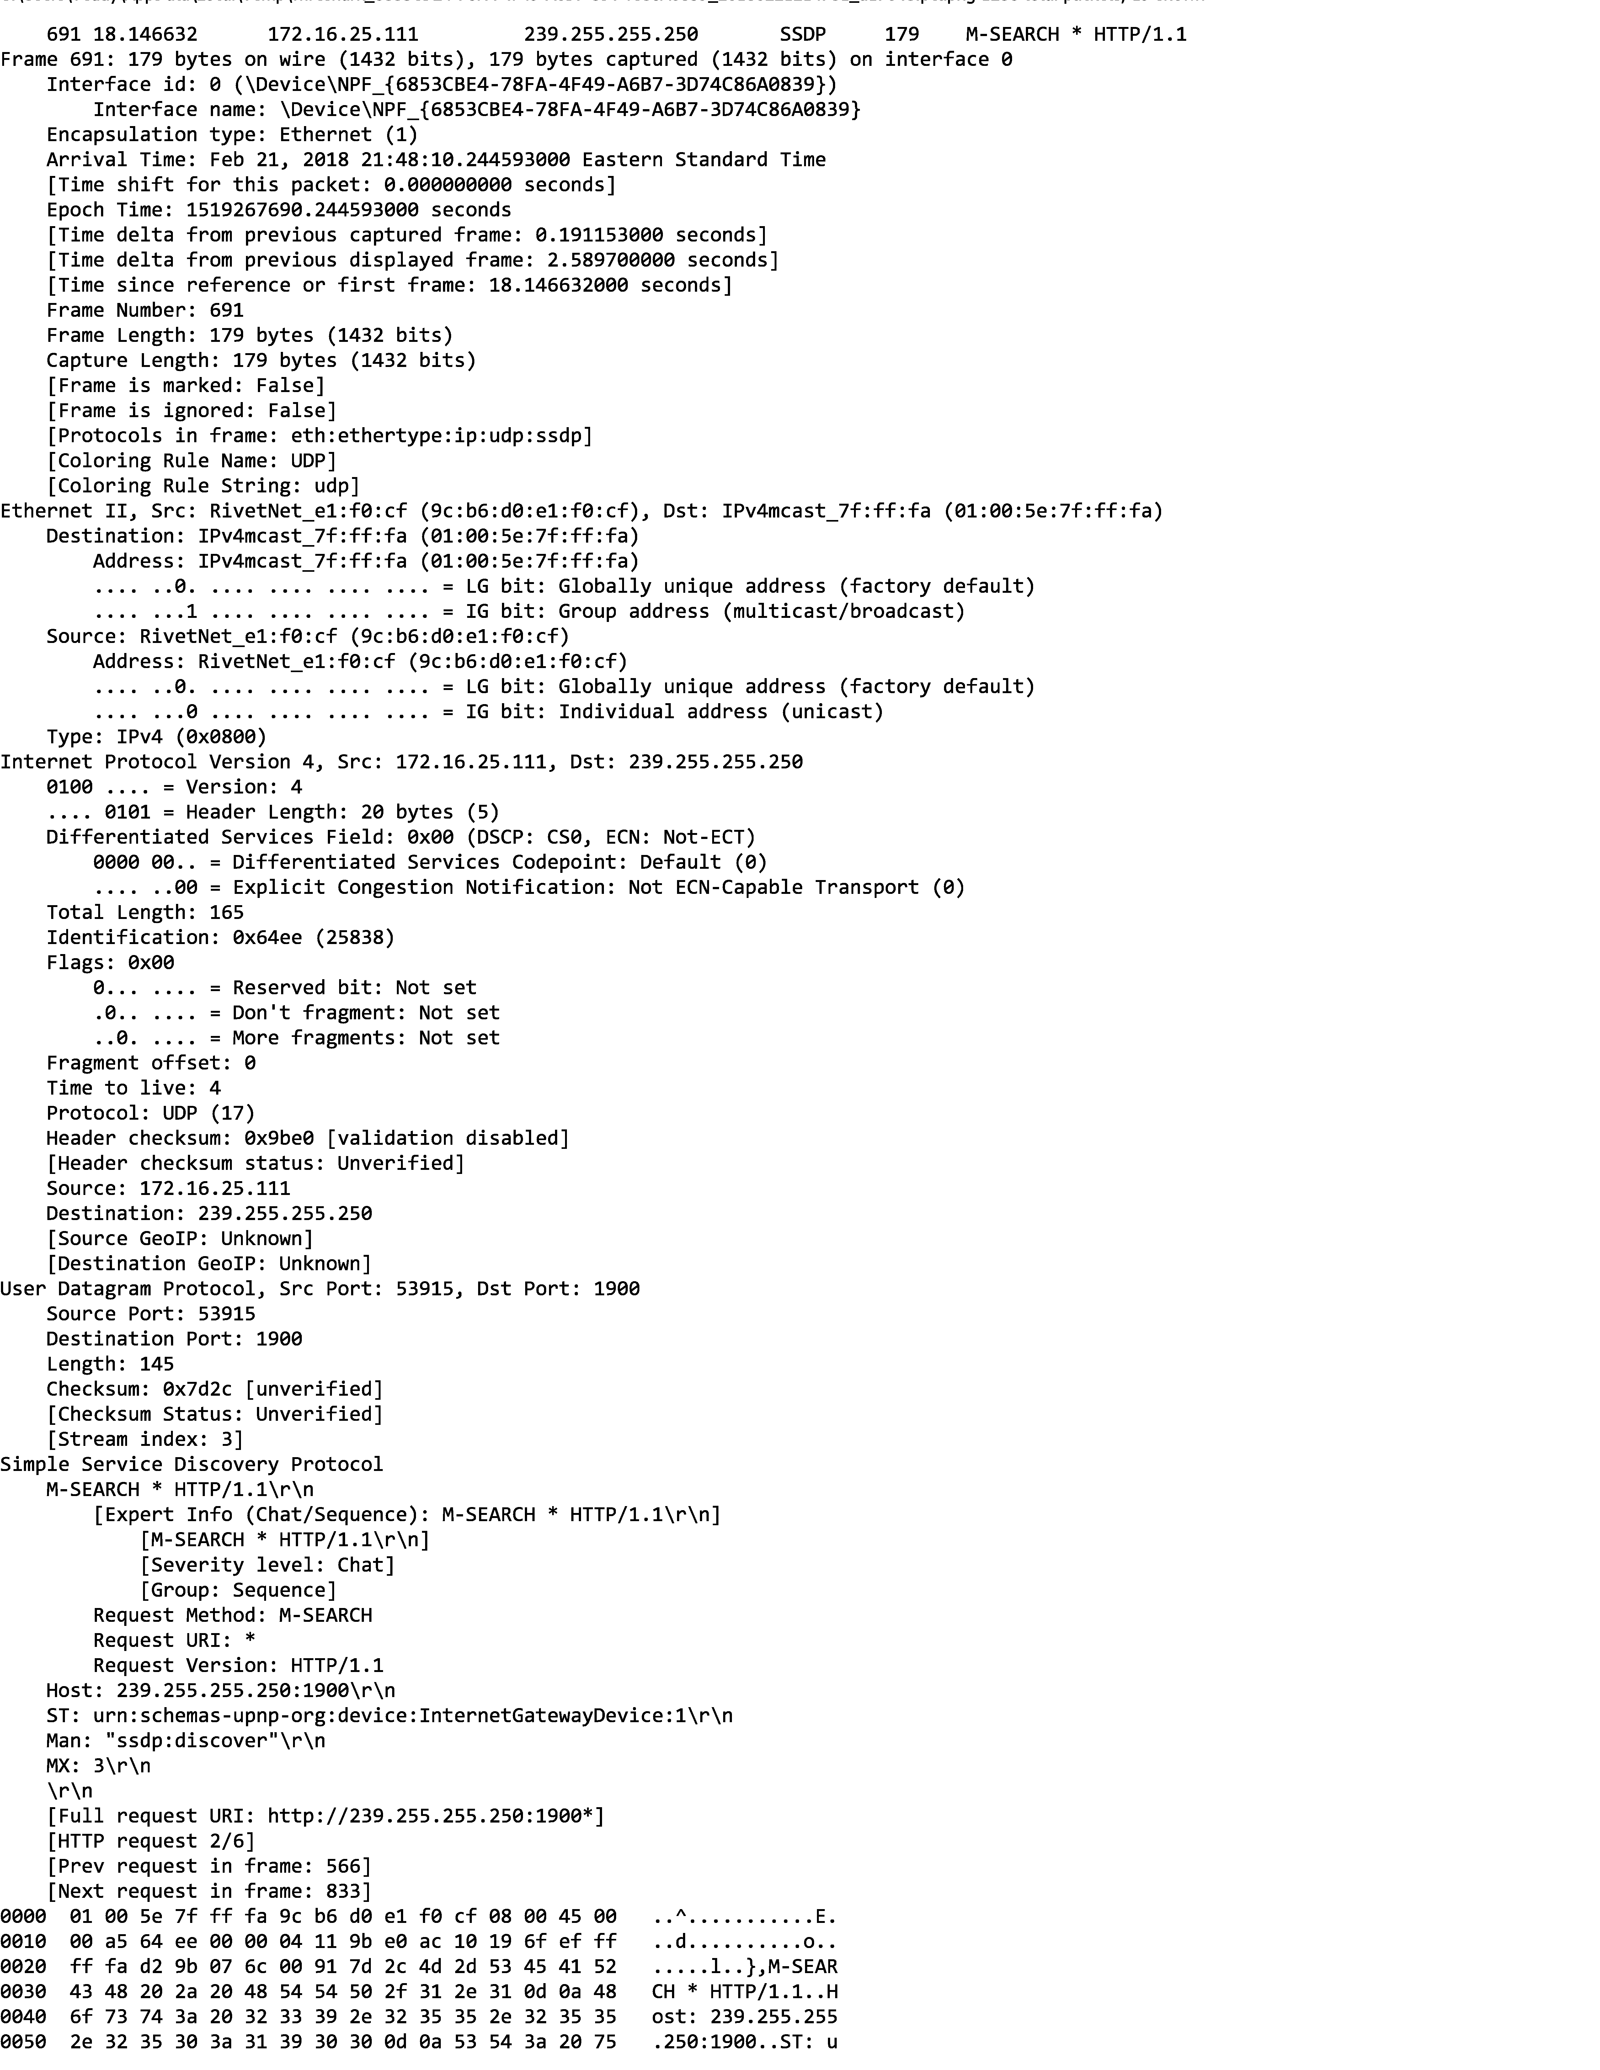

UDP Protocol Number 17 (0x11)

# Four UDP header fields

four 2 byte UDP header fields in the byte representation of the request

|  |  |  |  |
| --- | --- | --- | --- |
|  |  |  |  |

**0060 72 6e 3a 73 63 68 65 6d 61 73 2d 75 70 6e 70 2d rn:schemas-upnp­**

**0070 6f 72 67 3a 64 65 76 69 63 65 3a 49 6e 74 65 72 org:device:Inter**

Payload length of 137 bytes, total length = 137 + 8

**0080 6e 65 74 47 61 74 65 77 61 79 44 65 76 69 63 65 netGatewayDevice**

**0090 3a 31 0d 0a 4d 61 6e 3a 20 22 73 73 64 70 3a 64 :1..Man: "ssdp:d**

**00a0 69 73 63 6f 76 65 72 22 0d 0a 4d 58 3a 20 33 0d iscover"•.MX: 3.**

**00b0 0a 0d 0a**