Theodore Kim

URB 3874 – Sustainable Transportation in Cities

City of the Day Paper Work Plan

Sustainable Street Design and Standards in the City of Toronto, Ontario, Canada

Well planned streets is an critical component in the development of sustainable urban transportation systems, especially those cities whose primary modes of transportation are road dependent (automobiles, buses, streetcars, and taxi). In addition to road-based transportation systems, street design has an impact on promoting or discouraging pedestrian and bicycle transportation systems. The effects of innovative street design on the safety and effectiveness of various pedestrian, bicycle, and road-dependent transportation modes will be discussed in context of the city of Toronto in this paper.

Located on northwest corner of Lake Ontario, the city of Toronto is the largest city in Canada with a population of over 5,000,000[1]. First established as the city of York in 1793, Toronto served as the capital of the district of Upper Canada (most of which is now present day Ontario). Since its establishment, the city of Toronto has had five stages of development, each having contributed its own distinction to the development of the city and its streets: colonial settlement (c. 1793 – 1851), industrial expansion (c. 1851 – 1901), modernization (c. 1901 – 1946), and contemporary development (c. 1946 – present). Figure 1 has two different maps that demonstrate the historical development of Toronto in the colonial and modernization eras.

Possibly the most important effects of poor street design on road-based transportation modes are gridlock and road safety. Generally, increased street connectivity as well as a greater number of travel lanes are correlated with a high crash rate.[2] Next, these principles will be applied to the current conditions of Toronto’s streets. The approximately 85% of Toronto households who own at least one private vehicle[3] share its streets with the largest publicly operated streetcar network in North America[4], a publicly operated bus network, and a small private taxi industry. How Toronto has laid out and manages its 5,200 km (3231 miles) of streets to minimize congestion is the first topic that will be covered by the paper. To do so, the city’s strict and progressive street design standards will be studied, such as their “outside in” design approach which prioritizes road peripherals (biking lanes, sidewalks, dedicated parking lanes) over travel lanes.[5] In addition, the paper will study the city’s use of a diverse public forum to improve its roads as a means of building better neighborhoods.[6]

In addition to motor vehicle safety and congestion relief, street design can be used to promote greater pedestrian and bicycle travel. Higher than average street connectivity and density among a gridiron pattern is associated with a higher preference for pedestrian transportation.[7] Similarly, dedicated bike lanes along those streets are associated with higher biking. Successful innovations in street design has enable Toronto to develop a 54% cyclist rate and prolific pedestrian traffic. Toronto’s “Walking Strategy,” implemented in 2009, is a long-term plan to encourage pedestrianism in the city through the development of transportation infrastructure to make walking safer and more convenient.[8] Toronto has a rich history of urban biking, achieving a 48% cyclist rate by 1970. Since 2001, Toronto’s “Shifting Gears” plan has expanded the city’s street bike lanes by 579 kilometers and increased both cycling rate and safety in the city.[9]

New York City is constantly plagued by gridlock and, especially in the outer boroughs, pedestrian and cyclist traffic is often discouraged by the news of frequent collisions and accidents. The final component of the paper will try to apply the principles and innovations of Toronto to New York City, specifically the reduction of street width, addition of tree coverage and more dedicated bus and bike lanes to accommodate the multiple modes of street based transportation.

**Appendix**

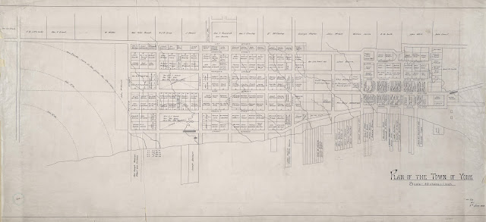

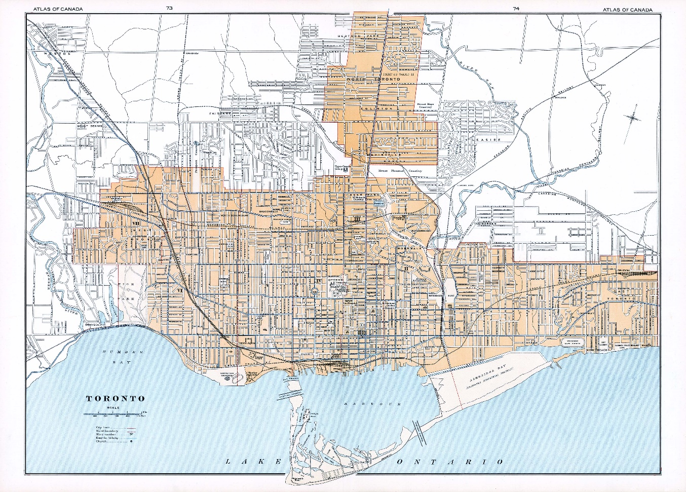

**Figure 1:** Two maps of Toronto’s street, the top is a gridiron plan of the original city of York (later renamed to Toronto), The above is a modern street map of the greater Toronto metropolitan area showing the predominantly offset parallel street design of the downtown area and more privatized street design of its inner suburbs. (Source: Nathan Ng, *Historical Maps of Toronto*, November, 2017 accessed February 9, 2018, http://oldtorontomaps.blogspot.com/2013/02/welcome-to-historical-maps-of-toronto.html)

1. “Census Profile,”Statistics Canada, May 31, 2016, http://www12.statcan.gc.ca/census-recensement/2011/dp-pd/prof/details/page.cfm?Lang=E&Geo1=CSD&Code1=3520005&Geo2=PR&Code2=01&Data=Count&SearchText=Toronto&SearchType=Begins&SearchPR=01&B1=All&Custom=&TABID=1
2. Wesley Earl Marshall and Norman W. Garrick, “Does street network design affect traffic safety?,” *Accident Analysis and Prevention* 43 (2011): 769 - 781
3. Matthew J. Roorda, *Toronto Area Car Ownership Study: A Longitudinal Survey and a Preliminary Analysis of Results*, Master's thesis, University of Toronto, 1998 (Ottawa: National Library of Canada, ON), 66.
4. Matthew Dickens, “Public Transportation Ridership Report: Fourth Quarter 2016”, American Public Transportation Association, March 3, 2017, http://www.apta.com/resources/statistics/Documents/Ridership/2016-q4-ridership-APTA.pdf
5. *Complete Street Guidelines,* City of Toronto, November 5 2017, https://www.toronto.ca/services-payments/streets-parking-transportation/enhancing-our-streets-and-public-realm/complete-streets/complete-streets-guidelines/
6. Luke Simcoe, *How Toronto’s urban planning department embraced diversity*, Toronto Metro, December 22, 2016, http://www.metronews.ca/news/toronto/2016/12/22/how-toronto-urban-planning-department-embraced-diversity.html
7. Wesley E. Marshall and Norman W. Garrick, “Effect of Street Network Design on Walking and Biking,” *Transporation Research Record: Journal of the Transportation Research Board* 2198 (2010): 103 - 115
8. *Toronto Walking Strategy – Sustainable Urban Transportation Award*, Transportation Association of Canada, 2013, http://conf.tac-atc.ca/english/annualconference/tac2013/session4/toronto.pdf
9. Nikhil Sharma, “A History of Bike Lanes in Toronto,” *Torontoist* (Toronto, ON), October 20, 2016, https://torontoist.com/2016/10/a-history-of-bike-lanes-in-toronto/