**PROBLEM 1.1**

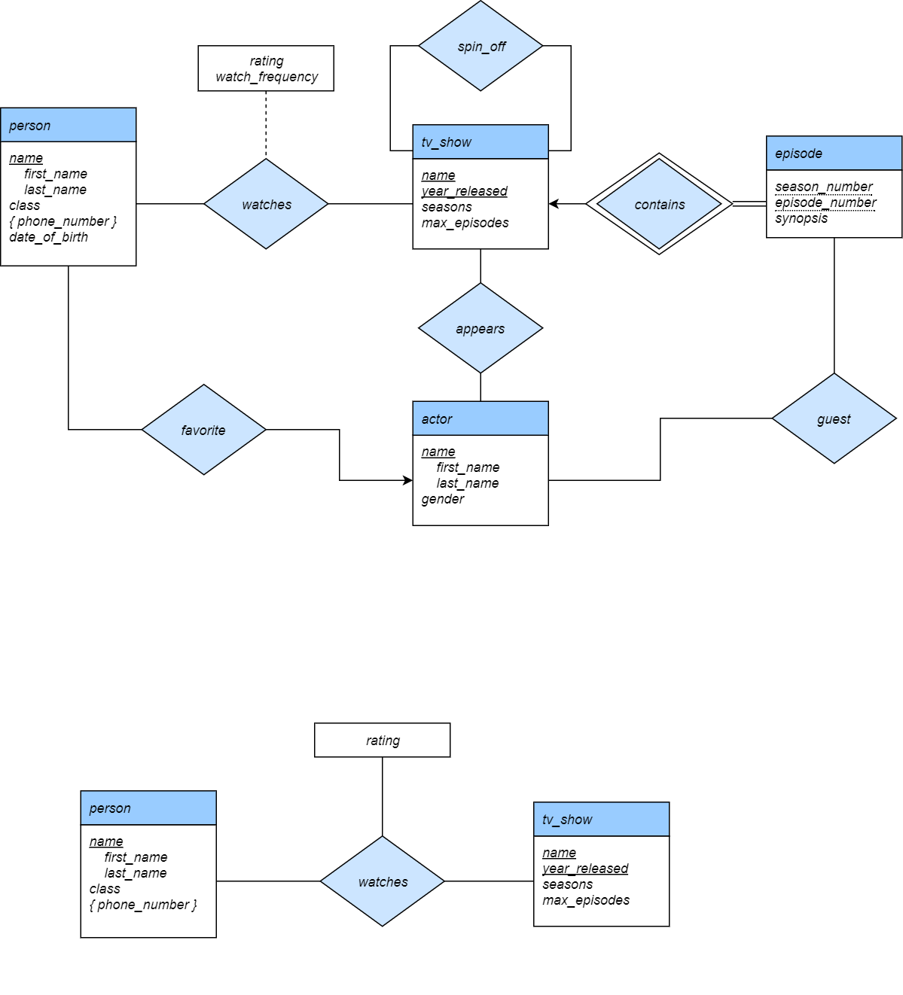

**PROBLEM 1.2:**

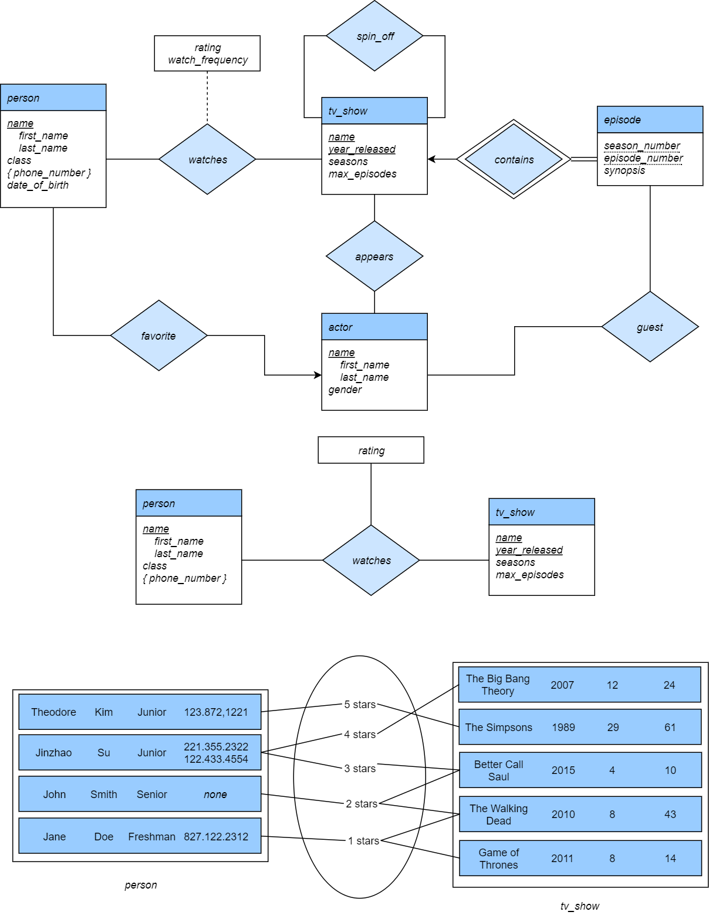

*watches*

**PROBLEM 1.3:**

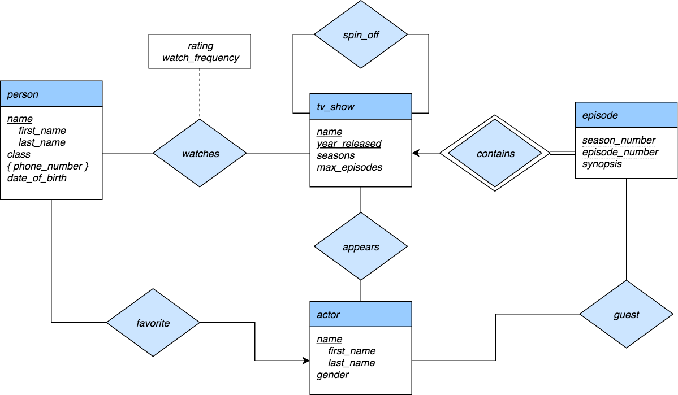

**PROBLEM 2.1:**

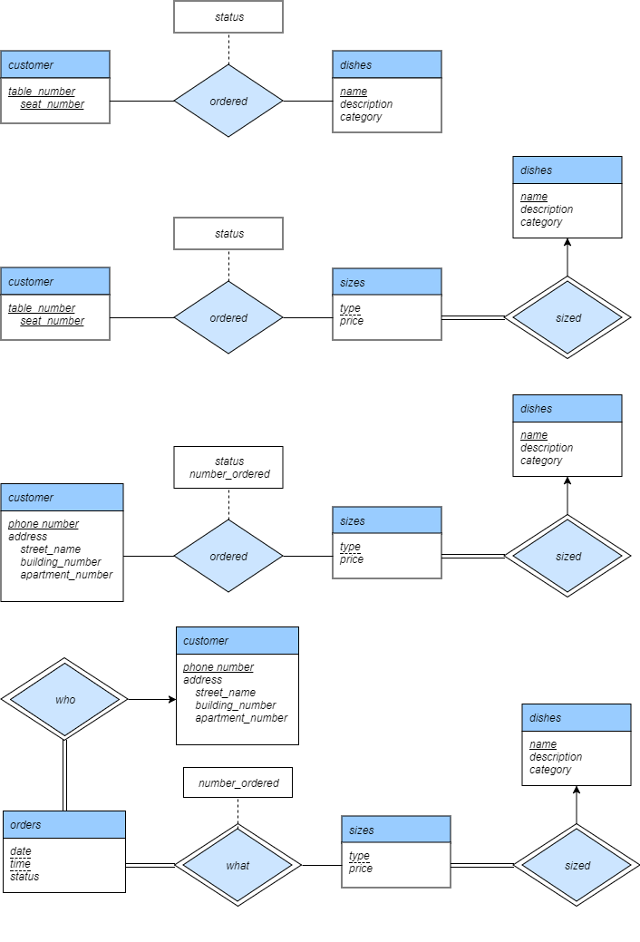

**PROBLEM 2.2:**



**PROBLEM 2.3:**

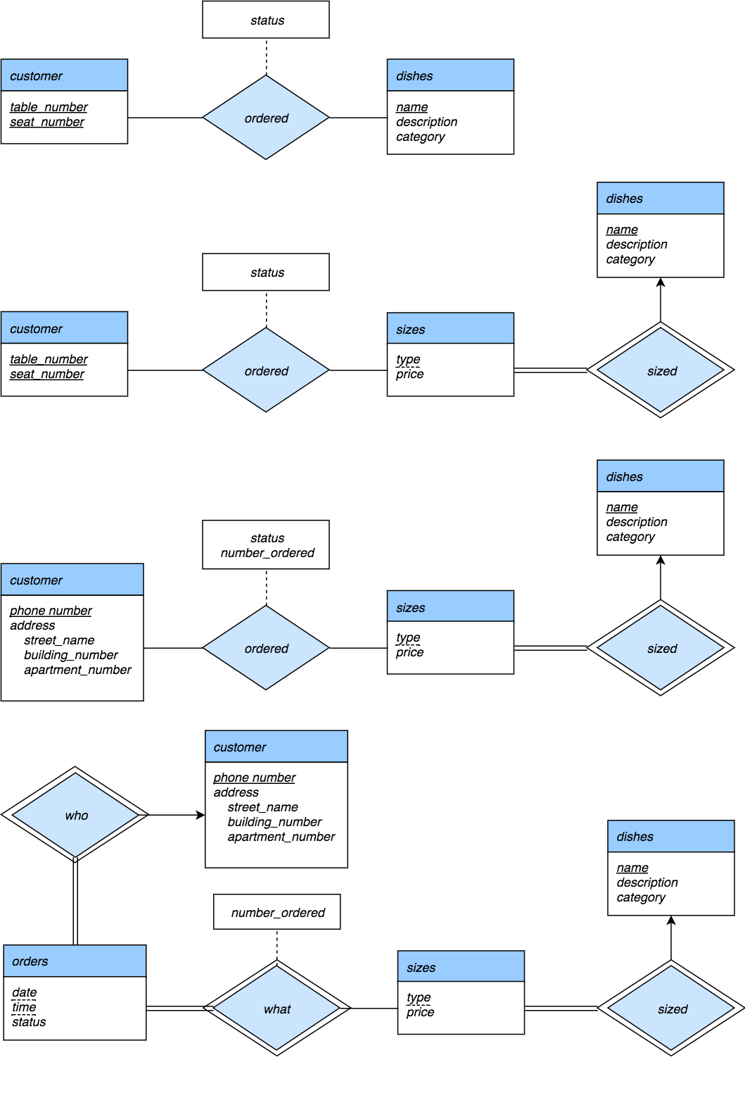

**PROBLEM 2.4:**



**PROBLEM 3:**

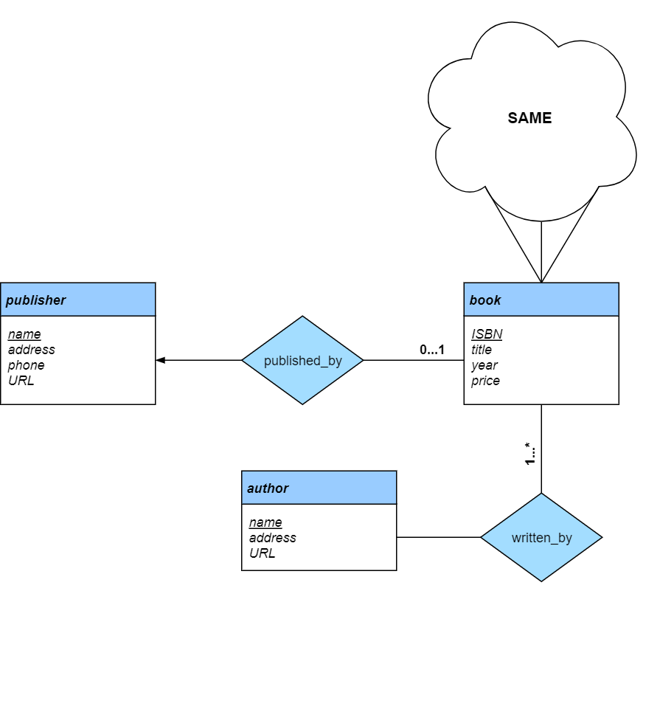

**PROBLEM 4:**

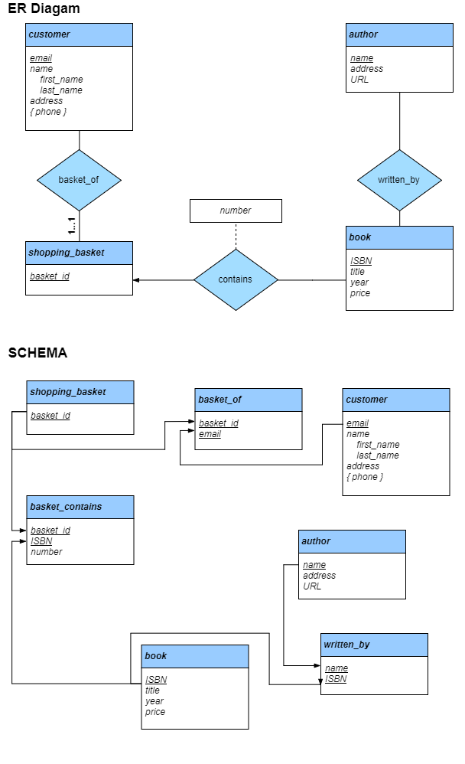

**PROBLEM 5:**

