Theodore Kim

JinZhao Su

CS-UY 3083: Introduction to Databases

Homework #5

Problem 1:

1. State if **A** (is a superkey), **B** (superkey that is also a candidate key), or **C** (is not a superkey)

{ city_name, state } : **B**

{ city_name, state, mayor } : **A**

{ city_name } : **C**

{ state, governor } : **C**

2. 500 rows

3. Identify a trivial functional dependency

If we have 𝛼={ city_name, state, governor } and then β={ state, governor }. β here would be a subset of 𝛼.

4. Identify a non-trivial functional dependency (left-side = superkey)

If we have 𝛼={ city_name, state } and then β={ mayor }. β here would not be a subset of 𝛼 and 𝛼 is a superkey.

5. Identify a non-trivial functional dependency (left-side = not superkey)

If we have 𝛼={ state } and then β={ governor }. β here would not be a subset of 𝛼 and 𝛼 is a not superkey.

6. Decompose Schema into two Schemas (BCNF)

States(state, governor)

Cities(city_name, state, mayor)

7. 1 row

Problem 2:

1. Create a relational schema for the ER diagram

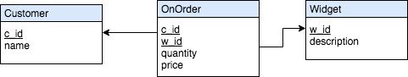

2. Identify a non-trivial functional dependency where the left side is not a superkey

**{ w_id } -> { price }** is a non-trivial functional dependency where w_id is not a superkey in the relation **OnOrder**

3. Decompose into BNCF Schemas

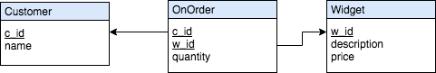

4. Fix the ER Diagram so that it is now BNCF

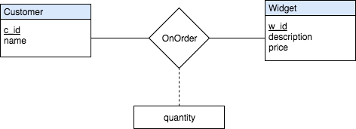

Previously, the ER diagram assigned the attribute “price” to the relationship set **OnOrder**.  Given that the price was unique to each widget, the relation **OnOrder** would contain duplicate information: the tuple { w_id, price }.  To prevent this, price should be moved as an attribute of the **Widget** entity set.