The association between temperature, rainfall and humidity with common climate-sensitive infectious diseases in Bangladesh, Chowdhury et al., 2018

* Global warming = real; Climate change 🡪 could change emergence and re-emergence of many infectious diseases.
* Six infectious diseases. Highest number of cases in autumn, then rainy season then winter and then summer (29%, 28%, 24%, 19%)
* Humidity: correlated negatively with some diseases, positively with others. Same for rainfall.
* WHO: dengue, diarrheal disease, pneumonia, some others: sensitive in tropical countries and might follow greatly increasing trend.
  + 25. Khan K, Campbell-lendrum D., Haines A., Jonathan C. Using climate to predict disease outbreaks: a review. Geneva, Switzerland: World Health Organization, (CSR) DoCDSaR; 2004. WHO/SDE/OEH/04.01. [Google Scholar] [Ref list]

Climate drivers of vector-borne diseases in Africa and their relevance to control programmes, Thomson et al., 2018

* Many parasitic, viral and bacterial diseases respond to variations in the climate whether through their geographic distribution, seasonality, inter-annual-variability, or temporal and spatial trends.
* Arthropod disease (insect/ ticks) very important in lower and middle income countries
* Temporal dynamics of diseases transmitted by insects and ticks will lag factors such as rainfall, temperature and humidity by a number of months because of the many inbuilt delays to the transmission process.
  + Rainfall creates potential breeding sites for mosquitoes, but then you need eggs to hatch, growth, infection, etc…
* EWS: early warning systems: epidemiological data alone can suffice: early seasonal rise in case numbers might be a good indicator of epidemic. Can be extended to climate sensitive diseases with observed environmental data
* Africa: many different climates: arid zones (sahara, deserts), steppes/semi-arid (Sahelian savannah), humid (congo river basin), etc…
* 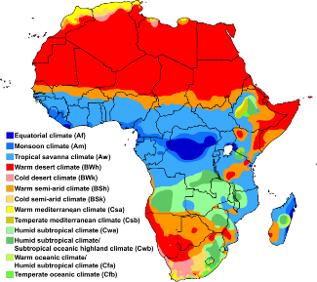 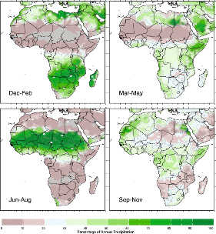climate and rainfall
* Impact of El Nino also

WHO:

Infectious diseases are caused by pathogenic microorganisms, such as bacteria, viruses, parasites or fungi; the diseases can be spread, directly or indirectly, from one person to another. Zoonotic diseases are infectious diseases of animals that can cause disease when transmitted to humans.

WHO:

According to The 1.5 Health Report, a synthesis of the health content of the Intergovernmental Panel on Climate Change (IPCC) special report on global warming of 1.5C: “There is strong evidence that changing weather patterns associated with climate change are shifting the geographic range, seasonality, and intensity of transmission of climate-sensitive infectious diseases.”

What Recent History Has Taught Us About Responding to Emerging Infectious Disease Threats, Paules et al., 2017

* Ebola outbreak 2014 was catastrophic, because crowded urban centers and lack of public health infrastructure.

Disease Control Priorities: Improving Health and Reducing Poverty. 3rd edition., Chapter 17Pandemics: Risks, Impacts, and Mitigation, Madhav et al., 2018

Pandemics:

* Risks:
  + Probably increasing in frequency
  + Spark + spread risk
  + Central and west Africa: high spark risk and lagging behind rest of world for spread risk
* Impacts
  + Mortality, morbidity
  + Economics
  + Behavioral changes
  + Social disruption
  + Political stress, tensions, violence
* Mitigation
  + How to stop them, look it up if needed
* Knowledge gaps:
* Most new pandemics originated through zoonotic transmission of pathogens from animals to humans.
* Spread risk: dense populations, social inequality, poverty, environmental correlates can increase individual susceptibility to infection significantly. Comorbidities, malnutrition, and caloric deficits weaken an individual’s immune system, while environmental factors such as lack of clean water and adequate sanitation amplify transmission rates and increase morbidity and mortality.
* Well-prepared countries have effective public institutions, strong economies, and adequate investment in the health sector. They have built specific competencies critical to detecting and managing disease outbreaks, including surveillance, mass vaccination, and risk communications. Poorly prepared countries may suffer from political instability, weak public administration, inadequate resources for public health, and gaps in fundamental outbreak detection and response systems.
* 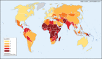Preparedness

COVID-19 in Africa: the spread and response, Massinga Loembe et al., 2020

* Info on how it evolved in the beginning

Emerging infectious diseases in Africa in the 21st century, Fenoliar et al., 2018

* Worldwatch institute:2001: healthcare in Niger is 800x times lower than US.
* Population is undernourished, poor healthcare, poverty, less per-capita spending on health, less availability of physicians
* I think from WHO: half of all deaths in Africa are caused by infectious diseases (just 2% in Europe).

Global trends in emerging infectious diseases, Jones et al., 2008

* 60% of emerging infectious disease are zoonoses, 72% of which are from wildlife.
* Evolved strains of pathogen: multi-drug resistant tuberculosis, chloroquine-resistant malaria)
* Critical need for health monitoring

WHO:

* Infectious diseases Kills 17 million a year (1996?)
* Antibiotics and other life saving drugs used against many disease are rapidly losing their effectiveness as bacteria and other microbes develop resistance to them. Most important, efficient and cheapest drugs are becoming useless…
* Also prevents a country from growing (crippling burden)

WHO 2019: REPORT

* Rates of death from all conditions are higher in low-income countries, but children in low-income countries are more than 100 times more likely to die from infectious diseases than those in high-income countries.
* The main SDG target concerning infectious diseases is Target 3.3. Indicators of progress consider HIV, TB, malaria, hepatitis and neglected tropical diseases (NTDs).1 Collectively, these diseases accounted for an estimated 4.3 million deaths in 2016 (1.7 million female and 2.7 million male), down from 5.3 in 2000 (2.2 million female and 3.1 million male) (Fig. 4.1). The risk of dying from these infectious diseases is highest in the WHO African Region and South-East Asia Region, and in low-income and lower-middle-income countries. The risk of death varies across the life course by disease. The risk of death from malaria is greatest in children aged under 5 years. Deaths from HIV peak in reproductive years, whereas the risk of death from TB, hepatitis B and NTDs increases with age (Fig. 4.2).
* 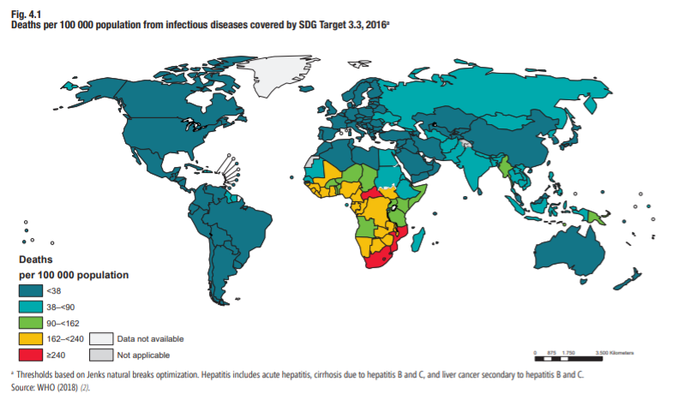
* Data for 2013–2018 show that almost 40% of all countries have fewer than 10 medical doctors per 10 000 people: 90% of low-income countries suffer from such shortages, whereas only 5% of high-income countries do (86). The average global density of medical doctors in 2017 was 15 per 10 000 people. Up to 93% of lowincome countries have fewer than 40 nursing and midwifery personnel per 10 000 people, whereas only 19% of highincome countries do. In terms of dentists and pharmacists, 64% and 60% of countries have fewer than five of these health workers, respectively, per 10 000 people (Fig. 8.4).