Path From Predictive Analytics to Improved Patient Outcomes

A Framework to Guide Use, Implementation, and Evaluation of Accurate Surgical Predictive Models

Harris et al., 2017

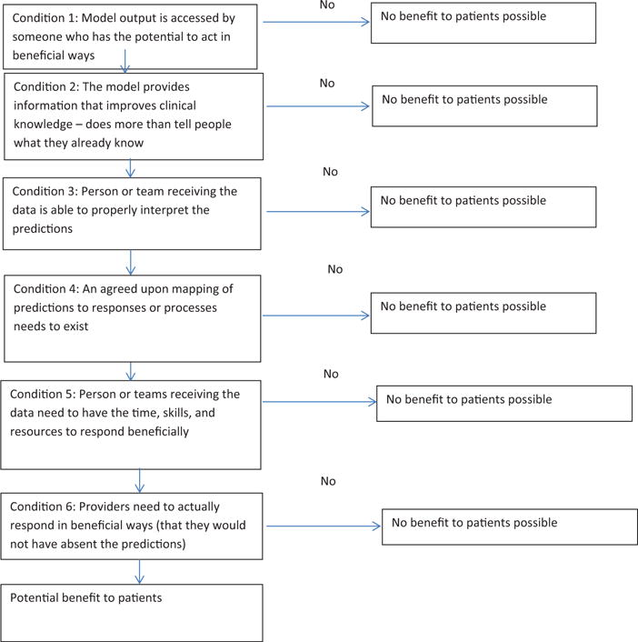

PROBAST: A Tool to Assess the Risk of Bias and Applicability of Prediction Model Studies

Wolff et al., 2019

PROBAST = prediction model risk of bias assessment tool: organized in 4 domains

* Participants
* Predictors
* Outcome
* analysis

probast can beused to assess studies of model development and model validation, including those updating a prediction model.

Development stage 1: scope and definitions: probast was designed mainly to access primary studies included in a systematic review. The group agreed that probast would assess both risk of bias and concerns regarding applicability of a study evaluating a multivariable prediction model to be used for in individualized diagnosis or prognosis.

Development stage 2: review of evidence

Development stage 3 : web based delphi procedure

* included various stakeholders to ensure that the views of end users, methodological experts and decision makers were represented.

Development stage 4: piloting and refining the tool

THE TOOL

Development of a prediction model can include adding new predictors to an existing prediction model. Similarly, validation of an existing model can be accompanied by updating and extending the model – that is, development of a new model.

bias: usually defined as the presence of systematic error in a study that leads to distorted or results and hampers the study’s internal validity.

Rob = risk of bias

Concerns regarding the applicability of a primary study to the review question can arise when the population, predictors, or outcomes of the study differ from those specified in the review question.

Types of prediction model study

Step 1: specify your systematic review question. Do this using CHARMS (checklist for critical appraisal and data extraction for systematic reviews of prediction modelling studies)

Step 2: classify the type of prediction model evaluation. For each model assessment, reviewers classify a model as “development only”, “development and validation in the same publication”, “validation only”.

Step 3: assess rob (risk of bias) and applicability. The ROB component of each domain comprises 4 sections: information used to support the judgment, 2 to 9 signaling questions, judgment of ROB and rationale for the judgment

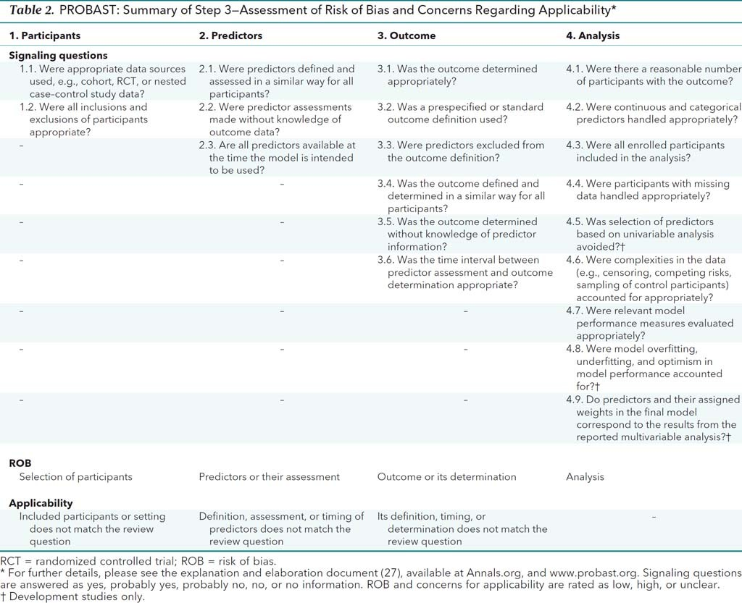

Step 4: overall judgment

ROB: “low”, ”high”, ”unclear”. If one domain had high ROB then the overall judgment should be high ROB.

If a prediction model was developed without any external validation on different participants, downgrading to high ROB should still be considered even if all 4 domains had low ROB, unless the model development was based on a very large data set or included some form of internal validation

The PRISMA statement for reporting systematic reviews and meta-analyses of studies that evaluate health care interventions: explanation and elaboration

Liberati et al., 2009

Systematic review: a systematic review attempts to collate all empirical evidence that fits pre-specified eligibility criteria to answer a specific research question.

Meta analysis: use of statistical techniques to integrate and summarize the results of included studies

Helping to develop the research questions: the PICOS approach:

* population: info about age / else their defining characteristics
* interventions: interventions under consideration in the systematic review need to be transparently reported
* comparator: control group
* outcomes: mortality / else
* study design: type of study design: reports of randomized, trials, observational studies, etc

prisma checklist:

* title : systematic review or meta-analysis or both
* structured summary: structured summary : background, objectives, data sources, study eligibility criteria, participants, interventions, study appraisal, synthesis methods, results, limitations, conclusions, implications of key findings, etc
* rationale: what is the rationale for the review in the context of what is already known
* objectives: explicit statement of questions being addressed with reference to participants / else
* protocols and registration: indicate whether review protocol exists and if yes then where
* eligibility criteria: study or report characteristics used as criteria for eligibility
* information sources: all types of information sources
* search: how you found stuff
* study selection:
* data collection process
* data items
* ROB for individual studies
* Summary measures
* Planned methods of analysis
* ROB across studies
* Additional analyses
* Study selection
* Rob within

PROBAST: Explanation and Elaboration

Mons et al., 2019

PICOTS: population, index, comparator, outcomes, timing, setting. Timing: define at what moment or time point the prediction model under review is to be used, and over what time period the outcomes are predicted (latter case if prognostic not diagnostic)

Assessing concerns regarding applicability:

Domain 1: participants:

* Were appropriate data sources used? Cohort, randomized controlled trial, etc.
* Were all inclusions and exclusions of participants appropriate

Domain 2: predictors:

* Were predictors defined and assessed in a similar way for all participants
* Were predictors assessments made without knowledge of outcome data
* Are all predictors available at the time the model is intended to be used

Domain 3 outcome

* Was the outcome determined appropriately
* Was a pre-specified or standard outcome definition used
* Were predictors excluded from the outcome definition
* Was the outcome defined and determined in a similar way for all participants
* Was the outcome determined without knowledge of predictor information
* Was the time interval between predictor assessment and outcome determination appropriate

Domain 4: analysis

* Were there a reasonable number of participants with the outcome
* Were continuous and categorical predictors handled appropriately