WEBSITE SPECIFICATION

Objectives:
The objective of this website is to provide tourists comprehensive and easy-to-use platform for planning their trips to the Bahamas. It aims to inform tourists about destinations, accommodations and activities etc. while also offering a booking system for hotels, tours and transportation. The main purpose is to increase tourism in the Bahamas and help local businesses expand by attracting more visitors to generate income for development.

According to (Champ Digital, 2024), “81% of travellers research destinations online before booking their trips”, therefore, the goals of the website are:
• To provide reliable and up-to-date travel information.
• Facilitate online booking of hotels, tours and experiences.
• Improve user engagement through travel tips, interactive maps and blogs about local culture.
• To promote The Bahamas as a tourist destination and generate income for development.
According to The Ministry of Tourism, tourist arrivals to The Bahamas reached a staggering amount of seven million in the year 2022 which well performed the statistics from the year 2019. Furthermore, the Ministry states that due to the increasing number of tourists over the years, new land was prepared to accommodate international visitors from all over the world. In addition to that, The Deputy Prime Minister and Minister of Tourism, Investments, and Aviation congratulated The Bahamas’ outstanding performance and effort they display within the industry. (Bahamas Ministry of Tourism, 2023)

Target Audience:

  - Demographics:

- Age: 18-80 years
- Gender: All
- Location: International users planning to visit the Bahamas.
- Income: Middle to very high-income.
- Marital status: Single or married.
- Language: English

  - Technical Aptitude:
  - Basic-Advanced end users.
  - Able to navigate through the website and explore the features it has to offer.
  - Able to fill in forms.
  - They are familiar with the use of mobile devices and computers.

Type of Website

Destination Travel Platform.
It includes:
- A search and room list feature.
- Booking functionality.
- A registration page for first time users and a sign in page for returning/ continuing users.
- An online and telephone support for further inquiries.
- Language translation feature for non-English speaking foreigners.
- A personalized recommendation tab for new and returning users.
The website will feature a simple, intuitive menu designed for the user. This is because, users often leave a website within seconds if they can’t find what they’re looking for; clear navigation is the key to keeping visitors engaged and satisfied.” — Nielsen Norman Group, 2020

INFORMATION DESIGN & TAXANOMY

SITE MAP NAVIGATION

  - HOME PAGE
- Language selection icon.
- Help centre redirect icon.
- Curency selection icon.
- Destination, Check-in and Check-out, reservation tabs integrated into a search bar.
- Sign-up/ login button.
  - ABOUT US PAGE
- Information about website services.
- Travel tips section.
- Frequently asked questions section.

  - CAR RENTAL PAGE
- Pick-up location search bar.
- Pick-up date calendar.
- Drop-off date calendar.
- Travel tips section
- Frequently asked questions section.

  - ATTRACTIONS
- Destination search bar.
- Destination images and a reserve button.
- Calendar tab for reservation/booking.

  - RESERVATIONS
- Information on reserved destinations.
  - ROOMS/ LISTINGS
- Hotels
- Resorts
- Lodges
  - ROOM DETAILS PAGE
- Image
- Prices
- Description
- Book button

  - BOOKINGS PAGE
- User sign in credentials
- Payment section.
- Frequently asked questions section.

  - CUSTOMER SERVICE PAGE
- Contact form
- Frequently asked question menu.
- A feedback form.
- Social links located in the footer.

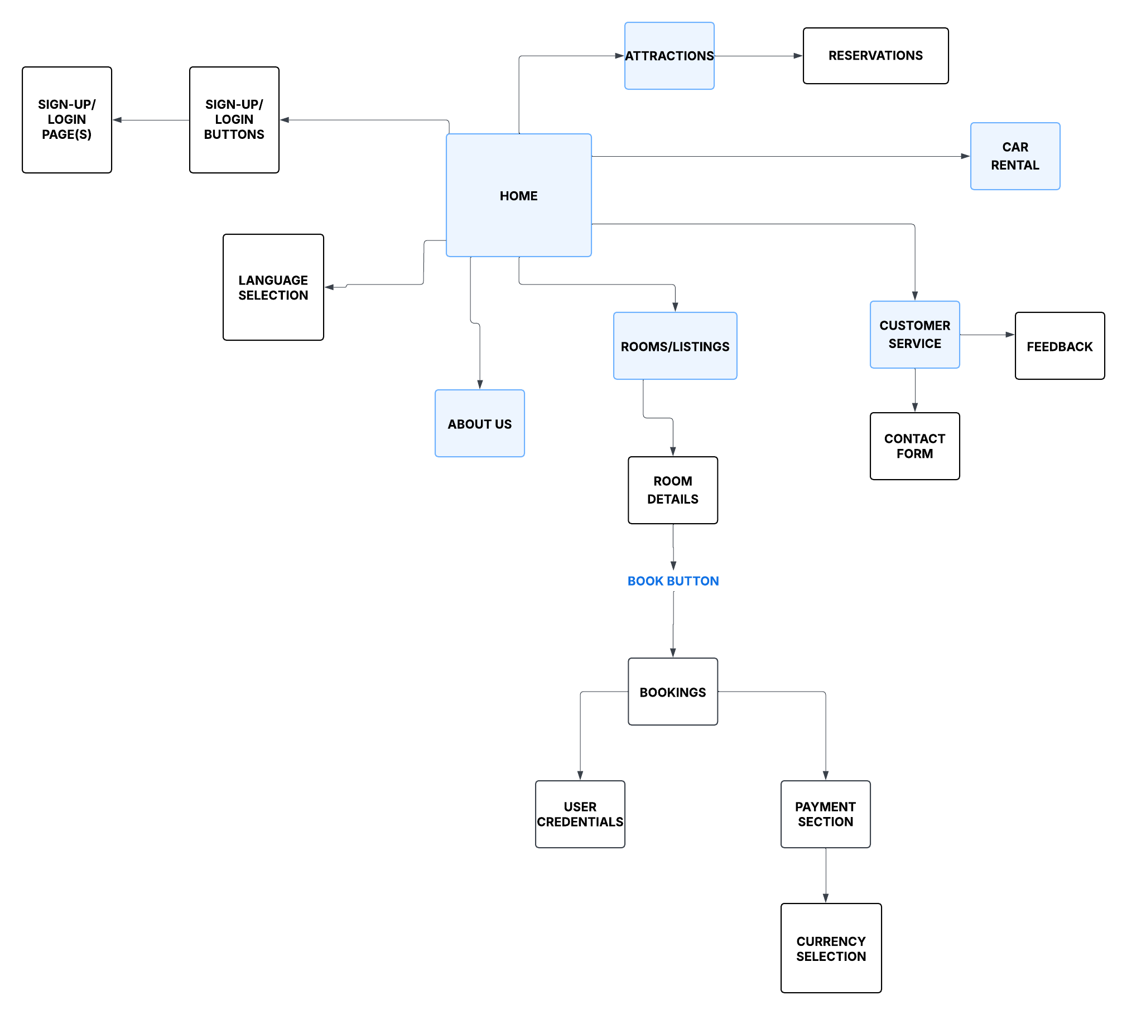

Home Page: This serves as the main entry point for the website. Users have the option to register an account free of charge upon entry for data keeping purposes. Furthermore, one can select their country’s native language for easier communication and understanding.
About us: This page provides any relevant information about the website and the services offered. It also includes travel tips to guide users and FAQ section to address common concerns.
Car Rental: This serves to allow users to search for transport services with the ability to enter a pick-up location, choose pick-up and drop-off dates as well as an integrated FAQs section and travel tips for assistance.
Attractions page: This allows users to explore activities and destinations while planning for their visit to The Bahamas. Users can make reservations and view their selection with the ability to cancel any unwanted reservations before confirmation.
Rooms/ Listings, Room Details and Bookings Pages
These pages work together to form the main booking process of the website.
The Rooms/Listings page displays available accommodation options such as hotels, resorts, and lodges. Users can browse through different listings based on their search preferences.
From this page, users select an accommodation and are directed to the Room Details page, which provides more detailed information including images, pricing, and descriptions of the selected accommodation.
Users can then proceed to the Bookings page, where they enter their user credentials, select payment method (either online or pay at property), and complete the reservation process. After booking, a confirmation message is displayed, and a personalized email may be sent to the user.
Customer service page: It includes a multi-channel customer support system. The platform allows users to contact support through a contact form, where they are required to provide relevant information such as their name, email, and query. Alternatively, users can seek assistance through social media platforms such as WhatsApp or Instagram, where they can communicate their issues based on the features of the selected platform.

TECHNICAL BRIEF
The website will be developed using the following:
FRONTEND TECHNOLOGY
HTML5: This will be used to structure the content of the website such as images, pages, text and forms.
CSS: Used for styling the website. This includes the background, buttons, text, icons and a responsive design.
JavaScript: Used to add interactivity with the website such as, form validation, dynamic island filtering and interactive island maps, as well as pop-up info and image slideshow.
DEVELOPMENT TOOLS

Code editor: Visual Studio Code for writing and managing source code.
Web Browsers: MS Edge and Google Chrome will be used for testing and debugging source code.

DESIGN AND GRAPHICS TOOLS
Canva/ Figma: Used to design
- Wireframes
- Visual elements
Pinterest: Alternative for visual elements
OTHERS
For database: MySQL to store input and destination data etc.
Book strap: To further enhance front end technology
Icon libraries: Font Awesome will be used to import business icons.

