SIGNALRANK
Master Product, Quantitative Research, AI, Risk, Execution & Engineering Blueprint
2026 Edition • Production-Grade Transformation Plan
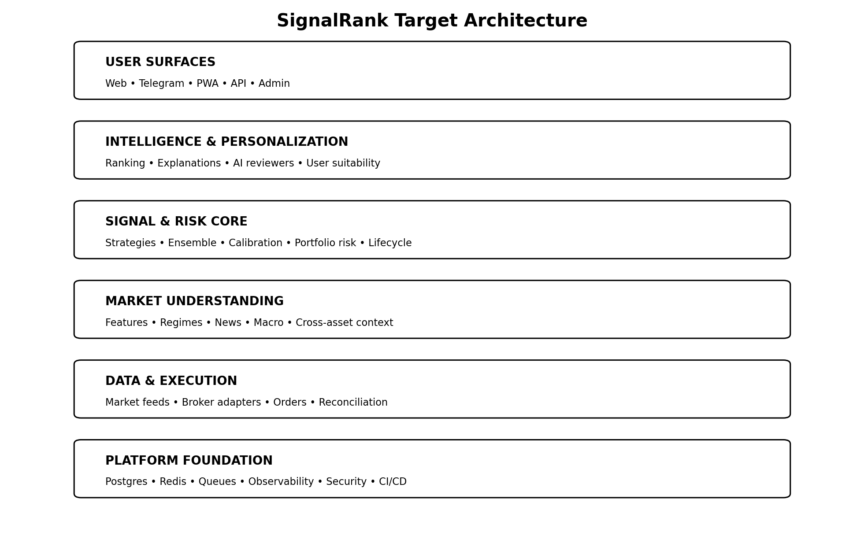
Purpose: turn SignalRank into a reliable, explainable, multi-asset market-intelligence and risk platform that can progress safely from research to signals, paper trading, assisted execution, and controlled live execution.
Important operating principle
No architecture, AI model, backtest, calibration curve, or historical win rate can guarantee future profit. SignalRank should optimize expected value, drawdown control, calibration, execution quality and long-run robustness rather than chase a headline win-rate target.

Document Control
This blueprint is intended to be the strategic source of truth for SignalRank. It consolidates product direction, architecture, quantitative methodology, operational controls and release gates into one implementation document.
Section outcome
A reader should be able to understand what SignalRank is becoming, how each subsystem should work, how it should be tested, and what must be true before real-money execution is allowed.
Area | Specification
Document status | Master blueprint / living specification
Primary audience | Owner, engineering, quant research, product, operations and security
System scope | Web platform, Telegram bot, market-data services, AI providers, research pipeline, databases, workers, broker execution, analytics and commercial platform
Current architectural baseline | Python asynchronous services, PostgreSQL, Redis, Railway-hosted backend/worker roles, Telegram webhook experience, web frontend, AI validation/explanation, scheduled scanning and outcome tracking
Target maturity | Production-grade multi-asset decision-support and controlled execution platform
Production principle | Evidence before promotion; safe degradation before silent failure; auditability before automation

How to use this blueprint
- Treat P0 items and release gates as mandatory before meaningful real-money exposure.
- Implement capabilities behind feature flags where a staged rollout is possible.
- Convert every production incident into a regression test and runbook update.
- Version strategies, features, datasets, models, scoring rules and deployment code independently enough to reproduce any signal.
- Keep research results distinct from delivered-signal results, paper results and broker-executed live results.
- Revisit target metrics periodically; thresholds should be evidence-driven, not permanent magic numbers.

Table of Contents
1. Executive Summary
2. Product Vision and Design Principles
3. Current-State Baseline and Immediate Gaps
4. Target System Architecture
5. Canonical Domain Model and Signal Lifecycle
6. True Multi-Asset Market Support
7. Market Data Platform and Provider Abstraction
8. Data Quality, Freshness and Integrity
9. Canonical Asset Registry and Symbology
10. Feature Engineering and Feature Store
11. Market Regime Intelligence
12. Strategy Framework and Strategy Governance
13. Ensemble Scoring and Meta-Models
14. Machine Learning, Calibration and Probability Quality
15. Continuous Learning and Model Promotion
16. Rejected-Signal Counterfactual Learning
17. Backtesting and Historical Simulation
18. Shadow Trading and Paper Portfolios
19. Risk Engine and Position Sizing
20. Portfolio Intelligence and Capital Allocation
21. Execution Engine and Order Safety
22. Broker and Venue Integration
23. AI Architecture: OpenAI, Gemini and Beyond
24. News, Macro and Event Intelligence
25. Signal Explanation, Freshness and Invalidation
26. Telegram Product Experience
27. Web Platform and Control Center
28. Mobile, PWA and Notification Experience
29. User Profiles and Personalization
30. Analytics, Attribution and Performance Intelligence
31. Admin, Owner and Operations Center
32. Observability, Reliability and SRE
33. Database, Storage and Data Lifecycle
34. Queues, Schedulers and Background Work
35. Security, Secrets, Privacy and Access Control
36. CI/CD, Release Engineering and Environment Parity
37. Testing and Certification Framework
38. Incident Response, Disaster Recovery and Runbooks
39. Monetization, Entitlements and Commercial Analytics
40. Public API, Webhooks and Ecosystem
41. Compliance, Trust, Data Licensing and User Safety
42. Performance, Scalability and Cost Engineering
43. Research Lab, Experimentation and Statistical Governance
44. KPI, SLO and Health Metric Framework
45. Prioritized Release Roadmap
46. Production Readiness Certification Checklist
47. Frontier Features and Long-Term Differentiators
48. Anti-Patterns and Things SignalRank Should Never Do
49. Suggested Data Schemas and Event Contracts
50. Final Target State
Appendix A. Priority Matrix
Appendix B. Acceptance Criteria by Release
Appendix C. Glossary

1. Executive Summary
SignalRank should evolve from a signal-delivery product into a continuously evaluated market-intelligence, risk and execution platform. The defining advantage should not be the number of indicators, strategies or AI calls. It should be the quality of the decision process: clean data, explicit evidence, calibrated probabilities, portfolio-aware risk, safe execution, transparent explanations, reliable delivery, measurable outcomes and disciplined learning.
The platform should search a broad opportunity universe across crypto, foreign exchange, equities, indices, commodities and other supported markets, but should never force activity simply to appear busy. A day with no trade can be correct if the opportunity set fails the evidence and risk gates. Conversely, a day with zero signals must be diagnosable: the owner should be able to tell whether there truly was no opportunity or whether a provider, scanner, strategy, threshold, cooldown, duplicate filter, scheduler or notification path failed.
North-star transformation
SignalRank should become a system that can explain every decision, reproduce every signal, measure every filter, quantify every risk, survive dependency failures, learn from both accepted and rejected opportunities, and move from research to execution only through explicit certification gates.

What “best of the best” means in practice
- Multi-asset by design, not crypto logic reused everywhere.
- Probability quality and expected value instead of raw confidence theatre.
- Risk-first portfolio construction instead of isolated trade recommendations.
- Evidence-backed continuous learning with champion/challenger promotion.
- Full signal lifecycle tracking from candidate generation to final outcome.
- Realistic simulation that includes fees, spread, slippage, latency and partial fills.
- Web and Telegram parity for the core user journey.
- Operational transparency: every stage has health, latency and funnel metrics.
- Safe broker execution with idempotency, reconciliation and kill switches.
- Commercial readiness with centralized entitlements, billing analytics, referrals and API access.

P0 rules before meaningful real-money use
- One canonical production database and one canonical staging database per intended environment; no accidental cross-environment sharing.
- Migrations verified at the latest expected revision and startup blocked on incompatible schema state.
- Runtime commit fingerprint must match the deployment expectation across API, workers and schedulers.
- Canonical active-signal state machine must be correct; expired or historical records cannot masquerade as active opportunities.
- Signal delivery and execution must be idempotent.
- All supported asset classes must pass data, strategy, lifecycle and notification certification independently.
- Paper execution and broker reconciliation must pass sustained staging tests before live orders are allowed.
- No critical dependency may fail silently; safe degradation and owner-visible alerting are mandatory.

2. Product Vision and Design Principles
Principle | Meaning
Evidence over activity | SignalRank should prefer fewer high-quality, explainable opportunities over a high message count. Activity is not performance.
Risk before reward | Every candidate must survive risk and portfolio checks before delivery or execution eligibility.
Reproducibility | Any historical signal should be reproducible from its code version, data snapshot, features, strategy version, model version and configuration.
Calibration over marketing confidence | A displayed probability should have statistical meaning. Confidence must be measured against realized outcomes.
Safe degradation | When a provider, AI service, broker, database or queue is impaired, the system should reduce capability safely rather than produce lower-quality decisions without disclosure.
Observability as a feature | Operational transparency is part of product quality, not an afterthought.
One source of truth | Canonical identifiers, lifecycle states, entitlements and model registries must prevent contradictory interpretations across services.
Human agency | Users should understand risk, choose their automation level and be able to disable execution instantly.
Research/production separation | Experimental logic should not influence user-facing production until it clears formal gates.
No vanity metrics | Raw win rate, accuracy and number of signals are secondary to expectancy, drawdown, calibration, sample size and robustness.

Core product promise
The ideal SignalRank promise is not “we always know what the market will do.” The credible promise is: SignalRank systematically evaluates a large market universe, identifies evidence-backed opportunities, quantifies uncertainty, rejects weak or risky ideas, explains what it sees, manages exposure, and continuously measures whether its decisions are improving.

3. Current-State Baseline and Immediate Gaps
SignalRank already has important foundations: asynchronous Python services, PostgreSQL persistence, Redis, Telegram delivery, scheduled scans, outcome tracking, multiple strategy families, AI-assisted validation/explanation, staging and production environments, and a developing web surface. The next stage is not to add random features around those pieces; it is to make them behave as one coherent system.

Known gap categories
Gap | Risk | Required change
Environment drift | Different roles can run different commits or schema assumptions. | Strict release fingerprint, environment manifest and startup gate.
Asset-class imbalance | Crypto may dominate because provider or strategy coverage is stronger. | Coverage matrix, per-asset-class funnels and provider abstraction.
Lifecycle ambiguity | Historical, delivered and active signals can be confused. | Canonical state machine and append-only signal events.
Learning uncertainty | Outcomes may exist without a safe model promotion loop. | Dataset registry, walk-forward evaluation, shadow mode and champion/challenger.
UX parity gaps | Actions available on Telegram may be absent on web or vice versa. | Capability inventory and parity tests.
Button/callback fragility | Telegram interactions can fail or become stale. | Idempotent callbacks, replay protection, callback diagnostics and tests.
Quality opacity | A low signal count is hard to distinguish from pipeline failure. | Signal funnel and “why no signal?” diagnostics.
Execution risk | Retries or unknown broker states can duplicate exposure. | Order-intent idempotency and reconciliation state machine.
Immediate definition of done
The first milestone is not “more signals.” It is the ability to prove that every intended market is being scanned correctly, every candidate moves through deterministic gates, every delivered signal has the right lifecycle state, and every missing output has an explainable reason.

4. Target System Architecture

Architectural layers
Area | Specification
User surfaces | Web dashboard, Telegram bot, PWA/mobile surfaces, public API and owner/admin console.
Intelligence and personalization | Opportunity ranking, AI explanation, user suitability, alert routing and natural-language assistant.
Signal and risk core | Strategy execution, ensemble scoring, calibrated probability, risk gates, portfolio allocation and canonical signal lifecycle.
Market understanding | Features, market structure, regime detection, macro/news context, cross-asset relationships and liquidity conditions.
Data and execution | Market-data providers, normalized instruments, broker adapters, order state machine, reconciliation and outcome tracking.
Platform foundation | PostgreSQL, Redis, queues, object storage, model registry, observability, security, CI/CD and backups.

Modular monolith before uncontrolled microservices
SignalRank should maintain clear domain boundaries without prematurely splitting every responsibility into separate network services. A modular architecture with explicit interfaces is easier to test, deploy and reason about. Split services when there is a concrete scaling, isolation, security or operational reason—such as execution isolation, high-volume market-data ingestion or compute-heavy research jobs.

Suggested core interfaces
MarketDataProvider
HistoricalDataProvider
NewsProvider
EconomicCalendarProvider
BrokerProvider
ExecutionProvider
AIProvider
FeatureProvider
Strategy
RiskPolicy
PortfolioAllocator
NotificationChannel
EntitlementService

5. Canonical Domain Model and Signal Lifecycle
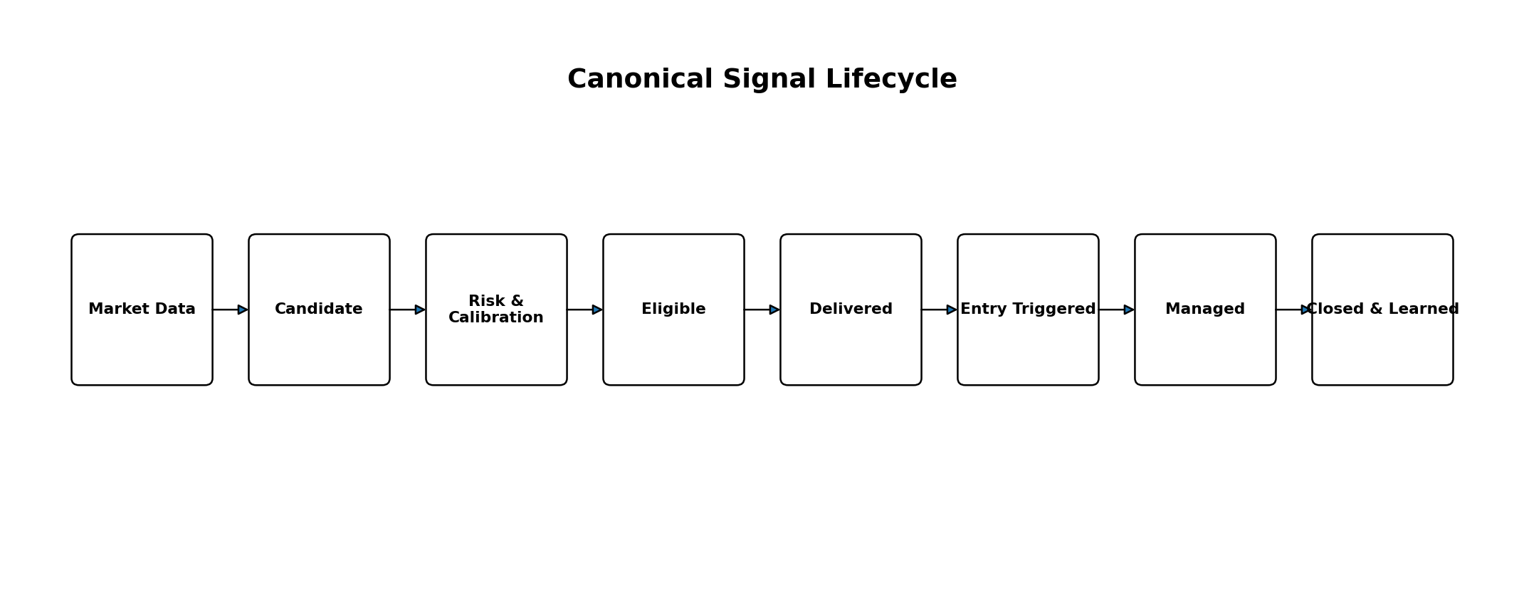
The most important domain correction is to make the signal lifecycle explicit. “A signal exists” is not enough. The system must know whether an idea is merely a candidate, eligible for delivery, delivered to a user, waiting for entry, entered, partially managed, closed, expired or invalidated.

Recommended canonical states
State | Definition
CANDIDATE | Generated by a strategy or ensemble but not yet risk/quality approved.
REJECTED | Failed one or more gates; reason codes retained for counterfactual analysis.
ELIGIBLE | Passed quality, risk, calibration, freshness, deduplication and user suitability.
DELIVERED | Successfully emitted to the intended channel/user with immutable delivery evidence.
WAITING_ENTRY | Delivered but entry condition not yet triggered.
ENTERED | Entry condition triggered or broker execution confirmed.
MANAGING | Open position/signal with active stop/target/trailing logic.
CLOSED | Final outcome recorded.
EXPIRED | Entry window expired without valid entry.
INVALIDATED | Market conditions changed enough that the original thesis is no longer valid.
CANCELLED | Operator/system cancelled before entry for an explicit reason.

Append-only signal events
SIGNAL_CREATED
QUALITY_GATE_PASSED
RISK_GATE_PASSED
SIGNAL_ELIGIBLE
SIGNAL_DELIVERED
ENTRY_TRIGGERED
POSITION_OPENED
TP1_HIT
STOP_UPDATED
POSITION_PARTIALLY_CLOSED
SIGNAL_INVALIDATED
POSITION_CLOSED
OUTCOME_FINALIZED
MODEL_LEARNING_RECORDED
The mutable signal table should expose current state for fast queries, while the event stream preserves the full history. This provides auditability, debugging and reproducibility without forcing full event sourcing across the entire platform.

6. True Multi-Asset Market Support
SignalRank should support markets through asset-class-specific domain logic. A unified interface is valuable, but the implementation must respect the differences between 24/7 crypto, session-based equities, OTC FX, index instruments, futures, commodities and later options.
Capability | Crypto | FX | Equities | Indices | Commodities
24/7 assumptions | Yes for many venues | No | No | No | Depends on venue
Corporate actions | No | No | Yes | No | Sometimes indirect
Funding/basis | Perpetuals/futures | Swap/rollover | No | Futures basis possible | Futures basis possible
Session calendars | Venue-specific | Global sessions | Exchange calendars | Exchange/CFD-specific | Exchange-specific
Quantity rules | Precision/min notional | Lots/units | Shares/fractional | Contracts/CFDs | Contracts/units
News sensitivity | Protocol/ETF/regulatory | Macro/central bank | Earnings/company/macro | Macro/index constituents | Supply/geopolitics/macro

Multi-asset acceptance criteria
- Every symbol maps to one canonical asset ID regardless of provider or broker.
- Every supported asset knows its market calendar, timezone, tradability and precision rules.
- Scanner health and funnel metrics are broken down by asset class.
- A zero-signal day can be distinguished from an unscanned or unsupported market.
- Strategies declare explicit asset-class support; unsupported combinations cannot run accidentally.
- Risk calculations use asset-appropriate contract, pip, tick and notional semantics.

7. Market Data Platform and Provider Abstraction
Market data is the raw material of every downstream decision. SignalRank should never be designed around a single provider’s symbol format or response schema. Provider adapters should normalize data into a canonical schema before feature or strategy code sees it.

Provider routing design
Canonical Asset Request
|
Provider Router
|-- Primary provider
|-- Secondary provider
`-- Fallback provider
|
Normalization + Quality Gate
|
Feature/Strategy Consumers

Provider health metrics
- request latency
- error rate
- rate-limit remaining/reset
- data age
- gap count
- provider disagreement
- WebSocket reconnect count
- sequence-gap count
- symbol availability
- last successful fetch

Failover rules
Failover must be evidence-based. If the primary feed becomes stale, SignalRank may use a validated secondary source only when the secondary symbol mapping, timestamp, precision and price sanity checks pass. If feeds materially disagree, the safer action is to quarantine the asset rather than silently pick whichever value arrived first.

8. Data Quality, Freshness and Integrity
A sophisticated strategy on bad candles is still a bad system. Data quality should be a dedicated subsystem, not scattered checks inside strategies.

Candle and quote validation
- missing intervals
- duplicate timestamps
- out-of-order data
- open/high/low/close impossibilities
- zero or implausible volume
- stale price age
- abnormal spread
- provider divergence
- timezone and DST errors
- corporate-action discontinuities
- futures rollover anomalies
- bad ticks and isolated spikes
- symbol status or delisting changes

Quality score and quarantine
Each market-data batch should carry a quality score and issue codes. Strategies can define a minimum acceptable quality level. Repeated failures should quarantine a symbol-provider pair until the data recovers or an operator clears the condition.
Safe rule
No strategy should be allowed to “make the best of” obviously corrupted data. Missing information is safer than false precision.

9. Canonical Asset Registry and Symbology
The canonical asset registry should be the single source of truth for instrument identity. Provider symbols and broker symbols become aliases, not primary identifiers.
asset_id
canonical_symbol
display_name
asset_class
subclass
base_asset
quote_currency
venue / exchange
country
currency
timezone
market_calendar
provider_symbols{}
broker_symbols{}
price_precision
quantity_precision
tick_size
lot_size
minimum_order
session_rules
is_signalable
is_tradeable

Registry governance
- version mapping changes
- record delistings and renames
- model ADRs/dual listings explicitly
- validate broker symbol capabilities before execution
- never let strategy code invent ad hoc symbol mappings

10. Feature Engineering and Feature Store
Features should be computed consistently across research, backtest, shadow and production. A feature store or at minimum a versioned feature specification prevents the common failure where research and live code calculate “the same” indicator differently.

Feature families
Family | Examples
Price/return | returns, log returns, gaps, trend slope, moving-average relationships, distance from rolling extremes
Volatility | ATR, realized volatility, range expansion, Bollinger width, volatility-of-volatility
Momentum | RSI, ROC, MACD state, stochastic measures, acceleration/deceleration
Volume/liquidity | volume z-score, VWAP distance, turnover, spread, depth/imbalance where available
Market structure | swing points, BOS, CHOCH, equal highs/lows, liquidity sweeps, displacement, FVG/order-block evidence
Derivatives | funding, open interest, basis, liquidations, term structure, options skew where licensed/available
Statistical | z-score, autocorrelation, rolling beta, correlation, cointegration, entropy-like measures
Cross-asset | DXY/FX relationships, yields, index/sector leadership, crypto beta, commodity relationships
Calendar/context | session, day-of-week, event proximity, market-open/close, holiday effects

Point-in-time correctness
Every feature used for historical evaluation must be computed only from information available at that historical timestamp. Corporate actions, revised macro releases, future candle completion and post-event data must not leak backward into training or backtests.

11. Market Regime Intelligence
A strategy’s edge is conditional. SignalRank should detect the environment and use that context to enable, disable or reweight strategies rather than assuming every strategy is equally suitable all the time.
- strong trend
- weak trend
- range/mean reversion
- breakout
- volatility expansion
- volatility compression
- panic/stress
- risk-on
- risk-off
- illiquid/thin
- news/event-driven
- momentum-dominant

Regime confidence
Regime classification should itself carry uncertainty. Instead of “market is trending,” SignalRank can represent a distribution such as trend 62%, range 24%, transition 14%. Strategy weights can respond smoothly rather than flipping at arbitrary thresholds.

Regime-specific analytics
- strategy expectancy by regime
- confidence calibration by regime
- drawdown by regime
- signal frequency by regime
- asset-class behavior by regime
- model drift by regime

12. Strategy Framework and Strategy Governance
SignalRank can maintain a broad strategy library—trend following, momentum, mean reversion, breakout, market structure, SMC/ICT-inspired logic, VWAP, Wyckoff, volume profile, pairs, statistical arbitrage, macro and news—but every strategy must behave as a governed, versioned component.

Strategy contract
strategy_id
version
supported_asset_classes
supported_timeframes
required_features
minimum_data_quality
candidate_generation(inputs) -> Candidate[]
explain(candidate) -> Evidence[]
risk_hints(candidate) -> RiskHints

Strategy health metrics
- sample count
- win rate
- expectancy
- profit factor
- average/median R
- maximum drawdown
- Sharpe/Sortino
- MAE/MFE
- performance by asset
- performance by timeframe
- performance by regime
- performance by long/short
- recent degradation vs long-run baseline

Strategy lifecycle
Use explicit states such as RESEARCH, SHADOW, ACTIVE, WATCH, DEGRADED, QUARANTINED and RETIRED. Promotion and quarantine decisions should be recorded with evidence, not performed silently by ad hoc code.

13. Ensemble Scoring and Meta-Models
Ten correlated momentum indicators do not provide ten independent confirmations. SignalRank should combine strategy evidence while accounting for overlap, disagreement and correlation.

Evidence decomposition example
Evidence block | Contribution idea
Trend | Direction and persistence
Momentum | Continuation/acceleration evidence
Structure | BOS/CHOCH/swing/liquidity context
Volume | Participation/confirmation
Regime | Suitability of the strategy for current environment
Macro/news | Event or fundamental pressure
Liquidity | Spread/depth/execution quality
ML/meta-model | Historical conditional probability estimate
Portfolio risk | Whether adding this opportunity improves or worsens overall exposure

Meta-model requirements
- calibrated output rather than arbitrary score
- feature importance/attribution where appropriate
- temporal validation
- asset-class support declared
- fallback when model unavailable
- model version attached to every signal
- probability monotonicity checks
- minimum sample requirements for subgroup calibration

14. Machine Learning, Calibration and Probability Quality
Prediction accuracy and trading profitability are different objectives. SignalRank should report both without allowing one to masquerade as the other.
Prediction quality | Trading quality
Accuracy | Expectancy
Precision/recall | Profit factor
ROC/PR AUC | Total R / net return
Brier score | Maximum drawdown
Log loss | Sharpe/Sortino/Calmar
Calibration error | Risk of ruin / tail loss
Reliability diagram | Fees, slippage and turnover

Calibration program
- global reliability curve
- asset-class calibration
- timeframe calibration
- strategy calibration
- regime calibration when sample size permits
- Brier score and expected calibration error
- confidence bucket sample counts
- uncertainty intervals for small buckets
Probability discipline
A displayed 80% should not mean “looks strong.” It should be a statistically estimated probability with a known calibration history and sample size.

15. Continuous Learning and Model Promotion
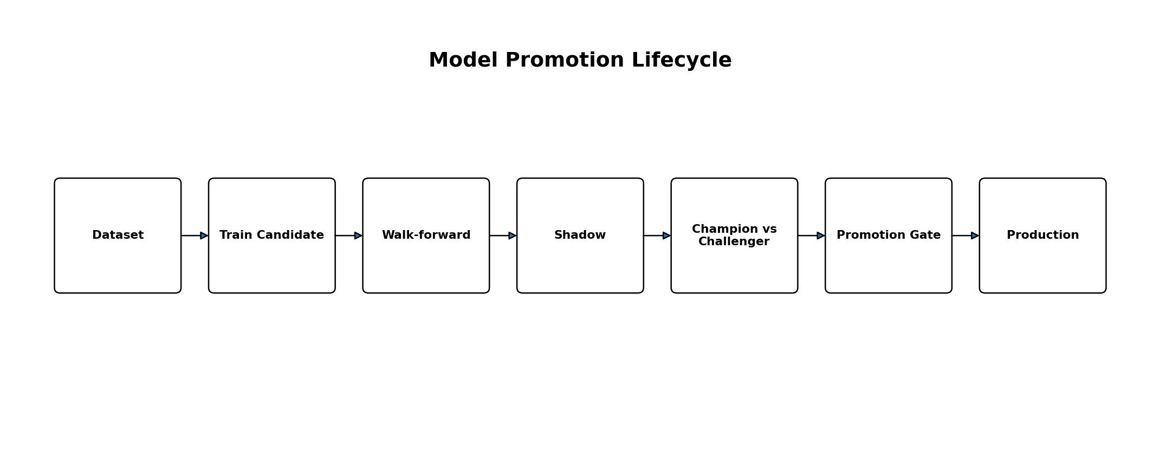
SignalRank should learn continuously from new outcomes, but production should not retrain itself blindly after every trade. Learning and promotion are separate processes.

Model registry
- model ID/version
- training period
- dataset version/hash
- feature schema version
- algorithm/hyperparameters
- calibration method
- validation metrics
- supported assets/timeframes
- training code commit
- artifact checksum
- promotion reason
- deployment timestamp
- retirement reason

Champion/challenger
The production model is the champion. Candidate models become challengers and must outperform or materially improve a defined objective without unacceptable regressions. Challengers should run in shadow mode on current data before promotion.

Promotion gate
- walk-forward evidence
- no leakage detected
- minimum sample size
- stable performance across multiple windows
- acceptable drawdown/tail behavior
- acceptable calibration
- no critical subgroup regression
- shadow-mode consistency
- reproducible artifact
- rollback plan

16. Rejected-Signal Counterfactual Learning
A major improvement is to learn not only from trades that users received, but from opportunities SignalRank intentionally rejected. Otherwise the platform cannot measure whether a filter is protecting users or suppressing profitable setups.

Store reasons for rejection
- below score threshold
- risk gate
- portfolio correlation
- duplicate/cooldown
- data quality
- AI disagreement
- news-event rule
- stale entry
- unsupported user profile
- provider uncertainty

Counterfactual outcome engine
For rejected candidates, simulate a standardized hypothetical entry and management policy where feasible, then compare realized hypothetical outcomes against accepted candidates. The goal is not to rewrite history but to estimate the incremental value of each filter.

Filter value metrics
- losses avoided
- winners missed
- net expectancy contribution
- drawdown reduction
- turnover reduction
- slippage reduction
- signal-volume impact

17. Backtesting and Historical Simulation
A credible backtest should behave like a constrained historical execution simulator, not an indicator replay that assumes perfect fills.

Realism requirements
- bid/ask spread
- fees/commissions
- funding or swap
- slippage
- partial fills
- latency
- market gaps
- minimum order size
- tick size
- lot size
- limit-order non-fill probability
- stop gaps
- session closures
- corporate actions
- futures roll logic

Validation methodology
- walk-forward windows
- purged/embargoed splits when labels overlap
- out-of-sample reporting
- sensitivity analysis
- transaction-cost stress
- parameter stability
- Monte Carlo trade-sequence analysis
- regime-specific results
Backtest honesty
Backtest, shadow, paper, delivered-signal and broker-executed performance must never be blended into one headline number.

18. Shadow Trading and Paper Portfolios
Shadow trading should run viable experimental strategies without showing them to users. This creates a live, forward-looking evidence stream without risking capital or cluttering the product.

Paper portfolio requirements
- initial cash/equity
- reserved margin
- realized and unrealized P/L
- position ledger
- fees and funding
- risk exposure
- drawdown
- equity curve
- trade history
- reconciliation of simulated fills
- strategy and signal attribution

Paper-to-live promotion
A broker execution path should first pass deterministic unit/integration tests, then simulated order-state tests, then paper broker tests, then a sustained live-market shadow period, and only then tightly capped real-money certification.

19. Risk Engine and Position Sizing
Risk should be a centralized service or domain module. Strategies may suggest invalidation and stop logic, but the final allowable exposure belongs to the risk engine.

Pre-trade risk checks
- account equity and available margin
- per-trade risk
- daily/weekly drawdown
- open portfolio heat
- asset concentration
- sector/country/crypto beta
- currency exposure
- correlated positions
- spread/liquidity
- volatility shock
- macro event proximity
- consecutive losses
- leverage and liquidation risk

Sizing methods
Method | Use
Fixed fractional risk | Simple default risk percentage of equity.
ATR/volatility sizing | Normalize exposure for changing price volatility.
Volatility targeting | Keep portfolio risk more stable across regimes.
Conservative fractional Kelly | Optional research tool with strict cap; never use full Kelly blindly.
Risk budget allocation | Allocate exposure across asset/strategy buckets under portfolio constraints.

Circuit breakers
- max daily loss
- max weekly drawdown
- max concurrent positions
- max correlated exposure
- max leverage
- loss-streak pause
- provider-health pause
- stale-data pause
- abnormal-volatility pause
- execution-latency pause

20. Portfolio Intelligence and Capital Allocation
SignalRank should rank opportunities in the context of the user’s existing exposure. Five individually strong crypto longs can be one concentrated risk bet.

Portfolio exposure graph
- asset-level exposure
- currency exposure
- sector/industry exposure
- country exposure
- crypto beta cluster
- equity beta
- risk-on/risk-off factor
- duration/yield sensitivity
- commodity factor
- strategy correlation

Opportunity ranking objective
The long-term objective should be to rank opportunities by expected risk-adjusted contribution to the portfolio, not merely by isolated signal confidence. This makes SignalRank a capital-allocation system rather than a notification engine.
Expected utility =
calibrated edge
x payoff quality
x execution quality
x user suitability
x portfolio diversification benefit
- tail-risk penalty
- transaction-cost penalty

21. Execution Engine and Order Safety
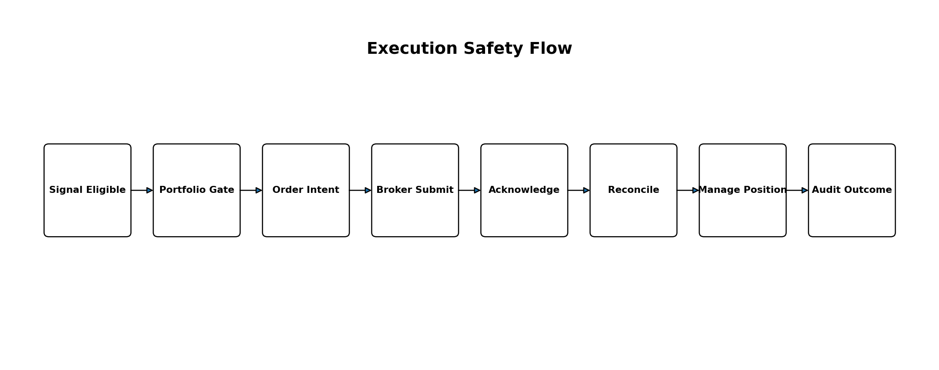
Execution is where software bugs can become immediate financial loss. The execution engine therefore needs stronger invariants than the signal-delivery layer.

Order state machine
CREATED
VALIDATED
SUBMITTING
SUBMITTED
ACKNOWLEDGED
PARTIAL
FILLED
CANCEL_PENDING
CANCELLED
REJECTED
UNKNOWN

Non-negotiable safeguards
- client/order idempotency key
- do not assume timeout means failure
- query broker before retrying unknown submissions
- reconcile internal and broker positions regularly
- record every broker response and transition
- block execution when market data is stale
- pre-submit precision/minimum-notional validation
- kill switch for new orders
- separate signal eligibility from execution eligibility
- withdrawal permissions never required

Automation levels
Mode | Behavior
Manual | Signal and plan only; user executes independently.
Assisted | SignalRank prepares order details; user explicitly confirms.
Automated | Eligible orders execute under pre-approved policy and strict risk caps.

22. Broker and Venue Integration
Broker adapters should expose a normalized capability model while preserving venue-specific constraints. SignalRank should know not only that an account is connected, but what that account can actually do.

Broker capability registry
- market/limit/stop support
- reduce-only
- OCO/bracket support
- fractional quantity
- margin modes
- hedge/one-way mode
- position endpoint semantics
- order query/reconciliation
- WebSocket/private stream support
- rate limits
- instrument metadata
- testnet/paper environment

Connection health
Expose last authenticated call, last private-stream event, key permission summary, IP restriction state where relevant, rate-limit status and reconciliation health. Expiring or misconfigured credentials should trigger a user-visible warning before they cause failed trades.

23. AI Architecture: OpenAI, Gemini and Beyond
AI should enrich SignalRank, not become a single point of trading truth. Quantitative evidence, deterministic rules and risk controls should remain authoritative for trading eligibility. LLMs are best used for synthesis, classification, explanations, anomaly investigation and natural-language interaction.

AI provider abstraction
AIProvider
|- OpenAI
|- Gemini
`- future providers
Capabilities:
structured_review()
explain_signal()
classify_news()
summarize_post_trade()
answer_user_question()
investigate_incident()

Structured output contract
SignalReview {
verdict
confidence_adjustment
supporting_evidence[]
contradicting_evidence[]
risks[]
invalidation_conditions[]
event_flags[]
data_freshness_warnings[]
}

AI safety and reliability
- AI never invents prices or account balances
- source market facts through deterministic tools/data
- schema validation on every response
- timeouts and fallback provider
- cost and latency budgets
- cache repeated context safely
- do not block core scanning when AI is degraded
- store model/provider/version with review
- separate AI narrative confidence from calibrated trading probability

24. News, Macro and Event Intelligence
Market context should include high-impact scheduled events and selected unscheduled news. The objective is not to predict every headline but to prevent SignalRank from treating event-driven conditions as ordinary technical setups.

Event classes
- central-bank decisions/speeches
- CPI/inflation
- employment/NFP
- GDP/PMI
- earnings/guidance
- major regulatory actions
- geopolitical supply shocks
- crypto protocol/exchange events
- commodity inventory/supply events

Event-aware policies
- block new entries
- raise minimum confidence
- reduce size
- shorten entry expiry
- widen slippage assumptions
- classify as event trade
- require AI/news review
- pause selected strategies

25. Signal Explanation, Freshness and Invalidation
A SignalRank signal should be a living thesis, not a static message. Its status can change as price moves, volatility changes, news arrives or the underlying market structure breaks.

Signal card contents
- direction and instrument
- entry zone / preferred entry / maximum chase price
- stop and invalidation rationale
- TP1/TP2/TP3 and management plan
- estimated risk/reward
- calibrated probability and sample context
- regime
- key supporting evidence
- key contradictions/risks
- event risk
- signal age and expiry
- current “enter / wait / no longer enter” status

Freshness decay
Confidence or actionability should decay when the market moves away from the setup, the intended entry is missed, spread deteriorates, the regime changes or a new event invalidates the original evidence. Historical confidence should remain recorded, while current actionability is computed separately.

Trade-management alerts
- entry touched
- entry missed/expired
- TP1 hit
- partial profit suggestion
- move stop to breakeven
- trailing stop update
- thesis weakening
- signal invalidated
- stop hit
- final close

26. Telegram Product Experience
Telegram should feel like a deliberate trading interface rather than a command wrapper. Every button should be state-aware, idempotent and backed by the same core services used by the web application.

Telegram priorities
- rich signal cards
- compact evidence summary with expandable detail
- consistent navigation
- pagination
- chart preview
- paper-trade action
- watchlist actions
- broker/execution status
- quality and performance views
- owner diagnostics
- error messages with reference IDs
- callback expiry handling
- deep links to corresponding web pages

Reliability fixes
- deduplicate update IDs
- verify webhook secret
- idempotent callback actions
- instrument callback latency
- capture stale callback reason
- graceful retry UI
- integration tests for every inline button
- avoid callback payloads that exceed platform limits

27. Web Platform and Control Center
The web application should become the complete SignalRank control center. Core trading capabilities should not require Telegram if the user prefers the website.

Recommended information architecture
- Overview
- Live Signals
- Signal Detail
- Markets
- Watchlists
- Portfolio
- Paper Trading
- Broker Connections
- Execution Policies
- Positions
- Performance
- Analytics
- Strategy Analytics
- Quality
- AI Insights
- Economic Calendar
- News
- Alerts
- Settings
- Billing
- Referrals
- API
- Admin/Operations

Dashboard questions
- What is the market doing?
- What are the strongest current opportunities?
- What am I already exposed to?
- How has SignalRank performed recently and over longer horizons?
- Is the platform healthy?
- Do I need to take any action on an open position, broker connection or risk limit?

Signal detail page
Use a professional chart with entry/stop/targets, strategy annotations, evidence blocks, confidence decomposition, regime context, event risk, historical analogs where statistically valid, lifecycle timeline, actionability status and the paper/manual/assisted execution controls appropriate to the user.

28. Mobile, PWA and Notification Experience
Before investing heavily in native apps, SignalRank should make the web application an excellent mobile-first PWA. Trading decisions are time-sensitive, so loading speed, touch targets, chart usability and notification routing matter more than decorative complexity.

PWA requirements
- installable home-screen app
- fast cached shell
- push notifications where supported
- offline access to recent history/read-only data
- responsive charts
- accessible controls
- low-bandwidth mode
- safe deep links into signals/positions

Notification policy
- user-selected asset classes
- minimum confidence/actionability
- selected strategies/timeframes
- portfolio alerts
- position-management alerts
- daily/weekly recaps
- breaking event alerts
- quiet hours
- channel preference
- rate limiting and digesting to prevent alert fatigue

29. User Profiles and Personalization
Personalization should improve relevance and suitability, not manipulate users into trading more often. SignalRank can rank the same global opportunity differently for two users because their risk capacity, portfolio exposure and preferences differ.

Profile dimensions
- experience level
- account size/risk budget
- risk tolerance
- leverage preference
- preferred asset classes
- timeframes
- holding period
- timezone/session
- notification schedule
- preferred strategies
- connected broker capabilities
- excluded assets
- manual/assisted/auto preference

Personal signal score
Personal Signal Score =
global opportunity quality
x user suitability
x portfolio suitability
x execution suitability
The underlying global signal quality should remain visible so personalization does not become a black box.

30. Analytics, Attribution and Performance Intelligence
Analytics should answer not only whether SignalRank made or lost money, but why. A good analytics system separates strategy quality, market conditions, user actions and execution quality.

Core user analytics
- equity curve
- net P/L and total R
- drawdown curve
- win rate
- expectancy
- profit factor
- Sharpe/Sortino where meaningful
- average holding period
- fees/funding/slippage
- performance by asset
- performance by strategy
- performance by timeframe
- performance by regime
- long vs short

Confidence analytics
For each confidence bucket, show sample size, realized hit rate, expectancy, average R, drawdown contribution and calibration gap. Small samples should be marked as uncertain rather than overinterpreted.

Loss taxonomy
- thesis wrong
- entry timing poor
- late delivery
- stop too tight
- news shock
- regime change
- bad data
- spread/slippage
- execution failure
- user deviated from plan

31. Admin, Owner and Operations Center
The owner console should make SignalRank operable without reading raw logs for routine questions. It should connect product metrics, quant funnels and infrastructure health.

Owner dashboard blocks
- environment and release fingerprint
- service health
- DB/Redis health
- active workers
- queue depth and lag
- scans/hour
- candidates/hour
- eligible signals/hour
- delivery success/failure
- asset-class funnel
- strategy health states
- provider health
- AI spend/latency
- broker execution health
- active subscriptions/revenue
- recent incidents
- model champion/challenger status

Signal funnel
Assets scanned
-> data-quality valid
-> strategy candidates
-> ensemble valid
-> risk valid
-> confidence valid
-> deduplicated
-> user eligible
-> delivered
-> entered/executed
-> outcome finalized
Every stage should expose counts and rejection reasons by asset class, strategy, timeframe and environment. This is the definitive answer to “why are there no signals?”

32. Observability, Reliability and SRE
Reliability is part of the trading edge because stale data, delayed signals or duplicate orders directly reduce strategy performance. Instrumentation should therefore cover business flow and infrastructure flow together.

Metrics
- API latency/error rate
- market-data freshness
- provider latency/error/rate limits
- scan duration
- candidate throughput
- strategy runtime
- queue depth/lag
- database latency/connection saturation
- Redis latency
- AI latency/error/cost
- Telegram delivery latency
- broker execution latency
- reconciliation mismatch count

Distributed traces
scan -> fetch market data -> normalize -> feature compute
-> strategy -> ensemble -> risk -> AI review
-> persist -> eligibility -> notify/execute -> outcome

Structured logging keys
environment, service, git_sha, schema_version,
trace_id, job_id, signal_id, asset_id, user_id,
strategy_id, model_version, provider, severity

SRE policy
Operational alerts should be actionable. “Error count increased” is less useful than “FX scanner has not completed a successful cycle for 12 minutes and EURUSD data is 9 minutes stale.” Alert thresholds should include duration and user impact to avoid noise.

33. Database, Storage and Data Lifecycle
Operational state, high-volume time series, research datasets and model artifacts have different storage needs. SignalRank should keep PostgreSQL as the authoritative transactional system while introducing separate storage only when volume or query shape justifies it.

Storage responsibilities
Storage | Responsibility
PostgreSQL | Users, signals, lifecycle, orders, positions, entitlements, model registry metadata, audit events.
Redis | Locks, rate limits, ephemeral cache, queue coordination, deduplication—not sole durable truth.
Object storage | Large datasets, model artifacts, export files, archived snapshots.
Analytics warehouse/lake later | Heavy research queries, large feature/outcome history and long-horizon analysis.

Database engineering
- purposeful composite/partial indexes
- bounded pagination
- query timeouts
- connection pooling
- partition only when proven necessary
- archive old high-volume raw events
- foreign keys for domain integrity where practical
- unique constraints for idempotency
- migration compatibility checks

34. Queues, Schedulers and Background Work
Background jobs should be explicit, observable and idempotent. SignalRank should not depend on “a worker probably ran” for market scanning, outcomes, notifications or retraining.

Suggested workload queues
- market-data
- scanner
- signals
- outcomes
- notifications
- execution
- AI
- training
- analytics
- maintenance

Job contract
- idempotency key
- attempt number
- timeout
- retry policy
- dead-letter destination
- trace ID
- created/started/completed timestamps
- last heartbeat
- failure reason
- safe replay behavior

Scheduling principles
Schedule work according to market calendars and candle boundaries. Closed equity markets do not need crypto-like scanning frequency. Add distributed locks or leader election so multiple workers cannot unintentionally execute the same scan window.

35. Security, Secrets, Privacy and Access Control
SignalRank handles high-value credentials and potentially automated trading authority. Security therefore needs a dedicated engineering program, not a pre-launch checklist.

Security review scope
- authentication and session security
- authorization/BOLA
- admin privilege escalation
- CSRF/XSS
- SQL/command injection
- SSRF
- webhook forgery/replay
- secret leakage
- dependency vulnerabilities
- CI secret exposure
- broker-key permission review
- audit-log integrity
- rate limiting/abuse controls

Secrets
- never in source control
- never in browser bundle
- never logged
- environment separation
- encrypted broker credential storage
- rotation process
- redaction in support/debug exports
- detect withdrawal permissions and warn/block where possible

RBAC
Use centralized role and capability checks rather than scattered admin conditionals. Example roles: user, premium, VIP, support, analyst, operations, owner and super-admin. Sensitive operations such as model promotion, risk-limit changes and execution-policy overrides require auditable elevated permission.

36. CI/CD, Release Engineering and Environment Parity
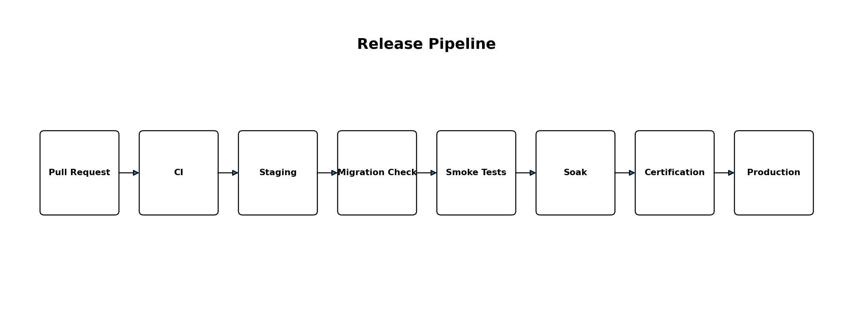
Release engineering should make it difficult to deploy an unknown combination of code, schema and configuration. The previous class of runtime-commit mismatch should become structurally impossible or immediately visible.

Release fingerprint
{
git_sha,
branch,
app_version,
environment,
schema_revision,
build_timestamp,
model_champion,
feature_schema_version
}

CI checks
- format/lint
- type checks
- unit tests
- integration tests
- API contract tests
- migration validation
- frontend build
- secret scan
- dependency/security scan
- golden dataset regression
- configuration validation

Deployment practices
- feature flags
- blue/green or canary where useful
- post-deploy smoke tests
- automatic rollback on critical health regression
- migration-before-code compatibility planning
- no manual production-only patch without source control

37. Testing and Certification Framework
SignalRank needs both software tests and trading-system certification. Passing unit tests does not prove the live opportunity pipeline is correct; conversely, a profitable paper period does not prove there are no software defects.

Testing pyramid
Layer | Examples
Unit | indicators, scoring, risk math, sizing, lifecycle transitions
Property/invariant | no negative quantity, stop/target directional invariants, idempotency, accounting balances
Integration | Postgres, Redis, market providers, AI providers, Telegram, broker sandbox
Contract | provider response schema and symbol capabilities
End-to-end | signup -> settings -> signal -> notification -> paper/execution -> outcome
Chaos | provider outage, Redis restart, DB failover, AI timeout, network interruption
Load | large asset universe, notification burst, concurrent users, strategy compute
Regression | every previously fixed production defect

Golden datasets
Maintain frozen market windows with expected features, strategy candidates and scoring outcomes. A change that alters those results must be intentional, reviewed and documented. Golden datasets catch silent quant regressions that ordinary API tests cannot detect.

Certification dimensions
- asset class
- timeframe
- strategy family
- market session
- provider
- notification channel
- broker adapter
- risk mode
- execution mode
- mobile/web/Telegram surface

38. Incident Response, Disaster Recovery and Runbooks
The goal of incident management is not merely to restore service; it is to reduce the probability and impact of recurrence.

Runbooks
- market provider unavailable
- provider returning stale data
- database unreachable/full
- Redis unavailable
- queue backlog
- Telegram outage
- AI provider outage
- broker API degraded
- broker key compromised
- bot token compromised
- migration failure
- duplicate-order suspicion
- strategy produces abnormal volume
- model quality regression

Incident record
Timeline
User/financial impact
Detection method
Root cause
Immediate mitigation
Permanent fix
Regression test
Monitoring improvement
Owner and due date

Backup and restore
- automated database backups
- retention policy
- regular restore drills
- model artifact backup
- configuration backup
- document recovery time/recovery point objectives
- do not treat untested backups as a completed control

39. Monetization, Entitlements and Commercial Analytics
Commercial logic should be centralized so product capability is consistent across Telegram, web and API. Plan checks scattered through handlers eventually become contradictory and difficult to audit.

Entitlement service
EntitlementService.can(user, capability, context)
Capabilities may include:
- premium signal access
- asset-class access
- advanced analytics
- AI explanations
- paper trading
- broker connection
- assisted execution
- automated execution
- API/webhook access

Commercial metrics
- MRR/ARR
- ARPU
- trial conversion
- paid conversion
- retention
- churn
- plan mix
- feature adoption
- revenue by acquisition source
- AI cost per paid user
- infrastructure cost per active user
- gross margin by plan

Referral system
- referral code/link
- source attribution
- registration
- qualified conversion
- reward
- fraud rules
- chargeback/reversal handling

40. Public API, Webhooks and Ecosystem
Once the internal services are stable, SignalRank can expose a carefully permissioned external API. This should reuse the same entitlement, rate-limit and audit infrastructure as first-party clients.

Possible API areas
- signals and signal detail
- markets and instrument metadata
- performance summaries
- positions (authorized accounts)
- watchlists
- paper-trading operations
- webhook subscriptions

Webhook events
signal.created
signal.eligible
signal.invalidated
position.opened
position.updated
position.closed
broker.connection_degraded
risk.limit_triggered

API safeguards
- scoped keys/OAuth
- per-plan quotas
- signature verification for webhooks
- idempotency
- audit logs
- versioning
- deprecation policy
- no raw broker credentials exposed

41. Compliance, Trust, Data Licensing and User Safety
SignalRank should design for credibility. Trading products lose trust quickly when they blur research with live results, hide sample size, redistribute data without rights or imply certainty that the system does not have.

Trust rules
- clearly label backtest/shadow/paper/delivered/live results
- show sample size and time window
- preserve risk warnings
- do not guarantee returns
- show data age and source category where appropriate
- record methodology changes
- make subscription terms clear
- provide user-accessible execution kill switch

Data licensing
Before commercial redistribution of quotes, charts, news or derived market data, review provider and exchange licensing terms. A provider that allows personal API use may restrict redistribution or public display. Keep licensing metadata in the provider registry so product features cannot accidentally exceed rights.

Regulatory readiness
As SignalRank adds execution, copy-like behavior, paid recommendations or operation across jurisdictions, obtain qualified legal review for the applicable financial-services, marketing, consumer-protection, privacy and recordkeeping obligations. Product architecture should make disclosures, audit logs, user consent and feature restrictions configurable by jurisdiction if needed.

42. Performance, Scalability and Cost Engineering
Performance work should target the critical path: data freshness, scan completion, delivery latency and execution safety. Do not optimize decorative endpoints while repeatedly recomputing expensive features.

High-impact optimizations
- batch provider requests where supported
- use WebSockets for real-time streams when appropriate
- bounded concurrency
- cache canonical metadata
- incremental indicator calculation
- reuse feature computation across strategies
- avoid duplicate candle fetches
- vectorize numerical work
- profile slow SQL
- separate heavy research jobs from real-time workers
- cache AI context/result where semantically safe

Cost attribution
- provider cost by asset class
- AI tokens/cost by feature
- database/storage cost
- worker compute cost
- notification cost
- cost per generated/delivered signal
- cost per active user
- cost per paid plan

43. Research Lab, Experimentation and Statistical Governance
A dedicated research workflow prevents promising ideas from leaking directly into production and reduces cherry-picking. Every experiment should have a hypothesis, dataset, methodology, results and decision.

Experiment record
Experiment ID
Hypothesis
Universe and date range
Dataset version
Feature/strategy/model version
Baseline
Candidate change
Primary metric
Guardrail metrics
Results + uncertainty
Decision
Follow-up

Statistical governance
- minimum sample size
- confidence intervals
- multiple-testing awareness
- out-of-sample confirmation
- walk-forward stability
- parameter sensitivity
- transaction-cost stress
- regime robustness
- Monte Carlo path analysis

Avoid optimization traps
- choosing a parameter because it maximized one backtest
- retraining until a test set looks good
- ignoring failed experiments
- using future revised data
- changing stop/target rules after seeing outcomes
- promoting on a short winning streak

44. KPI, SLO and Health Metric Framework
SignalRank needs three different measurement families: trading/research quality, product quality and platform reliability. They should not be mixed into one vague “system performance” score.

Research/trading KPIs
- expectancy
- profit factor
- net R
- maximum drawdown
- calibration error/Brier score
- risk-adjusted return
- strategy stability
- missed-winner vs avoided-loser rate
- slippage sensitivity
- live vs simulated divergence

Product KPIs
- signal open/view rate
- watchlist adoption
- paper-trading activation
- broker-connect success
- notification opt-out rate
- retention
- paid conversion
- feature adoption
- support/error rate

Operational SLO examples
SLO | Illustrative definition (set final target from baseline)
Market freshness | Critical real-time feeds remain within the asset/timeframe freshness budget.
Scan completion | Scheduled scan cycles complete before the next decision window.
Notification delivery | Eligible signals are delivered within the defined latency objective.
API availability | Core user actions meet an agreed availability target.
Execution reconciliation | Unknown/unreconciled broker orders remain below a near-zero tolerance and trigger immediate escalation.
Outcome finalization | Closed signals receive final outcome and analytics within an explicit lag budget.
Targets should be based on measured baseline and user impact rather than copied from unrelated systems. Error budgets can then guide when reliability work must take priority over feature work.

45. Prioritized Release Roadmap
Release | Scope
Release 1 - Correctness Foundation | Environment parity, migrations, commit fingerprint, canonical lifecycle, identity, provider health, active-signal correctness, current critical bugs, full smoke suite.
Release 2 - True Multi-Asset | Canonical asset registry, calendars/sessions, provider routing, asset-class funnels, strategy coverage declarations, FX/equity/index/commodity certification.
Release 3 - Quant Intelligence | Regimes, ensemble scoring, confidence decomposition, rejected-signal tracking, realistic backtesting, shadow trading, calibration dashboard.
Release 4 - Learning System | Feature/dataset versioning, walk-forward training, model registry, champion/challenger, drift/degradation monitoring.
Release 5 - Portfolio & Risk Brain | Position sizing, correlation/exposure graph, portfolio heat, circuit breakers, opportunity allocation.
Release 6 - Product Experience | Web/Telegram parity, signal detail, charts, quality center, AI assistant, mobile/PWA, notification controls.
Release 7 - Execution | Paper -> assisted -> controlled automation, broker adapters, order state machine, idempotency, reconciliation, kill switches.
Release 8 - Scale & Commercial Platform | API/webhooks, advanced subscriptions, referrals, public evidence, status page, warehouse, canary releases, advanced operations.

Release rule
Do not begin a higher-risk capability merely because development is exciting. Execution should not outrun lifecycle correctness, and autonomous learning should not outrun evaluation discipline. Later releases may be developed in parallel, but production activation must respect dependencies.

46. Production Readiness Certification Checklist

Environment & release
- ☐ Expected Git SHA visible on all roles
- ☐ Expected schema revision applied
- ☐ Environment variables validated
- ☐ No staging/production database crossover
- ☐ Health endpoints green

Data
- ☐ Provider freshness within budget
- ☐ No unexplained candle gaps
- ☐ Asset mapping validated
- ☐ Market calendar/session correct
- ☐ Fallback provider tested

Signals
- ☐ Lifecycle transitions tested
- ☐ Deduplication verified
- ☐ Cooldown behavior verified
- ☐ Freshness/expiry verified
- ☐ No historical record shown as active

Risk
- ☐ Sizing math verified
- ☐ Portfolio limits enforced
- ☐ Circuit breakers tested
- ☐ Kill switch tested
- ☐ Risk audit trail present

Execution
- ☐ Paper adapter certified
- ☐ Idempotent order intent
- ☐ Unknown-order reconciliation tested
- ☐ Partial fills tested
- ☐ Duplicate submission test passes

AI
- ☐ Structured schema validation
- ☐ Timeout/fallback tested
- ☐ No fabricated market facts in tool path
- ☐ Cost limits active
- ☐ AI outage does not stop core scanning

UX
- ☐ Telegram buttons tested
- ☐ Web routes/actions tested
- ☐ Mobile layouts checked
- ☐ Errors have useful messages/reference IDs
- ☐ Settings persist consistently

Operations
- ☐ Metrics/traces/logs available
- ☐ Critical alerts configured
- ☐ Runbooks current
- ☐ Backup/restore test recent
- ☐ Rollback tested
Live-money gate
Live automated execution should remain disabled until every critical certification category passes in the target production-like environment and the owner explicitly enables the feature under conservative limits.

47. Frontier Features and Long-Term Differentiators
After correctness, risk and product quality are mature, SignalRank can pursue differentiators that are difficult to copy because they depend on accumulated data, evaluation discipline and system integration.
Differentiator | Purpose
SignalRank Intelligence Score | Calibrated composite of technical, structure, momentum, liquidity, regime, macro/news, model evidence, strategy historical edge and risk.
Opportunity Graph | Rank all actionable opportunities by expected portfolio contribution rather than asset-by-asset confidence.
Cross-Asset Market Brain | Continuously model factor relationships among currencies, yields, equities, commodities and crypto.
Signal Replay | Replay historical signal formation and lifecycle candle by candle for learning and debugging.
Natural-Language Research Assistant | Ask questions over real SignalRank data: why no FX signals, which strategy degraded, what caused delivery slowdown.
Owner Incident Copilot | Read-only investigation assistant over logs, traces, provider health and funnels.
Strategy Marketplace / Profiles | Curated, certified strategy profiles under the same risk layer.
Public Verification Layer | Verifiable separation of backtest, shadow, paper, delivered and live performance evidence.
Adaptive Execution | Venue/order-type selection based on spread, depth, urgency and historical execution quality.
Portfolio Digital Twin | Simulate the impact of candidate trades before committing capital.

48. Anti-Patterns and Things SignalRank Should Never Do
- Never guarantee a win rate or return.
- Never promote a model because one small recent window looks impressive.
- Never hide sample size behind a confidence percentage.
- Never let AI invent prices, positions or news.
- Never silently trade on stale or corrupted data.
- Never retry an unknown broker order blindly.
- Never use Redis as the only durable copy of critical trading truth.
- Never count correlated indicators as independent votes without adjustment.
- Never mix backtest, shadow, paper and live results into one performance claim.
- Never let one provider’s symbol format leak through the entire codebase.
- Never treat “zero signals” as acceptable without diagnostic visibility.
- Never run experimental strategies on users without explicit promotion.
- Never deploy code whose expected migration state is unknown.
- Never make live execution dependent on an LLM response.
- Never allow broad broker withdrawal permissions as a requirement.
- Never optimize only for signal volume.
- Never change production thresholds without an audit record.
- Never lose the reason a candidate was rejected.
- Never disable risk controls to make a strategy look better.
- Never ship a critical bug fix without a regression test.

49. Suggested Data Schemas and Event Contracts

Signal record
signals
- id
- asset_id
- direction
- timeframe
- strategy_id / strategy_version
- model_id / model_version
- feature_schema_version
- regime_id
- generated_at / data_timestamp
- entry_zone_low / entry_zone_high / preferred_entry
- stop_loss
- target_1 / target_2 / target_3
- expiry_at
- calibrated_probability
- expected_rr
- expected_value_estimate
- quality_score
- risk_score
- current_state
- invalidation_reason
- created_commit_sha

Candidate decision record
signal_decisions
- candidate_id
- gate_name
- gate_version
- decision: PASS / FAIL / WARN
- reason_code
- measured_value
- threshold
- timestamp
- trace_id

Model registry record
models
- model_id
- version
- status: CHALLENGER / CHAMPION / RETIRED
- dataset_id
- feature_schema_version
- train_start / train_end
- metrics_json
- artifact_uri
- artifact_checksum
- training_commit_sha
- promoted_at
- promotion_reason

Order intent record
order_intents
- id
- signal_id
- user_id
- broker_account_id
- client_idempotency_key UNIQUE
- intended_side / quantity / order_type / prices
- state
- broker_order_id
- submit_attempts
- last_reconciled_at
- failure_code

Audit event
audit_events
- id
- actor_type / actor_id
- action
- entity_type / entity_id
- previous_json
- new_json
- environment
- trace_id
- occurred_at

50. Final Target State
The completed SignalRank should behave like a disciplined decision system. It continuously ingests and validates market information, builds a current view of market regimes, evaluates multiple independent sources of edge, rejects weak ideas, calibrates its uncertainty, measures portfolio impact, personalizes delivery, manages the signal lifecycle, optionally executes through safe broker adapters, and learns from every accepted and rejected decision.

Ideal live experience
18,423 instruments evaluated
1,147 strategy candidates
83 passed structural/strategy validation
19 passed quality + calibration + risk
6 currently actionable
Top opportunity:
EUR/USD LONG
Calibrated probability: 0.84
Regime: trend continuation
Entry zone: ...
Stop: ...
Targets: ...
Risk: ...
Key evidence: ...
Contradictions: ...
Event risk: ...
Current actionability: WAIT / ENTER / NO LONGER ENTER
The important part is not the interface numbers themselves. It is that every number is explainable and every state has evidence behind it.

Definition of excellence
- SignalRank can explain why an opportunity exists and why another was rejected.
- The owner can prove every supported market is actually being scanned.
- The system knows the difference between confidence, probability, expected value and risk.
- The platform learns from history without allowing uncontrolled self-modification.
- Web, Telegram and future apps are clients of one consistent capability layer.
- Execution failures cannot silently double exposure.
- Incidents are diagnosable from traces, funnels and health metrics.
- Research claims and live results remain clearly separated.
- Users retain control over risk and automation.
- Growth in users, markets and strategies does not require compromising correctness.

Appendix A. Priority Matrix
Priority | Capability | Reason
P0 | Runtime commit/environment parity | Blocks safe production operation
P0 | Canonical lifecycle and active-state correctness | Prevents misleading/duplicate/stale signals
P0 | Execution idempotency and reconciliation | Prevents duplicate financial exposure
P0 | Data freshness/quality gates | Prevents decisions on corrupted data
P0 | Asset-class coverage diagnostics | Proves non-crypto paths actually work
P1 | Canonical asset registry | Foundation for multi-provider/multi-broker scale
P1 | Risk engine + circuit breakers | Required for controlled execution
P1 | Shadow/paper trading | Forward evidence before live capital
P1 | Observability + signal funnel | Makes failures diagnosable
P1 | Web/Telegram parity | Consistent user experience
P2 | Model registry + champion/challenger | Safe continuous learning
P2 | Counterfactual rejected-signal learning | Measures filter value
P2 | Regime engine | Improves strategy suitability
P2 | Portfolio exposure graph | Reduces correlated risk
P2 | AI provider abstraction | Resilience and structured intelligence
P3 | Public API/webhooks | Ecosystem expansion
P3 | Native apps | After PWA quality is high
P3 | Strategy marketplace | Requires mature governance
P3 | Cross-asset market brain | Advanced differentiator
P3 | Adaptive execution | Advanced post-certification optimization

Appendix B. Acceptance Criteria by Release
Release | Acceptance gate
R1 | All roles expose the same expected release fingerprint; schema current; signal lifecycle regression suite passes; no unexplained active-signal mismatch; every Telegram core action passes E2E.
R2 | Each target asset class has certified provider mapping, session logic, strategy coverage and signal-funnel visibility; zero-output causes are explainable.
R3 | Regime/ensemble/calibration dashboards operate on shadow/live-forward data; rejected candidates receive counterfactual outcomes; backtest includes realistic costs.
R4 | Dataset/model registry exists; walk-forward pipeline reproducible; challenger cannot self-promote; drift/degradation alerts work.
R5 | Portfolio risk and sizing enforced consistently; circuit breakers/kill switches tested; opportunity ranking uses portfolio context.
R6 | Core user capabilities have web/Telegram parity; mobile layouts verified; AI explanations are structured and grounded in system data.
R7 | Paper and assisted execution certified; order state machine handles timeouts/partials; reconciliation proves no duplicate exposure in fault injection tests.
R8 | Commercial/API scale features use centralized entitlements, rate limits, audit logs and cost analytics; status/operations tooling supports growth.

Appendix C. Glossary
Term | Definition
Actionability | Whether a signal remains suitable to enter now, distinct from its original confidence.
Calibration | Agreement between predicted probabilities and observed frequencies.
Candidate | A potential signal before all gates pass.
Champion | Current production model.
Challenger | Candidate model evaluated against the champion.
Counterfactual | Estimated outcome of a rejected decision under a defined hypothetical policy.
Drawdown | Decline from a prior equity peak.
Expectancy | Average expected return per trade, commonly expressed in R or currency after costs.
Feature drift | Change in the distribution of model inputs.
Idempotency | Property that repeating an operation does not create duplicate effects.
MAE | Maximum adverse excursion while a trade is open.
MFE | Maximum favorable excursion while a trade is open.
Portfolio heat | Aggregate amount of capital at risk across open positions.
R | Return or risk unit relative to the initial planned risk.
Regime | A classified market environment such as trend, range or volatility expansion.
Reconciliation | Comparing internal orders/positions with the broker’s authoritative state.
Shadow trading | Running strategies on live data without user delivery or capital.
Signal funnel | Counts and rejection reasons across each stage from scan to delivery/execution.
SLO | Service Level Objective for reliability or latency.
Walk-forward | Time-ordered train/validate/test process rolled through historical periods.

Closing Statement
There will always be future research ideas, new markets and new execution techniques. The goal of this blueprint is therefore not to freeze SignalRank permanently. It is to establish a foundation strong enough that future improvements can be added without sacrificing correctness, traceability or user safety. Once these principles, gates and interfaces are in place, “adding more” becomes disciplined evolution instead of accumulating hidden risk.
Final architectural principle
SignalRank should optimize for trustworthy decisions under uncertainty. Every feature is secondary to that.

