Ordening files in folders

Files and folders

Excercise

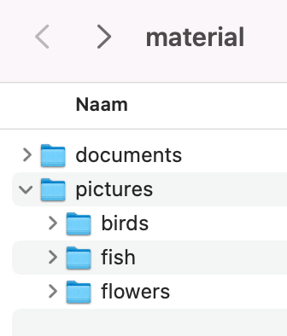

In this zipfile there are documenten, and pictures. We are going to orden them by creating folders in a logical structure and move the files to them. The structure of the files is shown in the picture above

Try to

1. start Windows Explorer (for example with shortcut Win+E);
2. create a folder with the name *files_folders*;
3. create folders inside this named: *documents* and *pictures;*
4. inside *pictures* create folders *birds* and *fish* and *flowers*;
5. move the files from this zipfile to the appropriate folder;
6. open this excercise and export it to pdf-file and to txt-file in the *documents* file;
7. compress the *files_folders* folder to a zip-file and share it with me.