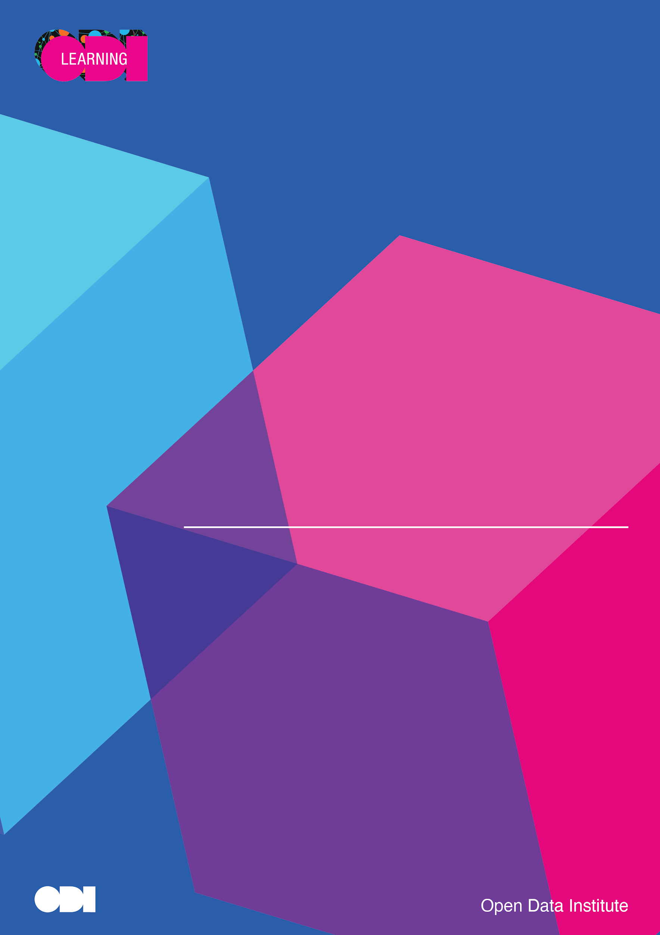

{{doctitle}}

ODI Consequence and Risk Evaluation (CARE)

Published: {{date}}

## Contents

Contents 1

About 1

{{title}} 2

Aim 2

Intended Consequences 2

Data used 2

Stakeholders 2

Risk summary 3

Likelihood 3

Impact 3

Risk 3

Priority risks 3

Risk management table 4

Additional resources and support 5

The Data Ethics Canvas 5

What is the Data Ethics Canvas? 5

Consultancy Services 5

Expand your knowledge and skills 5

## About

The author of the document, and responsible owner is {{author}}.

This report was generated by the Open Data Institute's CARE tool. The Open Data Institute assumes no responsibility or liability for the accuracy, completeness, or reliability of the contents herein, which are the sole responsibility of the author. Any decisions or actions taken based on the information provided in this report are at the discretion and risk of the author and reader.

## {{title}}

### Aim

{{objectives}}

### Intended Consequences

{{intendedConsequences}}

### Data used

{{dataUsed}}

### Stakeholders

{{stakeholders}}

## 

## Risk summary

|  |  |
| --- | --- |
| **Risks** | **Stats (average)** |
| {{donutChart}} | **Likelihood**  {{averageLikelihood}}  **Impact**  {{averageImpact}}  **Risk**  {{averageRisk}} |

## Priority risks

{{topRisks}}

### Risk management table

{{unintendedConsequneces}}

## Additional resources and support

### The Data Ethics Canvas

#### What is the Data Ethics Canvas?

The Data Ethics Canvas is a tool for anyone who collects, shares or uses data.

It can help you to identify and manage ethical issues – at the start of a project that uses data, and throughout.

It encourages you to ask important questions about projects that use data and reflect on the responses. These might be:

* What is your primary purpose for using data in this project?
* Who could be negatively affected by this project?

The Data Ethics Canvas provides a framework to develop ethical guidance that suits any context, whatever the project’s size or scope.

[Learn more about the data ethics canvas, download it or access learning](https://theodi.org/insights/tools/the-data-ethics-canvas-2021/)

### Consultancy Services

In all our work, we invest the time to get to know you and your business. We are creative and professional and unafraid to be your critical friend. Like you, we believe in doing work that makes a difference, so we evaluate our projects to demonstrate their impact.

[Learn more about what we do](https://theodi.org/what-we-do/consultancy-and-products/)

### Expand your knowledge and skills

The ODI provides everyone hands-on experiences of working with data where they can discover for themselves the implications of data on business and society. Our goal is to help everyone become more data literate and confident with applying their skills back in their organisations.

[View all our courses](https://learning.theodi.org/courses)