Scheme in Z

Codul asupra caruia sunt create schemele:

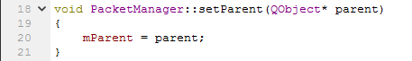

SetParent cu parametrii [mParent] [parent]

SetParent

|  |
| --- |
| Player  Player’  parent1?:parent  parent2!:mParent |
| parent1? $ϵ$ parent_get\dom parent_set  parent_set’=parent_set $∪\{parent1 ?→$ parent2!}  parent_get’=parent_get |

Player cu parametrii [Parent] [mParent]

Player

|  |
| --- |
| parent_get: $P$ parent  parent_set: Parent $↛$ mParent |
| dom parent_set $⊆$ parent_get |