Theodora Nguyen

Professor David-Guy Brizan

CS 245-01

2 March 2020

Assignment 1

Part 1, Defense for Quadratic Sort Algorithm:

For Part 1 of Assignment 1, I decided to implement Insertion Sort as my quadratic sorting algorithm. If an array list is nearly sorted, Bubble Sort and Selection Sort will still iterate through the array to check if every element is in the right order. Insertion Sort will sort any elements that need to be sorted and will not take extra steps if it has completely sorted. Thus, insertion sort has the fastest run time out of all the quadratic sorting algorithms.

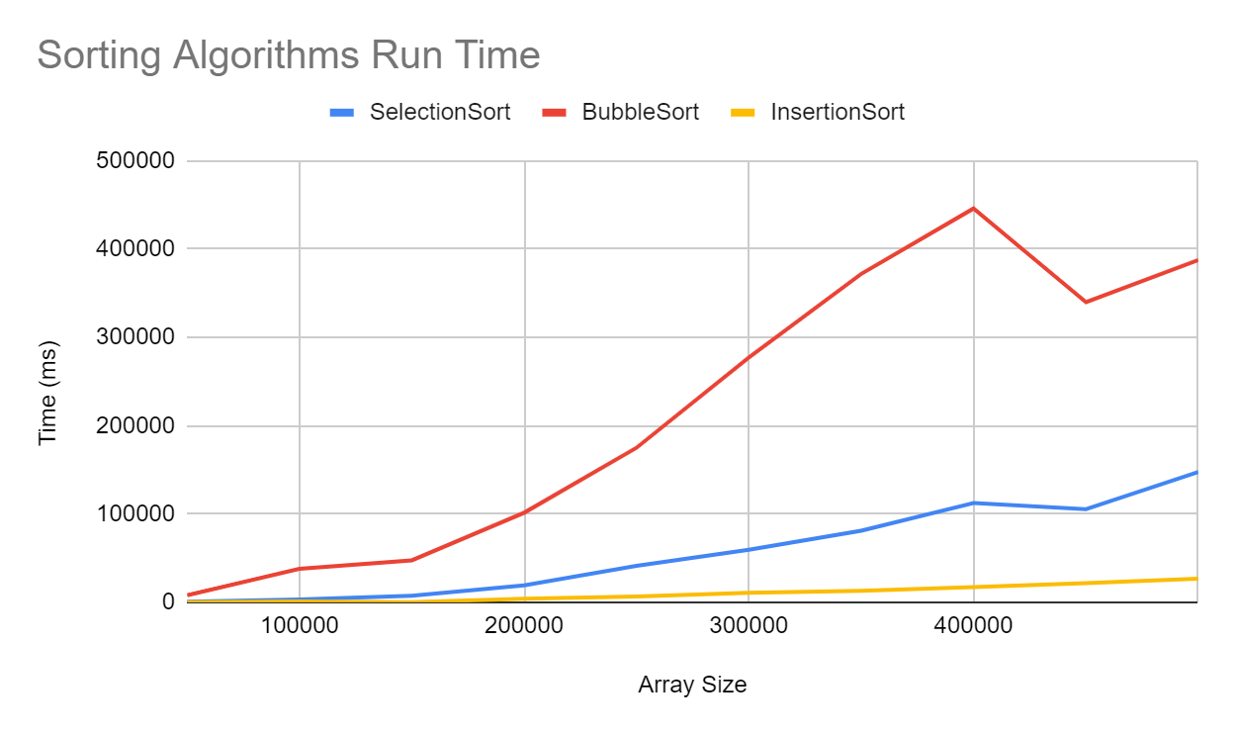

Part 2, Defense for Algorithm:

Because there are multiple files, I decided to implement merge sort because it can sort out of place. It is good for sorting slow-access data. Other algorithms are not nearly as fast.