The C++ Language Layer for The Teaching Machine©
Revisions
- Original December 1997
- Updated symbol table interface. Jan 13, 1998.
- Changes for JavaCC 0.7 (1998 Jan 22)
- Major rewrite for Winter 2001.

Note
This document describes the original implementation of C++, which has been superceded by a new implementation. See document cpp.doc for documentation of the new implementation.

Packages

The C++ language layer consists of the following packages.
- CPlusPlus. Implements the façade class for the C++ subsystem.
- CPlusPlus.Datum. Contains representations of the data objects of the subject program.
- CPlusPlus.AST. Contains representations of the subject program. The behaviour associated with the representations constitutes the interpretation of the subject program. Thus this package also contains bulk of the interpreter,
- CPlusPlus.Parser. Contains code to create an AST representation from an input string.
- CPlusPlus.Symtab. Representation of the symbol table.

Warning: As this is being written the C++ layer is still incomplete and the documentation will inevitably be incomplete as well.

The CPlusPlus Package

Class CPlusPlusLang
This class implements the `language’ interface (see the virtual machine layer interface document) and thus represents the interface to the entire C++ subsystem. All calls to the subsystem begin with this class.

The CPlusPlus.Datum Package
This package contains a hierarchy of types implementing data objects of various types. Each primitive C++ type and each C++ type constructor has a corresponding class in this package. The hierarchy so far is
AbstractDatum – implements Interfaces.Datum
AbstractScalar
AbstractInt
BoolDatum
CharDatum
IntDatum
LongDatum
AbstractFloat
FloatDatum
DoubleDatum
DoubleDatum
CinDatum
CoutDatum
AbstractPointer
PointerDatum
RefDatum
ArrayDatum
StructDatum

Datums are essentially immutable objects. They are initialized with attributes that do not change over the lifetime of a data-object, such as address and parent. The actual value of the data object (e.g., after executing i=13 the value of the data object named by i is 13) is not stored with in a Datum object. Instead, it is stored in the Memory object that constitutes a part of the VMState object. In a sense, the Datum objects provide interpretations to the Memory object.

Class AbstractDatum
public abstract class AbstractDatum implements Interfaces.Datum {

protected AbstractDatum(int add, int s, Datum p, Memory m, TypeNd tp) ;

/** Return the # of bytes storage required */
public int getSize() ;

/** Return the enclosing datum, or null, if none */
public Datum getParent() ;

/** Return the address of the first byte */
public int getAddress() ;

/** Return the byte value 0..255 of a byte (indexed from 0) */
public int getByte(int i) ;

/** Return the type of the datum */
public TypeInterface getType() ;

/* Write the value of the datum to the output window */
public void output( VMState vms ) ;

/** copyDatum --- requires that source has the same type as
this. Thus any conversions should already have taken place. */
public abstract void copyDatum( AbstractDatum source ) ;

/** getValueString --- Return a string suitable for display in the expression
window, memory window, or output window. */
public abstract String getValueString();

/** getTypeString --- Return a string suitable for display representing the type */
public abstract String getTypeString();

/** See GUI interface documentation */
public abstract Datum getChildDatum(int add);

/** Create a new datum at location addr which is a copy.*/
public abstract AbstractDatum copyTo(int addr) ;
}

In addition scalar datum classes have getValue and putValue methods. These are declared farther down class the hierarchy because there is not a single type suitable for these methods.

Pointers and references have a method
public Datum deref() ;
to dereference them. This method returns null if no datum of the right type can be found at the current address of the datum. putValue and getValue are provided, respectively taking and returning an int. NULL pointers have a value of 0.

Arrays are represented by members of ArrayDatum. After an object of this class is created, its members should be created and added using
public void putDatumAt(int i, Datum d ) ;
A similar mechanism exists for Structures.

Package CPlusPlus.AST
This package is by far the most diverse. Its classes have two responsibilities: representing the structure of a C++ program and interpreting the C++ program.

Aside. AST stands for Abstract Syntax Tree, but a better name would be Abstract Syntax Representation, as the representation of function bodies in particular is not a tree, but a graph.

Class ASTUtilies
This is a collection of static methods of common use in interpretation.

Class Node
Almost all classes of the package descended from class Node are in a hierarchy as follows
Node
ExpressionNd --- Represents expression trees
FunDfnNd --- Represents function definitions
VarNd --- Represents global variable definitions
TypeNd --- Represents types.
StatementNd --- Represents statements

All nodes contain a sequence of 0 or more children. This allows the nodes to easily be formed into trees. The interface is as follows:
public void addFirstChild( Node xx ) ;
public void addLastChild( Node xx ) ;
public NodeList children() ;
public Node child(int i) ; /* Indexed from 0 */
However, not all sorts of nodes take advantage of this general mechanism. Those that do can be formatted using a call to toString.

Expression Nodes
Expression Nodes represent expressions in a normal tree-like fashion. They support LanguageInterfaces.ExpressionInterface (see the Virtual Machine Layer Interface). Thus they can be stepped, selected, and converted toString. After an expression node has been stepped to produce a value, it records this value in the top evaluation of the evaluation stack. See the Virtual Machine Layer Interface for a more detailed discussion of how expressio evaluation works.

Expression node classes are arranged in a heirarchy according to how many children they have and how they are evaluated.

Here is a look at how one sort of ExpressionNd behaves. OpAbsBinBup is used to represent operations like addition that require full evaluation of both operands.
- Selecting: Each operand must be evaluated to a value (not just a reference), but it doesn’t matter which is evaluated first.
- If both operands have been evaluated to values, then the current node (the OpAbsBinBup) is selected. I.e., the current node is made the selected node of the current top Evaluation.
- If one operand has been evaluated to a value, then the select is delegated to the other operand.
- Otherwise one operand is selected to be evaluated first, and the select is delegated to that operand.
- Stepping: By the time the OpAbsBinBup is selected to be stepped, both its operands will have values (Datums) in the current top Evaluation. But they may have incompatible types. If either operand needs conversion, this is done in one step. Otherwise the appropriate operation is applied to their values, and a new datum is created representing the result. The result datum is mapped to the current (OpAbsBinBup) node.

Variables are also interesting to consider as they are prototypical of lvalues (i.e. expressions that can occur on the left-hand-side of an assignment operator). Variable expressions are represeted in the AST by IdNds. These behave in the following way.
- Selecting: As these node have no children, they always select themselves.
- Stepping: For IdNds representing variables, stepping is done in the following way:
- If the node is mapped to null in the current top Evaluation, then a reference datum (class RefDatum) is created and the mapping is changed in the current top Evaluation, so that the IdNd maps to the new reference datum.
- If the node is mapped to a reference datum, then this means the node has already been stepped once and has been reselected. This happens because the node’s parent was not satisfied with the reference datum; required a real value. In this case, the reference datum is replaced with a copy of the datum to which it refers.
Example: Suppose we have int i ; i = 0 ; j = i ; the IdNd in the first assignment expression is selected and stepped producing a reference to the actual datum in the stack memory named i . The parent node (the assignment operator), then uses this reference to find and change the original datum. In the second assignment the IdNd for i is selected and stepped as before to create a reference datum. But the parent, this time requires a real value (an rvalue), so it selects the IdNd a second time and it is stepped a second time, producing a datum of class IntDatum, which is a temporary copy of the original.

The question arises: Why bother with these reference datums? Why not just map the IdNds to the corresponding Datum in the memory? The answer is that when we are through with a temporary datum, we must destroy it. For example in 1+2*3 the datum representing the product is destroyed as the addition is being done. In 1+i it would be wrong to destroy the datum representing the value of i unless it were are copy. However, I am left wondering if there might not be a better way.

Temporary datums (those created as part of the evaluation process are currently kept on the top of the stack. This has a big problem. Consider ‘a’+1. Suppose the ‘a’ was evaluated first and the 1 second. As the + node is being stepped, we notice that the character must be converted to an int. We actually want this to be a separate step, as the conversion should be displayed in the Expression Window, if we are single stepping. But to convert a character to an int where characters take 1 byte and ints take 4, is hard to do in place on the stack, especially when there is another datum (the 1) sitting above the character. A second reason is the we don’t want all these temporaries showing up in the Stack Window. That is what the Expression Window is for. From the point of view of realism, we could go either way. Some compilers put all temporaries on the main stack, others use a separate stack, or registers. Anyway, for the above reasons the temporaries will likely be stored in a fourth memory region called the scratch pad which will be managed as a heap. The scratch pad corresponds to the registers of the machine.

Function Definition Nodes
A function definition node (class FunDfnNd) represents a function definition like
int foo(char c) {return c+1 ;}
It consists of a name (foo), a type (function taking one char and returning int) a list of parameters (char c), and a body which is represented by the first statement.

Variable Definition Nodes
These represent variable definitions. Each variable definition consists of a name, a type, and an initializing expression. There is a special class NoExpNd for expressions that aren’t there, which is used for uninitialized variables.

Type Nodes
Type nodes represent types found in the program. Either primitive, or compound. For example if a declaration int *i[10]; is encountered a type tree is built consiting of three nodes:
array(10) of à pointer to à int

Type nodes do not use the generic child mechanism of the Node class. Instead type constructors contain members of type TypeNdLink. A TypeNdLink is simply a `mutable reference’ (i.e. a pointer) to a TypeNd.

One important behaviour for type nodes is creating datums of corresponding type. For example a node representing the type `array of 10 pointers to int’ can actually create an array of 10 pointers to int. The method is
public abstract AbstractDatum makeDatum(
VMState vms,
MemRegion mr,
AbstractDatum parent) ;
This is an example of Gamma et. al.’s Factory Method design pattern.

Statement Nodes
C++ supports many different kinds of statements. During parsing the statements of each function are converted to a control flow graph (essentially a flowchart) constructed out of various kinds of statement nodes. All these statement nodes implement the LanguageInterfaces.StatementInterface and thus can be stepped and selected.

Local variables are removed from the stack and the symbol table on the first step of the first Statement Node encountered that is outside of the variable’s scope. For example in the code
{int i = 2*j+10 ;
j = j-i ; }
k = j ;
The local integer i is removed from the stack and the symbol table when the StatDo (a kind of StatementNd representing the k=j; statement is first stepped. To accomplish this, each StatementNd contains the number of local variables that should exist when it is encountered. Any excess variables are removed.

The selected statement node uses the current top Evaluation to store a record of how far it has progressed in its exection. This value is null if the statement node is in its initial (just selected state) and is a small integer for other states of evaluation. For example a StatDo (repsonsible for executing expressions whose value is to ignored) has 2 states of execution.
- null – when stepped it pushes a Evaluation for the expression on the evaluation stack and changes to state 1.
- 1 – when stepped, it removes the expression’s value from the memory stack, selects the next node and changes the state back to null (ready for next time).
This technique is a little weird. It is killing a fly with a sledgehammer (Evaluations), but the sledgehammer was lying around anyway for expression evaluation.

Statement nodes are linked together using StatementNdLinks, which are simply mutable references to StatementNds.

CPlusPlus.Parser

Parser source code generation
The parser is produced using the Java Compiler Compiler (JavaCC) version 0.7.1 from Metamata (formerly from Sun). The JavaCC specification is in file cplusplus.jj. The specification describes the lexical structure of C++ and a recursive descent parser for a subset of C++. The output of JavaCC is a number of java source files:
- ASCII_CharStream.java --- standard class
- ParserException.java --- standard class
- TokenMgrError.java – standard class
- Token.java --- standard class
- cppparserConstants.java --- used behind the scenes
- cppparserTokenManager.java --- lexical analyzer
- cppparser.java --- parser
The last two are the interesting ones. Their public classes are used in CPlusPlusLang.parse to provide a lexer and a parser respectively.

The generated files are created by the DOS command javacc. So one has to install the javacc program before modifying the cplusplus.jj file.

Parser creation.
When a file needs to be parsed the following steps are taken (in the CPlusPlusLanguage class, method parse)
- A new cppparserTokenManager is created. It is initialized with the string consisting of the file’s contents.
- A new cpparser is created. It is initialized with the cppparserTokenManager created in the last step.
- The parser’s main entry point (method translation_unit) is then called with a freshly created VMState object to parse the file.

During the parsing process, the symbol table is initialized with all the global declarations. This is the only effect of parsing.

File Sources
A FileSource is a source of input files. This might represent a directory on the host computer or it might represent a directory accessed over the internet by http. Include
files will be searched for in a FileSource.

interface FileSource {
/* Finds and opens the file of the
InputStream getInputStream( String filename) throws IOException ;
}

Preprocessing
The preprocessing step has not yet been designed.

Multiple Translation units

Parser design.
The parser is a recursive descent parser. This means that each nonterminal of the context free grammar is represented by a method that is responsible for consuming an example of that nonterminal in the input, or reporting an error by raising an exception. For information on recursive descent parsing see Aho, Sethi, and Ullman, Compilers, Principles, Techniques, and Tools, Addison Wesley, 1986. For information on and documentation of JavaCC, see http://www.metamata.com.

Most nonterminal methods return some kind of AST Node. For example, the method expression, which parses statements, returns a ExpressionNd.

In other cases, other techniques are used. For statements, the method statement is passed in a StatementNdLink, which must be set to point to the first statement node of the control flow graph generated for the parsed statement. Furthermore, the method returns a StatmentNdLink which should be set to the node representing the node to go-to after the parsed statement completes normally (i.e by control falling out of the bottom).

Expression Parsing
Expressions are parsed using an algorithm of Keith Clarke’s. Until this is better documented, here is a description of the idea http://www.metamata.com/JavaCC/FAQ/june-augmail/237.html. See also the comments in the code.

CPlusPlus.SymbolTable
The symbol table is the least developed package in the program at the moment. The following documents its current features, but is subject to change and will be extended.

By rights, the symbol table should be part of the Virtual Machine Layer. But as it is hard to create a symbol table interface suitable for all conceivable languages, it is instead part of the language layer. Someday, it would be nice to make the symbol table machine independent.

Representing variable bindings
The run-time association of variable names to datums is perhaps the most important
function of the symbol table. All variables belonging to a single subroutine invocation are grouped together in a structure called a frame. The frames in turn are grouped as a stack. Each frame consists of a `static link’ and a stack of associations between names and references to datums.

For example, consider the following code.
int i ;

int main() { ß A
int i ; ß B
f(10) ; }
void f(int j) {
int k ; ß C
return ; }
As execution begins at point A there is one frame (representing all the global variables).
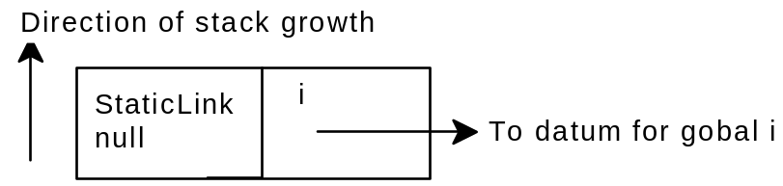
Figure 1 As execution begins
As the main function starts a new frame is pushed for the local variables of main. As once the declaration of the local variable i is processed the situation looks like this.
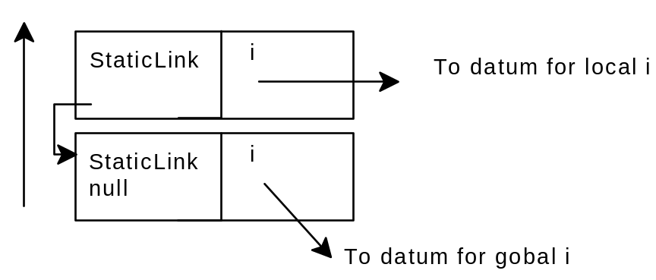
Figure 2 At point B
As the call to subroutine f is executed, a new frame is pushed and one entry is pushed onto the frame for each parameter. After the declaration of k. The symbol table looks like this.
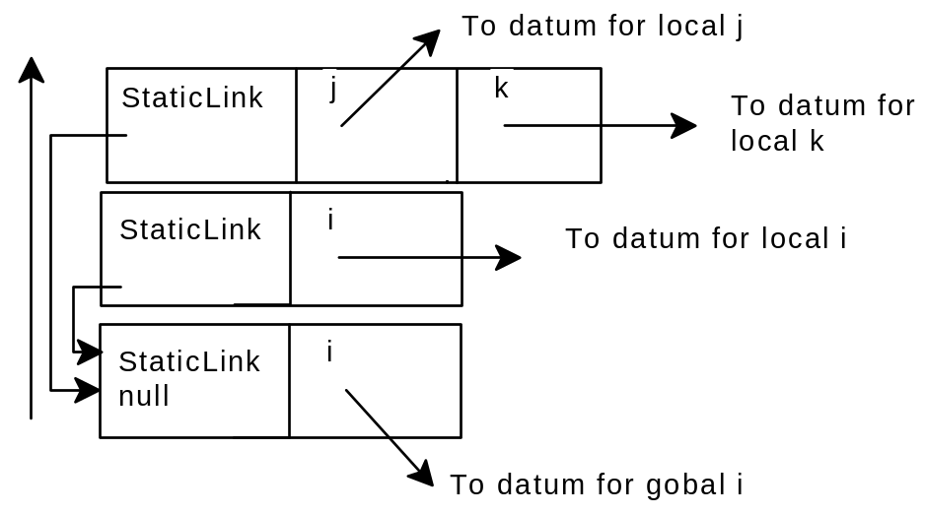
Figure 3 At point C
Searching for a variable of a given name (variable lookup) begins with the top variable in the top frame. If the variable is not found in the top frame, then the static link is followed to find the next frame to search. Notice that in Figure 3 the middle frame (corresponding to the invocation of main) is skipped. Thus a refernce to i will refer to the global variable i.

Class SymbolTable

The symbol table object is used during both parsing and interpretation to keep track of which names are known at each point and of what they represent. The symbol table must be backtrackable.

public class SymbolTable implements backtrack, ViewableST {

/** Constructor */
public SymbolTable()

/** COMPILE-TIME FUNCTIONS */

/** Add function definitions */
public void newFunctionDefn( FunDfnNd def )

/** Static global variables */
public void addStaticGlobal( String name, AbstractDatum d)

/** RUN-TIME FUNCTIONS */

/** Retrieve function definition */
public FunDfnNd getFunctionDefn( String name )

/** Enter function -- push a scope */
public void enterFunction()

/** Exit function -- pop a scope */
public void exitFunction()

/** Add a new auto variable to the current stack */
public void newVar(String name, AbstractDatum d )

/** How many vars are in the current top frame */
public int varsInCurrentFrame()

/** Delete one variable */
public void deleteVar()

/** Get a variable by name. Returns null if not found */
public VarEntry lookupVar( String name )

/** Checkpoint -- see the backtrack interface */
public void checkpoint()

/** Undo -- see the backtrack interface */
public void undo()

/** getEntry -- see the ViewableST interface. */
public STEntry getEntry(int index)

/** getEntryAt --- see the ViewableST interface */
public STEntry getEntryAt(int address

/** size --- the number of entries that getEntry can return */
public int size()

}

