Graphical Animation of Data Structures and Algorithms©

Revisions
- Original. 17 Nov 1997. TSN
- Suggestions from MPBL. Including some representations. 21 Nov 1997. TSN
- A couple of updates. 23 September 1998. TSN

Goals
- Graphical display of structures, pointers (including references), arrays and scalars, on static, heap, or stack.
- Uniform notation for blackboard and screen.
- User control of format.
- Automatic layout of data structures such as linked lists, trees, and graphs.
- Notation is 3-D: two screen dimensions + time.
- For example, data structures should not jump around more than necessary when the state changes.
- The display should use the standard interface to the higher-layers of the TM.
- Effective use of screen area.
- Abbreviation, elision, and scrolling under user control.
- Perhaps abbreviation, elision, and scrolling under program control.
- Fish-eye views or similar techniques?
- The implementation will be based on the Teaching Machine.

Ideas

On notation
General: Each Datum (data item) is represented by a rectangle. The address may optionally be printed next to it.
Variables: Names next to (or above) representation.
Scalars: Box containing value.
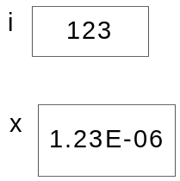
Arrays: Box containing elements vertically. Elements labeled by indexes:
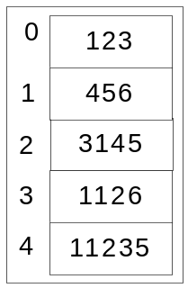
Horizontal layout should be an option. Pictures of arrays should be resizable. If not all elements can be held in the given size, then scroll bars should be added.
Class members and structures: Box containing data members vertically. Data members labeled by member names:
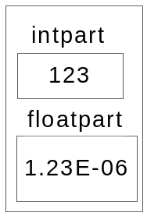
As with arrays, horizontal layout, size changes, and scrolling should be possible.
Pointers and references: Box containing the tail of an arrow pointing to the pointed-to object.
Example: After p=&s:
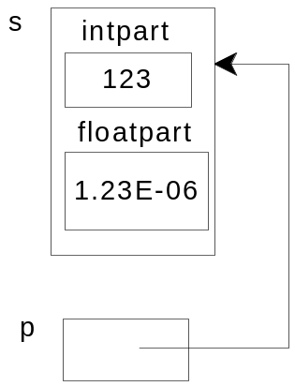
Example: After q=A+2:
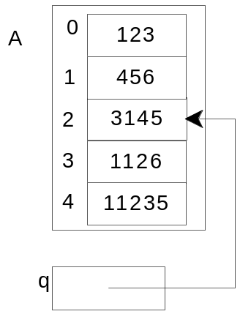
Null pointers:
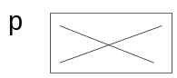 or 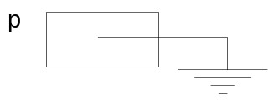 or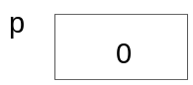 or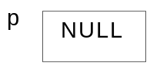. The last 2 might be a bit too C-centric.
Bad pointers: A pointer is bad if it is not null and does not dereference to a datum. For example, deleting a heap object will cause any pointers to it to go bad. A bad pointer might be displayed as
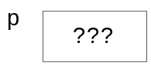 or 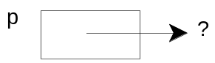
Optionally, the numerical value of the pointer might also be displayed.
It may be necessary to distinguish references from pointers. At the moment, they are both seen by the GUI as AbstractPointers.
Other representations: For sorting algorithms, it is nice to display natural numbers in boxes of size proportional to their value. In other cases, we may want the size of a box to indicate the space required by its contents. There may be other examples where nondefault representations will be useful. Also, whatever we decide over the next few months is unlikely to be the final solution. So the design and implementation must recognize this as an area of likely change.

On layout
Objects should be laid out neatly and with a minimum of crossing and joints in lines.
Lines should not coincide.
Stack and static variables should be located at predicable locations. (Perhaps in a stack on the left hand side of the display.)
Heap objects should not be displayed in the viewport unless they are reachable from some stack or static datum in the viewport. Furthermore, if the viewport gets too crowded, then not every such object can be displayed. Perhaps those with the longest shortest path from a stack or static datum should be the first to go.
[[Mike comments “Scope”. Not sure what you mean. But it raises the old question of whether to show all variables on the stack or only those currently accessible.]]
If a pointer is displayed, but not that to which it is pointing, then it is elided. Elided pointers might be displayed as
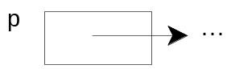
There are certain conventions for the layout of certain kinds of data structures. E.g. trees and lists. It would be nice to find general-purpose layout heuristics that lead to these data structures being displayed in a fairly conventional way.

On time
The display is not a static thing, but will evolve over time as the underlying algorithm is executed. The idea of layout extends then into the temporal dimension. The object is to end up with a movie of the process.
In particular, the layout should not be done afresh for each refresh of the display. It is important to highlight the changes to the data, by not changing the position of things that have not changed. Thus the representation of each datum must not be moved, once it is placed unless there is a command from the user requesting a redraw, or it is lost from view.
An alternative is that datums may be move, but they do so in an animated fashion. I.e., they slide from position to position with all pointers tracking them.
In any case, it is important that the display engine can identify when it gets a datum that it has gotten before. For this reason, the display-manager may assume that the same source object will be represented by the same datum each time it is requested of the CommandProcessor object.

On interaction
Ideally, user interaction should rarely be needed. Ideally, the user need only advance the execution of the program.
However, we may want to allow the user several forms of interaction with the display: eliding and expanding arrays, structures, and pointers; scrolling the display vertically (to change the set of stack/static variables visible); scrolling through arrays; moving screen representations on the screen; changing the size of the displayed area.
The user may also have control of parameters controlling layout: the format for displaying different kinds of objects; the size of the font used; etc.

On program control
It may be possible for the program itself to control the display. Commands embedded in the program (and perhaps not displayed to the user) could control the display.

Example algorithms
This section includes a number of algorithms, used in teaching Data Structures, which might be suitable for display with the teaching machine. They are based on the following types:
struct LNode {
int data ;
LNode *next ; }

struct TNode {
int key ;
char data ;
TNode *left ;
TNode *right ; }

Length
int length( LNode *p ) {
int i = 0 ;
while( p != 0 ) {
i += 1 ;
p = p->next ; }
return i; }

Copy 0
void copy( LNode *src, LNode *&targ ) {
if( src == 0 ) targ = 0 ;
else {
LNode *p = src ;
LNode *q = new LNode ;
while( true ) {
q->data = p->data
if( p->next ==0) break ;
q->next = new LNode ;
p = p->next ;
q = q-> next ; }
q->next = 0 ; } }

Copy 1
void copy( LNode *src, LNode *&targ ) {
LNode **pp = & targ ;
while( src != 0 ) {
*pp = new LNode ;
(*pp)->data = src->data ;
pp = & (*pp)->next ; }
*pp = 0 ; }
Note that this algorithm uses pointers to structure members.

Copy2
void copy( LNode *src, LNode *&targ ) {
if( src == 0 )
targ = 0 ;
else {
targ = new LNode ;
targ->data = src->data ;
copy( src->next, targ->next ) ; } }

Deal
void deal( LNode *src, LNode *&left, LNode *&right) {
if( src == 0 )
left = right = 0 ;
else {
left = src ;
deal( src->next, right, left->next ) ; } }

Merge
void merge(LNode *left, LNode *right, LNode *&targ) {
if( left==0) targ = right ;
else if( right==0) targ = left ;
else if( left->data < right->data ) {
targ = left ;
merge( left->next, right, targ->next) ; }
else {
targ = right ;
merge( left, right->next, targ->next) ; } }

Mergesort
void mergesort( LNode *&list ) {
if( list != 0 && list->next != 0 ) {
LNode left, right ;
deal( list, left, right) ;
mergesort( left ) ;
mergesort( right ) ;
merge( left, right, list ) ; } }

TreeSearch 0
TNode treeSearch( TNode *t , int key) {
while( t != 0 ) {
if( t->key < key ) t = t->left ;
else if( t->key > key ) t = t->right ;
else break ; }
return t ; }

TreeSearch 1
TNode treeSearch( TNode *t , int key) {
if( t == 0 ) return 0;
else if( t->key < key ) treeSearch( t->left ) ;
else if( t->key > key ) treeSearch( t->right) ;
else return t ; }

TreeInsert 0
bool treeInsert(TNode *&t, int key, char data) {
if( t==0 ) {
t = new TNode ;
t->key = key ;
t->data = data ;
t->left = t->right = 0 ; }
else if( t->key < key ) treeInsert( t->left ) ;
else if( t->key > key ) treeInsert( t->right ) ;
else t->data = data ; }

TreeInsert 1
bool treeInsert(TNode *&t, int key, char data) {
TNode **pp = & t ;
while( *pp != 0 ) {
if( (*pp)->key < key ) pp = & (*pp)->left ;
else if( (*pp)->key > key ) pp = & (*pp)->right ;
else {
t->data = data ;
return ; } }
*pp = new TNode ;
(*pp)->key = key ;
(*pp)->data = data ;
(*pp)->left = (*pp)->right = 0 ; }

