Virtual Machine Layer Interface for The Teaching Machine©
- Revisions
- Changed interface of VMState to support scratch region and a datum representing the result of function or expression evaluation. (1998 Jan 22)
- Changed interface of Store to support scratch region. (1998 Jan 22)
- Changed interface to VMS to add support for a stack of result datums and a focus datum.
- Added saveCurrentLine and RestoreCurrentLine to VMState. TSN. Mar 18.
- Added chasePointerVirtual to Store. TSN Mar 20.
- Added is_uninteresting method to NodeInterface. TSN. 2001 Oct 31.
- Added getProperty and setProperty to VMState. TSN 2001 Oct 31.

Packages

The virtual machine layer consists of the following packages.
- VirtualMachine: Contains classes that represent the data structures of the virtual machine.
- LanguageInterfaces: Describes the interfaces of classes that exist in the Language layer, but which are called-back from the virtual machine layer
- Evaluator: Contains the evaluator class, responsible for implementing the callback routines that execute the sources program.

The VirtualMachine Package

Overview
The VirtualMachine implements classes that represent the state of an abstract machine.
The state consists of:
- A Memory mapping addresses to bytes.
- A Store mapping addresses to datums. The store is divided into at least 3 regions: A heap, a stack, and a static store. (This may change to 4 in the future with the fourth being a scratch pad area for temporary values.)
- The Symbol Table. Although the symbol table is implemented in the langauge layer, a reference to it is held in the state.
- An Evaluation Stack. The evaluation stack is used to hold information about things that are in the midst of being evaluated. In C++ these are expressions and functions.
- The output stream. This is a sequence of all characters that have been output thus far by the program.
- A line number saying what line of source is now being displayed.
The Memory presents a low-level view of the memory, where each address is considered to hold a byte. Whereas the store presents a high-level view, where each address holds 0, 1, or more datums.
Datum objects do not store their values, only their addresses. If a datum needs to know what its value is, it looks at the bytes in the Memory object. This arrangement may seem awkward, but it has a huge advantage: to undo changes to memory, one only needs to undo changes to the Memory object; one does not need to find all the datums and undo changes to them. The design objective is to mimimize the number of classes that have to be backtrackable (i.e. implement the Backtrack.Backtrack interface); we don’t want every little datum class to have to support a backtrack method. A side benefit is that it will help implementing unions, should we ever want to do that.
The store object is for keeping track of all the active datums. When a datum is created, it should be added to the store. When a datum is no longer needed, it should be removed from the store.
The evaluation stack contains information about incompletely evaluated functions and expressions. For example, if main calls foo and foo is evaluating a statement a=b*c ; Then the evaluation stack will contain the evaluations for the following things
top | The expression a=b*c
 | The function foo
 | The expression foo(…)
bottom | The function main
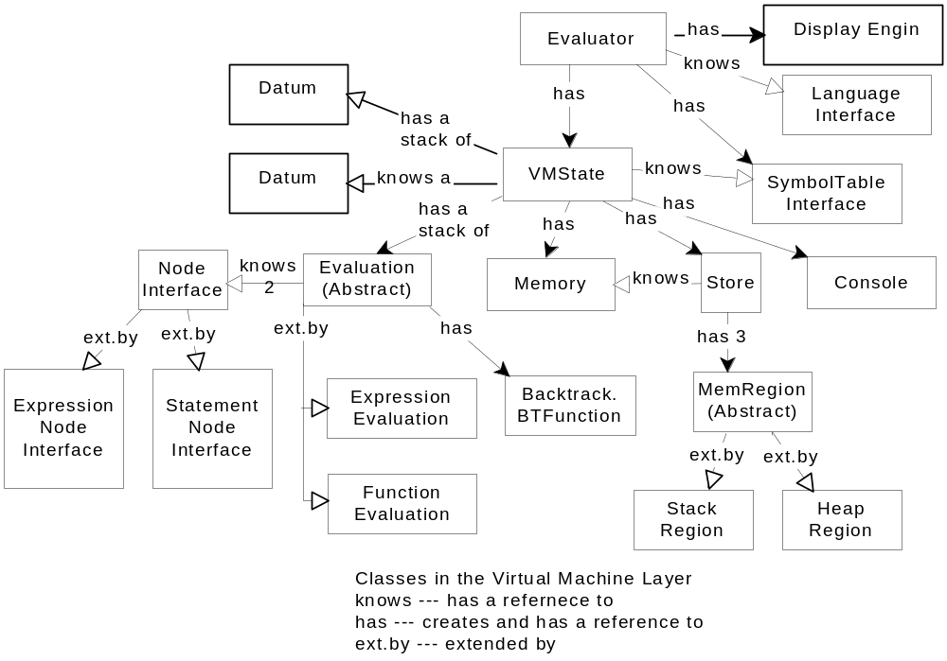
Figure 1
Evaluations come in two forms. One for expressions and one for functions. Because of C++’s syntactic structure, these always alternate on the stack.

Class Relationships Diagram
Figure 1 shows a Booch diagram illustrating the classes and their relationships.

Backtracking
It is intended that the user can step backwards through computations as well as forwards. That is the user can `undo’ the effect of one or more evaluation steps. To accomplish this ability (a) the virtual machine state object conforms to the Backtrack.Backtrack interface. This interface supports two methods: vms.checkpoint() makes a copy of the state, and vms.undo() backs the state up to its value at the previous checkpoint. Many levels of undo (say 20) are allowed. (b) Checkpoints are taken at the start of each user evaluation step.

Class Evaluation

Abstractly each Evaluation represents the following things
- A root node --- set on construction.
- A selected node --- may be null.
- A done flag
- A function (in the mathematical sense) from nodes to Object references. This function will be called f in the subsequent descriptions. Initially it is the function that maps every node to null.

public abstract class Evaluation implements backtrack{
protected Evaluation(NodeInterface rt)
/*
done := false ;
root := rt ;
selected := null ;
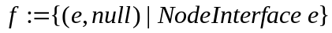
*/

public NodeInterface getRoot() ;
/* Returns the root */

public void setSelected( NodeInterface nd ) ;
/* selected := nd */

public NodeInterface getSelected( ) ;
/* result = selected */

public void map(NodeInterface e, Object d) ;
/* Changes the function f so that e maps to d. I.e.
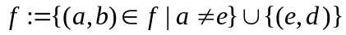

I should note that initially f maps every node to null
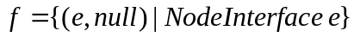
Thus f always maps each node to one thing, though that thing may be null. */

public Object at( NodeInterface e ) ;
/* Returns the object f maps e to. I.e.
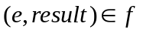 */

public abstract boolean isDone() ;
/* Returns done */
}
Note this is an abstract class; it has concrete descendants for evaluating expressions and functions.
As mentioned above, an important component of the Virtual Machine State is a stack of Evaluations. The fundamental algorithm for driving the Virtual Machine forward is based on this stack:
if the evaluation stack is empty
do nothing
else if the top of the evaluation stack is done
if the top of the evaluation stack is an expression evaluation
save its ultimate value
pop the evaluation stack
else if there is a selected node for the top evaluation
send a `step’ message to the selected node
else
send a `select’ message to the root node of the top evaluation
This algorithm is in the advance method of the Evaluator.Evaluator class. The `select’ method must select the next node to be evaluated. The “step” method advances the evaluation of a node. Both these methods are callbacks to the Language Layer; they are described by interface LanguageInterfaces.NodeInterface.

Class ExpressionEvaluation
The expression evaluation class represents partially evaluated expressions such as might appear in the Expression window of the GUI.

public class ExpressionEvaluation extends Evaluation {

public ExpressionEvaluation( ExpressionInterface exp ) ;
/* Construct an ExpressionEvaluation with exp as root */

public boolean isDone() ;
/* Returns true if f does not map the root to null */

}
Because this class is at the heart of expression evaluation, I will explain the expression evaluation mechanism here.
Suppose we have an expression a = a+b to be evaluated. Such an expression would be represented by an abstract syntax tree (AST) like this:
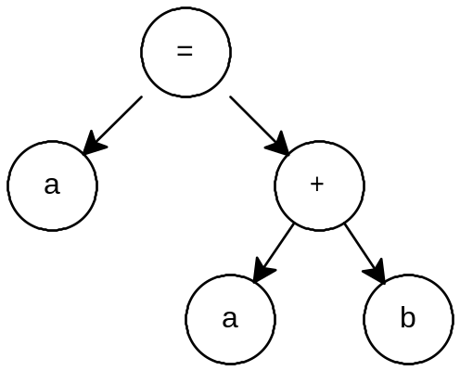
First we construct an ExpressionEvaluation with the root of the expression as its root:
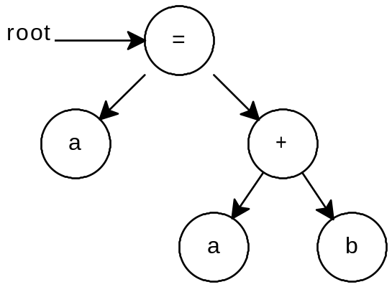
The root must implement interface ExpressionInterface (q.v.) which means it supports three methods
- void select(VMState)
- String toString(VMState)
- void step(VMState)
These methods are called by the evaluator. toString is only called when the evaluator needs to update the Expression Window display.
In this case the evaluator first calls select (with the root as the recipient object). There is no order of evaluation forced for this expression; we will assume that the left-most a node is selected first. The selected node will be the next to be evaluated. If the expression is converted to a string, the selected node (and its subtree will be shown high-lighted: a = a + b.
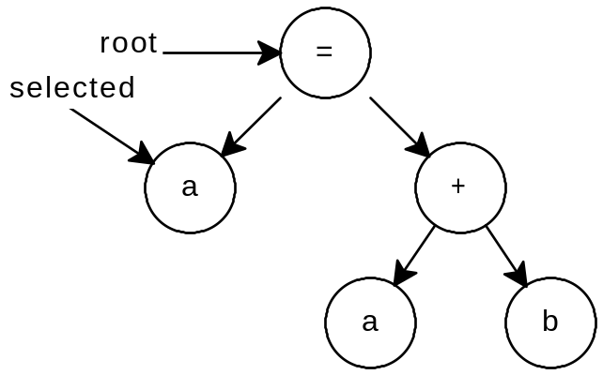
Now step is called (with the selected node as the recipient object). The selected node is evaluated. In this case a new and temporary Datum representing a reference to the variable a will be created. This is rather like loading the address of a variable into a register or onto the stack.
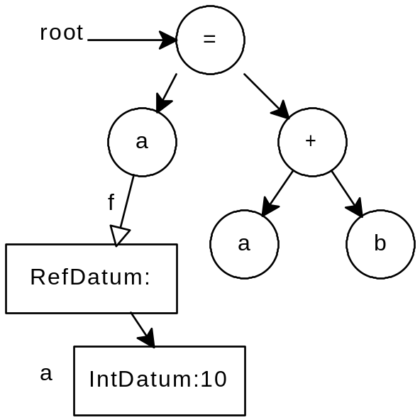
The arc from node a is labeled f to indicate that the function component of the Expression Evaluation (f) has been modified to map that node to the RefDatum shown. The tree itself is not modified during evaluation. This is important because it allows recursive functions to work without copying the trees and because it means the trees do not need to be backtrackable. The IntDatum is labeled a to show that this is the Datum representing variable a. After another round of select and step calls to the root, we have:
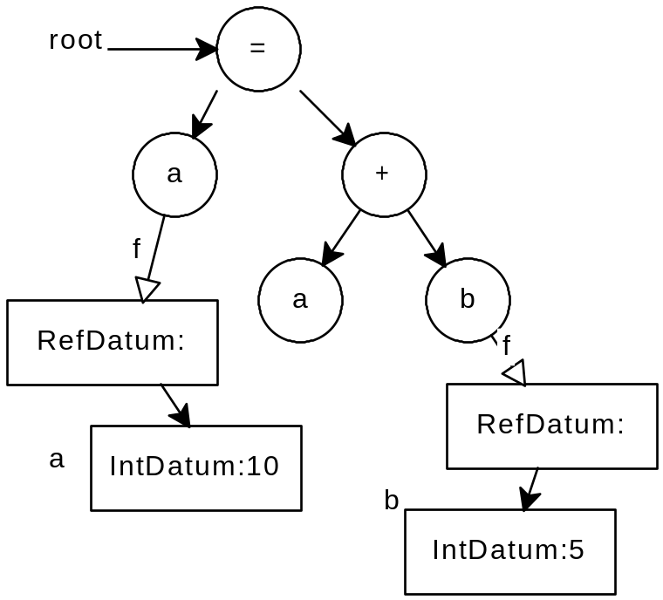
Now since the + sign demands a value, not an lvalue (i.e. a location) as its operand, the b node is not completely evaluated, it will be selected again and will be stepped again. This second step on the b node will result in a temporary copy of variable b being made. The reference datum is no longer needed and can be disposed of.
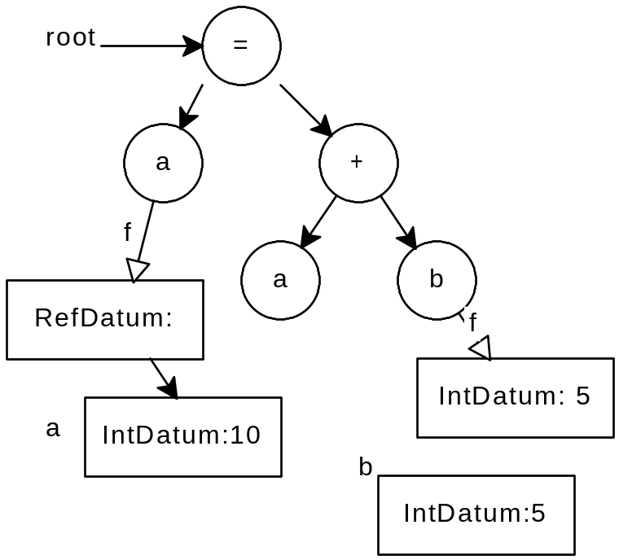
The other operand of + is evaluated similarly and the + node will be selected: 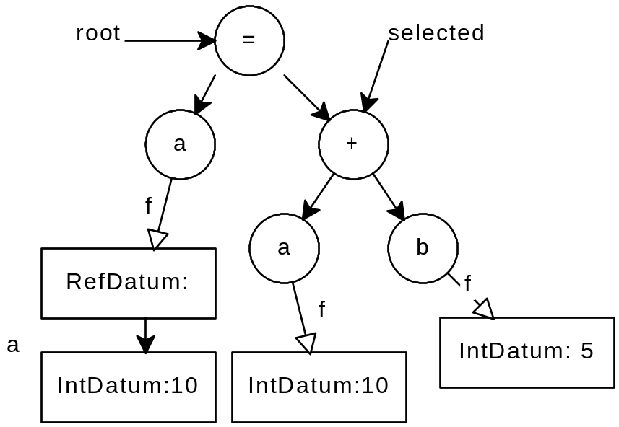
As the + node is stepped the temporary IntDatums may be disposed of and a new one created to hold the sum
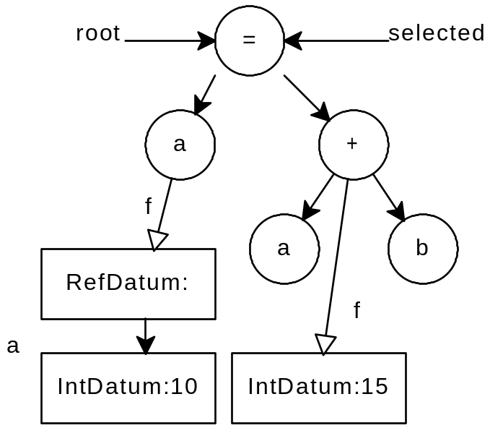
Now the = node is stepped. This changes the value of the Datum representing a. At this point the root has a value, so the evaluation of the expression is over.
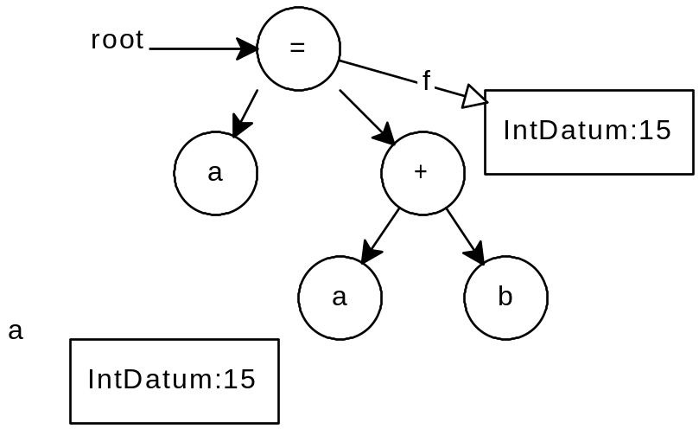
The above example shows the evaluation process from the point-of-view of the Virtual Machine layer. There is much that is not explained: how is it decided what node will be selected? how is it decided how many steps each node needs? These questions are left to the Language layer.

Class FunctionEvaluation
public class FunctionEvaluation extends Evaluation {

public FunctionEvaluation( StatementInterface stmt ) ;
/* Create a FunctionEvaluation with stmt as root. */

public boolean isDone()
/* Always false. */
}
Function evaluations are used analogously to expression evaluations. The main piece of information needed is what the current node is (the selected node) and what state that node is in (i.e. what stage in its evaluation it is at). The states of a node are indicated by Java Integer objects. For example, the function body {if(i==0) {return 0 ; else {i -= 1; } return i; will be represented by an AST (ok, it’s not really a tree): 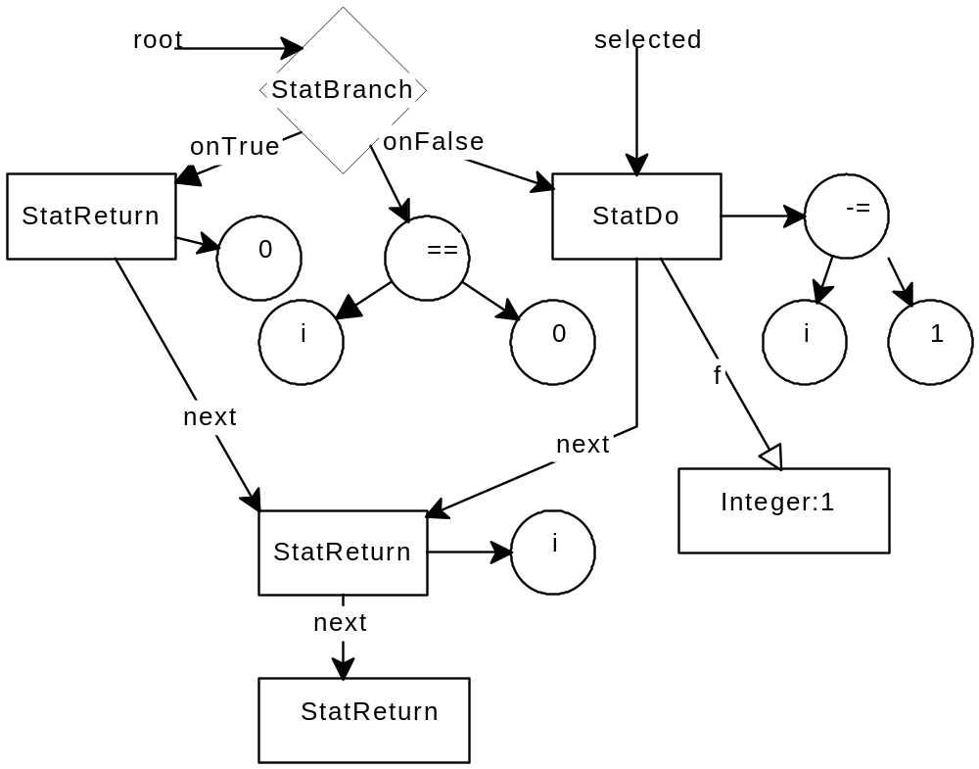
The selected node corresponds to the statement i -= 1; that it is mapped to Integer 1 in the current evaluation means that the expression i -= 1 has already had its ExpressionEvaluation created and pushed on the evaluation stack. So the next time it is stepped, its job will be to delete the datum representing the result of evaluating that expression, and to select the next node (the one for the statement return I).
With function evaluation – in contrast to expression evaluation--, stepping a node should always result in the selection of the next node, so there really shouldn’t be calls to root.select(…).

Class Memory
Memory is essentially a big backtrackable array of bytes. It is used by datums to store their values.
public class Memory implements backtrack {
/** Constructor: Create a memory with top as the highest address. */
public Memory(int top ) ;

/** Get a byte from memory at address a*/
public byte getByte( int a ) ;

/** Change memory at address a to value v */
public void putByte(int a , byte v ) ;
}

Class EmptyDatum
EmptyDatum objects must on occasion be returned from the Store. For convenience, this class is declared in the VirtualMachine Package.
public class EmptyDatum implements EmptyInterface

Class Memregion
Memregions represent sections of the store. They handle the allocation and deallocation of datums within the store.
public abstract class MemRegion implements backtrack {

MemRegion(int first, int size, Store store) ;

public abstract int findSpace(int i) ;
}
There are two package-scope implementations of this class: stackRegion and heapRegion. (The static and scratch regions are implemented as stackRegions.)

Class Store
The store is a collection of Datums. The store is divided into four memory regions:
- the static region – holds static variables and string constants etc,
- the heap region – holds heap allocated data (including all Java objects),
- the stack region – holds stack allocated variables, and
- the scratch region -- holds temorary variables used in evaluating expressions.
There are methods for accessing each of these regions. The regions are arranged like this.
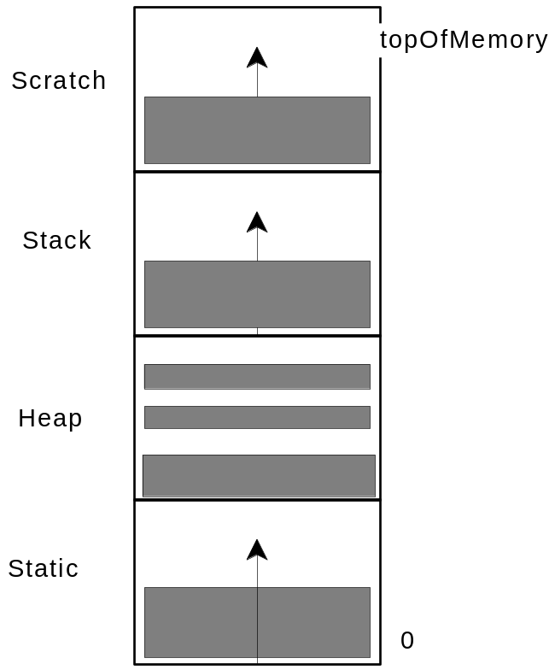

public class Store implements ViewableStore, backtrack {

public Store(Memory m, int boStatic, int toStatic, int boHeap, int toHeap,
int boStack, int toStack, int boScratch, int toScratch) ;

/** See ViewableStore in GUI documentation*/
public Datum getDatum (int address) ;

/** Add a new Datum to the store */
public void addDatum(Datum newDatum) ;

/** Remove a datum from the store */
public void removeDatum(Datum oldDatum) ;

/* Return the stack region of the memory */
public MemRegion getStack() ;

/* Return the heap region of memory */
public MemRegion getHeap() ;

/* Return the static region of memory */
public MemRegion getStatic() ;

/** Obtain the top datum from the stack. */
public Datum top() {
return theStack.top() ; }

/** Obtain the top datum from the scratch area */
public Datum topScratch()

/** Deallocate the top datum from the stack. */
public void pop() { removeDatum( top() ) ; }

/** Deallocate the top datum from the scratch area. */
public void popScratch() { removeDatum( topScratch() ) ; }

/** Set mark in the scratch area */
public void setScratchMark()

/** Get the most recent mark for the scratch area */
public int getScratchMark()

/** Erase the most recent mark for the scratch area */
public void unsetScratchMark()

/** Number of Datums in the scratch area */
public int scratchSize()

/** Find the datum that has a particular address and type.
chasePointer climbs the inheritence hierachy. So if it is searching for a P, but there is really a C at the address, where C inherits from P, it returns a datum of type P.

If none can be found, returns null */
public Datum chasePointer( int address, TypeInterface type )

/** Find the datum that has a particular address and type.
chasePointerVirtual is aware of the inheritance hierarchy, but returns the corresponding to the (dynamic) class of the object found. So if it is searching for a P, but there is really a C at the address, where C inherits from P, it returns a datum of type C.

If none can be found, returns null */
public Datum chasePointerVirtual( int address, TypeInterface type )

}
The Language Layer creates Datums in the following steps:
- Get the appropriate memregion. E.g. with store.getStack()
- Use the region to find space of the size needed for the datum. (Method findSpace)
- Create the Datum using its constructor (the address is passed to the constructor).
- Register the Datum using store.addDatum(…).
Note that findspace does not actually reserve the space. So it is imperative to call addDatum right away, otherwise two datums can end up sharing the same bytes!

Other methods
- When a datum is no longer needed it is deallocated with removeDatum.
- The top and pop methods provide convenient access to the stack.
- The topScratch and popScratch methods serve a similar function for the scratch region.
- The setScratchMark, getScratchMark, unsetScratchMark, and scratchSize methods are used with the popScratch method to provide simple storage management of the scratch region. Before a source expression is evaluated setScratchMark is called. This pushes the current size (in Datums) of the scratch area on a stack. When the source expression has been evaluated, temoraries are popped until the size of the scratch area (scratchSize) equals the last mark pushed (getScratchMark). Finally the mark is popped (unsetScratchMark).
- chasePointer is used for dereferencing pointers and references.
- getDatum is used by the GUI for displaying the memory. It is not described here. as it is described in Support Packages for The Teaching Machine.

Class Console
The input and output of the execution is accumulated in a Console object -- essentially a two backtrackable sequences of characters -- one for the output and one for the unconsumed input.
public class Console implements backtrack, ViewableOutput {

/** Size in lines */
public int getSize() ;

/** A line (counting from 0 ) */
public String getLine(int i) ;

/** Output a character */
public void putchar(char c) ;

/** Add to the input buffer */
public void addInputString( String input ) ;

/** Is the input at an end of file? */
public boolean atEOF()

/** Get the next character. '\0' represents the end-of-file and `\uffff' represents that the user has not yet entered the character */
public char getchar() ;
}

Class VMState
A VMState object collects together the above elements and a symbol table in one object consisting of
- A stack of evaluations
- A Symbol Table (implemented by the Language layer)
- A Store
- A Memory
- A Console,
- A reference to a Datum representing the value of the last expression evaluated.
- A stack of references to datums representing the location to which the result of a function call should be copied.
- A source code line number representing the current source line number.
- A stack of source-code line numbers
- A reference to a datum representing the current store focus.
- A flag that the interpreters can use to stop the evaluation process.

public class VMState implements backtrack {

/* Construct the state. */
public VMState(BTTimeManager tm,
int boStatic, int toStatic, int boHeap, int toHeap,
int boStack, int toStack, int boScratch, int toScratch,

ViewableST syms ) ;

public BTTimeManager getTimeManager()

/* Used for communicating function results from return statements to the call expression */
public void pushResultDatum( Datum d )

public void popResultDatum()

public Datum topResultDatum()

/* Save a datum */
public void setExpressionResult( Datum d )

/* Get a datum */
public Datum getExpressionResult()

/* Is the evaluation stack empty */
public boolean isEmpty() ;

/* Push a new Evaluation on the evaluation stack */
public void push( Evaluation e ;

/* Remove the top of the evaluation stack */
public void pop() ;

/* Return the top Evaluation */
public Evaluation top() ;

/* How big is the stack */
public int stackSize()

/* Return the store */
public Store getStore() ;

/* Return the symbol table */
public ViewableST getSymbolTable() ;

/* Return the memory */
public Memory getMemory() ;

/* Return the Console object */
public Console getConsole( ) ;

/* Set the current source code line number */
public void setCurrentLine(int i) ;

/* Get the current source code line number */
public int getCurrentLine() ;

/* Push the current line number */
public void saveCurrentLine() ;

/* Pop the current line number */
public void restoreCurrentLine() ;

/*Set datum to highlight */
public void setDatumFocus( Datum d ) ;

/* Get datum to highlight*/
public Datum getDatumFocus() ;

/* Set flag to stop evaluation */
public void setStopEvaluation( boolean newVal ) ;

/* Get flag to stop evaluation */
public boolean getStopEvaluation() ;

/* Set a stopping point for undo */
public void checkpoint()

/* Revert the state to the previous checkpoint */
public void undo()

/* Associate an object with a name (not backtrackable!) */
public void setProperty( String name, Object info )

/* Get the object with a name (else null) */
public Object getProperty(String name)
}

The Evaluator Package

Class Evaluator
The evaluator object does more than just evaluate. It has to implement most of the callbacks from the GUI Layer.
public class Evaluator implements ViewableExpression, ViewableCode, DisplayInterface

Construction.
public Evaluator(Language l) ;
The evaluator is passed a Language object. This object supports callbacks for parsing, creating a symbol table, and for initializing the state (e.g. to create static variables). On construction, the evaluator simply stores a reference to the Language object. The DisplayManager object is constructed when the Evaluator is constructed --- causing a top-level window to appear to the user.

DisplayInterface callbacks
public void fileOpenRequest(String fileName, String dirName)
On a finleOpenRequest:
- a new symbol table is created (via a callback to the language object),
- a new VMState is created (via a callback to the language object),
- the file is parsed
- the state is initialized
- the various windows of the Display manager (the static memory, the stack memory, the heap memory, the symbol table, the expression display, the code display, the output display, and the program counter) are connected to the appropriate objects at the Virtual Machine or Language layer.
public void closeTheFile() ;
Doesn’t do much.
public void terminate() ;
Stops the program.

ViewableCode and DisplayInterface callbacks
/** Deliver the source code to the GUI (first line is 0)*/
public String getLine(int I);
The next 6 methods implement callbacks for the various buttons.
The exact meaning of these buttons has to be decided Below are suggestions. In the current state of implementation the first 5 are all equivalent to a single advance and the goBack is not implemented.
public void goForward() ;
Does one advance. See the documentation of class Evaluation, for the definition of an advance.
Likely change: The advance routine sometimes does so little there is no visible response. We need another button that advances until something interesting happens, where `interesting’ will be defined by the language layer, but should mean there is a change to something that is visible (or could be visible) to the user.
public void intoExp() ;
Advances until there is a new ExpressionEvaluation object on top of the evaluation stack or the evaluation stack is smaller.
public void intoSub() ;
Advances until there is a new FunctionEvaluation object on top of the evaluation stack or the evaluation stack is smaller.
public void overAll() ;
Advances until the evaluation stack is smaller.
public void toCursor(int line);
Advances until the current source line is equal to line, or the stack is empty.
public void goBack() ;
The above 5 callbacks should all checkpoint the Virtual Machine State before they begin. goBack calls undo to revert to an earlier state.

The LanguageInterface Package
The Language interface package declares the callbacks that must be supported from the Virtual Machine Layer to the Language layer.

Class NodeInterface
The NodeInterface interface defines the callbacks that must be supported by abstract syntax tree nodes known to Evaluation objects. It has been discussed in the description of Classes Evaluation, ExpressionEvaluation, and FunctionEvaluation. The is_uninteresting function is used to mark nodes where where we don’t want evaluation to stop. For example, the evaluation of a constant is “uninteresting”.
public interface NodeInterface {
void step(VMState vms) ;
void select(VMState vms) ;
boolean is_uninteresting() ;
}

Class ExpressionInterface
Expression nodes must be converted to strings for dsiplay to the user.
public interface ExpressionInterface extends NodeInterface {

String toString( VMState vms ) ;
}

Class StatementInterface

Statement node have line numbers
public interface StatementInterface extends NodeInterface {
int lineNumber() ;
}
Likely Change: I’m not sure where this is called from. It may not be needed.

Class Langauge
An object conforming to this interface defines the langauge being interpreted.
Likely change. There may be more to it than this, as more langauges are supported. For C++, this seems sufficient so far.
public interface Language {
public ViewableST makeSymTab( ) ;
public void parse( String str, VMState vms) throws PError ;
public void initializeTheState( VMState vms ) ;
}
These are called in this order when a new file must be interpreted.

Class PError
This exception is used by the parser to indicate that it failed.
public class PError extends java.lang.Exception{
public PError(String ss )
}

