Overview of the Teaching Machine©
- Revisions
- Updated Oct 99 to correct the most egregious errors.

Architecture
The teaching machine is designed in five layers.
- The Main Layer contains two java.awt.applet.Applet’s and a java.awt.Frame that contains the main subroutine.
- The Language Layer: Deals with parsing and language dependant aspects of interpretation and data storage. Responsibilities include representation of data objects; representation of types, expressions, and statements of the language; parsing source code; symbol table representation (both compile-time and run-time) executing the internal representation of the program.
- The Virtual Machine Layer: Deals with language independent aspects of interpretation and data storage. Responsibilities include representation of memory, representation of the execution state, representation of input and output, driving the execution, backtracking the execution.
- The GUI layer. Providing a user interface. Displaying the objects of the virtual machine to the user.
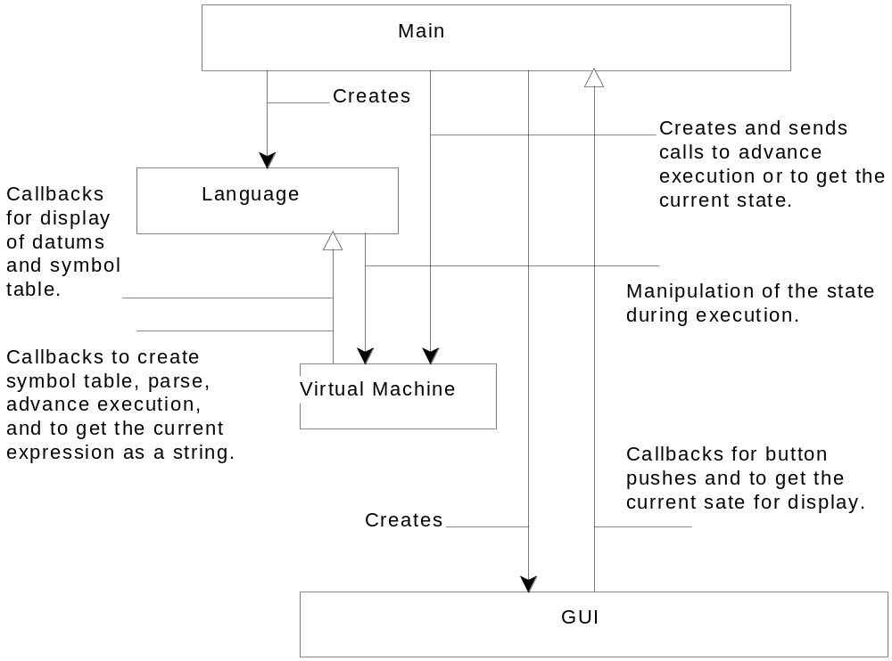
Figure 1
- The Utility layer consists of a collection of useful classes.
Each layer acts as a library for the layers above. Thus there is no direct circularity in calls between layers. But the lower layers do need to call on the upper layers. This is done via callbacks through specific interfaces (in the Java sense of the word). The call structure of the layers is shown in Figure 1.

Packages and projects
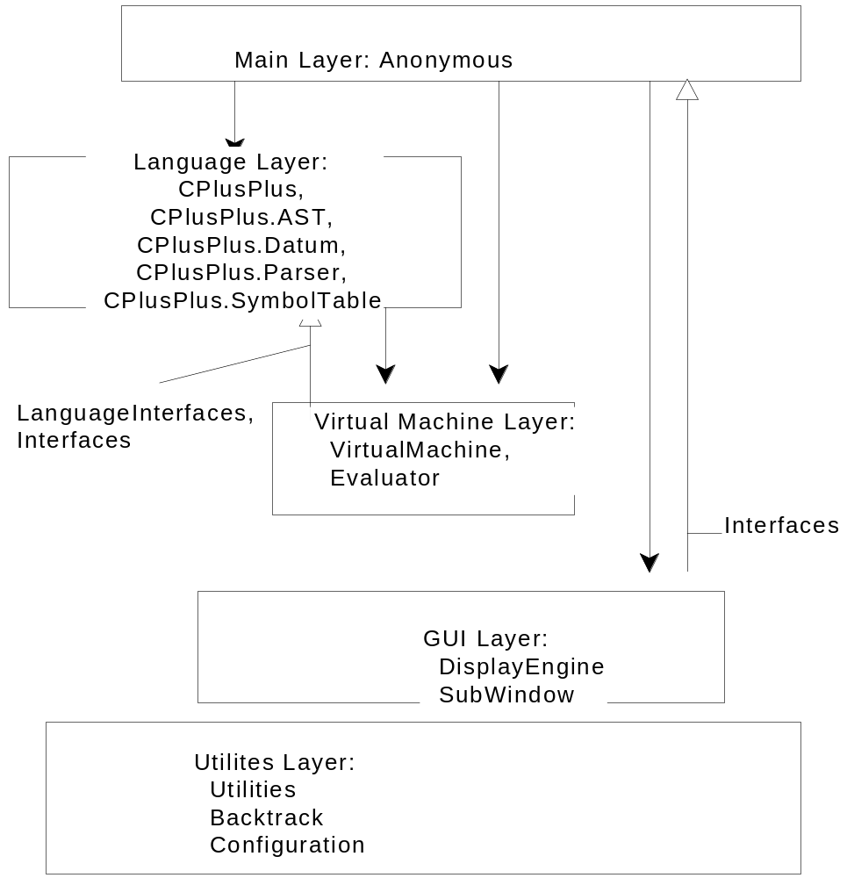
Figure 2
Packages either implement layers or define interfaces for callbacks. Figure 2 shows the packages (assuming the C++ language layer is used).

Documentation
The system is documented in the following documents:
- Utilities Layer
- Interface in Utility Layer Interface for The Teaching Machine.
- Implementation To be done.
- GUI Layer and the Interfaces package
- Interface in Support Packages for The Teaching Machine
- Implementation in To be written.
- Virtual machine Layer and the LanguageInterfaces
- Interface in Virtual Machine Layer Interface for The Teaching Machine
- Implementation in To be written
- C++ Language layer
- Interface in Virtual Machine Layer Interface for The Teaching Machine.
- Implementation in The C++ Language Layer for The Teaching Machine.
- Main Layer
- Implementation in this document

The Main Layer (Anonymous Package)

Class TMMainFrame
This class contains the main method.
public class TMMainFrame extends java.awt.Frame
implements ExternalCommandInterface,
Configurable {
public static void main(String args[]) ;
}
main creates a TMMainFrame object and adds a menu to it and a TMBigApplet (see below) to it.

Class TMBigApplet
This is an applet class which glues the GUI Layer to the Virtual Machine Layer.
It creates an DisplayManager object to represent the GUI Layer and an Evaluator object that represents the VirtualMachine layer. It is also responsible for creating the appropriate Language object, to represent the Language layer.
public class TMBigApplet extends Applet
implements ExternalCommandInterface,
ImageSourceInterface,
StatusInterface {
}

Class TMTinyApplet
This is an applet class which creates a TMMainFrame. It displays nothing itself and thus takes no room on a web page. If you want a web page that creates a TM in a separated
window, then use TMTinyApplet. If you want the TM’s graphics to be on a web page, then use the TMBigApplet
public class TMTinyApplet extends Applet
implements ExternalCommandInterface {
}

Class TMMainFrameAppletStub
When we run as an application, the BigApplet needs an AppletStub and an AppletContext. That’s just the way applets are. This class implements both these interfaces to the extent required. When we run as an Applet, the web browser supplies an AppletStub and an AppletContext that get used instead.
public class TMMainFrameAppletStub implements AppletStub, AppletContext {
{
}

