Table of Contents

Wordpress Notes 2

Introduction 2

Required Folders for a Wordpress Theme 3

Required Files for a Wordpress Theme 3

The Wordpress Hierarchy 4

# Wordpress Notes

## Introduction

* Wordpress themes are nothing more than a hierarchy of template parts. What a template or custom theme does is it takes all the various sections of a website (i.e. header, navigation, etc.) and splits them into individual files.

## Required Folders for a Wordpress Theme

* The wordpress directory, once unpacked, is located: C:\xampp\htdocs
* Themes for wordpress are placed: wp-content > themes
* To create a folder for a new theme you would:
  + Navigate to wp-content > themes
  + Create a new folder
  + Paste your template code into the new folder you created
  + We can now open this folder in our code editor
* Now we need to create all the **folders** that are necessary for a Wordpress template:
  + **assets Folder**
    - within this folder:
      * css
      * js
      * images
      * fonts
  + **classes Folder** (used to create any .php functionality we will need to override Wordpress functionality
  + **inc folder** (stands for “includes” and will hold any include-files
  + **template-parts folder** (allows us to further granulate template parts)
  + **templates folder**

## Required Files for a Wordpress Theme

* Technically, only two files are required for a Wordpress theme:
  + **index.php file**
  + **.css file**
* Anything beyond this is *relative to how you want to customize your Wordpress theme*.
* We will create the following files:
  + **404.php**
  + **archive.php**
  + **comments.php**
  + **footer.php**
  + **functions.php** (where you can override/initiate different features of your theme in Wordpress)
  + **header.php**
  + **index.php**
  + **page.php** (this will display *static pages* – things that *are not* dynamic like blog posts)
  + **readme.txt**
  + **search.php**
  + **single.php** (responsible for displaying *single blog posts*)
  + **style.css**
  + **font-page.php** (landing page)
  + **screenshot.png** (a screenshot of the site for the Wordpress store)

## The Wordpress Hierarchy

* The Wordpress hierarchy can be found here: <https://wphierarchy.com/>

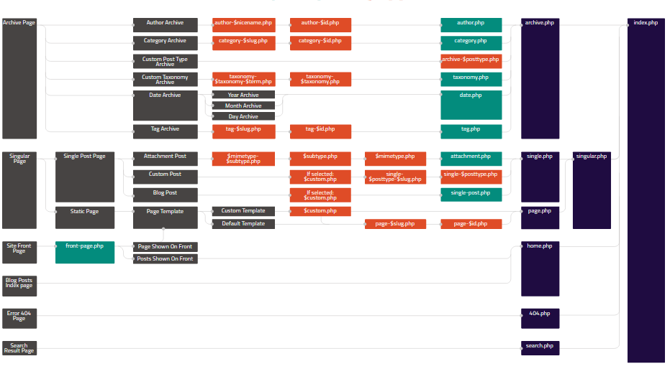

* Each WP element can function on its own with a given page type, or, by following the routes, you can see how other pages can be created from parent pages to allow for greater/more specific functionality:
  + The **index.php** file (on the far right side) is the fall-back page for Wordpress
  + From **index.php** you can create a page called **singular.php.**
  + **singular.php** can be broken into **single.php** and **page.php** if the single/page pages happen to not be the same

## Adding the First Functional Elements to our Wordpress Theme

### Style.css

* Navigate to **style.css**
  + These pages *must* begin with a comment section that Wordpress will interpret when it loads the site



* + Once this has been saved, we can load our Wordpress account and log into the back-end and we will see the FollowAndrew site. If we click on “Theme Details” we will be able to see all the details we loaded into the **.css** file.
* We can now activate the theme.

### Front-page.php

* At this point we will start moving the code from the master-template we designed into the various Wordpress pages.
* In our **mater-template** open the **index.html** page