**R.O.D.G.E.R**

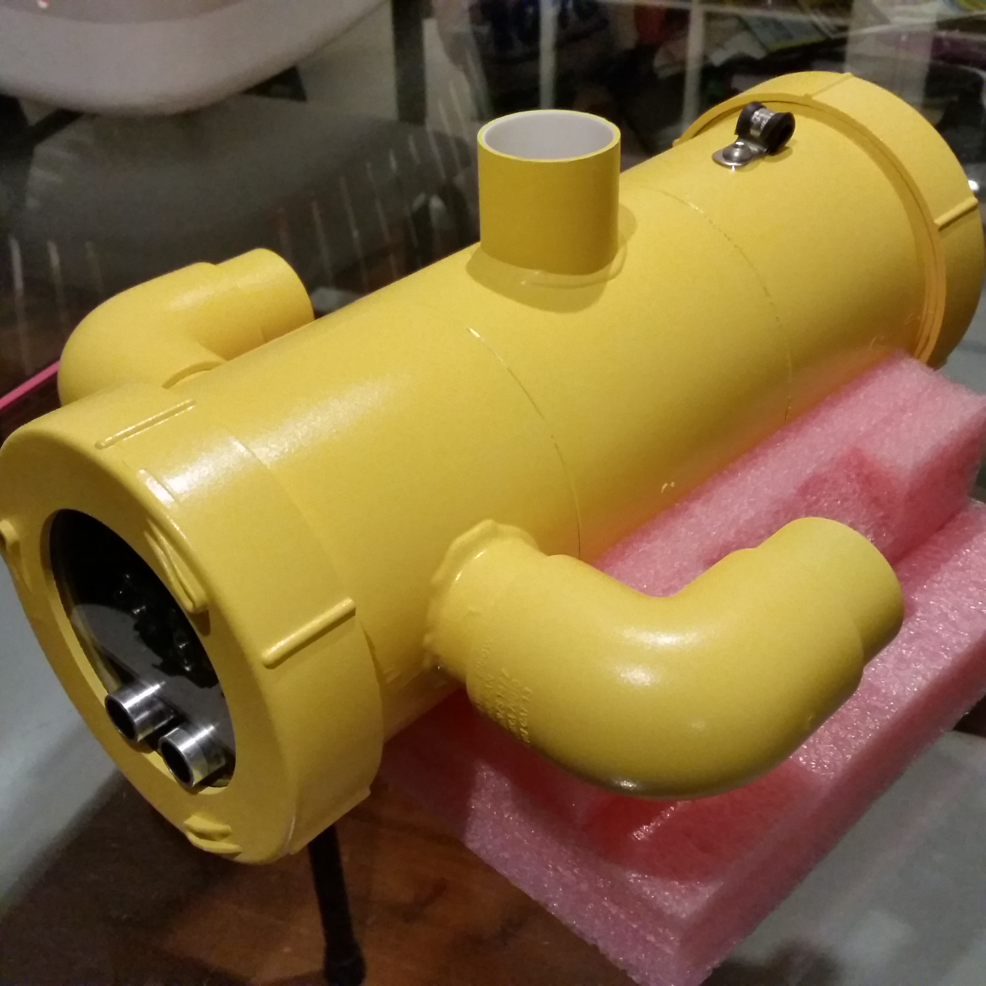

R.O.D.G.E.R (Remote Operated Drone Geared at Exploring Rivers) is a versatile and capable underwater craft priced at a fraction of the cost of high-end, commercial ROVs.

It is equally adept at inspection tasks in tanks, pools and pipes as it is in dams and rivers.

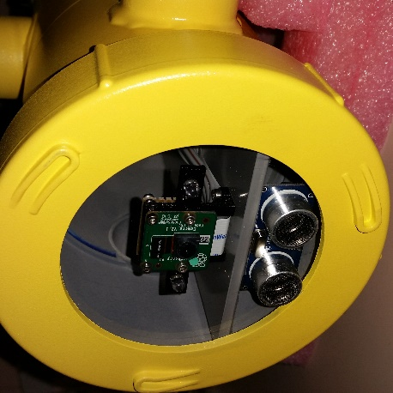Based on the popular Raspberry Pi, and utilizing open source software, this ROV is easily controlled via a Playstation controller, whilst a web-based dashboard provides feedback to the operator.

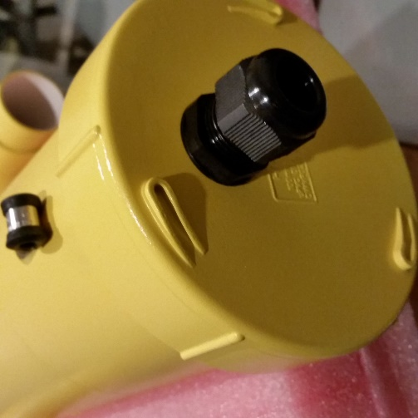R.O.D.G.E.R features real-time video via the on-board camera. External illumination allows environmental inspection down to moderate visibility, while video processing allows object detection. An optional ultrasonic sensor provides enhanced collision avoidance. System monitoring gives the operator information such as temperature, orientation and battery health.

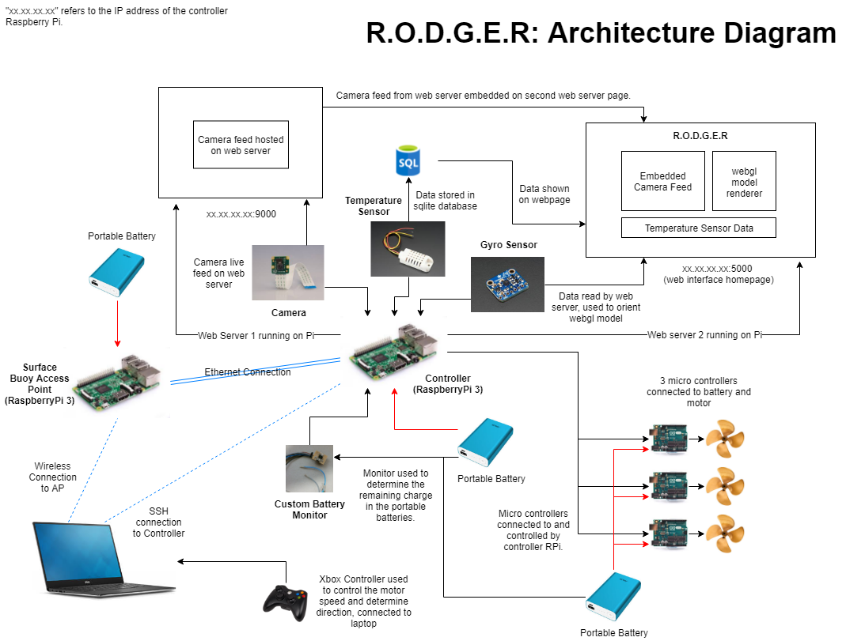

# Basic Specifications:

**Physical:**

Length: 370mm

Width: 320mm

Height: 200mm

Weight without ballast: TBD

Material: PVC

Depth Rating: 10-15m

Tether Length: 20m

**Electrical:**

Thruster configuration: 2 vectored, 1 vertical

Thrusters: 140W, 700Kv(rpm/v)

Battery: Lipoly, 2250mAh, 3S, 11.1V, 40C

Controller: Raspberry Pi x 2