Lumped Capacitance Test

Before we do anything complicated, it will be good to perform a simple test of a lumped capacitance model since the data is already well known.
For a lumped capacitance model,
https://web.me.iastate.edu/tsippel/htlab/l3-transient-conduction.html

thermal diffusivity of steel (ss 304L, 80C), approx:
4.13e-6 m^2/s
thermal conductivity of steel, approx
15.61 W/(m K)
for convenience, length scale of 2cm diameter
a suitable heat transfer coefficient in air would be around:
20 W/(m^2 K)

Lumped capacitance may be used in this situation
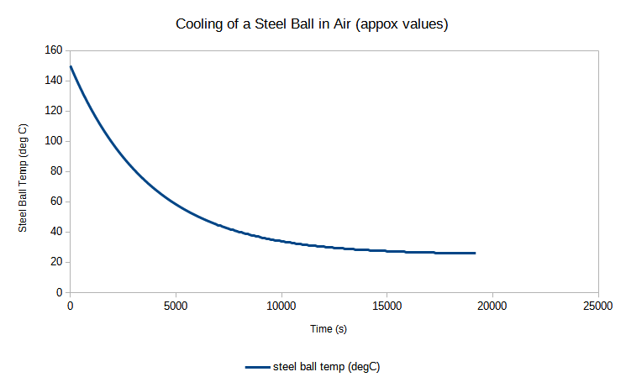

For a 2cm OD steel ball (150 degC) in air aout 25 degC, it takes about 19200 s to get back to room temperature (a few hrs). The heat transfer coeff is 20 W/(m K).

