Recruits’ Programme Notes for Recruits

Essential Contents:

  - Basics- Company Object, motto, emblem, etc.
  - Organization of BB in SG and company
  - Attires
  - Badgework

1. Boys’ Brigade History
  - International
  - In S’pore

2. Boys’ Brigade General Knowledge
  - BB Object, Motto, Emblem, Vision and Mission
  - BB Vesper and Table Grace
  - Badgework
  - BB Structure
  - BB Traditions
  - Community Events
  - Uniform Parts/Expectations
  - Attires

3. 60th RIBB
  - History
  - Structure
  - Theme Verse and Songs

1. Boys’ Brigade History

a. International

- The Boys’ Brigade
- Founded on 4th October 1883, at the Free College Mission Hall at North Woodside Road in Glasgow, Scotland by Sir William Alexander Smith
- Founded based on twin pillars of Christianity and Discipline
- 1st uniformed group ever
- Sir William Alexander Smith
  - Felt need for order amongst Boys
- Became Brigade Secretary in 1888
- Knighted in 1909 by Edward VII

b. In S’pore

- The Boys’ Brigade
- Founded on 12th January 1930 on 77th Prinsep Street, with Prinsep Street Presbyterian Church by James Milner Fraser
- After World War II, a man by the name of Mr. S. P. Chua was the one who revived the Boys’ Brigade in Singapore
- BB Singapore Honoured
- Since 1971, the Brigade has the distinguished honour of having the President of the Republic of Singapore as its Patron
- On 18 Sep 1999, the BB in Singapore received its own flower, Dendrobium The Boys’ Brigade. It symbolizes the aspiration of BB youth, and reflects a new generation with the best hybrid of courage from our heritage and boldness to face the future
- On 12 Jan 2000, 77 Prinsep Street was marked as the 41st Historic Site of Singapore by the National Heritage Board to commemorate 70th anniversary of BB in Singapore
- BB in Singapore Today
- As of 2011, BB has a total of 7,000 Boys and Officers in 117 Companies, each of which is attached to a school and co-sponsored by a church
- Although a Christian organisation, BB is endorsed by the Ministry of Education as one of the Uniformed Youth Organisations in schools. BB is also a member of the National Council of Social Service and the National Youth Council. In addition, BB is gazetted as an institution of public character and is registered as a charity under the Charity Act 1982 (Registration No. 0067)
2. Boys’ Brigade General Knowledge
a. BB Object, Motto, Emblem, Vision and Mission

Object: The advancement of Christ's kingdom among Boys and the promotion of habits of Obedience, Reverence, Discipline, Self-respect and all that tends towards a true Christian manliness
Motto: Sure & Stedfast, adapted from Hebrews 6:19, King James Version of the Bible: “Which hope we have as an anchor of the soul, both sure and stedfast, and which entereth into that within the veil”
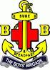

Emblem (Pictured): Anchor with red cross behind, anchor with motto. The red cross was added in 1926 after the merging of BB and the Boys’ Life Brigade

Vision: To be the Youth Organisation of Choice

Mission: To nurture Youth, based on Christian values, to lead and serve

b. BB Vesper and Table Grace

BB Vesper: It is a prayer that we sing at the end of a BB gathering or function. Every BB Boy and Officer is expected to know how to sing it.
Great God who knowest all our needs
Bless Thou our watch, and guard our sleep;
Forgive our sins of thought and deed,
And in Thy peace Thy servants keep.
We thank Thee for the day that's done
We trust Thee for the days to be;
Thy love we learn in Christ Thy Son,
O May we all His glory see!
Amen.
Table Grace: The BB also had a unique way of saying grace before we eat our meals together. This is our way of thanking God for the food He has provided for us.
Be present at our Table Lord
Be here and everywhere adored
These mercies bless and grant that we
May feast in fellowship with Thee
Amen!
c. Badgework
- BB Programmes
- Juniors Programme – 8 to 11 years old (Primary 3 to Primary 6)
- Seniors Programme – 12 to 16 years old (Secondary 1 to Secondary 4 or 5)
- Primers Programme – 17 to 19 years (Post-Secondary, Junior Colleges/Polytechnics/Institutes of Technical Education, girls are eligible to enroll in this programme)
- Main Badges
- Target
- Adventure
- Christian Education
- Citizenship
- Community Service
- Drill
- First Aid
- Leadership
- Life Skills
- Total Defence
- Elective Badges
- Arts
- Craft
- Hobbies
- Athletics
- Bugler/ Piper/ Drummer
- Bandsman
- Environmentalist
- Gymnastics
- International Relations
- Kayaking
- Musketry
- Naturalist
- Sailing
- Sportsman
- Swimming
- Special Awards
- Cross for Heroism
  - For performing an act of self-sacrifice, heroism or attempting to save life. The ribbon on the Cross for Heroism is Royal Blue
  - The first Cross for Heroism was awarded to Warrant Officer Jeffrey Jiang Song En of 12th Singapore BB Company on August 23 2003. With the help of two officers, he lifted a man who was lying on a railway track to safety when he saw a fast-approaching train
- Diploma for Gallant Conduct
  - Awarded to Boys who have shown gallant conduct in attempting to save life, or marked courage in the face of danger, unaccompanied, however, by the high degree of heroism which would merit awarding the Cross for Heroism
- Senior Proficiency Award, with the following criteria met:
  - Target
  - Adventure + Christian Education + Community Service + Drill + First Aid (Stage 2)
  - Life Skills (Stage 2)
  - Leadership (Stage 1)
  - Total Defence (Silver)
- Founder’s Award, the highest award a Boy can obtain in the Seniors Programme, with the following conditions met:
  - Recommendation by Captain and endorsement by Chaplain
  - Attended 75 parades in previous 3 years
  - Involvement in Brigade-level event approved by Seniors Programme
  - Attained the following badgework:
    - Senior Proficiency Award
    - Leadership (Stage 2)
    - Christian Education (Stage 3)
    - Any 2 out of the 5 Specific Awards at Stage 3:
      - Adventure
      - First Aid, in which the Boy must be at least 14 years of age to qualify
      - Drill
      - Community Service
      - Piper/Drummer
    - National Event, which is awarded to Boys who have participated as a BB member in events such as National Day Parade, National Camp, Singapore Youth Festival, as well as any national event approved by the Brigade Executive. It can be replaced by attaining badgework for 3 of any 5 courses below:
      - Anti Drug Abuse
      - Civil Defence
      - Energy Experience Programme
      - Heritage
      - Remembrance Day Observance Ceremony
- Awards in The Primers’ Programme
- The President’s Award
  - Highest award in the Primers’ Programme and the epitome of Boys’ development in the Boys’ Brigade who have fulfilled the demands of leadership and service
- Anchor Award
  - Awarded to Primers who have completed the Core curriculum of the Primers’ Programme
d. BB Structure
- Honorary Office-Bearers (Important Positions)
- Patron
  - His Excellency Mr. Tony Tan Keng Yam, President of the Republic of Singapore
- Honorary President
  - LG (Ret) Winston Choo Wee Leong
- The Brigade Executive (Important Positions)
- Brigade President
  - Prof Ho Yew Kee
- Brigade Chaplain
  - Rev Malcolm Tan
- Vice-Presidents
  - Mr. David Chan Wan Keat
  - Mr. Poh Leong Berg
  - Mr. Elliot Tan Vincent
  - Mr. Colin Chen
- Brigade Secretary
  - Mr. Peter Ong
- The Brigade Office (Important Positions)
- Executive Director
  - Mr. Desmond Koh
- Ranks
- Boys (Seniors Programme)
  - Recruit (RCT)
  - Private (PVT)
  - Lance Corporal (LCP)
  - Corporal (CPL)
  - Sergeant (SGT)
  - Staff Sergeant (SSG)
  - Warrant Officer (WO)
- Primers
  - Cadet Lieutenant (CLT)
  - Senior Cadet Lieutenant (SCL)
- Officers
  - Officer Cadet (OCT)
  - Second Lieutenant (2LT)
  - Lieutenant (LTA)

e. BB Traditions
- BB Week
- This is the annual fund-raising effort which lasts for a month. It is an opportunity for members and friends to contribute financially to the on-going work of the BB
- BB Day Singapore
- BB Day is organised every 12 January, commemorating the founding of the BB in Singapore on 12 January 1930, at Prinsep Street Presbyterian Church, which was pronounced as a historical site by the National Heritage Board on 12 January 2000. On BB Day, members will put on their full uniform to school, with special activities planned. This is strategic because recruitment usually begins about this time, too
- BB Handshake
- The BB has a unique handshake. The last finger of the right hand interlocks that of another's
- BB Blaze
- Previously known as Adventure Quest, it is an annual multi-disciplinary adventure race where BB companies send up to three teams for the competition, with each team comprising four members and one reserve. Teams are to navigate through various stations during the race, on foot, by bike, and by kayak. The stations along the way test various adventure skills such as knot-tying and First Aid. BB 60th came in 2nd and 6th in last year’s BB Blaze competition
- Annual Parade
- A grand ceremony where recruits and some Year 4s are promoted. The Founder’s Award, the highest award in the Seniors’ Programme, will also be given out to worthy recipients. On this very special occasion, Boys will march in as a contingent, showcasing their mastery of drill movements. Most importantly, it marks the passing of the mantle of leadership from the Year 4 batch to the Year 3 batch, as well as the handing over of the red sash to the new CSM
- Boys
- The founder of BB, Sir William Alexander Smith, once said, “If I am to be remembered by posterity, I should like it to be as the man who taught people to spell Boy with a capital B.” Hence, the word ‘Boy’ is always spelled with a capital B. They are the most important people in the BB.
- Buttonhole Badge
- This is a badge of membership and should be worn by members when they are out of uniform
- Bugle Calls
- Bugle calls have been in use since very early times. It is a tradition in the BB to use bugle calls for parades and camps. The following calls should be noted: Reveille, Fall In, Dinner Calls, Retreats, Last Post, Lights Out
- Camps
- The Founder pioneered camping for Boys in 1898. Camping has since been an important activity. As far as possible, Boys should camp under canvas. Try to attend every camp organised by your company
- Character Quest (CQ)
- Previously known as Bible Quiz, CQ is an annual competition with differing emphases on biblical characters. Up to four teams of four represent each Company in a theory component, akin to a written exam, and then an outdoor, Amazing Race-like component, in order to determine the winner of the competition
- Company Designation
- Boys should be used to be talking of their company as "the 9th Singapore Company" or "the 60th Singapore Company"
- Drill Competition
- RIBB participates in the annual South One Cluster Drill Competition, around July. Each BB Company sends a squad of about 15 Boys, which will execute a series of drill commands as a squad
- Enrolment Service
- One of the important ceremonies of a company is the Enrolment Service. It is an annual ceremony held early each year to officially enroll a company’s officers and Boys. This service is typically held in late March and in church during Sunday service with the presence of the sponsoring church’s congregation
- Founder's Day
- It is observed on the last Sunday in October. This day commemorates the Founder's birth, which falls on 27 October. It should not be confused with 4 October, which commemorates the founding of BB in Glasgow, Scotland.
- Old Boys
- "Once in the BB always in the BB." Every effort should be made to encourage the participation of old Boys in some of the organisations and activities of the church and the company
- Prayer
- All meetings should begin and close in prayer. The BB Vesper (evening prayer) is set to song, and is usually sung at the end of a day’s programme
- Squad System
- The company is usually divided into squads, under the command of an NCO. Squad meetings should be held regularly. Squad outings, which promote the squad spirit, should be encouraged
- The Boys’ Brigade
- The name of our organisation is “The Boys’ Brigade” (with a capital “T”), regardless of its place in a sentence. For example, “I remember as a child, when I was a member of The Boys’ Brigade, …”
- Uniform
- Always wear your uniform correctly and with pride. Make it a practice to wear it to and from BB parade
- Publicise the BB by being seen at public places in uniform
f. Community Events
- BB CARES
- Stands for ‘Community Activities Rallying Everyone to Serve’
- BB Companies organise activities to benefit welfare organisations of their choice
- Part of the annual President’s Challenge event
- BB Share-a-Gift
- Started in 1988
- Previously known as The Boys’ Brigade Sharity Gift Box
- An annual event held during the Christmas period
- Officers, Boys and external volunteers help collect gifts such as food and beverages and distribute them to the needy in Singapore
- BBSG was awarded the Singapore Youth Award in 2004
- BBSG was also conferred the Singapore Youth Award Medal of Commendation on 7 July 2013
g. Uniform Parts/Expectations

Field Service Cap
The cap is worn on the right side of the head, one inch above the right ear and two finger breaths above the right eyebrow. The cap badge is worn on the left side of the cap at 5cm from the front.

Name Tag
White plastic plate measuring 7.5cm by 2cm worn slightly above the left breast pocket in uniform. Only the name of Boy should be engraved on it. The name tag should be worn at all times in Day Dress, Ceremony Dress, Musketry Kit, Fatigue Dress and PT Kit. It may be removed in PT Kit when Boys are engaged in outdoor or adventure activities. When worn on the BB Polo T-shirt, it should be worn above the BB emblem.

White Haversack
This is worn over the right shoulder with the sling passing under the belt on the left. The pouch should rest on the left hip with the top edge of the pouch in line with the lower edge of the belt. The haversack must be washed, starched and ironed, and metal parts polished.

Belt
This should be worn fairly tightly around the waist. The buckle should be in the centre and belt runners separated. Both the leather and metal parts should be polished.

Regulation Shoulder Flashes
These are fastened to the uniform shirt immediately below the shoulder seam on each arm.

Lanyard
The white lanyard is worn around the left shoulder with the long end to the back, secured by a knot to prevent slipping. The end of the remaining length is affixed to the left breast pocket button. Only white-coloured lanyards are to be worn at all times. No coloured lanyards are permitted.

NCO Chevrons
These are to be worn on the right arm above the elbow with the V pointing downwards. A LCP Chevron has one stripe (V), a CPL has two stripes, and so on.

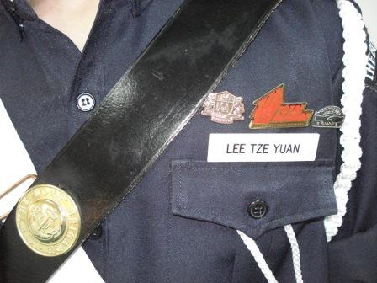

Cross Belt
This is worn by Staff Sergeants and Warrant Officers over the left shoulder, over the white haversack with the metal boss the point of the intersection. The cross-belt will be retained as part of the Staff Sergeant and Warrant Officer Full-Uniform. From 2006 onwards, no Boys should be clad in coat.

Wearing of BB Regulation Polo-T
The BB Regulation blue Polo shirt should be kept clean and neat. No cloth badges or crests of any kind (eg Company or LDC II) should be sewn on. No collar pins or badges of any kind (eg Founder’s collar pin) should be attached. No other badges of any kind, lanyard and appointment tags should be worn on the collars or sleeves of the BB Regulation blue Polo shirt.
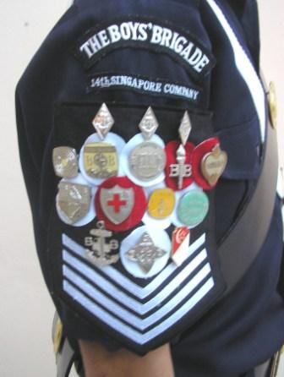
Wearing of Badges/Medals
Badges are to be worn properly and in the correct order. Proficiency badges should be worn in alphabetical order, with no more than five in a row. The Target badge should be placed first in the first line of Proficiency badges. The NYAA, Total Defence and Link badges, if awarded, should be worn above the name tag, with the Best Boy medal (also known as the S. P. Chua Medal) below the name tag, in a central alignment as shown below:
NYAA Badge | Total Defence Badge | Link Badge
Name Tag
Best Boy Medal
The SANA, Heritage, Remembrance Day, Energy Conservation and Civil Defence badges are souvenir badges and not BB Proficiency badges. Henceforth, they should not be worn on the Uniform. Only the Founder’s Badge, Senior Proficiency Star and JP Gold Badge (in this descending order) are to be worn on the left arm. The Long-Year Service badge, when awarded, will replace the 3-Year Service badge to be worn on the chevron, and should no longer be worn on the left arm. It is also no longer a special award. The Best Boy medal may be worn only as part of the Full Uniform attire.
Wearing of Sashes/Collar Pin
All sashes worn at Company level to denote appointments such as CSM should not be worn at Brigade-level functions. The Founder’s collar pin is a souvenir badge, not a Proficiency badge, and should not be worn on any BB uniform or BB Regulation blue Polo shirt.
Code of Conduct
All members of The Boys' Brigade in Singapore should take pride in wearing their uniforms smartly. All uniforms should be kept clean and special care taken for the metal and leather parts. No parts of the uniform should be added on to or removed in public. All Boys in uniform are to salute to all BB Officers when at Brigade functions or activities. All male Officers are to be addressed as "Sir" and female Officers as "Madam" or "Ma'am" on parade. Off parade, Officers should be addressed as "Mr. ", "Miss ", etc. Proper decorum should be adhered to when in uniform, as it affects the image of The Boys' Brigade.
Hair Regulation
As an approved CCA operating within schools, the BB needs to be compliant to the school rules pertaining to haircut. Officers are to lead by example, with neat haircut, adhering to the MOE guidelines for teachers in schools. For Boys/Male Officers, the haircut should be neat, and should not cover the ears and eyebrows. Hair should be just above the collar at the back. No artificial colouration of hair is allowed and no body ornaments such as earrings should be worn. For female Primers/Officers, the haircut should be neat with no loud colouring. Long hair should be neatly tied up.
General
All Boys who report for any Brigade activity, event or course with improper uniforms or haircut would be suspended from participation.

h. Attires

Day Dress
The Day Dress is the attire worn on most parades, consisting of a dark blue long-sleeved shirt with sleeves neatly rolled up just above the elbow and dark blue longs. The following are also worn:
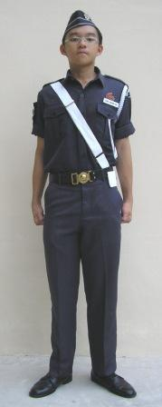 PTE/LCP/CPL/SGT 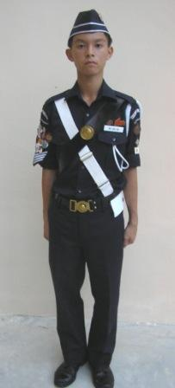 SSG/WO

- Field service cap with cap badge
- Haversack
- Belt
- Regulation shoulder flashes and company designation
- Name tag
- Dark blue socks
- Black boots (laced)

NCOs wear a white lanyard and the chevrons of their ranks. Staff Sergeants and Warrant Officers also wear a shoulder belt complete with metal bosses. A red sash is worn when a Boy is performing a function such as acting as the duty NCO, a marker, a drum major or when performing ceremonial duties. It is to be worn over the haversack and should not replace it.

Ceremonial Dress
The Ceremonial Dress is meant for grand occasions and events. It is essentially the Day Dress but with sleeves fully rolled down and buttoned. White gloves and anklets are also worn. 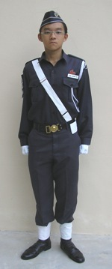 PTE/LCP/CPL/SGT

Musketry Kit (Pictured on following page)

This attire is designed to be worn for musketry training and is suitable for drill practice or less formal occasions. It consists of the blue BB regulation T-shirt, name tag and dark blue longs. Field service cap, belt and black boots (laced) are also worn. NCOs wear a wristband - commonly known as a field rank - that indicates their rank.

Boys are reminded that for Brigade-level activities, events or courses that stipulate musketry kit, only the BB Regulation blue (not Company) Polo shirt is to be worn.

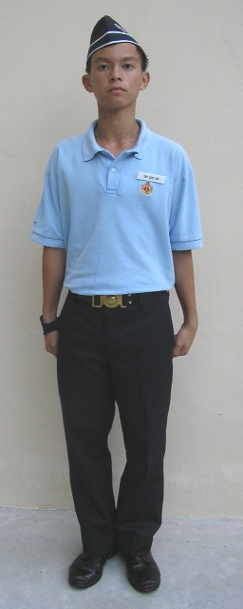

Fatigue Dress (Pictured on following page)

This attire is for informal occasions or when fatigue duties are performed. It consists of the regulation blue BB T-shirt, name tag, dark blue longs or blue jeans (outdoor activities) and field ranks for NCOs. Running shoes with dark blue socks are to be worn; with a jockey cap being optional.

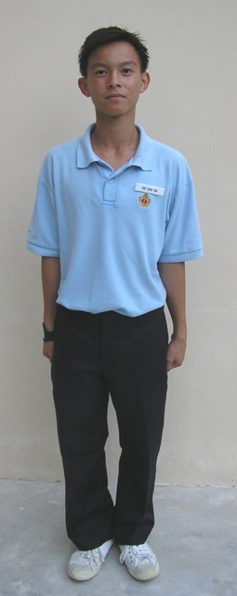

PT Kit
The PT kit can be worn for informal or sporting sessions. It is usually worn during 60th normal parade. It consists of the regulation blue BB T-shirt, and PE shorts. Boys are to wear white socks with their running shoes. The name tag and field rank may be removed during games.

PE Kit
This is not a BB standard attire but is simply used often by our company for normal parade attire. it consists of RI PE shirt, RI PE shorts, white socks and sports/school shoes.

3. 60th RIBB
a. History
- 60th Company
- Founded 13th March 1991 by Boys from Victoria School
- In honor of the 60th anniversary of the founding of our brother company, 2nd Company; 60th resulted from thus
- Sponsoring Church: Kampong Kapor Methodist Church
- First Brigade Level Event in 1991 with the BB Sharity Gift Box Project
- First officers of 60th commissioned in 1999: Mr. Benjamin Gaw and Mr. Christopher Chia (founding batch of Boys)
- Also in 1999 was the first batch of Boys from 60th who earned the Founders’ Men award: WO Mark Yong, WO Timothy Ang, WO Kelvin Ng and WO Tay Wee Yang
- 60th Today
- Now with a Pipes and Drums Band, with the 60th Bagpipe Band formed in 2004
- First overseas Service Learning Trip in 2007 to Thailand
- Liaised with 4th Company (Victoria School) and 2nd Company Girls’ Brigade (Raffles Girls’ School)
b. Structure

- EXCO
- Company Sergeant Major: Randal Lee
- Deputy Company Sergeant Major (Admin): Dominik Tan
- Deputy Company Sergeant Major (Welfare): Darryl Shya
- Band Major: Zhu Hanming
- Band
- Band Major: Zhu Hanming
- Pipe Major: Zhu Hanming
- Drum Major: Tan Jen Yang
- NCOs
- Inter-squad Competition Committee: Wu Yidi (I/C), Alvin Leung, Andrew Liang
- PRADA (Archival/Comms) Committee: William Hartono (I/C), Victor Chong (DY I/C)
- CIP NCO: Immanuel Leong
- Awards NCO: Bryan Tan
- Logistics NCO: Jaron Eng
- Singspiration NCO: Matthew Kho
- Squad Sergeants
- SS 1: William Hartono
- SS 2: Tan Jen Yang
- SS 3: Bryan Tan
- SS 4: Jaron Eng
- SS 5: Harish Sai Bhaskar
- SS 6: Gan Siang Hong
- Deputy Squad Sergeants
- DYSS 1: Bryan Lee
- DYSS 2: Tyrone Yeo
- DYSS 3: Joshua Leong
- DYSS 4: Neilsen Chan
- DYSS 5: Lim Ngee Jhin
- DYSS 6: Ivan Tang
- Primers (Not an exhaustive list)
- Andre Hui
- Pearlynn Wee
- Ng Kai Chin
- Ng Wei Chin
- Pang Lon Kai
- Daryl Teo
- Zhou Kai Jing
- Previous Year EXCO
- Company Sergeant Major: Victor Gwee
- Deputy Company Sergeant Major (Admin): Arel Chua
- Deputy Company Sergeant Major (Welfare): Liang Shi Yi
- Band Major/Pipe Major: Poon Xue Ping

c. Theme Verse and Songs

Theme Verse (From 2 Timothy 1:7):

For the Spirit God gave us does not make us timid, but gives us power, love and self-discipline.

Theme Songs:

Power of Your Love by Hillsong United

Still by Hillsong United

