ETL Project: Heather Leek, Theodore Moreland, Adam Feldstein

**Data Sources**

<https://www.kaggle.com/cityofLA/la-restaurant-market-health-data>

<https://www.yelp.com/developers/documentation/v3>

<https://www.yelp.com/developers/documentation/v3/business_search>

<https://www.yelp.com/developers/documentation/v3/business_reviews>

<https://api.yelp.com>

The Kaggle data source provided a list of all restaurants in Los Angeles, CA including their name, address and health inspection information such as the health grade and health grade percentage. The Yelp API was utilized to pull LA restaurant reviews and star rating for 1,000 restaurants.

**Data Cleanup & Analysis**

**EXTRACTION**

Data was extracted from the data sources listed above. The team utilized restaurant_inspections_original.csv file from the Kaggle which was downloaded directly in the CSV format. Additionally, the team utilized the Yelp API to call data for 1,000 LA restaurants (data set limited per the API). All API data was called in a JSON format, loaded into a dataframe and then output into a CSV file.

**TRANSFORMATION**

The first transformation was performed on the restaurant_inspections_original.csv file. The file contained 20 columns. The entire file was read into a Jupyter notebook. The OS path, Pandas and CSV libraries were imported for use into the Jupyter notebook. The entire file was read into an inspection dataframe. The team discerned that only eight columns within the file were relevant to the analytics process. Therefore, the team created a variable to rename eight columns through a dictionary that contained the old column name and a new column name. The new column names were more descriptive of the data being utilized. For example, facility name was renamed restaurant name.

The new column names were inserted into the existing inspection dataframe. Next, the eight columns were inserted into a list that was later utilized to reduce the inspection dataframe to a new inspection cleaned dataframe with eight columns rather than twenty.

Next the team dropped all duplicates in the file as the original dataset contained multiple inspection histories for each restaurant. Only the first inspection record for each restaurant was kept within the dataframe as the original file was organized with the latest inspection first. Finally, the team cleaned the zip code field by keeping only the first five digits as the original file contained a mix of five digit and nine-digit zip codes. The last step in the transformation of the inspection cleaned dataframe was to output it to a clean CSV file (restaurant_inspections_clean.csv).

The next transformation was performed on the Yelp restaurant and review data that was extracted through the API calls. For the Yelp reviews and ratings data, the team imported the OS, Pandas, JSON, Api_key, Requests and Rate Limit libraries into the Jupyter notebook. The team had to utilize an API key to perform the API call within the extract.

Data from the API was stored within two dictionaries. The restaurant dictionary stored the restaurant id, name, rating, review count, address, city, state and zip. The restaurant review dictionary stored the restaurant id, name, star rating, 3 randomly selected reviews and the date time for each review.

Data from the API calls was appended within each of the two dictionaries. Next, the data from each dictionary was put into a Pandas dataframe. Finally, the team dropped any duplicates in each dataframe and exported the contents of each dataframe into a CSV file. Two CSV files were output including yelp_reviews.csv and yelp_la_restaurants.csv.

**LOAD**

The team created a database in MYSQL Workbench called restaurant_db. Three tables were created in the database for the Kaggle inspection data and the API yelp review data. See tables below:

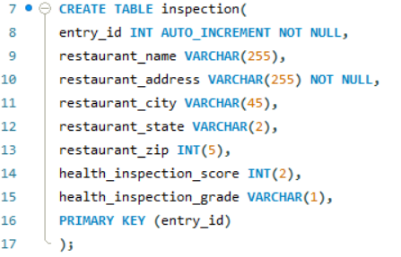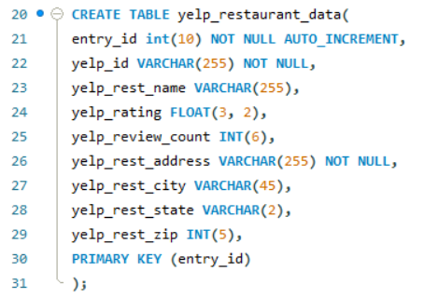

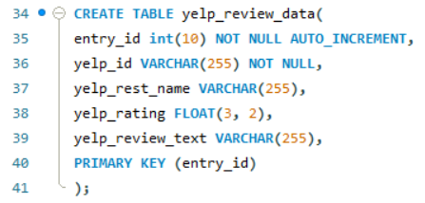

The team created the inspection table to store all the name and address attributes related to LA restaurants and their last health inspection grade and percentage. The primary key selected for this table was the restaurant id which was a unique id that tied the restaurant to the health inspection. The second table created was yelp_restaurant_data. This table contained restaurant address and name attributes as well as the overall yelp rating and total number of review available on yelp for the restaurant. The final table created was the yelp_review_data. This table contains the unique yelp_id which was tied to the yelp_restaurant_data table. The review_data table also contained the review text for 3 random review for 1,000 LA restaurants.

The team utilized these tables so they could join restaurant attributes and health inspection grade to the review rating and number of reviews. If data analysis was being conducted, the team would have hypothesized that restaurants with higher health grades had more favorable reviews on Yelp.

After the database was created, the team utilized a separate Jupyter Notebook file to read in all the CSV files. The team imported Pandas, OS and SQLAlchemy libraries. Each file was saved into its own dataframe. Columns for each dataframe were renamed to correspond with the database created in MySQL. After columns were renamed, the team created a connection to the database and loaded the tables into the restaurant_db database.

Note: If you want to run the scripts on your own, you need to have a database called restaurant_db. Next you will need to run the MySQL script to initialize the database. There should be a separate filed named db_access.py and it should contain the following variables db_user (string with user name for MySQL database); db_pass (string with password for the database) and db_address (string with the network address for your database).