Tobel Three Bagger Code

Theo Tobel

12/13/2021

# Create a graph, "Center Field Distance over Time"  
  
plot(mean_cf ~ Year, data = park_config_stats, ylim = c(min(park_config_stats$mean_cf-park_config_stats$sd_cf), max(park_config_stats$mean_cf+park_config_stats$sd_cf)), ylab = "Mean Center Field Distance (in feet)", main = "Center Field Distance over Time", type = "l")  
  
lines(park_config_stats$Year, park_config_stats$mean_cf+park_config_stats$sd_cf, lty = "dotted")  
  
lines(park_config_stats$Year, park_config_stats$mean_cf-park_config_stats$sd_cf, lty = "dotted")  
  
legend("topright", legend = c("Mean", "One Standard Deviation"),  
 lty = c(1,3), cex = 0.7)

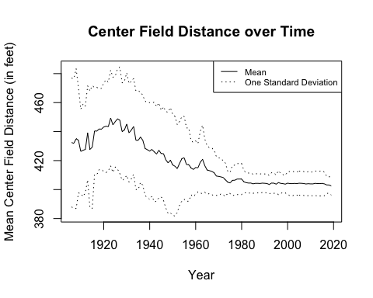

# Run Paired T-Test for differences in home runs  
  
t.test(experiment_negative$Change_Year_HR_per_AB,   
 experiment_negative$Prev_Year_HR_per_AB, paired = TRUE,  
 alternative = "greater")

##   
## Paired t-test  
##   
## data: experiment_negative$Change_Year_HR_per_AB and experiment_negative$Prev_Year_HR_per_AB  
## t = 2.5632, df = 141, p-value = 0.005709  
## alternative hypothesis: true difference in means is greater than 0  
## 95 percent confidence interval:  
## 0.0005768059 Inf  
## sample estimates:  
## mean of the differences   
## 0.001629171

# Run Paired T-Test for differences in triples  
  
t.test(experiment_negative$Change_Year_Triples_per_AB,   
 experiment_negative$Prev_Year_Triples_per_AB, paired = TRUE,  
 alternative = "less")

##   
## Paired t-test  
##   
## data: experiment_negative$Change_Year_Triples_per_AB and experiment_negative$Prev_Year_Triples_per_AB  
## t = -2.36, df = 141, p-value = 0.009823  
## alternative hypothesis: true difference in means is less than 0  
## 95 percent confidence interval:  
## -Inf -0.0001587892  
## sample estimates:  
## mean of the differences   
## -0.0005321155

# Create a Q-Q Plot to check the assumption of normality for differences in triples  
  
experiment_negative %>% mutate(Triple_diff = Prev_Year_Triples_per_AB - Change_Year_Triples_per_AB) %>%  
 pull(Triple_diff) %T>% qqnorm %>% qqline

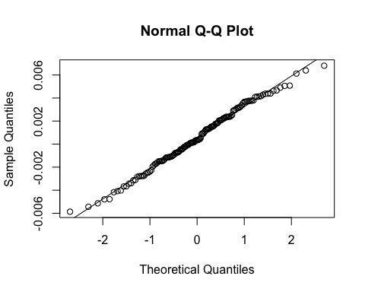

# Create a Q-Q Plot to check the assumption of normality for differences in home runs  
  
experiment_negative %>% mutate(HR_diff = Prev_Year_HR_per_AB - Change_Year_HR_per_AB) %>%  
 pull(HR_diff) %T>% qqnorm %>% qqline

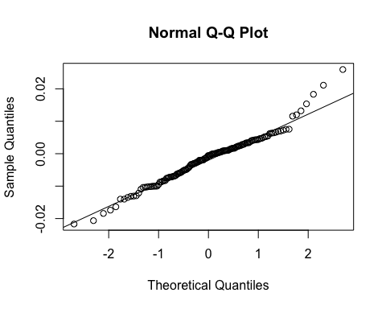

# Create a scatter plot for "Year of Change vs. Change in Center Field Distance" for ballparks that decreased in size  
  
ggplot(experiment_negative, aes(Change_Year, CF_change)) +  
 geom_point()+  
 geom_smooth(method = "loess") +  
 xlab("Year of Change") +  
 ylab("Change in Center Field Distance (in feet)") +  
 ggtitle("Year of Change vs. Change in Center Field Distance")

## `geom_smooth()` using formula 'y ~ x'

