Project: Customer Churn Predictor

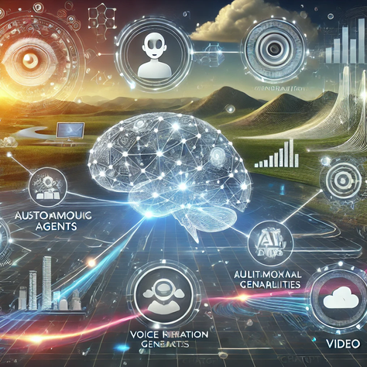
Theodor Lazarjan 2026

Table of Contents
What is the task? 2
Session 1: Understand the problem, get the data 2
Session 2: Build and train the model 5
Session 3: Build the app 8
Links: 10

What is the task?
A small program that looks at a customer's profile (how long they've been a customer, what plan they're on, how much they pay, etc.) and predicts whether they're likely to cancel their service. You'll train it on real data, then wrap it in a simple app where you can type in a customer's details and get a prediction.
This is a real, complete machine learning pipeline:
data → model → working app
Churn prediction is one of the most common real business problems in ML. Telecoms, banks, gyms, and subscription companies all do a version of this. You're building the small version of the same thing.

Session 1: Understand the problem, get the data
Research first (do this before touching code)
- What does "churn" mean in a business context, and why do companies care so much about predicting it? Read 2–3 articles, take notes in your own words:
Churn means a customer stops using a product/service. For example, if a customer cancels their phone contract or subscription. It is based on how much the number of users decreases:
(Number of Lost Customers / Total Customers at the Start of Time Period) × 100 = Churn Rate

It is important to predict the churn number because a high number means that they are losing money. If they can predict that customers and which customers are canceling, they can intervene (example: discounts). It is important because keeping a customer is cheaper/easier than finding a new one.
Advantages: reduce customer loss, increase revenue, improve customer satisfaction, and make better business decisions.
https://www.forbes.com/advisor/business/churn-rate/

- What's the difference between a categorical feature and a numerical feature? Why can't a model use text categories like "Month-to-month" directly?
Categorical data can be put in groups or categories using names or labels. There are two categories, Nominal data and Ordinary data.
A numerical feature contains numeric values that represent quantities or measurements.
Machine learning models can’t work with categories and only with numbers. They cannot understand objects or words like "Month-to-month".
Categorical features must be converted into numbers before training. One method is One-Hot Encoding, each category becomes its own column with values 0 or 1.
https://www.questionpro.com/blog/categorical-data-vs-numerical-data/

- What's a false positive and a false negative here? If you wrongly flag a happy customer as "about to churn," what's the cost, versus missing a customer who actually leaves? Which mistake is worse for a business, and why does that matter for how you'll judge your model later?
In this project, the target is the true or false value of our label “Customer will churn”.
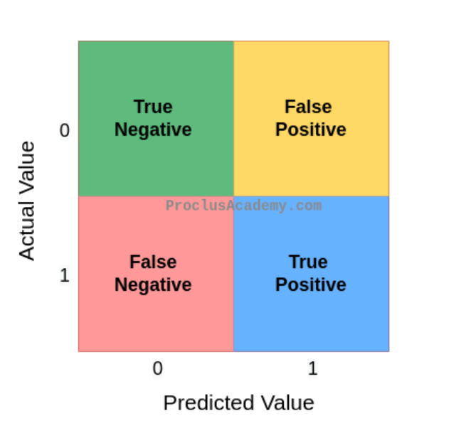
False Positive (FP): The model predicts that a customer will leave, but the customer actually stays.
Costs: The company give an unnecessary discount, Profit may decrease slightly.

False Negative (FN): The model predicts that a customer will stay, but the customer actually leaves.
Costs: The company loses the customer, Future subscription money is lost and need to find a new customer.

A False Positive only wastes a small amount of money on retention offers. False Negative is more expensive because the company loses a customer without trying to keep them.
If the False negative is important we use the recall:
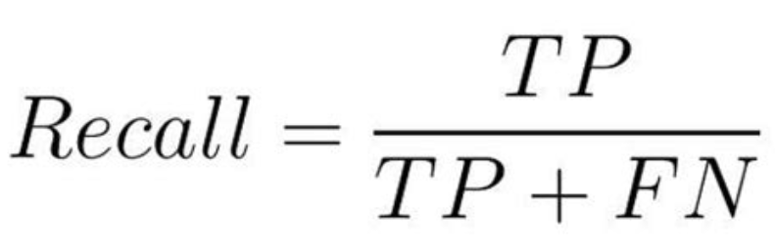
From every customer that cancels how many did the model get?
A high recall means the model misses fewer customers who are about to leave.

Recall: when it is most important to miss as few customers who churn
Precision: when the model shouldn’t give that many customers a discount
F1-score: when you want a balance between Precision and Recall.
Matrix: https://proclusacademy.com/blog/explainer/confusion-matrix-accuracy-classification-models/
Recall: https://encord.com/blog/classification-metrics-accuracy-precision-recall/

Then, hands-on
- Download the Telco Customer Churn dataset (search for it, it's a well-known free dataset on Kaggle, about 7000 customers with a Churn Yes/No label).
https://www.kaggle.com/datasets/abbas829/telco-customer-churn-dataset?resource=download
- Load it with pandas. Look at the columns:
- How many customers churned vs stayed? Is the dataset balanced or skewed?
There are 5,900 customers who stayed and 1,900 customers who churned. The dataset is imbalanced. There are a lot more customers who stayed than customers who churned.
This is important because it can be bad in two ways:
-You have more data on one of the class for the training part which means that it can learn more about the date of one class but not the other
-the model would be more likely to chose the majority class because it would be right almost 70 % of the time so accuracy would be bad and we need a judge that can predict the minority class: recall.
- Pick 3–4 columns and check if they seem to correlate with churn just by eye (e.g. do month-to-month contracts churn more than yearly ones?).
Unnamed: 0 → Unnecessary
customerID → Unnecessary
gender → No Comment
SeniorCitizen → No Comment
Partner ↔ Dependents
Dependents ↔ Partner
tenure ↔ TotalCharges, Contract -> important for churn
PhoneService ↔ MultipleLines
MultipleLines ↔ PhoneService
InternetService ↔ OnlineSecurity, OnlineBackup, DeviceProtection, TechSupport, StreamingTV, StreamingMovies
OnlineSecurity ↔ InternetService
OnlineBackup ↔ InternetService
DeviceProtection ↔ InternetService
TechSupport ↔ InternetService
StreamingTV ↔ StreamingMovies, InternetService
StreamingMovies ↔ StreamingTV, InternetService
Contract ↔ tenure -> important for churn
PaperlessBilling ↔ PaymentMethod
PaymentMethod ↔ PaperlessBilling
MonthlyCharges ↔ TotalCharges -> important for churn
TotalCharges ↔ MonthlyCharges -> important for Churn
Churn → Target variable

Session 2: Build and train the model
This is our structure:
Google Collab file in the github.

Gather Data
Explore Data (head, info, target-feauture relations feature relationships)
Data Cleaning (object types, missing values, blank strings, duplicates, unnecessary columns, outliers)
Feature Engineering (create new features)
Feature Selection (remove not important features)
Encoding (One-Hot Encoding, Label Encoding)
Scaling (StandardScaler)
Dimensionality Reduction (PCA, LDA)
Separate Features and Labels (X, y)
Train/Test Split (stratify for classification)
Preprocessing Pipeline (imputer, encoder, scaler, Pipeline)
Choose & Instantiate Model (Decision Tree classifier/regressor, Linear Regression, polynomial regression, Logistic Regression, kNN, Naive Bayes, SVM)
Train Model (fit)
Predict (predict, predict_proba)
Threshold Optimization
Evaluate Model (Accuracy, Precision, Recall, F1, Confusion Matrix, ROC-AUC / MAE, MSE)
Cross Validation (k-Fold) -
Hyperparameter Tuning -
Overfitting / Underfitting Check (train vs. test)
Feature Importance
Final Model

Plotting data from link
Scatterplot
Correlation matrix
Violin plot
Box plot

Random forest
Random forest feauture importance

Put plots into ai -> what does it mean -> how to make better
Regex expression

Links:
Front Page image: https://theswissquality.ch/what-to-expect-from-openai-chatgpt-5-key-details-launch-and-features/
Article 1: https://www.forbes.com/advisor/business/churn-rate/
Article 2: https://www.questionpro.com/blog/categorical-data-vs-numerical-data/
Matrix: https://proclusacademy.com/blog/explainer/confusion-matrix-accuracy-classification-models/
Recall: https://encord.com/blog/classification-metrics-accuracy-precision-recall/
Dataset: https://www.kaggle.com/datasets/abbas829/telco-customer-churn-dataset?resource=download

Review data

