RLWM ACT-R RMSE model fitting and outcome analysis for split-half data

Theodros H.

10/2022

# Results

As described above, learning data for all participants were split into the first 6 stimulus iterations and the last 6 before model fitting. Additionally, the two conditions, set-size 3 and set-size 6 were also fit separately.

## Overview of modelfitting results

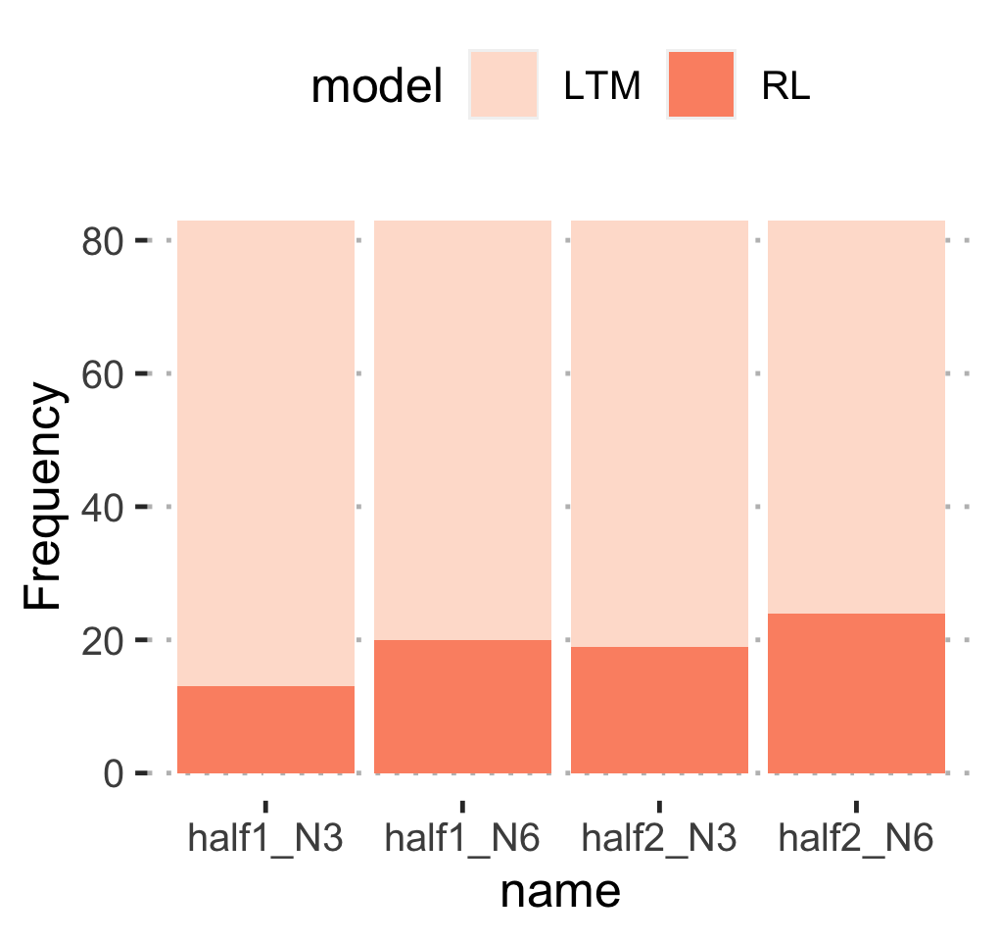

Figure 1

We found that the LTM model still fit more subjects in both halves (first half- LTM: M = 66.5, RL: M = 16.5; second half- LTM: M = 61.5; RL: M = 21.5), and conditions (set-size 3 - LTM: M = 67, RL: M = 16; set-size 6 - LTM: M = 61, RL: M = 22) much like the results obtained through the model fitting procedure in experiment 1 (Figure 1). Furthermore, more subjects fit the LTM model in the set-size 3 condition compared to the set-size 6 condition (more in the first half than in the second half, for both), which means, for those subjects that fit the RL model, higher numbers of subjects fit RL model for set-size 6 conditions than set-size 3 (more in the second half than in the first half for both conditions). This trend aligns more with Collins (2018) findings but these results do not take into account individual dynamics (covered in detail below).

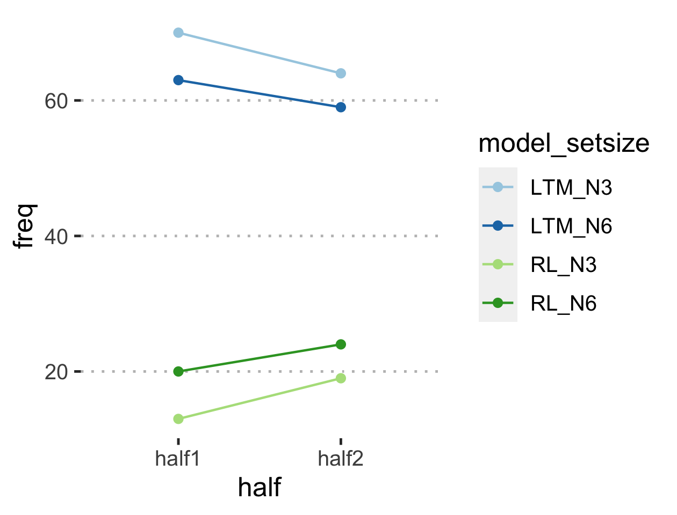

## 

## Overview of model-fitting quality

The plot below shows mean BIC value for the best fitting model for each of the halves and set-sizes.

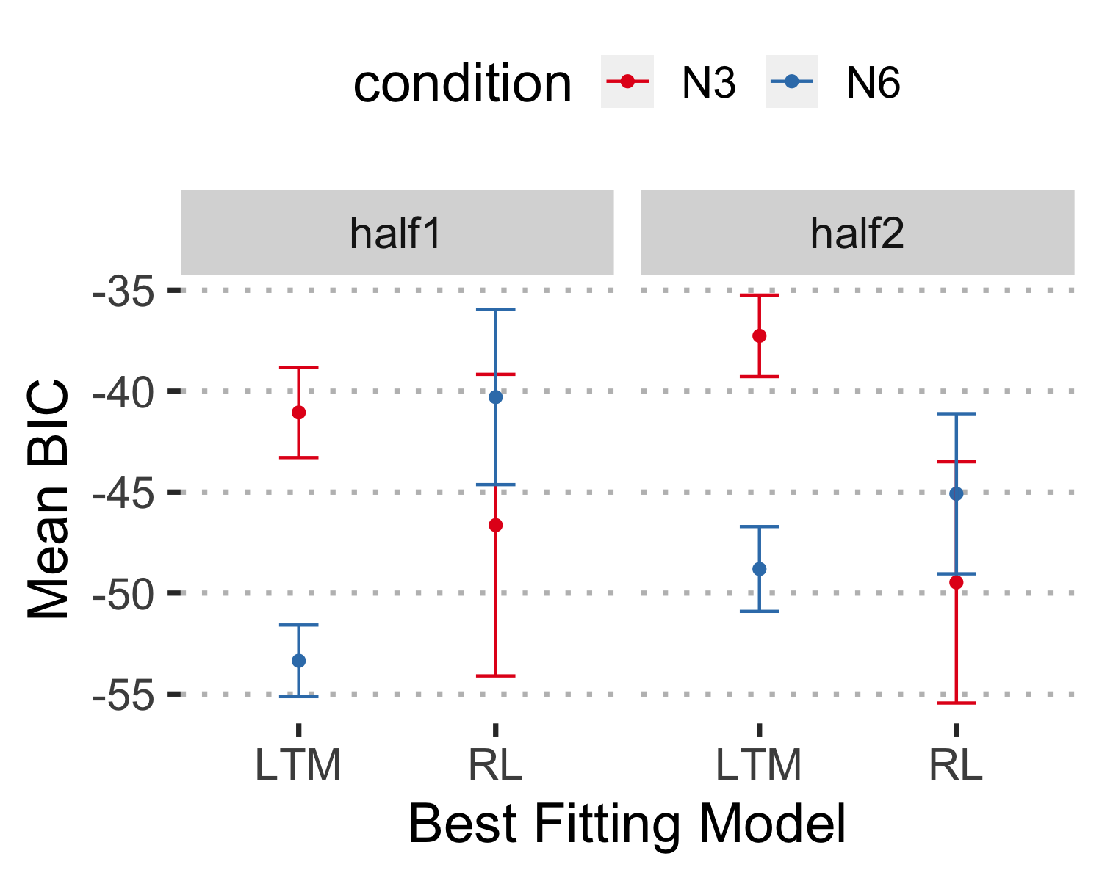

## Dynamics

### Does the best fit model change from 1st half to second half and between the two set-sizes?

Next, we sought to track learning dynamics for each individual learner. In other words, we wanted to see if learners changed strategies in response to 1) their learning experience, by comparing model fits to the first half and second half of learning, 2) task demands, by comparing model fits to th two set-size conditions, and, 3) interactions between the two.

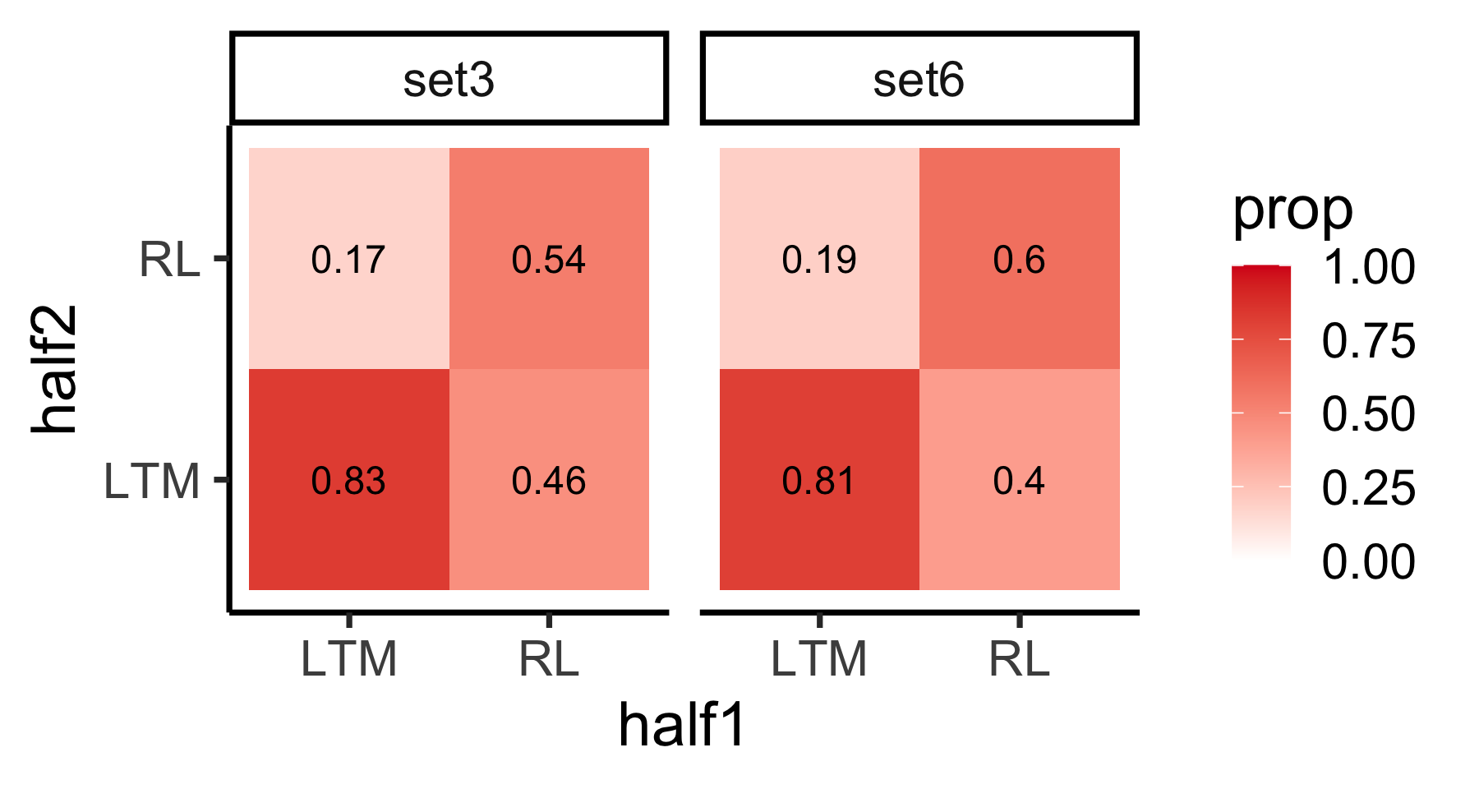

We found that over 81% of learners who fit the LTM model in the first half also fit that model in the second half of learning (set-size 3: 82.86%; set-size 6: 80.95%). In contrast, more than 50% of those subjects who were best fit by the RL model in the first half also fit the RL model in the second half (set-size 3: 53.85%; set-size 6: 60%), the rest shifted to LTM.

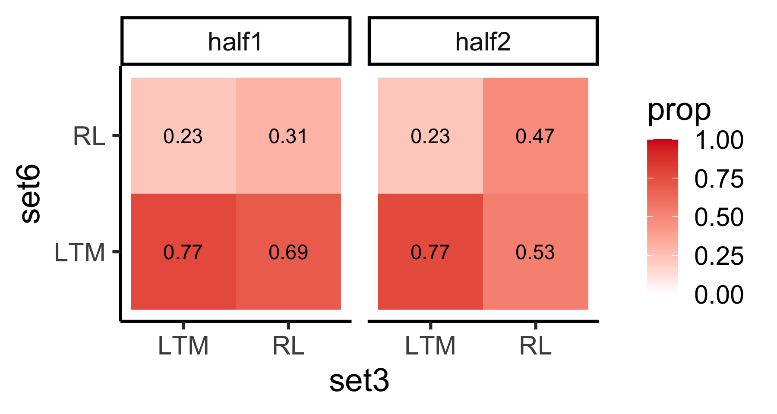

Patterns of model fits for the set-sizes were similar to the first half – second half fits above. More than 75% of subjects who fit the LTM model during set-size 3 trials also fit the LTM model in set-size 6, and these are largely the same across the first and second half of the task (half 1: 77.14%; half 2: 76.56%). In contrast, fewer numbers of subjects who fit the RL model for set-size 3 blocks also fit RL in the set-size 6 blocks; and these numbers differ between half 1 and half 2 (half 1: 30.77%; half 2: 47.37%)

## Are the parameter values largely different for each half and set-size?

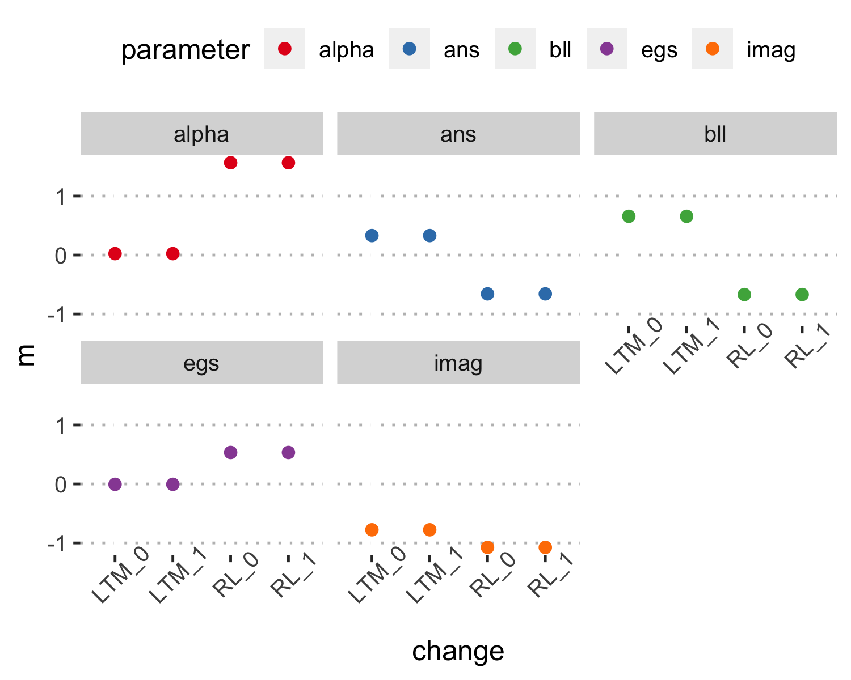

## Individual plots