Abstract

Ad hoc networks are characterized by limited resources (e.g., energy, storage, bandwidth). We propose a scheme of regulating energy consumption in networks where nodes disseminate information epidemically. Assuming multipath propagation as the major source of noise in our wireless channel model, we propose a cross-layer scheme of adapting the transmission characteristics while reacting to noise fluctuations in a fashion that a perceived net reward is maximized and infection is enhanced at modest energy cost.

- Introduction

Ad hoc networks are characterized by the strong need to rationalize the usage of scarce resources in order to preserve them. Such networks customarily serve context aware applications; this may concern collaborative context awareness. Information that needs to be disseminated among network nodes can be context information, or even context information requests [1].
This is achieved through information dissemination schemes. Unconditional data Flooding by all nodes can serve this purpose but results in excessive resource consumption [2], [3]. The epidemic information dissemination model is based on data transmission in a probabilistic rather than deterministic way [4], [5]. Such a stochastic approach limits the redundant transmissions observed in flooding and leads to less energy and network resources spent [6]. Introducing adaptive dissemination schemes [7], [8] allows for further flexibility, which usually imposes a tradeoff between resource consumption and effective dissemination[...].
We propose a context-aware, adaptive epidemic information dissemination scheme with distinct cross-layering features.
It functions in cooperation with Adaptive Modulation and Coding (AMC) and exploits the awareness of the channel state. It tunes the message forwarding probability (or forwarding factor) and the coding mode utilizing information from the lower layers as input. These two parameters comprise the nodes’ state whose change follows a Markov decision process (MDP) process based on known cross-layering models [26], [27]. The MDP follows a decision strategy that attempts to maximize a perceived net benefit.
Our paradigm has two degrees of freedom; epidemic dissemination parameter tuning assists the capabilities of the AMC and vice-versa. It exploits the flexibility provided by this combination, while remaining energy-sensitive.
The purpose of this combined tuning is to achieve high network coverage without excessive energy cost due to redundant transmissions or unnecessarily large error control code-imposed overhead.

The rest of the paper is structured as follows. Section 2 presents previous work on adaptive information dissemination schemes and briefly presents some aspects on cross-layering in cognitive radio. In Section 3 we elaborate on the adopted wireless channel model. In Sections 4 and 5 respectively, we formalize our information dissemination adaptation strategy and the related Markov Decision Process modeling. Section 6 formalizes the algorithm and Section 7 shows performance metrics for evaluating the model as well as simulation results. Finally, conclusions and future work are discussed in Section 8.

- Previous work

Redundant transmissions in ad hoc networks, where nodes do not have global topology knowledge, are a significant energy-consumption factor. Various approaches to overcome this issue have been proposed. It has long been suggested that nodes apply selective message forwarding schemes depending on local conditions ([6], [4], [9], [10]). These are used to help nodes adapt the way they disseminate data. The term local may refer to either the node itself or its neighbors. Knowledge on such conditions may be obtained through either active or passive methods. In the former case, a node typically actively queries its neighbors on specific metrics. The response it receives may be used to support context-awareness. In the negotiation-based adaptive epidemic scheme in [6] the nodes, which are about to forward data (referred to as infected nodes) poll their neighbors about their residual energy before adjusting their message forwarding probability. Moreover, there are approaches that select a subset of neighboring nodes prior to information forwarding. Such selection schemes are also based on local information. The publish-subscribe paradigm in ‎[4] assists in filtering some nodes out of the potential information receivers. The model proposed in [11] foresees quench waves, consisting of messages of a protocol whose specific purpose is to limit redundant transmissions. One notices that the schemes described so far require the explicit co-operation of neighbor nodes.
Passive methods like the use of a Time-To-Live (TTL) field in the disseminated information brings energy cost reduction [14]. Artificially limiting the buffer size has a similar impact [13]. However, a trade-off needs to be defined here, as non-redundant traffic may be affected too. The model in [9] is based on the adaptation of the forwarding probability on a node w.r.t. the (local) network density, based on the concept that, over-frequent transmissions are unnecessary in a dense network. In [10], a significant amount of energy is saved by regulating the transmission range of the wireless node. In this manner the probability that an infected node ‘infects’ a ‘susceptible’ one is effectively adapted. Passive schemes have the advantage of no explicit extra transmission energy cost.
Epidemic dissemination schemes find application in context-aware settings [14], which has also been displayed in applied scenarios in previous work [15].
We contribute to the field of adaptive epidemic-based information dissemination schemes by proposing a passive scheme, based on local decisions and with no extra communication cost. Neighboring nodes are not polled on their residual energy or infection state. Information forwarding among neighboring nodes is probabilistic. The node states that promote the successful reception of the information without incurring too high energy cost are considered more favorable. It is intuitive that increasing the forwarding probability counterbalances loss due to high channel noise. Moreover, stronger codes from the ones available by the AMC assist in mitigating the effects of corrupted data delivery. This component of cross-layer awareness builds on the channel model and AMC in [16]. Our scheme combines the flexibility of the adaptive modulation and coding with the intelligence of adaptive epidemic algorithms, thus, constituting a novel scheme with cross-layer features.

- Channel model

We assume a number of nodes ad hoc networked in the fashion of a non-fully connected network. There is multipath propagation noise between each two nodes. We assume a scheme of bursty noise superimposed. We make the simplifying assumption that the noise for the path i->j be identical to the one for the path j->i. Hence, a single SNR value is assigned to each (non-directional) pair (i,j).
The multipath propagation noise follows the SoS paradigm. According to this, the SNR of each path (channel/pair) falls within designated intervals, by definition equivalent to different states, thus following a FCMC. Assuming that the noise follows the hiperlan model we can statistically observe the transition probabilities and, thus, the full transition matrix of the said FSMC.
The state of channel (i,j) at time t is described by the discrete r. v. h_{i,j}^{t} , which depends on the signal-to-noise ratio due to both multipath reception and bursty noise, if the latter is present. We postulate that h_{i,j}^{t} follows this rule:
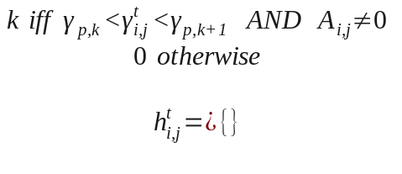 (1)
where γ_{i,j}^{t} is the SNR for link (i,j) at time t and the thresholds γ_{p,i} implement the partitioning of the SNR range and separate the different modes from each other [19]. These specified values are termed SNR thresholds.
To mitigate the impact of noise, we adopt convolutional error-control coding. The packet error rate (PER) in wireless channels in the presence of convolutional error-control coding has been investigated in recent work [20], and our work builds on this knowledge and adopts the model proposed there for the simulations. The use of an adaptive modulation and coding scheme is adopted, with different modulation schemes and encoding rates characterizing each AMC mode. According to this AMC, the signal-to-noise ratio (SNR) range within which the wireless interface of the network nodes operate is divided in a fixed number (six) of disjoint intervals delimited by the SNR thresholds. A modulation and coding mode of the ones available for this AMC scheme is assumed to correspond to each interval. The PER is approximated by Eq. (4), reproduced here from [20].
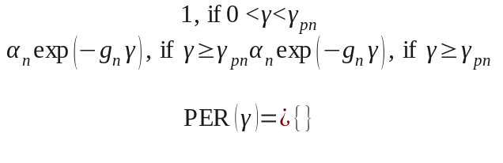 (2)
Clearly, the parameters γ_{pn} separate the (disjoint) SNR intervals as mentioned above and coincide with the SNR thresholds of equation (1). SNR is denoted by γ .The parameters α_{n} and g_{n} depend on the mode and their values are assumed from [20].

- System model and adaptation algorithm

Information dissemination in the discussed network occurs in an epidemic-based manner [21]. Nodes that do not carry information are assumed to be susceptible, whereas those that do are infected. An infected node attempts to infect others by means of broadcasting the information it possesses. An infected node i disseminates the information at time t with a forwarding probability β_{i}^{t}. The result is that an infected node’s susceptible neighbor gets infected with a finite probability. Moreover, an infected node can be cured at some time once the carried (infecting) piece of information turns obsolete or unusable. All possible cure mechanisms are summarized with a cure rate δ_{i}(t) ∈ [0, 1] for a node i at time t. We adopt the Susceptible-Infected-Susceptible (S-I-S) model [21], according to which an infected node that is cured becomes susceptible again with rate δ_{i}(t) and may be further infected.
The operation of each node at (discrete) time instance t is characterized by two parameters, namely the forwarding probability (or forwarding factor, β_{i}^{t}) and the AMC mode (μ_{i}^{t}). The AMC mode is a finite integer number and to simplify our problem, the forwarding factor is also discretized. The pair (β^{t}, μ^{t}) for a node i describe exactly its state at time t, which is collectively written as:
s^{t} = (β^{t}, μ^{t}) {β_{m}}x{μ_{n}}, m =1,2,…. κ , n =1,2,… λ (3)
In addition to the above, we define a set of possible actions which impact the state of the node ([26],[27]). These actions increase, decrease or leave unchanged the forwarding factor and AMC mode. From each state s^{t}, the Markov chain can go to a new state out of the allowed ones by means of an action α^{t} chosen from the possible ones depicted in Table 1:

Table 1: Possible channel state transitions

 | Increment μ | Decrement μ | Keep μ
Increment β | β^{t+1} = β^{t} + Δβ, μ^{t+1} = μ^{t} + 1 | β^{t+1} = β^{t} + Δβ, μ^{t+1} = μ^{t} – 1 | β^{t+1} = β^{t} + Δβ, μ^{t+1} = μ^{t}
Decrement β | β^{t+1} = β^{t} – ν*Δβ, μ^{t+1} = μ^{t} + 1 | β^{t+1} = β^{t} – ν*Δβ, μ^{t+1} = μ^{t} – 1 | β^{t+1} = β^{t} – ν*Δβ, μ^{t+1} = μ^{t}
Keep β | β^{t+1} = β^{t}, μ^{t+1} = μ^{t} + 1 | β^{t+1} = β^{t}, μ^{t+1} = μ^{t} - 1 | β^{t+1} = β^{t}, μ^{t+1} = μ^{t}

Due to the presence of the multiplicative factor ν in forwarding factor decrement actions, the allowed state changes for the forwarding factor represent an AIMD (additive increase multiplicative decrease) mechanism. The values Δβ and νΔβ are termed beta step and beta contraction, respectively. Among the possible actions, the one is chosen that maximizes a suitable utility function U^{t} which obeys the generic form utility = net benefit = reward – cost.
We utilize an implementation of this utility function:
U^{t} = P^{t}_{sr,i} - N^{t} – CC^{t}_{i} (4)
where P^{t}_{sr,i} is the probability of successful reception of the infecting information from at least one neighbor of an infected node; N^{t} is the normalized energy cost (NEC) defined as the energy cost within a time interval normalized over the maximum possible cost over the same interval. CC is the cost due to state change and has been introduced to summarize all possible sources such as FPGA reconfiguration, processing power or temporal lag. We postulate that the probability P is given by
P^{t}_{sr,i} = (1-δ^{t}_{i})β^{t}_{i}(1-PER^{n}) (5)

- Proposed Algorithm (also MDM and OST)

The above description can be formulated as an infinite horizon Markov decision process (MDP), which dictates that when an OST condition is fulfilled, an action α^{t} takes place that results in a state change of the s^{t} FSMC in order for reward maximization to be achieved. This condition has to be associated with the effective utility functions defined earlier.
A known [27] such condition is
U^{t+1} > U’^{t+1} (6)

where U'^{t+1} is the expected future utility. It is the weighted average of the possible ones. The weights are the normalized observed action occurrence frequencies
The essence of this algorithm is that for the next time slot, the action that fulfills the OST condition is chosen, whereas if no action offers this benefit, the node state remains unchanged. .
The above model description makes apparent that the possibility of a node state change (change of s^{t}) is examined according to the changes of the channel state. An AMC normally dictates regular mode changes, depending on the change of the SNR. In the presence of the superimposed bursty noise, channel state changes can be very abrupt, prompting for consequent node state changes.
This ‘hasty’ node state change may not always be optimum. On the contrary, it may be best to not change node state due to an abrupt but brief channel state change. There is a reasonable range of response speed between the two extremes. We engineer the utility function in such a manner as to facilitate aggressive (fast-responding) or conservative policies. The utility function can be generalized to be an average over a period of time, which in practice is a (sliding) window. The speed of response is quantified as the size of this window. The generalized utility function is then:

U_t_generalized = (1/window)*Σ U_t (t=τ-window, t=τ) (7)

This utility function introduced in equation (4) potentially renders often changes too costly. Hence, a tradeoff has to be made between hasty and lazy mode changes.

The solution to the optimization problem is approached with the algorithm of Listing 1 that tests whether condition (13a) holds in order to make a decision.

Algorithm: Decision at time t for node i
Input: node i, forw. prob. at t :β_{i}^{t}, coding mode at t: μ_{i}^{t}, possible actions are indexed j P = {1, 2, … p}
Begin
Foreach t = 1:T // at every time instance
Foreach i = 1:N // all nodes
Calculate expected future utility U’^{t} over all possible actions
Foreach j  P // all possible actions
Calculate utility U_{j}^{t}
Calculate forw. factor & mode for action j: β^{t}_{cand,j},μ^{t}_{cand,j}
Endfor
Foreach j  P // all possible actions
If U_{j}^{t} > U’^{t} // opt. stop. condition
then (β(t+1),μ(t+1)) = (β(t)_{cand,j},μ(t)_{cand,j}) // new state = j
Endif
Endfor
Endfor
Endfor
End
Listing 1

- Simulations and evaluation

Depending on requirements and environment, in some ad hoc network deployments it is important to achieve extensive coverage of the network, without 100% infection being critical. Sometimes speed of infection can be of more significance. For this reason we have defined some metrics associated with the 90% infection of the network for the evaluation of the proposed scheme:
- Infection rate: the proportion I(t) of the nodes that are infected at time t
- Time to full coverage (T2FC) and time to 90% coverage (T29C): the time till all (or 90%) nodes are infected for the first time, i.e. the infection rate I(t) reaches unity (or 0.9). Similarly, we define:
- Transmissions count to full coverage (TC2FC) and to 90% coverage (TC29C).
- Energy spent to full coverage (E2FC) and to 90% coverage (E29C).
Time, transmission count and energy cost are defined as normalized quantities, i.,e with respect to the corresponding quantity for the case of a scheme operating an AMC with an unchanging forwarding probability.
- Efficiency: this is defined as the infection rate over the E2FC: efficiency = I(t=T2FC)/E2FC
- Effective goodput: The count of infecting information bits (coding overhead excluded) times the actual infecting receptions over the energy spent. Intuitively this renders the useful bits transmitted:
g_{eff} = infections_count*packet_size/E2FC (8)
Simulations were performed to evaluate the enhancement provided by the proposed scheme to the AMC paradigm and the aforementioned metrics were observed.
The impact of the sliding temporal window used in the definition of the generalized utility function in equation (7) is also assessed. The values utilized in the simulations are presented in Table 1:

Table 1:
scheme | Sliding window duration (in time slots)
aggressive (paranoid) | 1
conservative | 3
Slazy (sleepy) | AMC mode lifetime
We present results for some representative values of the most important parameters for the different generalized utility functions. The proposed scheme achieves considerable energy cost savings compared to the static scheme (constant β) case and successfully enhances the AMC in this direction.
The continuous adaptation of the two degrees of freedom (ΑΜC mode and β), is better visualized in Figure 1. This three-dimensional plot depicts the average node state shift. For the parameter values assumed in this simulation, the nodes appear to drift towards states with lower forwarding rates and higher coding overheads. These two actions counterbalance each other, while respectively decreasing and increasing energy cost. The trade-off reached results in the improved overall energy cost and infection rate, as will be exhibited.
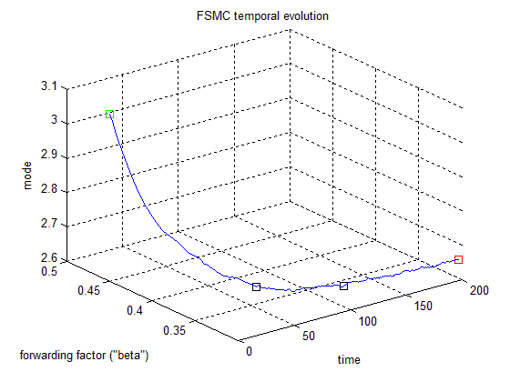

Figure 1: Temporal evolution of the node state: green is the original state and red is the ending state for a simulation. All quantities refer to average over all network nodes.

Simulations show that the approach presented in this paper can bring about a reduction in the energy cost of infection. The choice of aggressive or conservative node state adaptation affects the algorithm's behavior.
In figure 2 we present plots of the AMC mode, forwarding factor, utility function value and infection rate indicating the advantages offered by the proposed adaptive scheme.
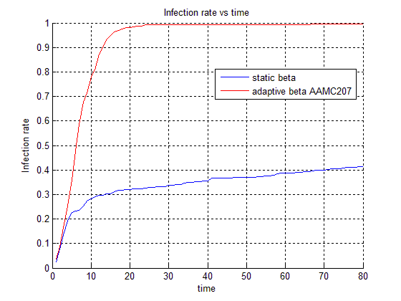

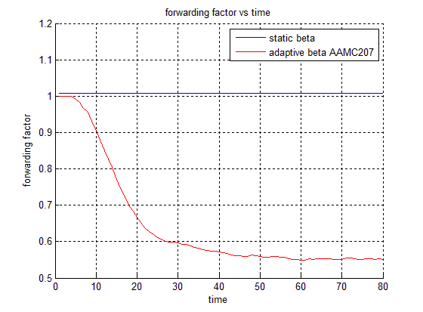
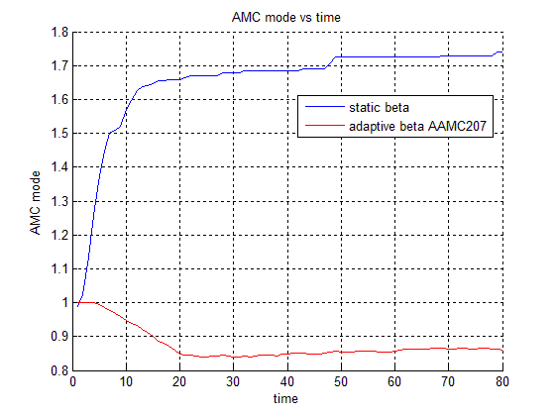
Figure 2: Infection rate, mean forwarding factor, mean AMC mode; comparison of adaptive scheme and static-beta-AMC

Finally, some metrics appear in table 4.

 | Adaptive β and mode AMC schemes (measurements are normalized to the static scheme measurements)
Metric | sleepy | Very conservative | conservative | aggressive | memoryless
T2FC | 0.862276015 | 0.839780397 | 0.78401373 | 1.301659616 | 0.933090497
TC2FC | 0.694033749 | 0.635412679 | 0.650751791 | 0.846337053 | 0.655072747
E2FC | 0.642452894 | 0.589043329 | 0.560657618 | 0.770976642 | 0.608540502
T29C | 1.760416667 | 0.75 | 0.666666667 | 0.9375 | 0.513891667
TC29C | 1.476476015 | 0.686808118 | 0.625724723 | 0.889298893 | 0.492619926
E29C | 1.380418263 | 0.716654761 | 0.671841287 | 0.855126945 | 0.52053526
NEC | 0.358949007 | 0.327230346 | 0.323989594 | 0.36367014 | 0.321064104
Energy Cost Gain | 0.357547106 | 0.410956671 | 0.439342382 | 0.229023358 | 0.391459498
Speed Gain | 0.137723985 | 0.160219603 | 0.21598627 | -0.301659616 | 0.066909503
Gain product | 0.049242812 | 0.065843314 | 0.094891922 | -0.069087098 | 0.026192361
Efficiency=I/TC2FC | 1.417770256 | 1.573767717 | 1.530526761 | 0.947366194 | 1.459276497

The temporal behavior of the proposed scheme is affected by the beta step between allowed values of β (i.e. the Δβ) and by the beta contraction (νΔβ). Increasing the β in a noisy environment yields an increase in energy cost. The sharp contraction of the β (due to the AIMD) in a low-noise setting tends to counterbalance this impact. With the coding mode regulation, the overhead carried by each message is continuously modified. This implies a changing message length and, therefore, an accordingly changing energy cost.
It becomes clear that better infection is achieved through the use of stronger error-control encoding (fig. 8b). The increase in energy cost is mitigated thanks to concurrent intelligent forwarding-factor adaptation (fig 8c). Of course the exact behavior depends on a number of factors, such as: the chosen initial values for the forwarding factor, the coding mode as well as the channel conditions and the characteristics of the AIMD mechanism utilized.
The difference in energy cost between two different states is generically equal to:
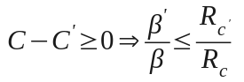 (29)
Given that AIMD is used, a decrement of the forwarding factor dictates a reduction in energy cost if:
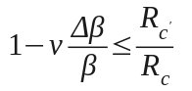 (30)
Whether (30) holds or not, depends on the AMC; for the AMC assumed here, it is satisfied for some states

- Conclusions and future work

In this work we proposed the expansion of the capabilities of an adaptive modulation and coding scheme by coupling it with an adaptive epidemic information dissemination algorithm. The AMC imposes different modulation and convolutional encoding schemes depending on the locally measured signal-to-noise ratio. We propose that at each node the forwarding rate and the coding mode be jointly tuned according to the assessment of a suitably selected utility function. Clearly, modifying the coding mode means modifying the coding overhead per packet. Moreover, this scheme employs an AIMD mechanism to regulate the forwarding probability, reminiscent of the TCP sawtooth-like window size tuning. A proactive adaptation mechanism is proposed for the upcoming time slot. This is in contrast to the reactive one suggested in our previous work [25].
Performance assessment of the proposed scheme indicated that in the presence of noise due to multipath propagation, full infection is achieved at a modest energy cost by exploiting the tuned forwarding probability and coding mode. The utility function is based on observations of quantities associated with the lower layers of the ad hoc network. Using utility function values averaged over a time interval caters for more aggressive or conservative adaptation schemes. Some fairly conservative adaptation schemes prove beneficial in the presence of bursty noise superimposed to the multipath one.
Considerable benefits result in cases that energy preservation and node lifetime elongation are of high significance. Achieving full coverage, while preserving energy, is a significant advantage in ad hoc networks that operate in noisy environments.
The setting examined in this work matches with the case of sensor-enabled nodes which disseminate the information they have previously received or generated. Given that the proposed scheme is one of the few context-aware cross-layer adaptive epidemic models, in the future we would like to expand our investigation in this field. The optimization of adaptive epidemic dissemination schemes through minimization of the cost and/or maximization of suitably defined utility functions is a challenging concept and requires a complex theoretical model. Our model could be additionally broadened with the study of environments with competition for radio resources. Further possible expansions of our work could include additional degrees of freedom, through modulation of e.g. the TTL value conveyed by packets [14].Future work could also cover multi-epidemic settings, which include additional, partially infected states and cater for differentiation in the disseminated data [23]. Infecting data consists of non-identical packets, and this provides for higher-layer awareness. Finally, information dissemination looks attractive in environments such as ITS and VANETs [24]. VANETs feature high node mobility, which is not addressed here; hence this is a sensible consideration for future work. Information being injected into the network from a single sink connected to the internet and roadside nodes can be covered by our present paradigm.

References

- Vassileios Tsetsos, Stathes Hadjiefthymiades, "An Innovative Architecture for Context Foraging", 8th International ACM Workshop on Data Engineering for Wireless and Mobile Access (MobIDE), Providence, Rhode Island, USA, June, 2009
- S. Ni, Y. Tseng, Y. Chen, and J. Sheu. “The Broadcast Storm Problem in a Mobile Ad Hoc Networks”, Wireless Networks, vol 8, Numbers 2-3, 153-167
- Anna Hac, Wireless Sensor Network Designs, Wiley, 2003
- Patrick Th. Eugster, Rachid Guerraoui, “Hierarchical Probabilistic Multicast” , Technical report, 2001
- Akdere, Bilgin, Gerdaneri, Korpeoglu, Ulusoy, Cetintemel, “A comparison of epidemic algorithms in wireless sensor networks”, Computer Communications 29(13-14): 2450-2457 (2006)
- Wendi Rabiner Heinzelman, Joanna Kulik, Hari Balakrishnan, “Adaptive Protocols for Information Dissemination in Wireless Sensor Networks”, MobiCom 1999, pp 174-185
- Christos Anagnostopoulos, Theodoros Anagnostopoulos, Stathes Hadjiefthymiades, “An Adaptive Data Forwarding Scheme for Energy Efficiency in Wireless Sensor Networks”, Intelligent Systems (IS), 2010 5th IEEE International Conference, pp 396-401, 7-9 July 2010
- C. Anagnostopoulos , O. Sekkas , S. Hadjiefthymiades, “An adaptive epidemic information dissemination model for wireless sensor networks", Elsevier, Pervasive and Mobile Computing Journal, Elsevier, August, 2011
- Abdelmajid Khelil and Neeraj Suri, “Gossiping: Adaptive and Reliable Broadcasting MANETs”, Latin American Symposium on Dependable Computing 2007, pp 123-141
- Garbinato, Rochat, Tomassini, Vessaz , "Injecting power-awareness into epidemic information dissemination in sensor networks", Future Generation Computer Systems, Volume 26 Issue 6, June, 2010
- Lidia Yamamoto, "Epidemic Dissemination in Ad Hoc Networks", Extended Abstract, Dagstuhl Seminar 04411, Service Management and Self-Organization in IP-based Networks, Schloss Dagstuhl, Germany, October 2004.
- http://www.xbow.com last accessed 25/09/2012
- Amin Vahdat and David Becker, “Epidemic Routing for Partially-Connected Ad Hoc Networks”, Duke University, Technical report. CS-2000-06, 2000
- Sekkas O., Piguet D., Anagnostopoulos C., Kotsakos D., Alyfantis G., Kassapoglou-Faist C., Hadjiethymiades S., "Probabilistic Information Dissemination for MANETs: the IPAC Approach", Proceedings of the 20th Tyrrhenian International Workshop on Digital Communications, Pula, Sardinia, Italy, September, 2009
- http://ipac.di.uoa.gr Integrated Platform for Autonomic Computing, last accessed 25/09/2012
- Qingwen Liu, Shengli Zhou, and Georgios B. Giannakis, “Cross-Layer Combining of Adaptive Modulation and Coding With Truncated ARQ Over Wireless Links”, IEEE Transactions on Wireless Communications, vol 3, issue 5, pp 1746-1755, Sept. 2004
- W. C. Jakes, Microwave Mobile Communications. Piscataway, NJ: IEEE Press, 1994.
- Pop, Beaulieau, “Limitations of Sum-of-Sinusoids Fading Channel Simulators”
- Qinqing Zhang, S. Kassam, “Finite-State Markov Model for Rayleigh Fading Channels”
- Qingwen Liu, Shengli Zhou, and Georgios B. Giannakis, “Cross-Layer Combining of Adaptive Modulation and Coding With Truncated ARQ Over Wireless Links”, IEEE Transactions on Wireless Communications, vol 3, issue 5, pp 1746-1755, Sept. 2004
- P. De and S. K. Das, “Epidemic Models, Algorithms, and Protocols in Wireless Sensor and Ad Hoc Networks”, in Algorithms and Protocols for Wireless Sensor Networks (ed A. Boukerche), John Wiley & Sons, Inc., Hoboken, NJ, 2008
- T. Kontos, E. Zaimidis, C. Anagnostopoulos, S. Hadjiefthymiades, E. Zervas, "An Adaptive Epidemic Information Dissemination Scheme with Cross-layer Enhancements", IEEE symposium on Computers and Communications, Corfu, Greece, June, 2011
- Anagnostopoulos et al., “An analytical model for multi-epidemic information dissemination”, Journal of Parallel and Distributed Computing vol 71, issue 1, Jan. 2011, pp 87-104
- Mario Gerla, Leonard Kleinrock, "Vehicular networks and the future of the mobile internet", Computer Networks, Volume 55 Issue 2, February, 2011, pp 457-469
- Theofanis Kontos, Evripidis Zaimidis, Christos Anagnostopoulos, Stathes Hadjiefthymiades, Evangelos Zervas: An adaptive epidemic information dissemination scheme with cross-layer enhancements. ISCC 2011: 230-235
- Liu, Wang, Cognitive Radio Networking and Security, Cambridge University Press, 2011
- Fu, van derSchaar, DEPENDENT OPTIMAL STOPPING FRAMEWORK FOR WIRELESS MULTIMEDIA TRANSMISSION, International Conference on Acoustics Speech and Signal Processing (ICASSP), 2010

