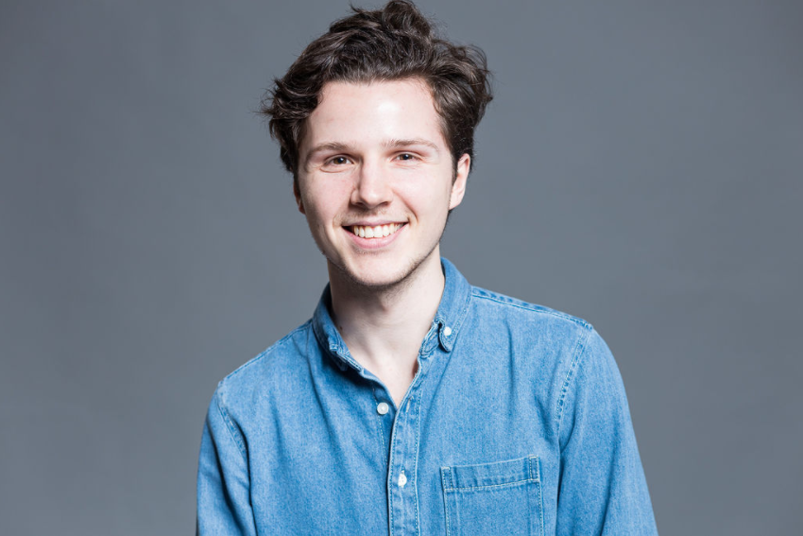

**THEO** **GILARDO**

French

+33 7 71 25 25 33

gilardotheo@gmail.com

[LinkedIn](https://www.linkedin.com/in/theogilardo/)

**PERSONAL PROFILE**

As a Digital Marketing graduate, I joined Le Wagon Bootcamp and discovered a new passion for coding! I am eager to learn, curious and I **am seeking a junior front-end developer position starting immediately**. You can **check my** [**website**](http://theogilardo.com/) **to visit my projects**!

**INTERNATIONAL EXPOSURE**

From Paris, I lived 3 years in Milan, worked in Munich for 6 months and completed my

MSc in Digital Marketing in Madrid and Berlin before learning how to code in Amsterdam. This international exposure has made me highly adaptable and easy to work with.

**IT SKILLS**

- HTML, CSS, SASS, Bootstrap

- ES6 Javascript, APIs, JSON

- Responsive Design, Figma

- Ruby, Ruby on Rails

- Relational Databases, SQL

- Git, Github, Version Control

**LANGUAGES**

**French (native language)**

**English (fluent)**

Spanish (notions)

**EXTRACURRICULAR**

**Wings For Life World Run**

Munich - May 6th 2018

Ran 18 km for spinal cord research

**INTERESTS**

- Freeride Ski

- Photography

- Travel lover (+25 countries visited)

**EDUCATION**

**Le Wagon**, *Jan – March 2020*  **Amsterdam, Netherlands**

*Coding Bootcamp*

* 9-week intensive coding Bootcamp learning **HTML, CSS,**

**JavaScript ES6, SQL, Git, GitHub, Heroku** and **Ruby on Rails**.

* Le Wagon is ranked number #1 **coding Bootcamp worldwide** (Switchup)

**ESCP Europe**, *2018-2019* **Madrid, Spain**

*MSc in Digital Marketing*

* Specializations in Berlin: **Customer Experience & SEO**
* Live Case Studies with **L'Oréal** and **Havas Media**
* Google Analytics, Google Ads, SEO & SEA trainings
* **5th Best Worldwide Business School** (Ft. rankings 2018)

**BOCCONI University**, *2014-2017*  **Milan, Italy**

*Bachelor of International Economics and Management*

* Specializations: **Marketing**, **E-commerce**
* **8th Best Worldwide** **Business School** (QS rankings 2019)
* **3rd Best European Business School** (Ft. rankings 2019)

**WORK EXPERIENCE**

**L’Oréal,** *Assistant Product Manager* **Paris, France**

*Jul – Dec 2019 – Biotherm & Helena Rubinstein (HR)*

* **Designed and distributed** all Biotherm/HR Travel Retail **promotion visuals** across the EMEAI markets
* Integrated with the Digital team Biotherm/HR Travel Retail data into one single **platform to facilitate & accelerate marketing operations**
* Implemented **digital promotions** for HR in the new Doha Podium
* Monthly audit of brand figures and performance on **Power BI**
* Organized a contest for the field with over **25k** worth of gifts and an event for key clients with a **20k budget**

**McDonald’s*,*** *Digital Marketing Internship*  **Munich, Germany**

*Jan – June 2018*

* Implement McDonald´s Deutschland restaurants location

structure on Facebook

* Work daily on **Adobe Analytics** to gain in real-time valuable

customer insights

* Optimized the Digital Kiosk channel to guarantee smooth

and flawless client orders

**Master The Monster,** *Marketing Internship* **Paris, France**

*Aug – Dec 2017*

* MTM is a video content production platform for marketers
* In charge of the **CRM** of clients (ProsperWorks SaaS)
* Actively worked on the **website content**
* Ran daily tests to improve the platform with engineers