To: Mr. Apple, Applichem Operations Manager

From: Theo Hargis

Date: April 13, 2020

Subject: Manufacturing Location Analysis Strategy Recommendation

***Executive Summary***

Over the next year of Release-Ease forecasted sales, Applichem’s current product distribution plan will result in the underutilization and inefficiency of three factories unless an adjustment is made to the distribution strategy. In addition, due to the projected rise of demand in the Chinese market two years down the line, without change, Applichem will face drastic supply shortages across the board. I recommend that Applichem readjust their analysis of production and distribution costs of each factory and market location, and modify their distribution plan accordingly, shut down the Osaka factory immediately, as well as invest in a new factory in Beijing to account for the increased demand in the Chinese market. This will reduce underutilization of certain factory spaces, thereby reducing costs, and increase Applichem’s overall production capacity to meet new demand targets.

***Benefits of Recommended Short-Term Distribution Strategy***

This strategy recommendation ensures that

* All demand targets will be met. with certain risk factors such as changing currency valuations and frequent labor law changes taken into account. This especially affects Venezuela, where there is no sign of improving economic conditions or international relations for the foreseeable future.
* Overall production and distribution costs are reduced by over $30,000, as seen in **Table 1** and **2**, as well as the reduction in Applichem’s fixed costs due to the Osaka factory closure.

***Benefits of Recommended Supply Chain Strategy***

This strategy recommendation ensures that

* All demand targets will be met with the same risk factors taken into account. Both alternative strategies resulted in supply shortages, as seen in **Figure 3**, while the added Beijing factory adds significant production capacity. This eliminates any stockouts, as well as the potential need for costly and strenuous overtime work in certain factories to meet demand targets.
* Overall production and distribution costs total approximately $1.15 million, almost $50,000 lower than the comparable alternative solution in expanding the Frankfurt factory capacity, as seen in **Table 4** and **5**. This is achieved through lower operating costs associated with production and distribution from the Beijing factory, as well as the closure of the Osaka factory.
* Applichem will gain a significant competitive advantage in the emerging Chinese market by expanding their operations to Beijing, as well as have access to a plentiful, low-cost labor market.

This recommended supply chain strategy will reduce Applichem’s operational costs by almost $50,000 once the Beijing factory is running, compared to the Frankfurt factory expansion alternative, while also meeting increased demand targets. **Table 5** shows that this is possible even with the closure of the Osaka factory, a very costly production option to utilize. In order to gain a better perspective on the tradeoff, I advise Applichem to do more research into the startup costs and taxes associated with starting a business in China, as well as how those compare to the monetary benefits of shutting down the Osaka factory in the long run. I highly recommend this new strategy as it will reduce Applichem’s short- and long-term operational costs, while also giving them substantial competitive footing in the Chinese market for years to come.

**Table 1:**

**Table 2:**

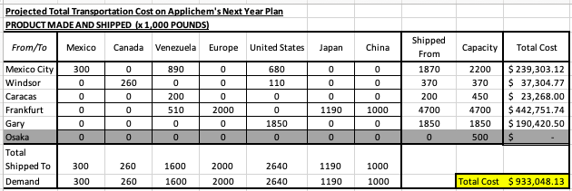

**Figure 3:**

**Table 4:**

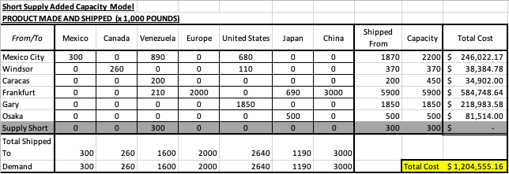

**Table 5:**

