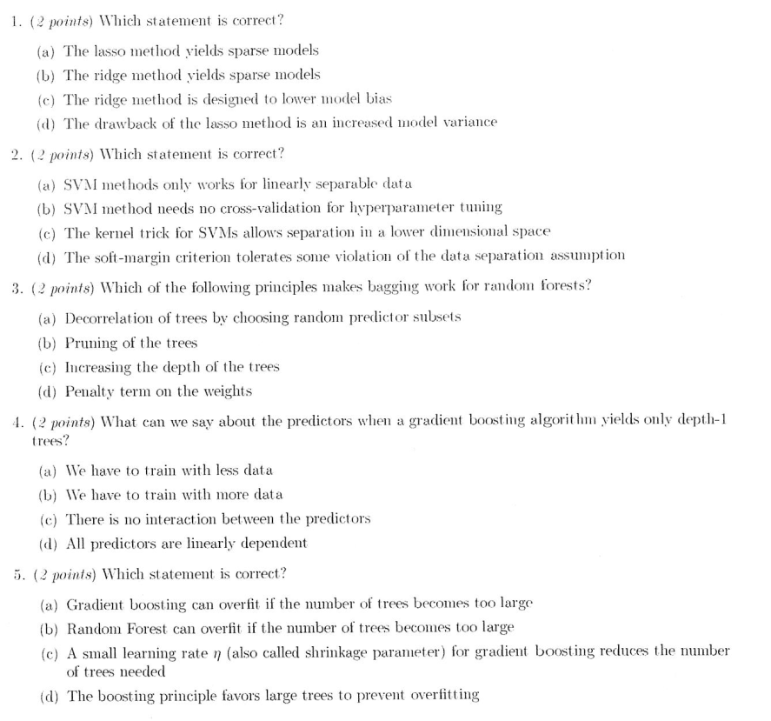

1. A
2. D ( Antoine M : C)
3. A
4. C
5. A

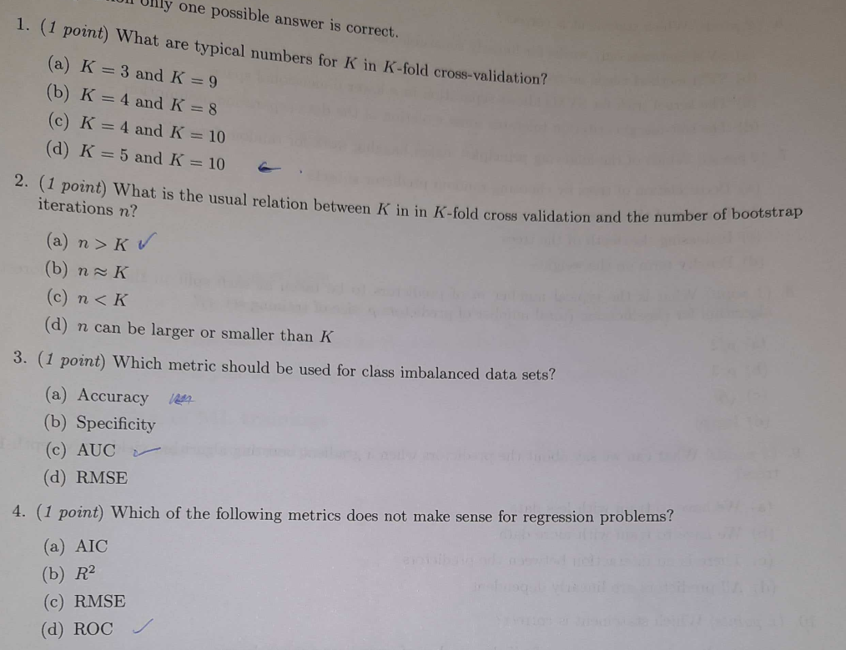

1. D
2. A
3. C
4. D

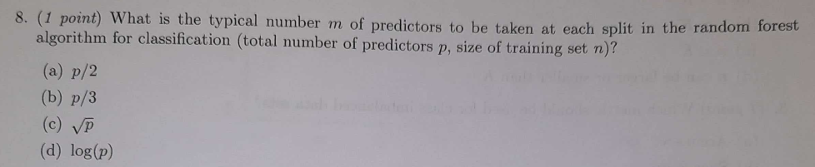

8. C

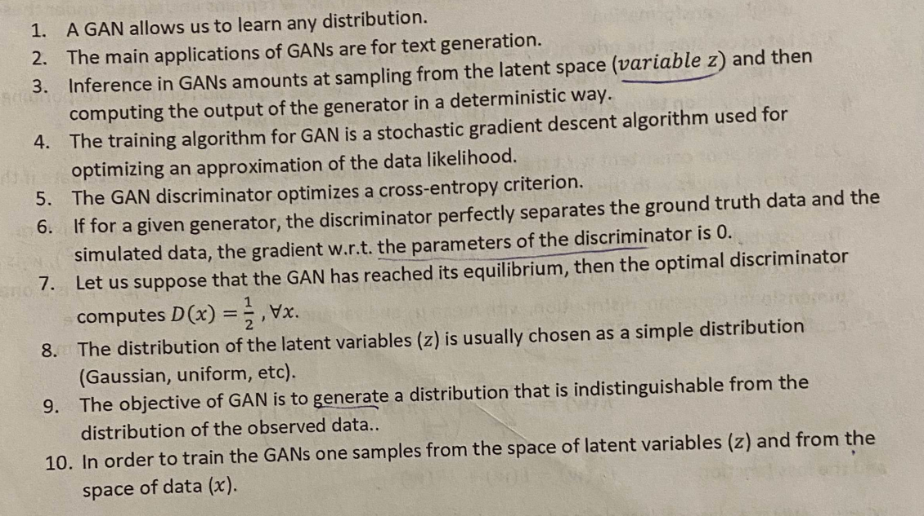

1. N
2. N (images)
3. Y (ChatGPT says that g_theta is not deterministic..)
4. N
5. Y
6. Y?
7. Y
8. Y
9. Y
10. N (Y, because bootstrapping real data is sampling?)