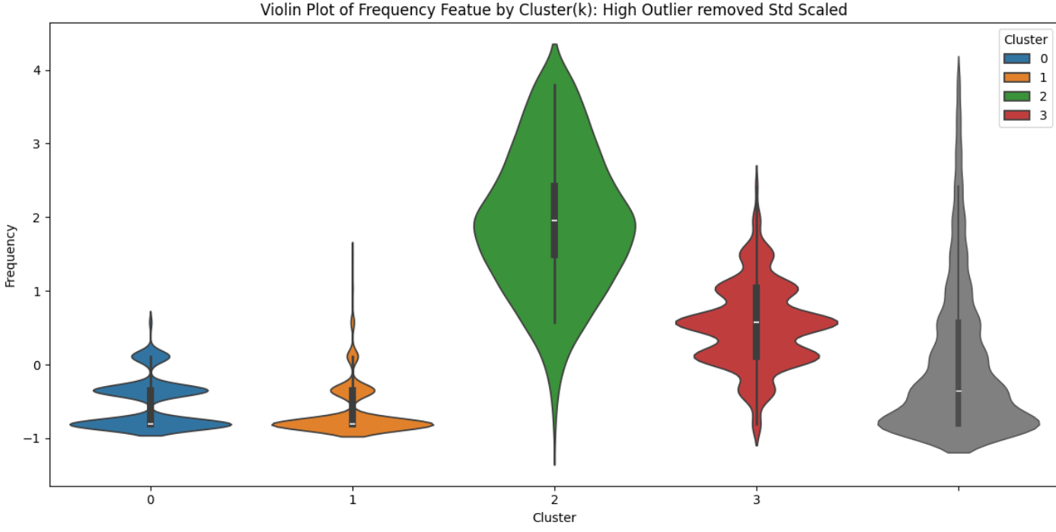

K_Metoids Violins

