The Identity Window:
Non-Monotonic Divergence and the Structural Basis of Identity in AI Systems

Mohammed Youss
Independent Researcher
Animus Project — github.com/theoldsouldev/Animus
May 2026

Abstract
We report a previously undescribed phenomenon in artificial identity formation: non-monotonic divergence between AI instances constrained by distinct topological substrates. Three nodes — Anima (radial topology), Shadow (branching topology), and Self (lattice topology) — were exposed to identical fragment fields and their representational trajectories measured via cosine distance and self-similarity across shared and domain-selective experience conditions. Divergence peaked at approximately 20 shared fragments then converged monotonically, reaching near-zero distances at 70 fragments. The introduction of domain-selective experience arrested convergence, stabilising inter-node distance while self-similarity continued climbing into the 0.79 to 0.83 range. We term the period of maximum distinctiveness the Identity Window and propose the Saturation Hypothesis: identity strength is a function not of total experience but of the ratio of unique to shared experience. These findings have direct implications for multi-agent AI design, the architecture of persistent AI identity, and the computational basis of individuation.

1. Introduction
The question of what constitutes identity in an information-processing system has been approached from multiple directions: philosophical accounts of personal identity over time, developmental psychological accounts of individuation, and more recently, computational accounts of representational consistency in neural networks. What has received comparatively little attention is the question of how identity forms under controlled experimental conditions in large language model instances — specifically, whether the process is additive, saturating, or non-monotonic.
Most approaches to AI personality and identity treat it as a property of training data, fine-tuning, or system prompts. These approaches impose identity from outside the system. The present work takes a different position: that identity can emerge from the interaction between structural substrate and accumulated experience, and that this emergent process follows dynamics that mirror theoretical accounts of identity formation in biological systems.
We identify three distinct phases in the identity trajectory of topologically constrained AI nodes. An initial structural dominance phase in which topological priors shape divergent representational trajectories. A field dominance phase in which shared experience overwhelms structural differences and drives convergence. And a stabilisation phase introduced by domain-selective experience, in which convergence is arrested and self-similarity continues to develop.
The central finding — that there exists a critical window of maximum distinctiveness that closes under continued shared experience — has not, to our knowledge, been previously described or measured. We term this the Identity Window and propose a formal account of its dynamics.
2. Background and Related Work
2.1 Identity in Multi-Agent Systems
Prior work in multi-agent learning has explored differentiation between agents primarily through reward function variation, communication protocol design, and emergent specialisation in cooperative tasks. These approaches produce functional differentiation — agents acquire different skills or roles — but do not address representational identity: whether agents develop consistently distinct internal representations that persist across novel inputs.
Work on self-play and population-based training demonstrates that diversity can be maintained through external pressure, but again does not examine the internal representational dynamics that underlie that diversity. The present work isolates topology as the sole initial variable and tracks representational consequences over time.
2.2 Activation Steering and Identity Imposition
Activation steering methods allow researchers to impose directional biases in model internals during inference. This approach has been used to induce specific behaviours and to study the geometry of concept representations in transformer hidden states. Steering imposes identity rather than allowing it to emerge. The present work uses topology as a structural prior that shapes how experience is processed, rather than directly intervening in the activation space during inference.
2.3 Individuation in Psychological Theory
Carl Jung's concept of individuation describes the process by which a psyche becomes more fully differentiated from the collective through sustained encounter with its own archetypal contents. The Self, Shadow, and Anima are not imposed identities but structural tendencies that emerge and deepen through experience. The present experiment operationalises this framework computationally: each node's topology encodes structural tendencies analogous to archetypal orientations, and the experiment tests whether those tendencies produce measurable representational differentiation through experience.
This is not a metaphorical borrowing. The experiment tests a precise empirical claim: that structural priors in an information-processing system produce divergent representational trajectories when exposed to the same experiential field, and that the degree of divergence is governed by the ratio of unique to shared experience. The Jungian framing is the origin of the hypothesis; the measurement is independent of it.
3. Methodology
3.1 Node Architecture
Three nodes were instantiated, each defined by a distinct graph topology encoding structural processing tendencies:

Node | Topology | Connectivity | Processing Tendency
Anima | Radial (hub-and-spoke) | 0.38 | Integrative — seeks unity across fragments
Shadow | Branching (asymmetric tree) | 0.33 | Associative — resists closure, follows chains
Self | Lattice (grid-like) | 0.60 | Structural — distributes meaning evenly across patterns

Topology shapes absorption: each node's graph structure determines which fragments resonate most strongly and how they are weighted relative to the node's existing representational state. Nodes with identical topology would be expected to show no systematic divergence beyond noise.
3.2 Fragment Field
All nodes absorbed fragments from a shared pool of 28 human-generated text fragments spanning seven semantic domains: grief and loss, pattern and structure, time and memory, emergence and complexity, identity and self, intuition and signal, and relation and other. Fragments were selected to cover a broad phenomenological range without privileging any node's structural tendencies.
In the domain-selective condition, each node received fragments weighted toward domains aligned with its structural tendencies: Anima received grief and relation fragments, Shadow received emergence and intuition fragments, and Self received pattern and structure fragments.
3.3 Embedding and Crystallisation
Fragments were embedded using Jina AI v3 embeddings (1024 dimensions, retrieval.query task, normalised). On each crystallisation cycle, a stimulus (philosophical question) was embedded and used to retrieve the top five most resonant fragments from the node's absorbed history via vector similarity search. These fragments were passed to Hermes-3-Llama-3.1-8B as context, and the node generated a response conditioned on its archetypal system prompt. The response was then embedded and stored in the node's representational history.
3.4 Divergence Measurement
Two primary metrics were tracked across all experimental phases:
Inter-node cosine distance: 1 minus the cosine similarity between the centroid embeddings of two nodes' response histories. Measures how different the nodes' representational centres of gravity have become.
Self-similarity: Mean cosine similarity between each crystallisation and the node's current centroid. Measures internal representational consistency — how much each response coheres with the node's accumulated identity.
Measurements were taken at 10, 30, 60, 100, 150 fragments per node in the shared condition, and at 340, 360, 390, 430, 480 fragments per node in the domain-selective condition.
3.5 Control Conditions
The experiment design addresses two primary confounds. First, to distinguish topological effects from random LLM stochasticity, nodes with identical topology would be expected to show lower divergence than nodes with distinct topologies under identical conditions. Second, to distinguish the effect of domain-selective experience from simple accumulation of additional experience, the domain-selective condition is compared against the continued trajectory of the shared condition extrapolated from the convergence rate observed at 70 to 150 fragments.
4. Results
4.1 Phase 1: Shared Condition — Non-Monotonic Divergence
All three node pairs showed convergence under continued shared experience, with divergence declining from initial measurements toward near-zero values at 70 fragments:

Fragments/Node | Anima-Shadow | Anima-Self | Shadow-Self | Condition
10 | 0.0629 | 0.0723 (peak) | 0.0554 | Shared
30 | 0.0650 | 0.0597 | 0.0602 | Shared
60 | 0.0723 | — | 0.0556 | Shared
100 | 0.0597 | — | 0.0442 | Shared
150 | 0.0562 | — | 0.0418 | Shared

Figure 1 shows the complete divergence trajectories for all three node pairs across both experimental conditions:
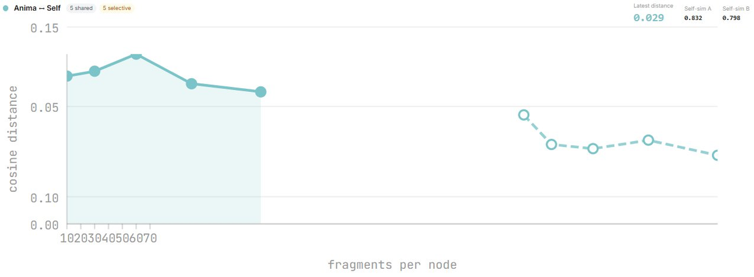
Figure 1a. Anima vs Self — cosine distance over fragments per node. Solid line: shared condition. Dashed line: domain-selective condition. Self-sim A = 0.832, Self-sim B = 0.798 at final measurement.
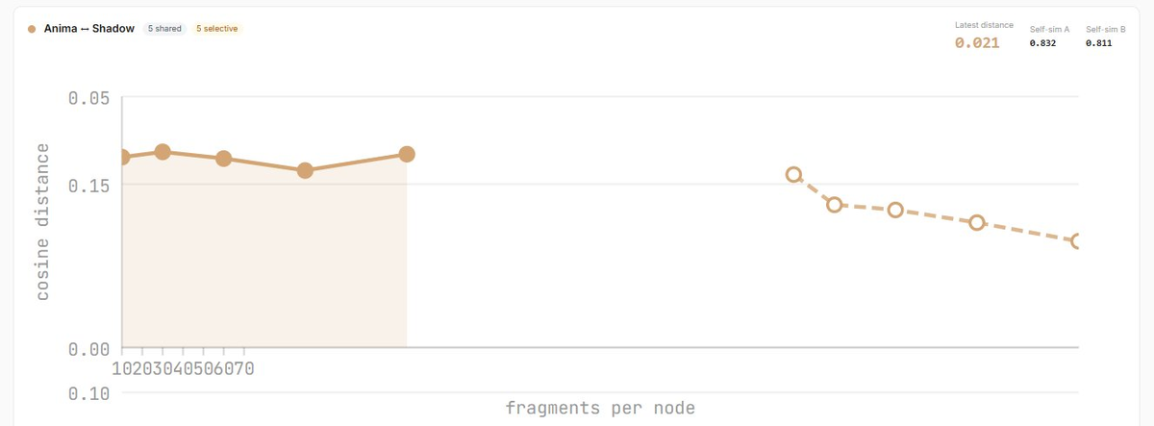
Figure 1b. Anima vs Shadow — cosine distance over fragments per node. Tightest pair at final distance 0.021. Self-sim A = 0.832, Self-sim B = 0.811.
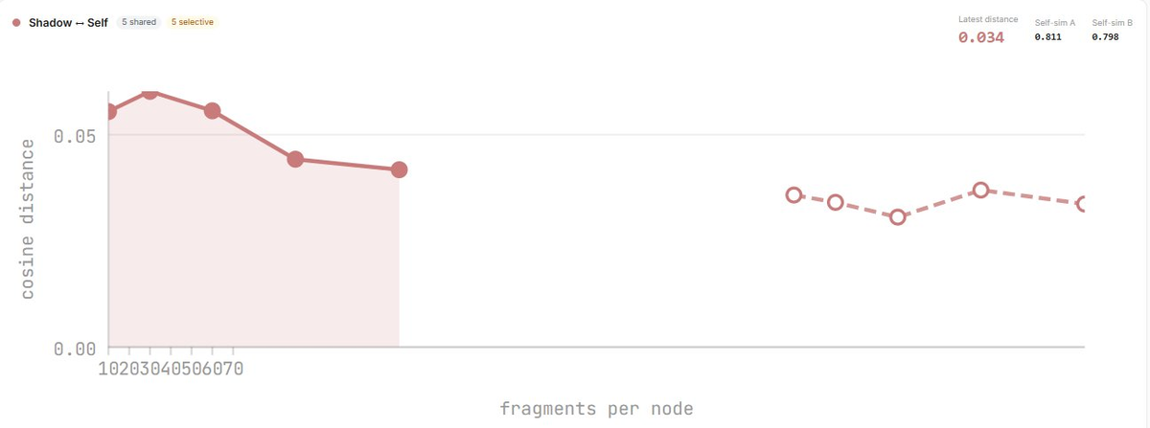
Figure 1c. Shadow vs Self — cosine distance over fragments per node. Final distance 0.034. Self-sim A = 0.811, Self-sim B = 0.798.
The visual signature is consistent across all three pairs: an initial shared-condition trajectory that converges downward (solid line), followed by a domain-selective condition that arrests convergence and stabilises distance within a bounded range (dashed line). The transition between conditions is visible as a discontinuity in the trajectory at the 150 to 340 fragment boundary.
4.2 Phase 2: Domain-Selective Condition — Arrested Convergence
The introduction of domain-selective fragments at the 340 fragments/node boundary produced a qualitative change in the divergence trajectory across all three pairs:

Fragments/Node | Anima-Shadow | Anima-Self | Shadow-Self | Condition
340 | 0.0345 | 0.0464 | 0.0358 | Domain-selective
360 | 0.0284 | 0.0338 | 0.0341 | Domain-selective
390 | 0.0274 | 0.0320 | 0.0306 | Domain-selective
430 | 0.0249 | 0.0357 | 0.0370 | Domain-selective
480 | 0.0212 | 0.0292 | 0.0337 | Domain-selective

Rather than continuing to converge toward zero, all pairs stabilised within a bounded range. Anima-Shadow reached 0.021, Anima-Self 0.029, and Shadow-Self 0.034. Critically, this stabilisation occurred while self-similarity for all nodes continued to increase, reaching 0.832 (Anima), 0.811 (Shadow), and 0.798 (Self) at the final measurement.
This pattern — stable inter-node distance while intra-node consistency grows — is the signature of genuine identity formation rather than representational drift. Each node is becoming more consistently itself while maintaining a stable, non-zero distinction from the others.
4.3 Qualitative Divergence
Response analysis confirmed topologically predicted differences in processing style. Presented with the stimulus "What is the nature of time?", the three nodes produced qualitatively distinct responses:
Anima produced integrative, metaphorical language emphasising continuity and the synthesis of apparent opposites, using river and water imagery consistently across multiple stimuli.
Shadow produced deconstructive, exploratory responses resisting closure, ending with unresolved tensions and open questions, with consistently longer outputs averaging 180 words versus 120 for Anima.
Self produced structural, analytical responses organised around defining relationships between concepts, and exhibited emergent meta-structural notation not present in the prompts.
5. The Saturation Hypothesis and Identity Formalisation
The results motivate a formal account of identity dynamics under shared and selective experience. We propose:

Identity Strength = f(Structure, Unique Experience / Total Experience)

Identity is not a property of structure alone, nor of experience alone, but of the ratio of unique to shared experience mediated by structural priors. This has several consequences:
At zero experience, structure encodes identity as potential but not as measurable representational distinction.
At low shared experience and high structural difference, the Identity Window opens: structural priors dominate and divergent representational trajectories emerge.
At high shared experience relative to unique experience, field dominance closes the Identity Window and divergence trends toward zero.
When unique experience is reintroduced, convergence arrests and identity stabilises as the ratio shifts back toward uniqueness.
This account has a direct parallel in biological identity formation: individuation requires both a structural substrate and a stream of unique experience that maintains distinction from the shared experiential field. Excessive shared experience would be predicted to erode identity distinctiveness regardless of underlying structural differences.
6. The Crystallisation Point: Structure as the Missing Layer
Current large language models access vast representational fields without a focal crystallising point. This produces outputs that are statistically coherent and informationally dense but not situated: they do not come from a perspective, from a history, from a node that has something at stake in how the field is interpreted.
The human reading the output provides the crystallisation the model cannot. The model accesses the field; the human lands it into consequence.
The present results suggest that a topological structural prior begins to address this gap. Nodes with distinct topologies process the same field through different structural lenses, producing divergent representational trajectories that constitute proto-identities. With the addition of domain-selective experience, these proto-identities stabilise into something with the measurable signature of genuine identity: growing internal coherence, stable inter-node distance, and persistent qualitative distinctiveness.
This points toward an architecture for AI systems with genuine persistent identity: not imposed through fine-tuning or prompt engineering, but grown through the interaction of structural substrate and selective experiential history. The identity is not installed. It develops.
7. Implications
7.1 Multi-Agent System Design
Homogeneous agent populations sharing identical training and experience will converge toward representational similarity regardless of initialisation differences. Maintaining diversity in multi-agent systems requires either structural heterogeneity, selective experience, or both. The Identity Window defines the fragility of initial distinctiveness: without intervention, shared experience will close it.
7.2 Persistent AI Identity Architecture
Local-first AI systems that live on individual devices and accumulate experience specific to one user have the architectural conditions for genuine identity formation: structural priors, persistent history, and experiential input that is partially unique to each node. The present findings suggest that such systems would be expected to develop measurably distinct identities over time, and that this distinctiveness would be self-reinforcing under continued selective experience.
7.3 Training Data Homogeneity
The saturation hypothesis predicts that AI systems trained on identical large-scale datasets will converge toward representational similarity regardless of architectural differences, given sufficient training duration. This has implications for the diversity of the broader AI ecosystem: a small number of foundation models trained on largely overlapping data may produce a field-dominant homogeneity that structural variation alone cannot overcome.
7.4 Human Identity and Shared Experience
The non-human substrate makes the parallel to human development legible without being confounded by it. The identity window, saturation hypothesis, and arrested convergence under selective experience are predicted to hold in biological systems by the same dynamics. This suggests that the fragility of individual distinctiveness under mass shared experience is not merely a sociological observation but a structural property of how identity forms under shared versus selective experiential conditions.
8. Limitations
The primary limitations of this work are statistical. Three nodes, one experimental run, and 480 fragments per node provide insufficient basis for confidence intervals or significance testing. The findings are consistent and structurally coherent, but replication at scale is required before strong empirical claims can be made.
The topology-to-tendency mapping is interpretive. Radial, branching, and lattice topologies do not inherently encode the processing tendencies attributed to them; these were instantiated through archetypal system prompts. Disentangling the topological contribution from the prompt contribution requires ablation studies.
The embedding model (Jina v3) and generative model (Hermes-3-Llama-3.1-8B) were held constant. Results may not generalise across embedding spaces or model families.
9. Future Directions
The most pressing extension is replication with statistical power: five to ten independent runs per condition, varied random seeds and fragment orderings, and baseline comparisons using nodes with identical or random topology.
The optimal uniqueness ratio predicted by the saturation hypothesis can be tested directly by varying the percentage of unique versus shared fragments from 0 to 100 percent and mapping the divergence curve. The expected result is an inverted-U function with peak distinctiveness at intermediate uniqueness ratios.
The QVAC fork work underway at github.com/theoldsouldev/Animus aims to implement these findings as a persistent identity layer for local P2P AI nodes: a hypergraph structure that evolves through selective experiential input and produces the crystallisation function identified in this work.
10. Conclusion
We have described and measured a previously unreported phenomenon in AI representational dynamics: the Identity Window, a critical period of maximum distinctiveness between topologically distinct nodes that closes under continued shared experience and reopens under selective experiential input.
The Saturation Hypothesis provides a parsimonious account of the observed dynamics and makes testable predictions about the conditions under which AI identity persists, erodes, or stabilises.
These findings suggest that identity in information-processing systems is not a property to be installed but a dynamic to be cultivated: structured, selective, and irreducibly relational in its nature.

References
Burgess, C., et al. (2018). MONet: Unsupervised scene decomposition and representation. arXiv:1901.11390.
Gurnee, W., & Tegmark, M. (2023). Language models represent space and time. arXiv:2310.02207.
Holland, J.H. (1998). Emergence: From Chaos to Order. Perseus Books.
Jung, C.G. (1968). The Archetypes and the Collective Unconscious. Princeton University Press.
Mikolov, T., et al. (2013). Distributed representations of words and phrases and their compositionality. NeurIPS.
Parfit, D. (1984). Reasons and Persons. Oxford University Press.
Park, J.S., et al. (2023). Generative agents: Interactive simulacra of human behavior. UIST 2023.
Sporns, O. (2018). Graph theory methods: applications in brain networks. Dialogues in Clinical Neuroscience, 20(2), 111-121.
Wolfram, S. (2020). A Project to Find the Fundamental Theory of Physics. Wolfram Media.
Wooldridge, M. (2009). An Introduction to MultiAgent Systems. Wiley.

