Experiment

Basic idea is to create a programme for taking photos based on the received taking-photos-waypoints file (which will be emitted by dashboard created by Theo).

Experiment is in an virtual GCS-UAV environment.

1. A drone simulator *dronekit-sitl* is running on the laptop on tcp port 5760



1. My phone is the GCS of this experiment. ALTA QGC is listening on udp port 14550
2. On Raspberry Pi, *MAVProxy* is set to connect all components 

--master is to connect the drone simulator on my laptop which has ip address 10.10.10.201 and *dronekit-sitl* is on port 5760.

--out(1) is for internal connection, specially to run other Python code.

--out(2) connects GCS which is my phone.

Flight plan

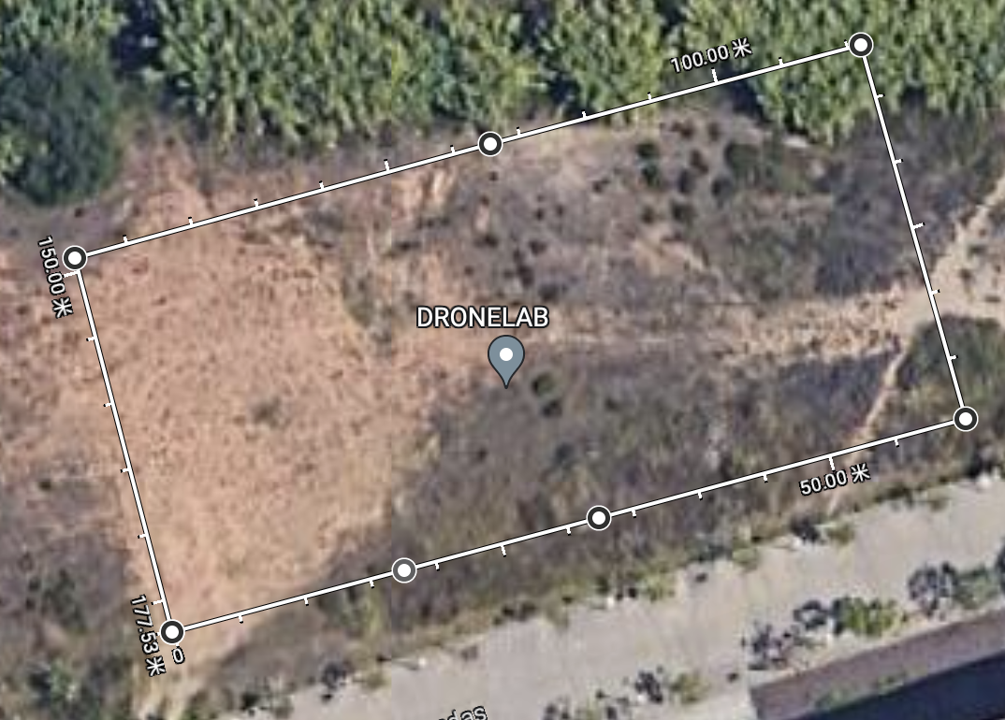

I did a simple flight plan which contains 6 points, starting from left-bottom point. Waypoints can be .json format and then is transformed to the format like this.

This is 7 waypoints, the 7th one is the same as 1st one and the last one is dummy waypoint that is used as a signal that the drone can execute RTL process.

These are 12 taking-photos-waypoints in which 1,3,5,7,9,11 are the same as waypoints.

After the drone takes off, every time when it reaches a taking-photo-waypoint, it will change flight mode to LOITER and wait 10s to take photo.

Problem: Flight mode won’t be changed to LOITER after taking off. Is it really hovering? Or how can we hover a drone at certain location using dronekit.