**Configuration environment for instant-ngp\***

* Visual studio 2019 community with C++
* CUDA 11.6.2
* Optix
* Git
* Clone original code from <https://github.com/NVlabs/instant-ngp>

**Modify transformation.json file to be compatible with drone 3d restructuring project\***

* Adding <https://github.com/nickponline/dd-nerf-dataset>
* Understanding code
* Figure out requirements
* Customize camera parameter etc.
* Add more thing to make different
* Test

Using OpenCV integrated stitcher to carry out 2D image stitching

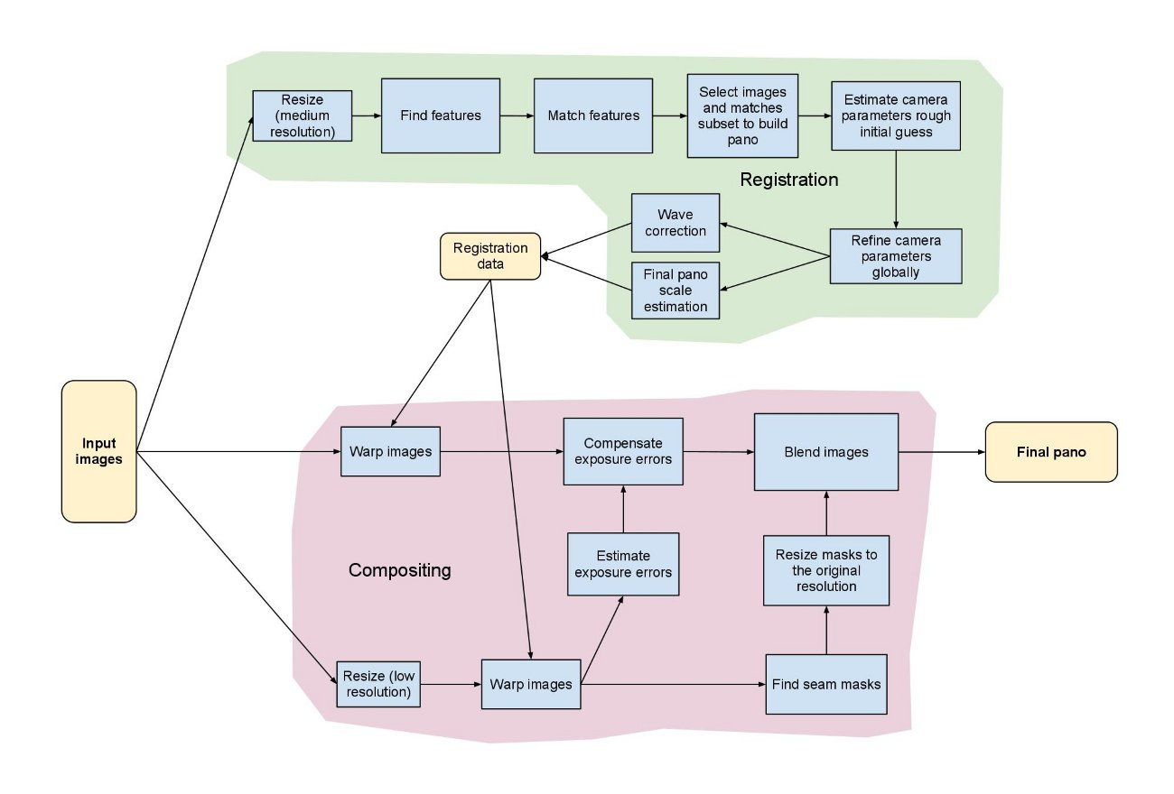

* Take 2 examples of images (indoor & outdoor)
* Learn stitcher in OpenCV
* Test

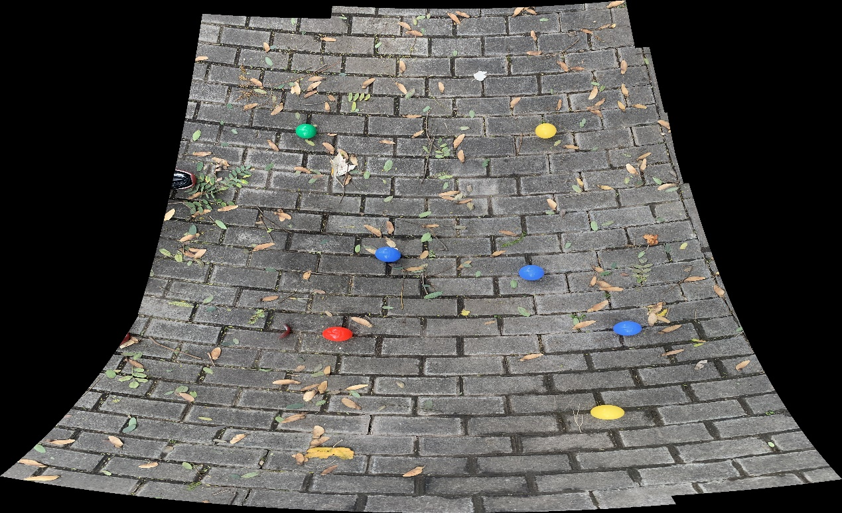

Output 1. with huge distortion

I got this from **OpenCV integrated stitcher**. Output 1 contains all possible elements and details in the 9 pictures, but it generated with a huge distortion. Some possible reasons are the altitude, parallel angle or position of my phone were changing. Also, maybe due to the stitcher mechanism, the top half of the stitched image is flatter, but the bottom isn’t. The order of processing images?

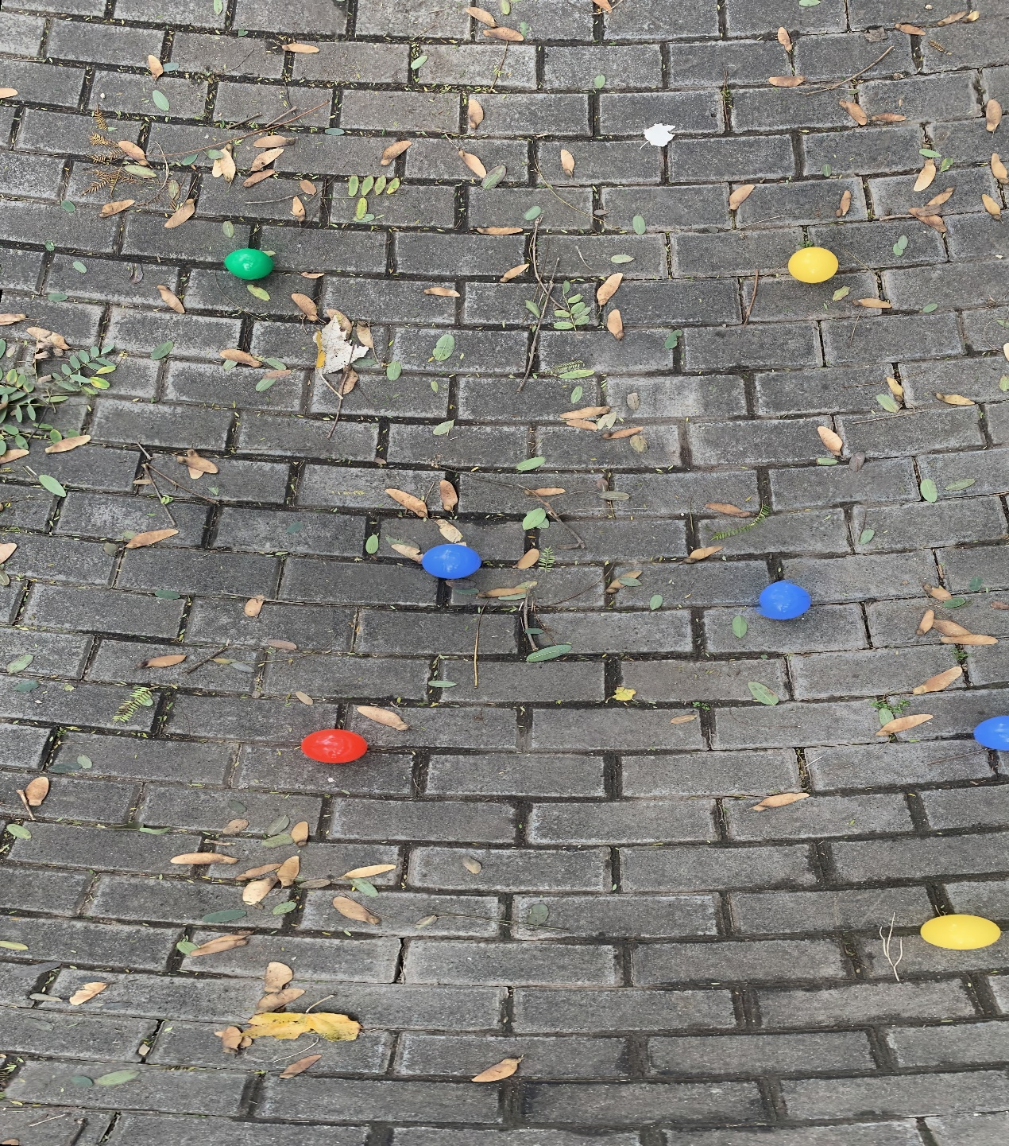

Output 2 with less distortion

Using a ***‘stitching’* library** in python, I got a result like this. There is loss of details around but better central distortion. May requires more lateral overlap when the drone flies around.

Another method to stitch is to use **traditional 2-images-stitching** (code already done at payload class) then loop over every images. For example, we have 1,2,3,4,5 images. I will stitch 12,23,34,45, and 12-23, 23-34, 34-45 etc…

I am not too optimistic about this approach since images have to be strictly sorted in folders and when reading as a list, and the elapsed time can be very long, also the system load would be high.