Final Year Project Definition Form

Student’s name
Theo Matthews

Course
Computing Science
Project title
Developing a mobile app for assessing mental-health risks

What is the project about?
GRiST is a web-based decision support system that uses its psychological model, that is based on how people think and reason, to perform risk assessments on potentially mentally unstable individuals. It incorporates a psychological model that has captured clinical risk assessment expertise, so an accurate risk assessment is produced once the system has been used. It provides a way for people without mental-health training to perform an accurate assessment of individuals they’re concerned about.
The tool is currently only available through a browser, and is not optimised for mobile. The embedded intelligence within GRiST would be of great use to 111 call operators, paramedics, and concerned close family and friends of risk prone people. The easiest and most effective way to disseminate the intelligence of GRiST to those without access to a desktop browser would be through a mobile application.
What is the project deliverable?
A mobile application developed for Android smartphones that provides a quick and accessible user interface that will feed data into the GRiST decision support system. The focus of the application will be to allow the user to conduct a mental-health safety assessment. Through an interface of sequential questions that vary depending on what inputs are given, it will provide access to the machine learning features of GRiST. Then, the application will return a validated evaluation, and what steps to proceed with. The application itself will be a platform for other features of GRiST and myGRaCE (a variant of GRiST) to be implemented on mobile in the future.
What is original about this project?
Research on the current state of the area shows that there are many applications for self-assessment of medical and mental conditions, but very few with real research backing. GRiST has had over 3,000 clinicians contribute 1 million assessments for 100,000 patients. No other application has this quantity of data and quality of research behind it. There are also very few applications designed for medical professionals to perform on the go assessment of any kind. The applications that are available are for EMS/paramedics to be able to streamline the information collection process and tracking of patients between site of emergency and the hospital. There are no applications designed for concerned people, be that paramedics, 111 operators, or close family, to be able to perform an accurate mental health risk assessment on individuals on a mobile platform. The ability to conduct these assessments without prior medical training thanks to the power of the embedded intelligence in GRiST could save many vulnerable people.

Timetable showing main stages in work plan

October – Research on current domain
November – Functional specification
Mid-November – Design specification, wireframes, and flow diagrams
December – Paper prototypes for design testing
January – Start implementation
February – First coded prototype
March – Iterate on app
April - Project evaluation and documentation

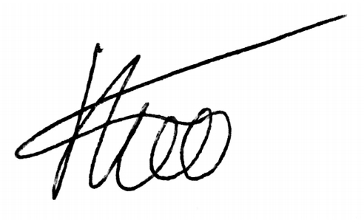
Student’s signature ____________________________________ Date ________________
21/10/2016

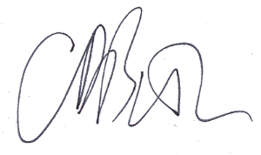

21/10/2016
Supervisor’s signature
21st October, 2016

Notes: (1) The layout of this form may be adjusted as necessary to fit the needs of any particular project.
(2) Everything except the signatures and dates should be entered using word processing.
(3) You can remove these notes from your final project definition!

