Ömer Karataş
DevOps & Site Reliability Engineer - Beşiktaş, İstanbul
 theomerkaratas@gmail.com  +90 (544) 727 5254
 linkedin.com/in/theomerkaratas  github.com/theomerkaratas

Summary
DevOps & Site Reliability Engineer skilled in CI/CD, Kubernetes, and Infrastructure as Code with Terraform and Ansible. Experienced in building reliable cloud platforms, implementing observability with Prometheus, Grafana, and ELK, and developing Terraform plugins in Go. Strong background in Linux, SQL, and automation, with proven ability to improve system reliability and deployment speed. For my digital resume, click here.

Experience

DevOps & Site Reliability Engineer

TOM
Aug 2025 – Present
- Designed, automated, and maintained CI/CD pipelines using tools such as Jenkins, ArgoCD, and GitHub Actions, ensuring faster and more reliable deployments across multi-environment clusters.
- Optimized cloud infrastructure with Terraform and Ansible, managing Kubernetes clusters, databases, and networking components while ensuring high availability and cost efficiency.
- Initiating forward-thinking Infrastructure as Code projects, positioning the organization for long-term success through automated provisioning and configuration management.
- Driving system observability using Prometheus, Grafana, and ELK Stack, enabling proactive monitoring and faster resolution times for incidents.
- Implementing and managing a robust alerting system, integrating automated call processes to immediately engage relevant teams during critical incidents.
- Engineered GitOps workflows using ArgoCD to automate application synchronization and lifecycle management across Kubernetes clusters, ensuring consistency between Git repositories and live environments.
- Architected a centralized logging infrastructure for Windows servers by integrating Elastic Stack (ELK), enabling real-time monitoring and advanced visualization in Kibana for Windows-specific performance metrics and event logs.
- Managed and optimized high-traffic Windows-based applications on IIS, automating deployment pipelines and maintenance tasks via Azure DevOps to ensure seamless application delivery.
- Leveraged Dynatrace for full-stack observability and performance profiling, collaborating with third-party vendors to troubleshoot complex system dependencies and refine alerting thresholds.
 Cloud Site Reliability Engineer

Huawei
Feb 2025 – Aug 2025
- Developing and maintaining Terraform plugins for RDS using Go Language, including writing test cases and comprehensive documentation.
- Possess foundational knowledge of core Huawei Cloud services such as EIP, DRS, DAS, VPC, RDS, and ECS.
- Configuring network parameters and troubleshooting connectivity.
- Diagnosing and resolving database and system issues using logs and performance metrics.
- Designed and executed API tests with Postman or Python to validate service functionality and performance after deployments, helping catch regressions early and maintain service quality.
 Data Analytics Associate

Garanti BBVA Emeklilik
Aug 2024 - Jan 2025
- Performing CRM tasks, including customer segmentation and campaign performance tracking.
- Extracting and analyzing data from DWH to provide actionable insights for customer engagement strategies.

Data Management Intern

Vodafone
Dec 2023 - May 2024
- Enable single version of the truth through the provision of a structured Logical Data Model (LDM) focused on business needs and common data definitions.
- Interpreting business requirements and determine optimum Data & Analytics solutions to meet needs.

Education

Bahcesehir University

Bachelor of Science – BS, Industrial Engineering
Sep 2017 - Jan 2024


Sabanci University

Master of Science - MSc, Information Technologies
Sep 2025 – Oct 2026 – GPA: 3,28
GitHub: https://github.com/theomerkaratas/sabanci-university-information-technology-master-degree
Website: https://theomerkaratas.github.io/sabanci-university-information-technology-master-degree/

Projects
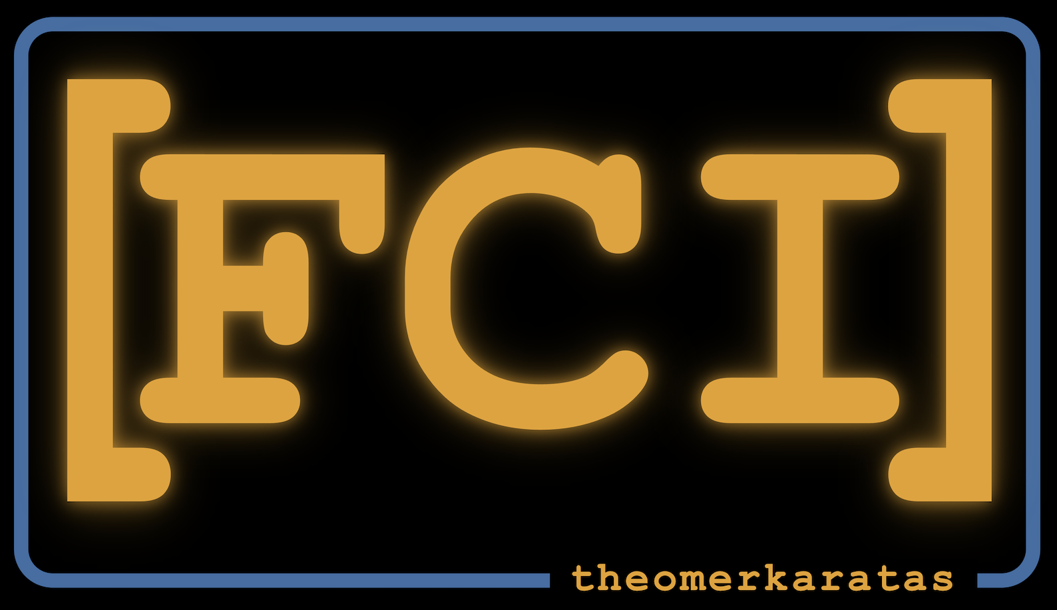
Free Cloud Initiative
- Designed and implemented a fully open-source, self-hosted cloud platform on a seven-node ARM64 Raspberry Pi Kubernetes cluster, providing container compute, managed PostgreSQL, S3-compatible storage, networking, IAM, and browser-based terminal access. Built with Go microservices, K3s, Argo CD, Helm, Terraform, Ansible, GitHub Actions, and a complete observability stack to demonstrate cloud, DevOps, and platform-engineering concepts in a reproducible environment.
- GitHub: https://github.com/freecloudinitiative
- Website: https://freecloudinitiative.com
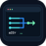
Azure DevOps Batch Operator (a22r)
- A terminal UI (TUI) and CLI tool built in Go for managing and bulk-updating Azure DevOps release pipelines. Features 50+ batch commands for pipeline cloning, drift detection, variable and stage synchronization, dry-run previews, and operation rollback support.
- GitHub: https://github.com/theomerkaratas/azure-devops-batch-operator

Licenses & Certifications

CGOA: Certified GitOps Associate – Linux Foundation

CAPA: Certified Argo Project Associate – Linux Foundation
KCNA: Kubernetes and Cloud Native Associate – Linux Foundation

Terraform Associate 003 – Hashicorp

Data Science Certificate Program – Istanbul Technical University

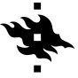
Elements of AI – University of Helsinki

Skills
- DevOps & SRE Tools: CI/CD, Jenkins, Azure DevOps, ArgoCD, GitHub Actions, Git, Terraform, Ansible, Docker, Kubernetes
- Message Brokers & Stream Processing: Kafka, Redis, RabbitMQ
- Cloud Platforms: Huawei Cloud, AWS, Linode, Google Cloud, Azure
- Monitoring & Observability: Prometheus, Grafana, Elastic Stack (ELK)
- Programming & Scripting: Go, Python, SQL, Bash, Powershell

