# Interview Questions on git

1. What is git ?

Git is **an Open Source Distributed Version Control System. CLI tool.** Use to maintain proper Dev. history. Few commands are execute in remote repo.

1. What is difference between git and GitHub and GitLab?

Git lab used for GitLab is majorly focused on DevOps and CI/CD.

1. What is difference between svn and git?

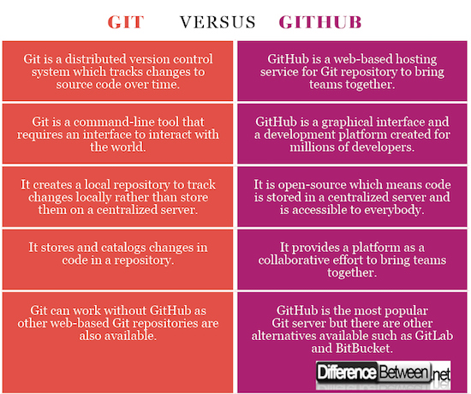

1. What is merge conflicts have you faced ever in you experience? if you face how you resolve?

Merge conflicts **occur when competing changes are made to the same line of a file, or when one person edits a file and another person deletes the same file**.

$ Git Pull Origin Master

1. What is git stash?

Git has area called as stash where you can temporarily store a snapshot of your changes without commiting them to repository.

It’s separate from working directory.

Shows work in progress

[] git stash

[] git stash pop 🡪 show WIP again.

[] git stash apply

[] git stash list

1. What is git HEAD?

The HEAD in Git is a file that references the current branch you are currently on.

1. What is staging area in git?

Staging area is **files that are going to be a part of the next commit**, which lets git know what changes in the file are going to occur for the next commit.

1. What is .gitignore file? What is the purpose of the file?

gitignore file **tells Git which files to ignore when committing your project to the GitHub repository**.

1. What is git branch? Have you worked on branches?

A branch is a version of the repository that diverges from the main working project. It is a feature available in most modern version control systems. A Git project can have more than one branch. These branches are a pointer to a snapshot of your changes.

When you want to add a new feature or fix a bug, you spawn a new branch to summarize your changes. So, it is complex to merge the unstable code with the main code base and also facilitates you to clean up your future history before merging with the main branch.

1. What is difference between git fetch and pull and clone

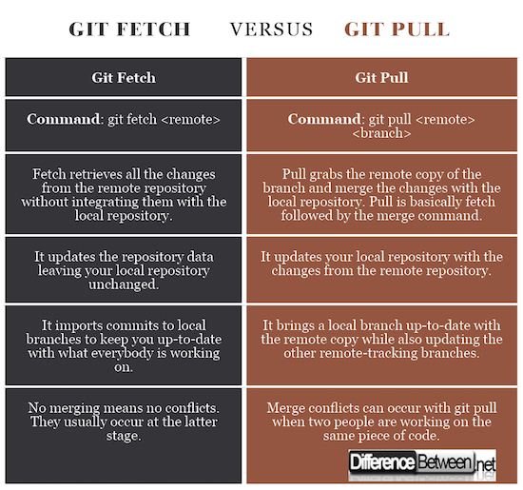

1. How to merge branches?

$ git merge <branch name>

1. How to check difference in between two files?

$ git diff <path> <path>

1. What is difference between 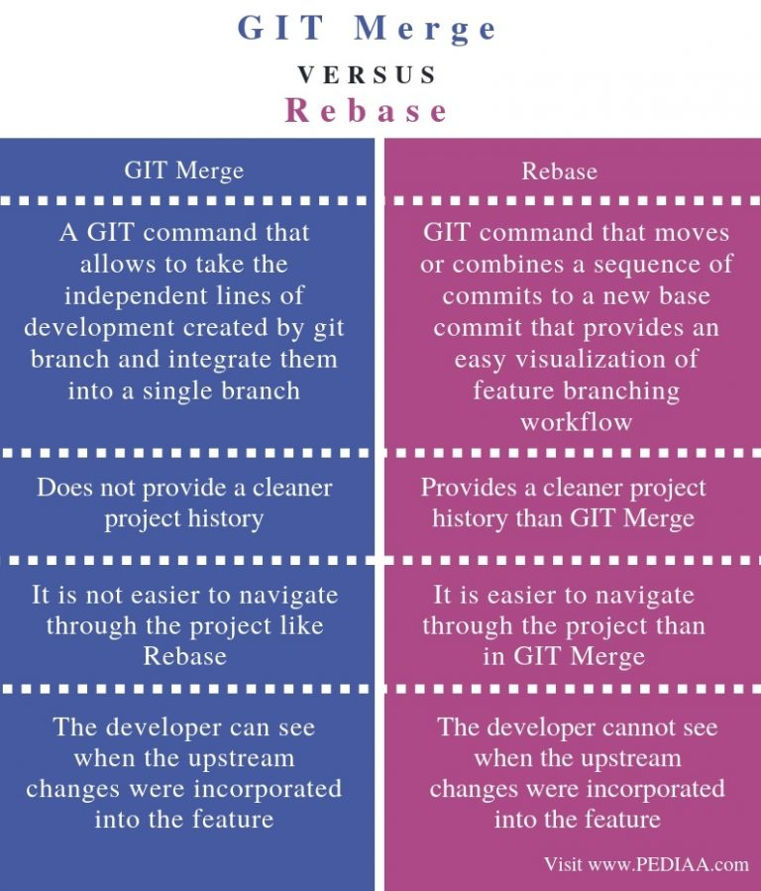
2. What is tag? How many types in tag? How we will create tags?

**Tag** operation allows giving meaningful names to a specific version in the repository.

Annotated tag : $ git tag -a < v1.4 > -m < "my version 1.4" >

Light-weighted tag: $ git tag **<tag** name**>**

1. What is cherry-pick in git?

$ git cherry-pick **<commit** id/comiit bash**>**

Cherry-picking in Git stands for applying some commit from one branch into another branch. In case you made a mistake and committed a change into the wrong branch, but do not want to merge the whole branch. You can revert the commit and apply it on another branch.

1. How edit the committed message?

$git commit –amend

1. How to check the last few commits?

$ **git log**

1. How to delete remote branch and local branch?

Local Branch:

$ **git branch -d <branch_name>**

Remote Branch:

**$ git push origin --delete remote_branch**

1. How to create local branch?

**$ git branch <new_branch>**

1. How to roll back committed code.

git revert < commit sha >

1. How to check the difference in file between working are and staging area ?

**$ git diff - Compare working area to index.**

**$ git diff --staged - Compare stage area to repository.**

**$ git diff HEAD - Compare working area to repository.**

1. Git branch strategy:

