Users & Groups:

id <uname>- root users with '0'

Ps -au <other users process we can kill them PID>



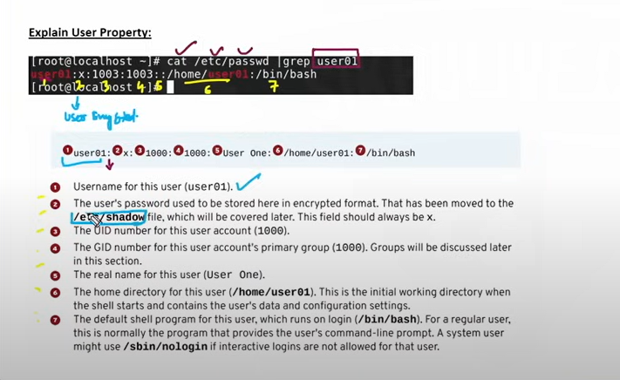

Cat /etc/group |grep user1

groups

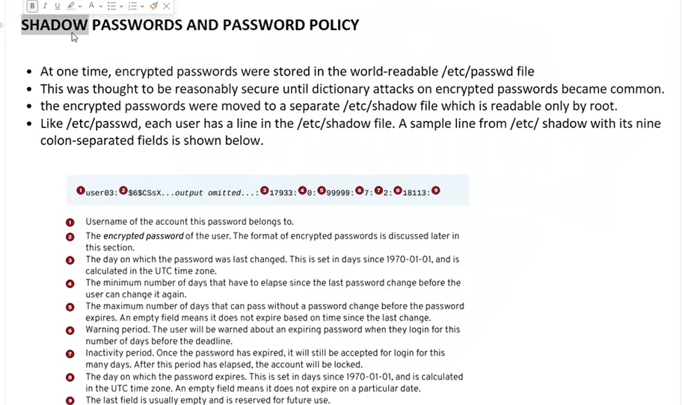

Chage -l <uid> shows password account information

Chage -d 0 <age> to change password

Useradd -r <linuxsystem>

Cat /etc/groups

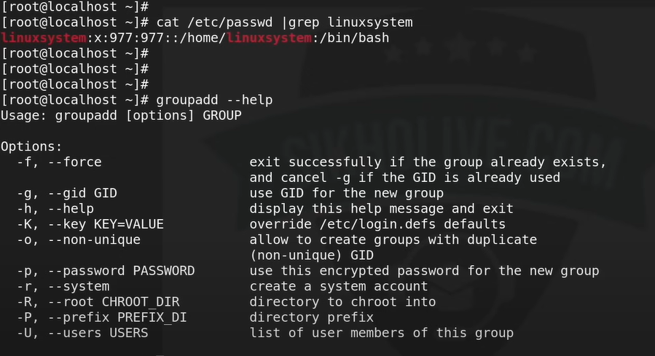

File system:

4 - Read

2 - write

1 - executiva

File - 666

Directory - 777

Top

pgrep -l -u tcuser

Pkill -U <uname>

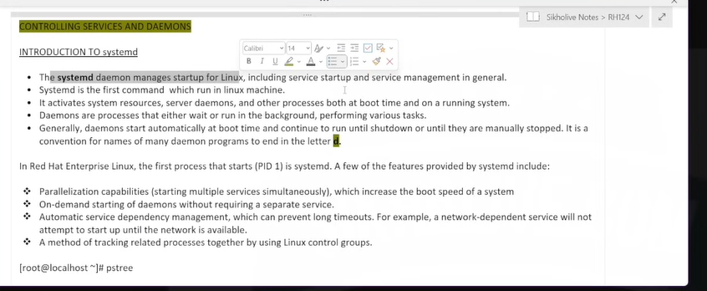

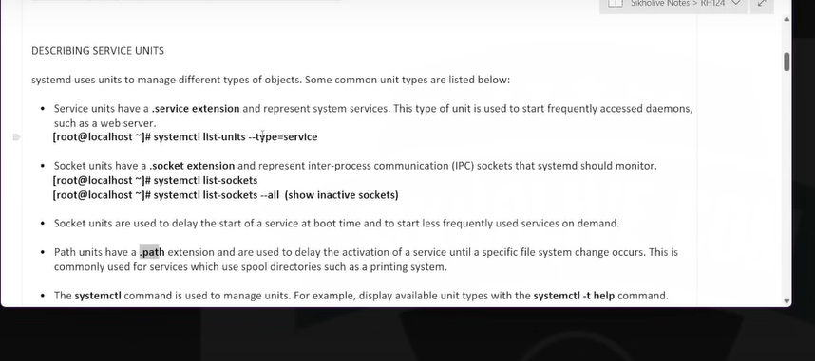

Systemctl list-units --type=service

Systemctl list-sockets

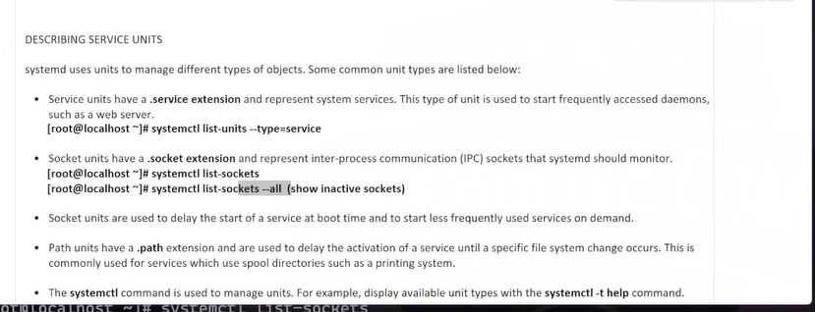

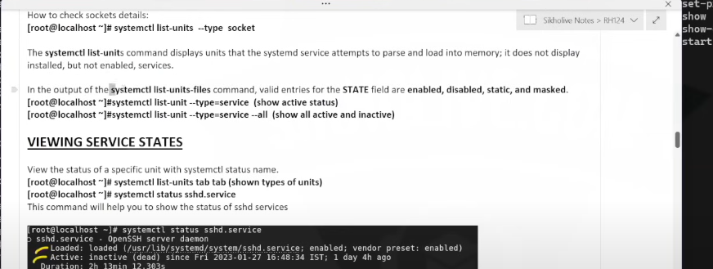

systemctl list-units-files <-- running systrmctl files

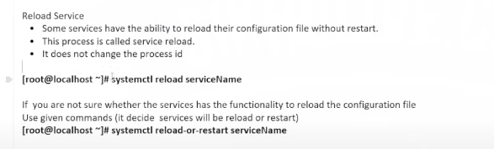

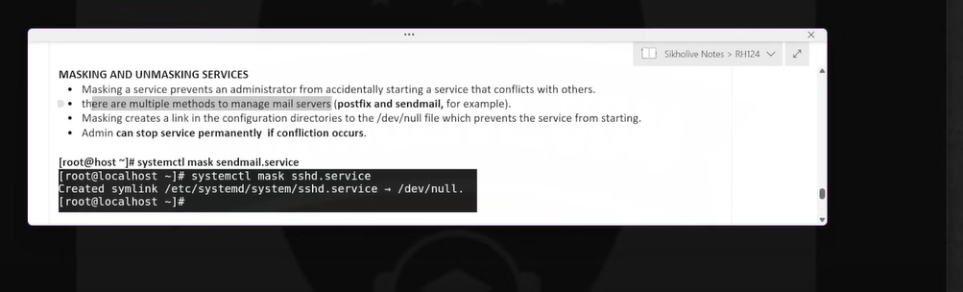

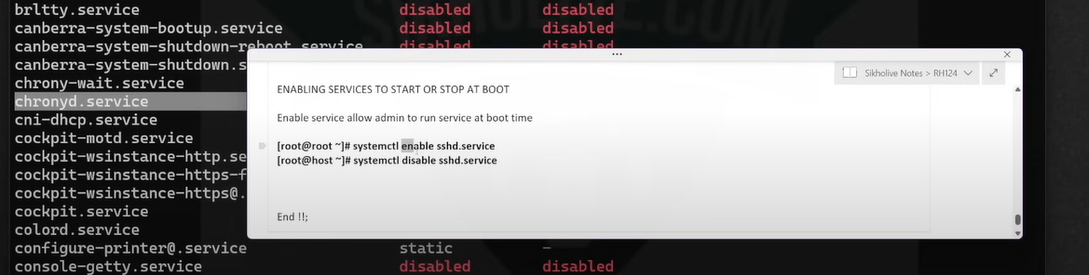

Before doing ssh-copy-id target machine should be there run via -

ping

Else we need to vi /etc/hosts

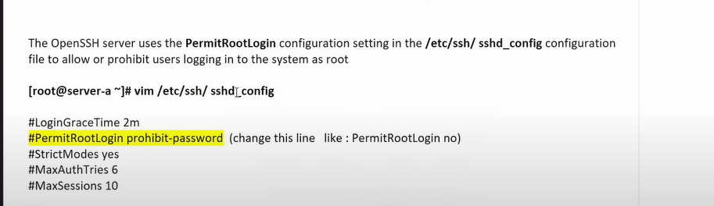

To allow specific Info or root user access -

