**PRACTICAL 10**

**K014-Heet Gala**

Exercise

1. The annual rainfall at a certain place is normally distributed with mean 30. If the rainfall during the past 8 years are 31.1, 30.7, 24.3, 28.1, 27.9, 32.2, 25.4 and 29.1, can we conclude that average rainfall during the past 8 years is less than the normal rainfall?

Write R program for above problem.

CODE:

#Q1

#Ho=not less than normal

#H1=less than normal

p=t.test(x=c(31.1,307,24.3,28.1,27.9,32.2,25.4,29.1),y=NULL,alternative = "less", paired=FALSE, mu=30, var.equal = FALSE,conf.level = 0.95)

p_value=p$p.value

print(p_value)

alpha=0.05

if(p_value<alpha)

{

print("reject null hypotheses")

}else

{

print("accept null hypotheses")

}

#conclusion:avg rainfall not less then normal rainfall

SCREENSHOT:

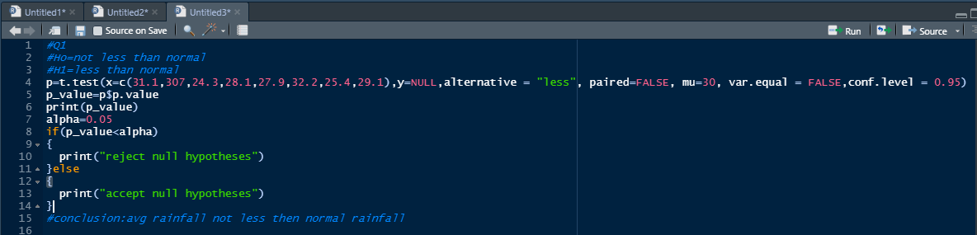

OUTPUT:

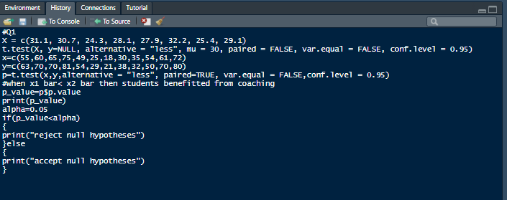

1. Two random samples gave the following data:

Sample Size Mean Variance

1. 16 440 40
2. 25 460 42

Can we conclude that the means of the two samples differ significantly?

Write R program for above problem.

1. The following data relate to the marks obtained by 11 students in 2 tests, one held at the beginning of a year and the other at the end of the year after intensive coaching.

|  |  |  |  |  |  |  |  |  |  |  |
| --- | --- | --- | --- | --- | --- | --- | --- | --- | --- | --- |
| Test 1:55 60 | 65 | 75 | 49 | 25 | 18 | 30 | 35 | 54 | 61 | 72 |
| Test 2:63 70 | 70 | 81 | 54 | 29 | 21 | 38 | 32 | 50 | 70 | 80 |

Do the data indicate that the students have benefited by coaching?

Write R program for above problem.

CODE:

#Q3

#Ho:not benefitted

#H1:benefitted

x=c(55,60,65,75,49,25,18,30,35,54,61,72)

y=c(63,70,70,81,54,29,21,38,32,50,70,80)

p=t.test(x,y,alternative = "less", paired=TRUE, var.equal = FALSE,conf.level = 0.95)

#when x1 bar< x2 bar then students benefitted from coaching

p_value=p$p.value

print(p_value)

alpha=0.05

if(p_value<alpha)

{

print("reject null hypotheses")

}else

{

print("accept null hypotheses")

}

#conclusion:students have benefitted from the coaching

SCREENSHOT:

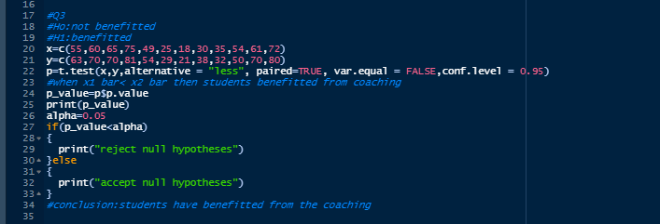

OUTPUT:

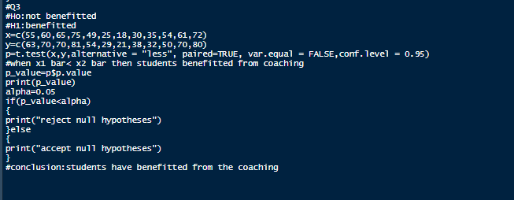

1. In a test given to two groups of students the marks obtained were as follows. First Group

18 20 36 50 49 36 34 49 41

Second Group

29 28 26 35 30 44 46

Examine the significant difference between the means of marks secured by students of the above two groups.

Write R program for above problem.

CODE:

#Q4

#H0: there is no significant difference in mean

#h1: there is significant difference in mean

x=c(18,20,36,50,49,36,34,49,41)

y=c(29,28,26,35,30,44,46)

p=t.test(x,y,alternative = "two.sided", paired=FALSE, var.equal = FALSE,conf.level = 0.95)

p_value=p$p.value

print(p_value)

alpha=0.05

if(p_value<alpha)

{

print("reject null hypotheses")

}else

{

print("accept null hypotheses")

}

#conclusion:THERE IS NO SIGNIFICANT DIFFERENCE IN THE MEAN

SCREENSHOT:

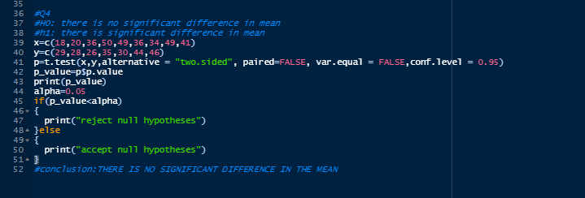

OUTPUT:

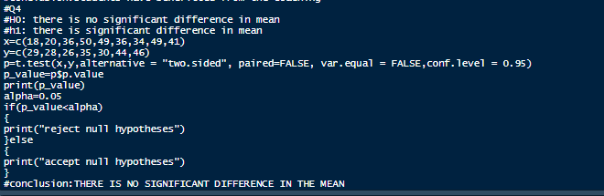

**PRACTICAL 9**

**K014-HeetGala**

QUESTION 1.

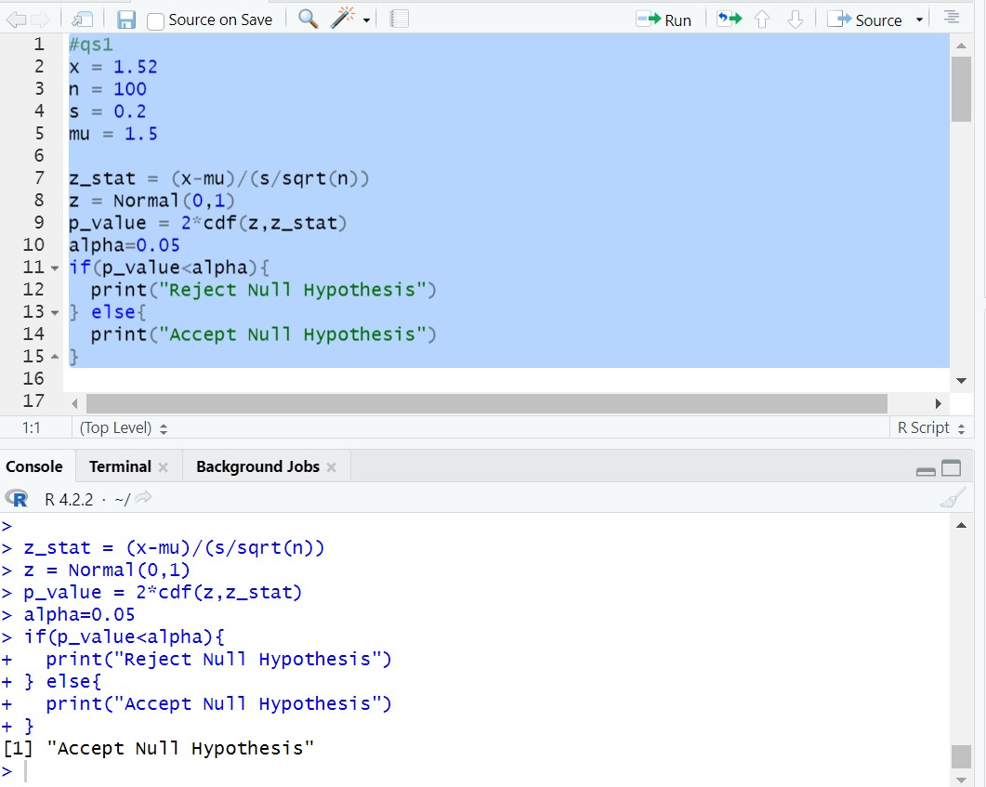

QUESTION 2.

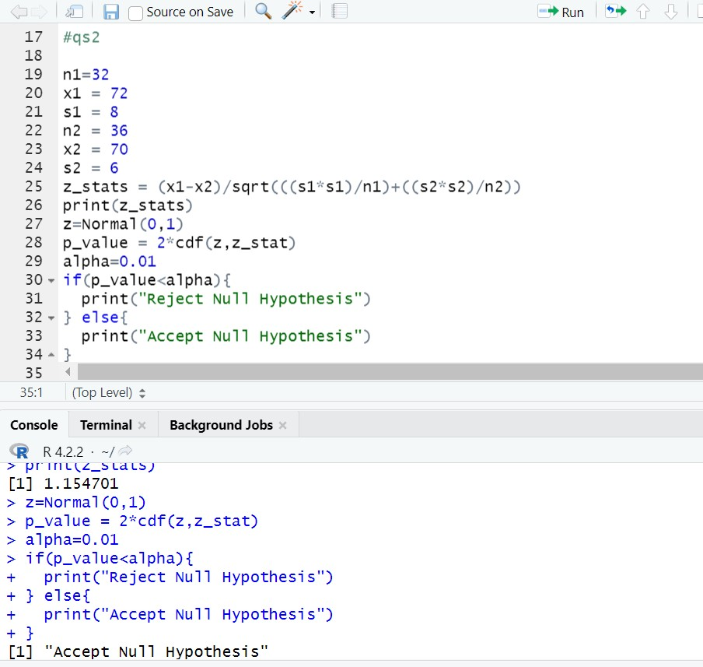

QUESTION 3.

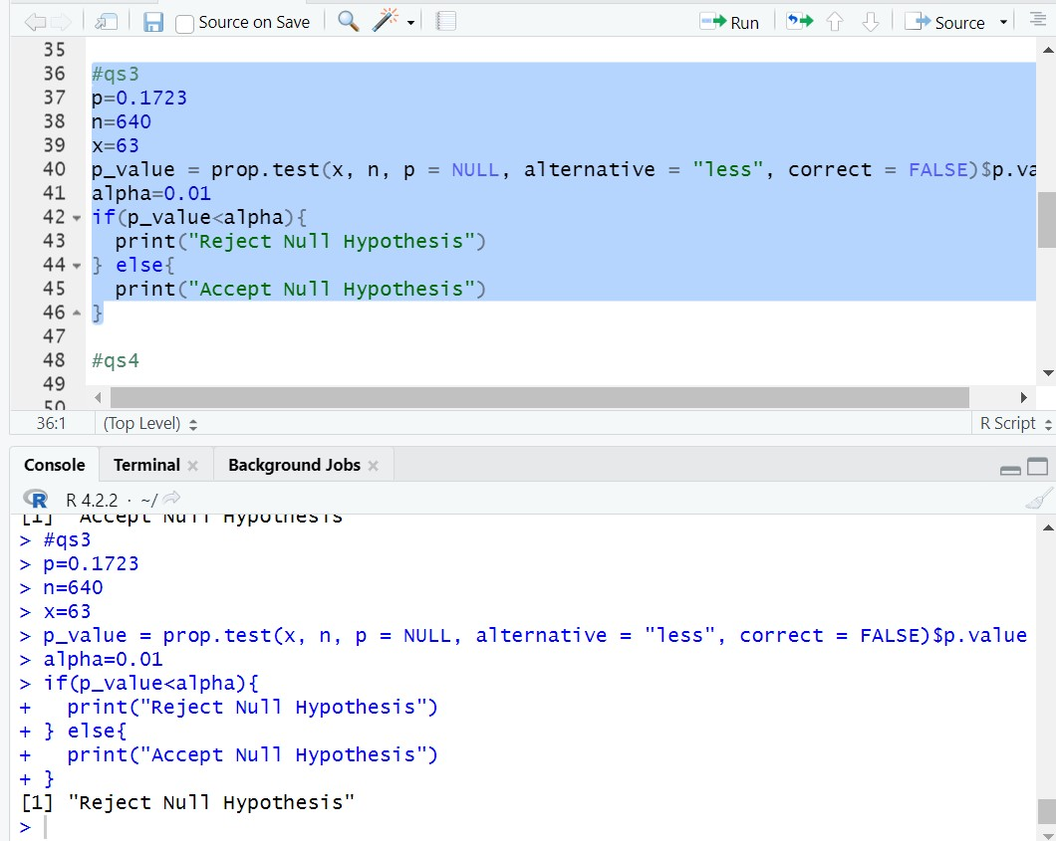

QUESTION 4.

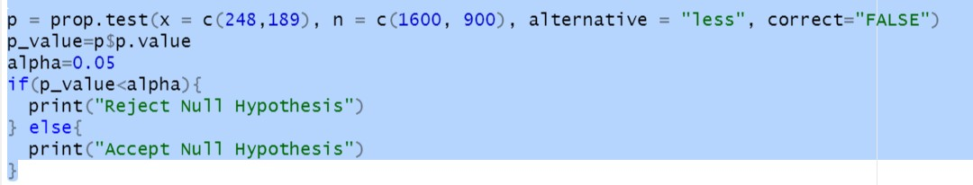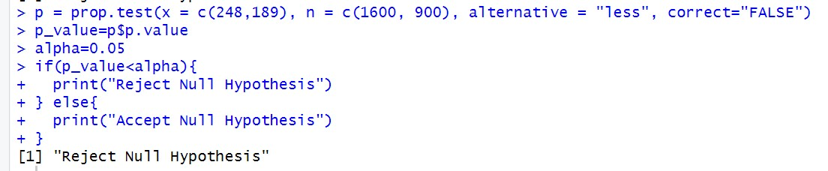

QUESTION 5.

